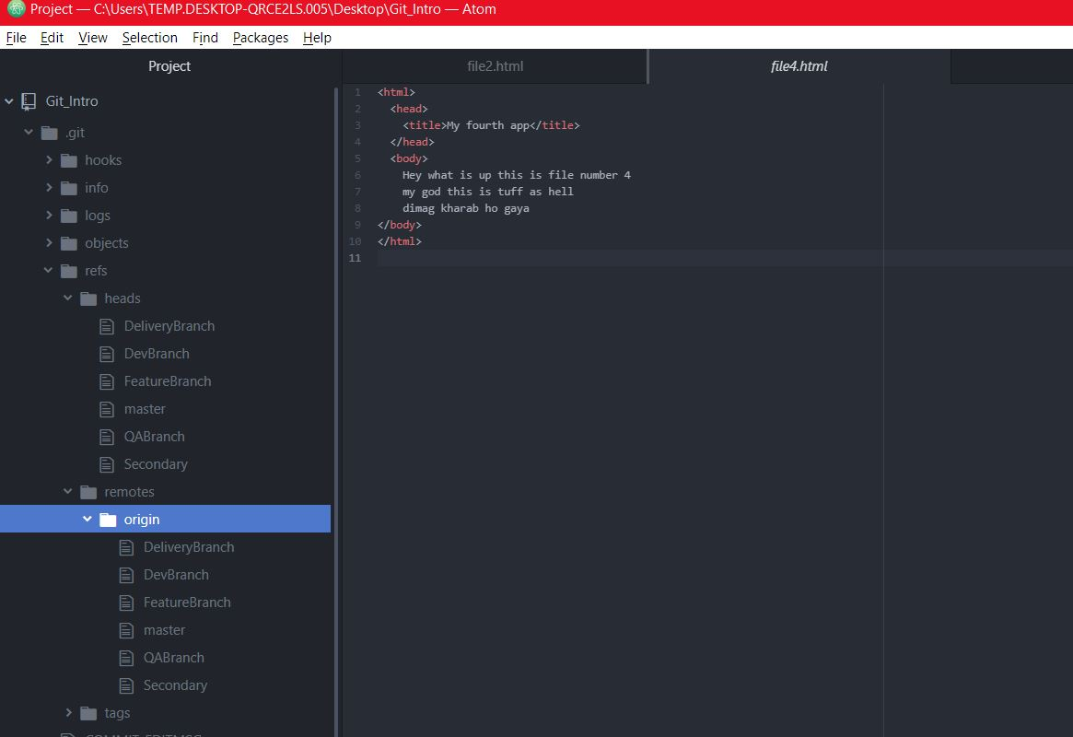

1. All the branches created locally as well as the origin\master on remote repository In github.
2. 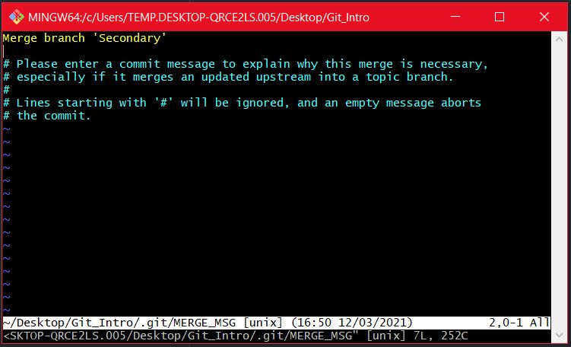
3. This is the merging the branch Secondary to the master branch .
4. 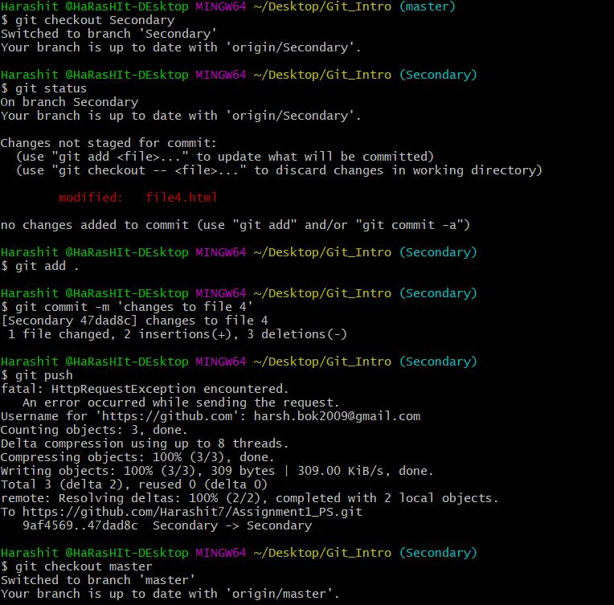
5. This is the example of checkout option, rebase merge option , merge recursive option git push example, git commit example , git add example git status example.
6. 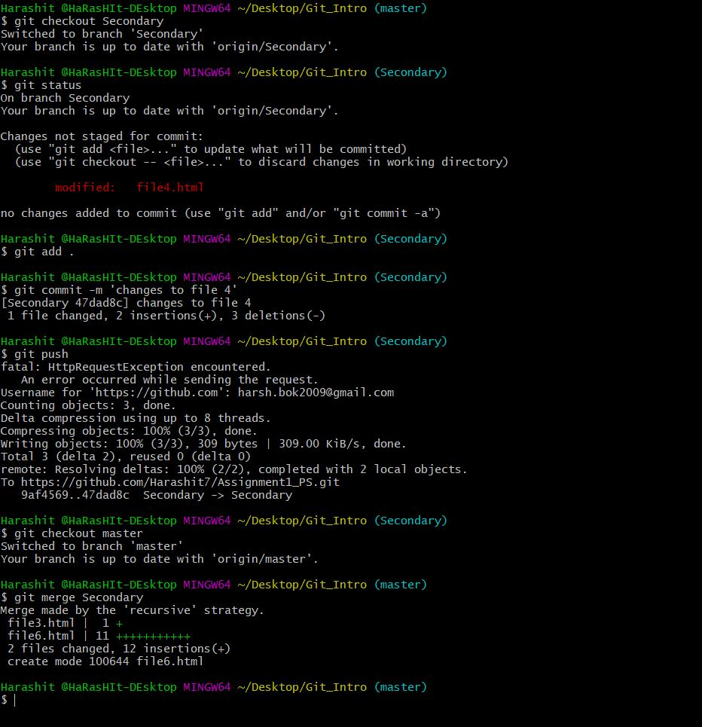
7. This is the merge happening in process where two files have been added to the master branch.
8. This is the example of the Network diagram for the foollowing branches . We can see that the merge between master and secondary took place by recursive strategy and not rebase since the branching wasn’t a straight line(direct)

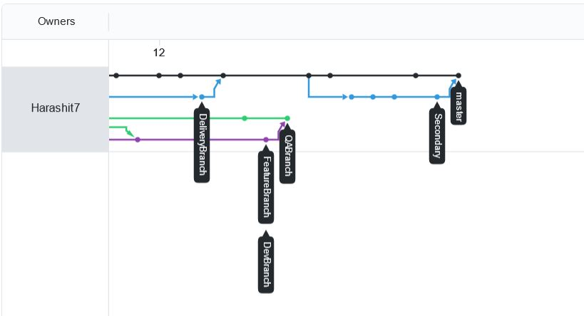

1. 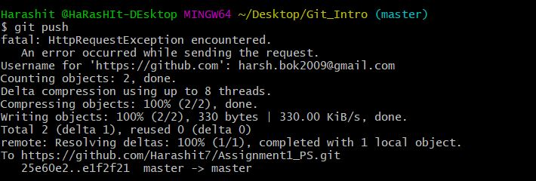
2. This is the pushing example data.
3. 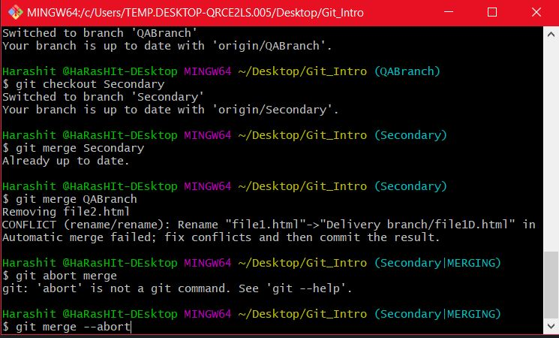
4. This is the merge conflict acting here.
5. Resolved here then merged the following.
6. 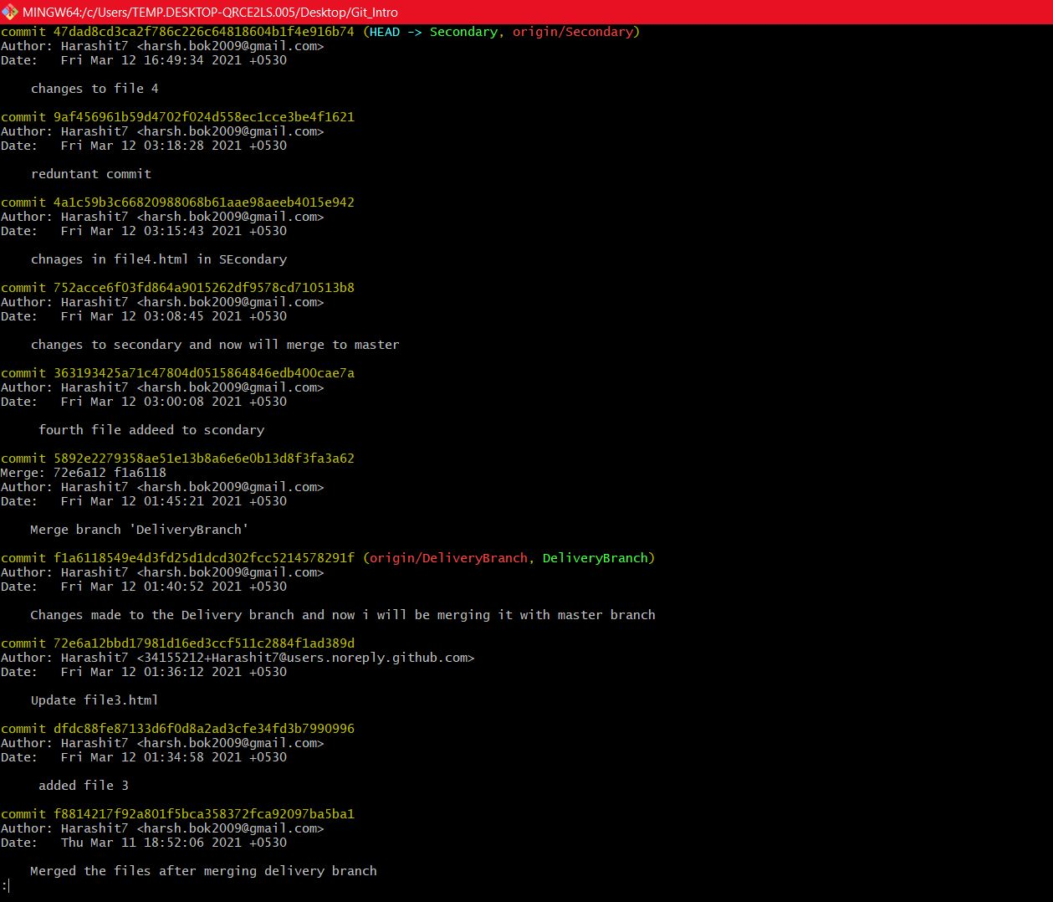
7. This is the git log
8. 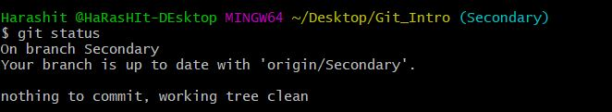
9. Git status example
10. 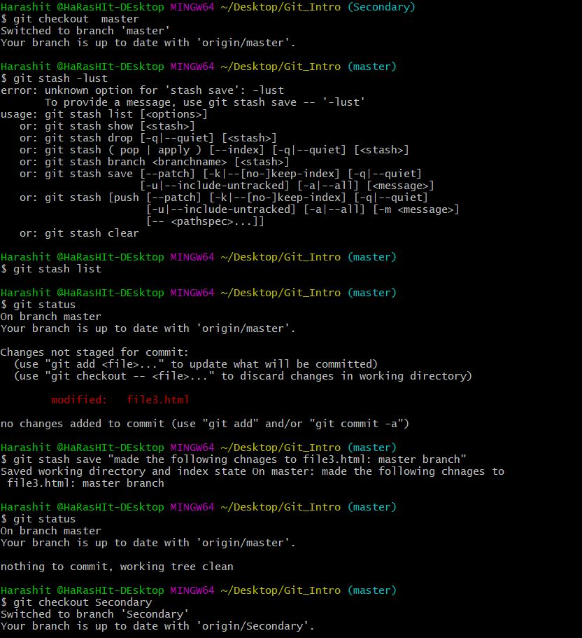
11. Using git stash above
12. 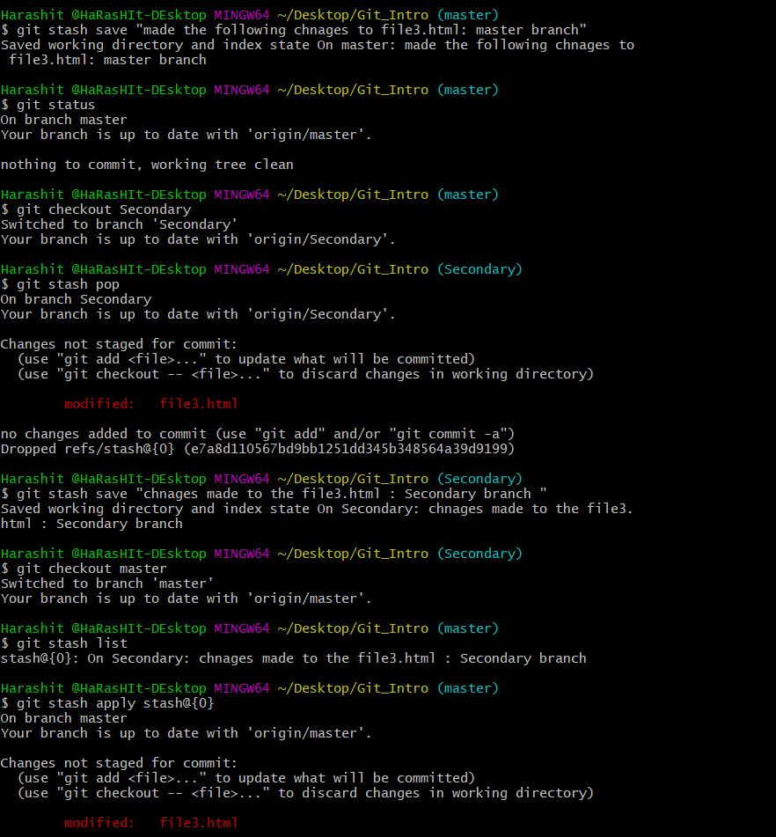
13. All the steps were done by the help of GUI client as well. Also the d part of assignment was used and taken help if during the course of the assignment.