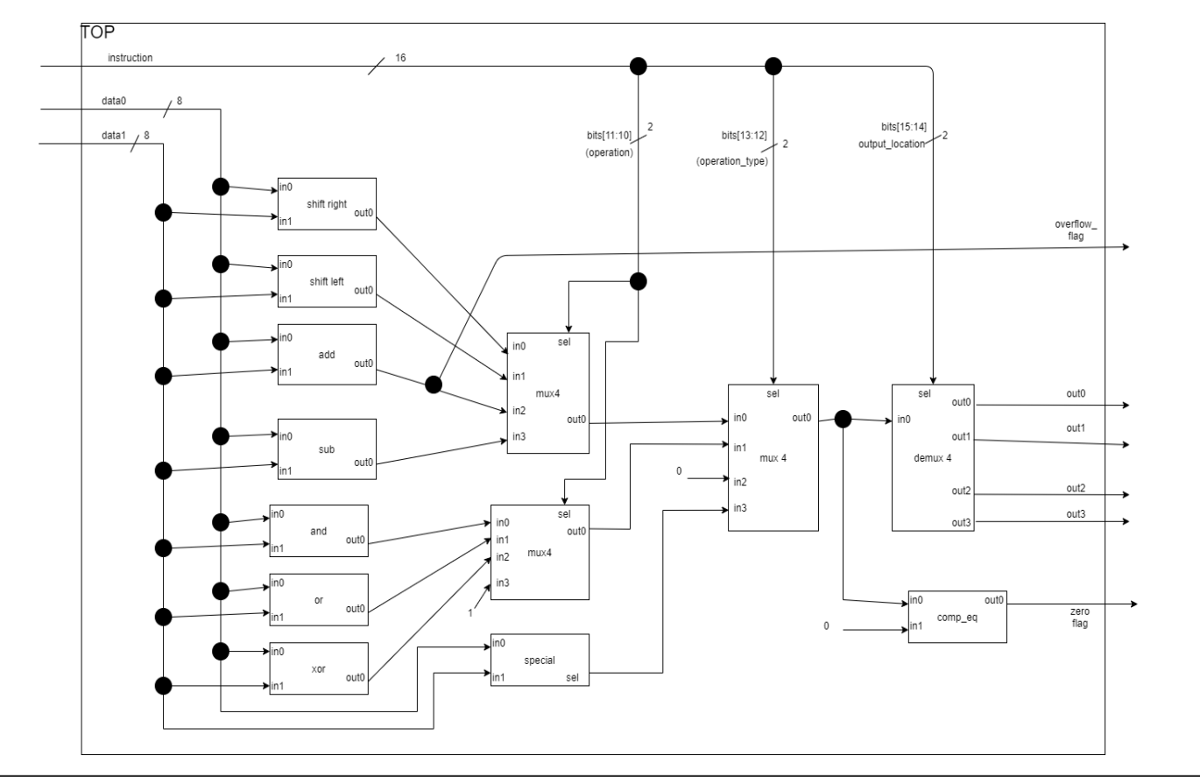The circuit above is a simplified arithmetic and logic unit (ALU), similar to what is found inside processors (Microprocessor/Microcontroller Architecture). Its role is to perform calculations between the 2 input data and to output the result (together with some flags signaling special situations) to one of the 4 outputs (for example, register blocks that subsequently save the result). To determine the desired operation, the bits in the instruction have the role of selecting the operation category (bits 13:12) and the specific operation within each category (bits 11:10). The shifting modules shift in0 with in1. Comp_eq is an equality comparator. The "special" module outputs 1 if the MSB and LSB of both inputs are all equal to each other, 0 otherwise. Separate module calculations are accepted as well. Add the appropriate wire dimensions where you consider it necessary. The overflow flag should be 1 when the sum does not fit into 8 bits.