

Department of Electrical and Computer Engineering

EECE 798U – Ethical Hacking

Instructor:
Dr. Hussein Bakri
Dr. Ali Al Azwar

Lab 3 Phase 0:
Obsidian & CherryTree

Submitted by:
John Harb 202670290
MEng Student

Lab3 – Obsidian – Phase 0
Installing obsidian on my kali linux:
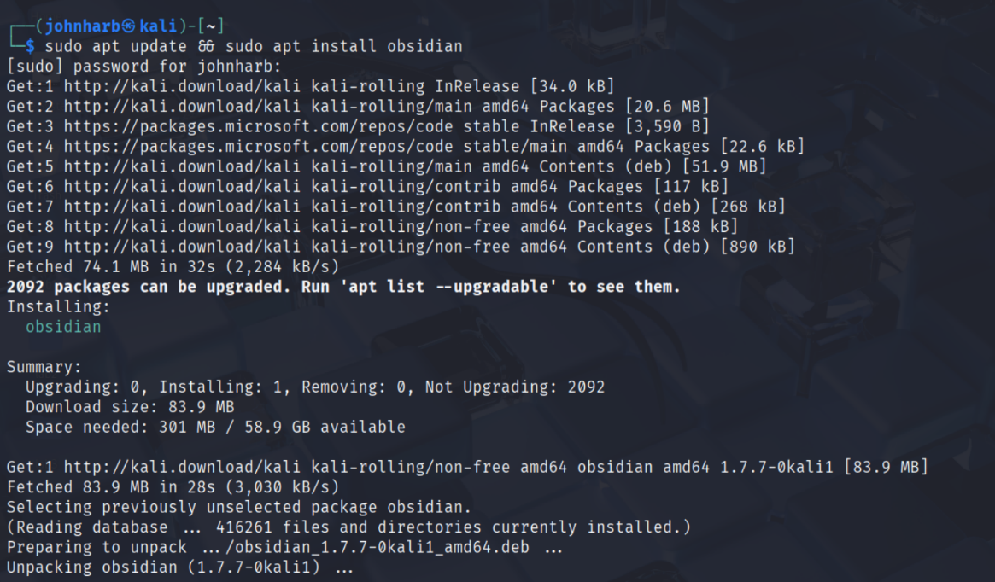

Obsidian Interface:
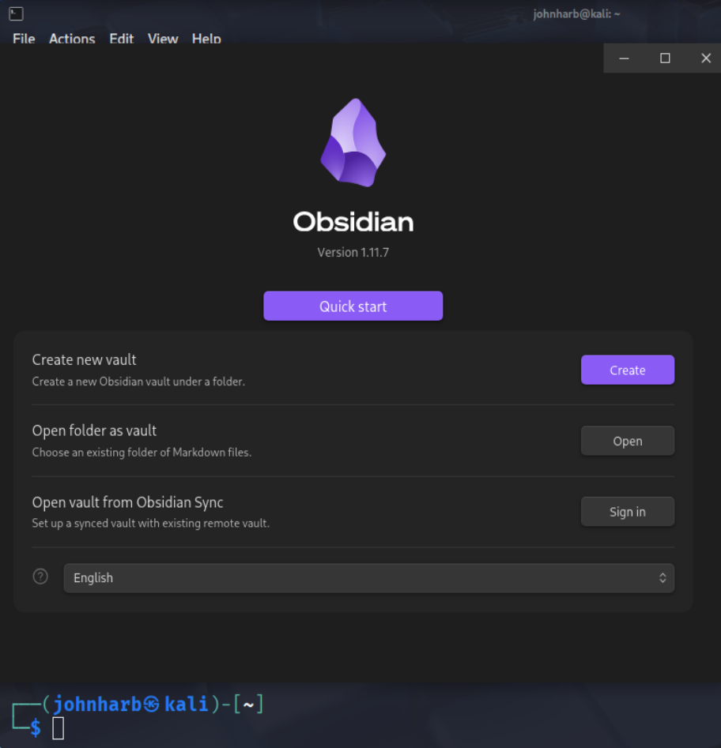
Creating the vault:
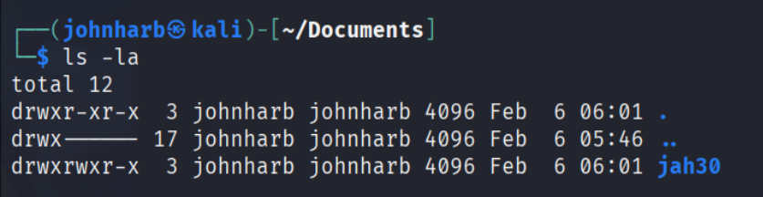

Reading View:
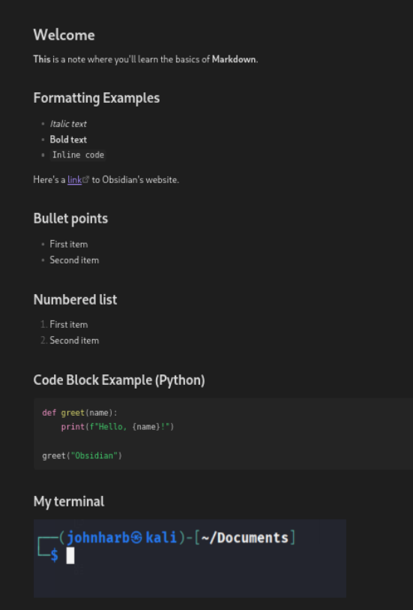

Source View/Mode:
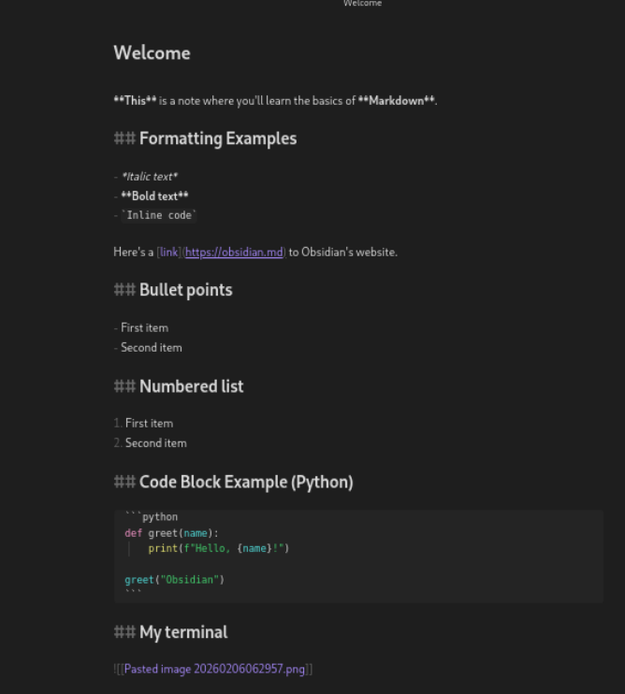

Light Mode:
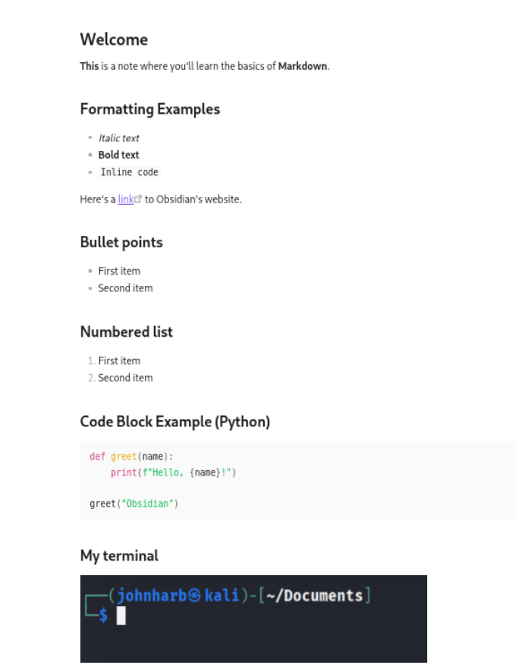

Pdf Export:
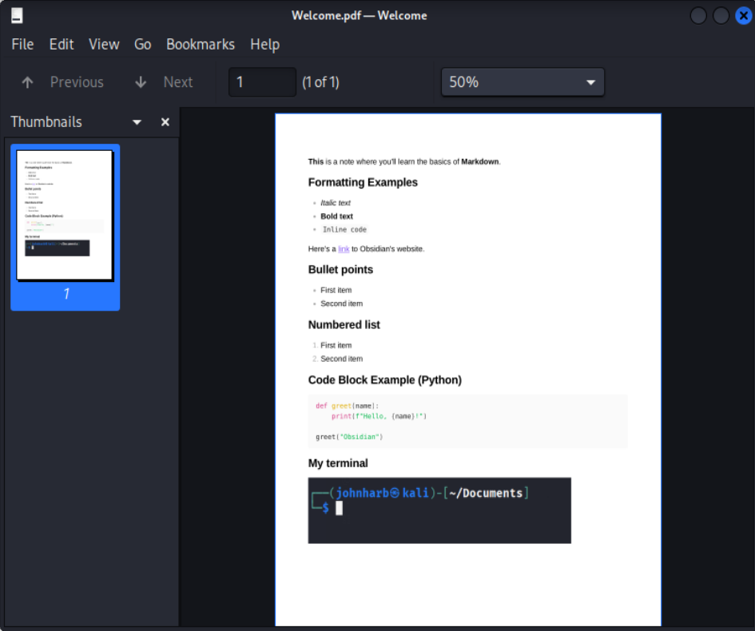

Lab3 – CherryTree – Phase 0b
Node creation:
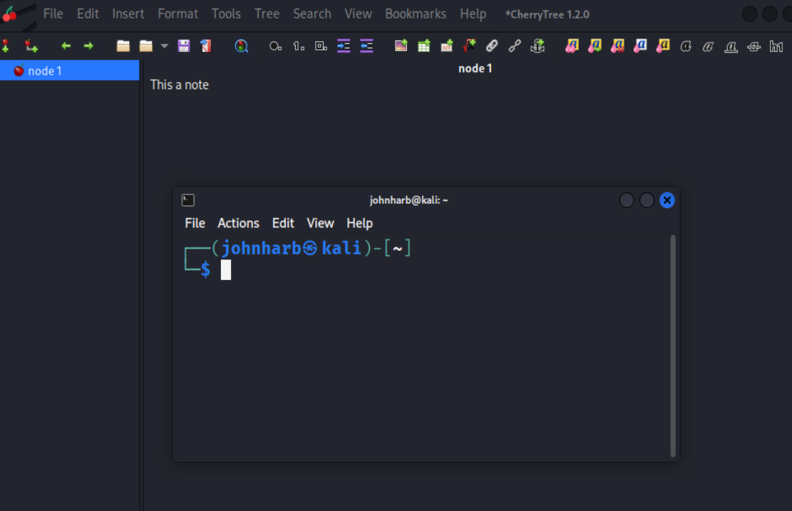

Sub node creation:
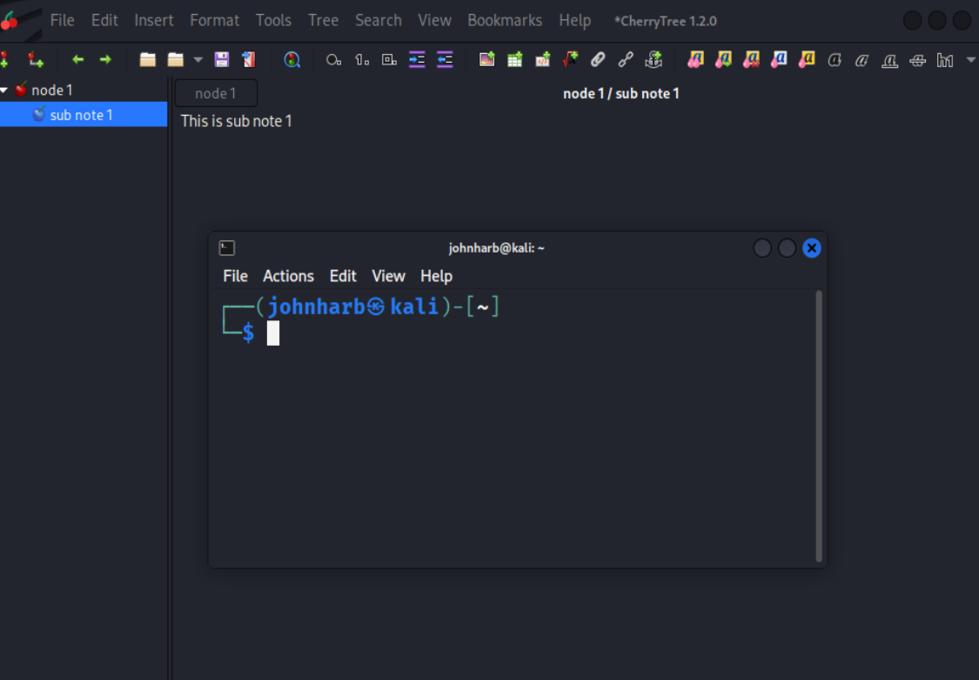
Saving my cherryTree file inside lab3 directory:
