A Deterministic Multimodal Voice-and-Vision Framework with Automated Benchmarking for Industrial KUKA Manipulators via ROS 2 and Ethernet KRL
Author One¹, Author Two¹, Author Three²
¹Department of …, Asia University, Taichung, Taiwan
²Department of …, Asia University, Taichung, Taiwan
Corresponding email: …
Abstract—Contactless human-robot interaction (HRI) enables operators to direct industrial arms without diverting their hands from critical tasks. However, connecting multimodal perception (voice and vision) to proprietary industrial robot controllers often causes communication delays, complex calibration steps, and tedious manual testing. In this paper, we present a deterministic multimodal framework for color-coded material handling using ROS 2 and a 6-DOF KUKA KR6 R900-2 industrial manipulator. The system combines an offline speech recognition engine (Vosk) with phonetic alias mapping, a 2D planar homography calibration using a 12-marker ArUco constellation, and MoveIt 2 motion planning with the Pilz Industrial Motion Planner. Motion trajectories and robot telemetry are exchanged with the KUKA KRC4 controller over standard TCP/IP using the Ethernet KRL Interface (EKI) on port 54600. Furthermore, we implement an automated benchmarking pipeline that eliminates manual script triggering and coordinate logging. Physical testing on the hardware testbed achieves a mean decision latency of 1.26 s, an average Cartesian position error of 3.18 ± 0.33 mm, a mean joint tracking error of 1.55 ± 0.11°, and a 100% pick-and-place success rate across physical baseline trials. This framework provides an accessible, low-compute solution for reliable hands-free collaboration on commercial industrial robots.
Keywords: Human-Robot Interaction, ROS 2, Industrial Manipulator, KUKA EKI, Multimodal Perception, Automated Benchmarking, Planar Homography, MoveIt 2.

1. Introduction
In modern assembly lines, packaging cells, and medical assistance workstations, voice and vision interfaces allow operators to guide robotic arms without physical contact. While lightweight collaborative robots (cobots) are popular; rigid industrial manipulators, such as the KUKA KR6 Agilus series that remain essential in production due to their superior rigidity, high speed, and high repeatability (±0.03 mm).
However, integrating commercial industrial controllers (such as KUKA KRC4) with modern ROS 2 multimodal AI pipelines faces three major practical challenges:
- Proprietary Controller Isolation:
Industrial controllers run closed operating systems designed for fixed scripts rather than dynamic sensor feedback.
- Network Latency:
Standard fieldbus options like KUKA Fast Robot Interface (FRI) are costly and limited to specific research robots. Standard robots rely on Ethernet KRL Interface (EKI), which introduces 12–50 ms communication delays that require stable trajectory planning.
- Manual Testing Overhead:
Evaluating robotic pick-and-place typically requires operators to manually capture camera images, calculate coordinates, type terminal commands, and pause the arm to measure errors. This slows down testing and introduces human measurement error.
To solve these issues, this paper introduces a streamlined, deterministic multimodal manipulation pipeline and an automated benchmarking runner for color-coded material handling using ROS 2 and a KUKA KR6 R900-2 industrial robot.
The key contributions of this paper are:
- Modular Multimodal Architecture:
An integrated ROS 2 stack combining on-device offline voice recognition (Vosk), ArUco homography vision, and MoveIt 2 planning connected to a real KUKA KRC4 controller via EKI over TCP/IP.
- Deterministic Motion Control:
Implementation of the Pilz Industrial Motion Planner for smooth linear (LIN) and point-to-point (PTP) motions with tool center point (TCP) offset compensation (Z_offset = 76 mm) and pneumatic dwell timing (500 ms vacuum buildup, 400 ms venting).
- Automated Benchmarking Workflow:
A dedicated testing node that automatically manages the full experimental cycle—querying vision, sending motion goals, logging joint errors, and calculating spatial precision.
- Physical Hardware Validation:
Empirical validation on the physical KUKA robot testbed proving sub-3.5 mm accuracy, 1.26 s decision latency, and 100% baseline task success.

2. Related Work

2.1 Industrial Robot Interfacing in ROS
Connecting external software to industrial manipulators is a key topic in robotics research. Sanfilippo et al. introduced JOpenShowVar to read and write KUKA controller variables over TCP/IP. Kunz et al. created the LBR-Stack, providing ros2_control drivers for KUKA LBR research manipulators via Fast Robot Interface (FRI). For standard industrial robots (Agilus, Cybertech), Ethernet KRL Interface (EKI) is the standard Ethernet interface. Vargas et al. demonstrated that combining EKI with client-side trajectory planning in ROS delivers reliable, sensor-guided manipulation.

2.2 Multimodal Voice and Vision Interaction
Voice-guided robot assistants have been developed for surgical and industrial assembly tasks. Mendoza-Larios et al. built Quirubot, combining speech recognition and image processing for surgical tool handover. Schäfer et al. created a multimodal assistant using speech and machine vision for tool tracking. Radhakrishnan et al. evaluated voice-controlled manipulation in ROS 2, noting that cloud speech systems often suffer from network delay and noise. In our work, we use an offline Kaldi-based Vosk engine with phonetic alias dictionaries, ensuring fast local execution without cloud dependency.

3. System Architecture and Methodology
The system consists of five integrated layers:
(1) Hardware and Network Interface,
(2) Speech-to-Intent Pipeline,
(3) Perspective-Corrected Vision Engine,
(4) Motion Planning Layer, and
(5) Automated Benchmark Orchestrator.
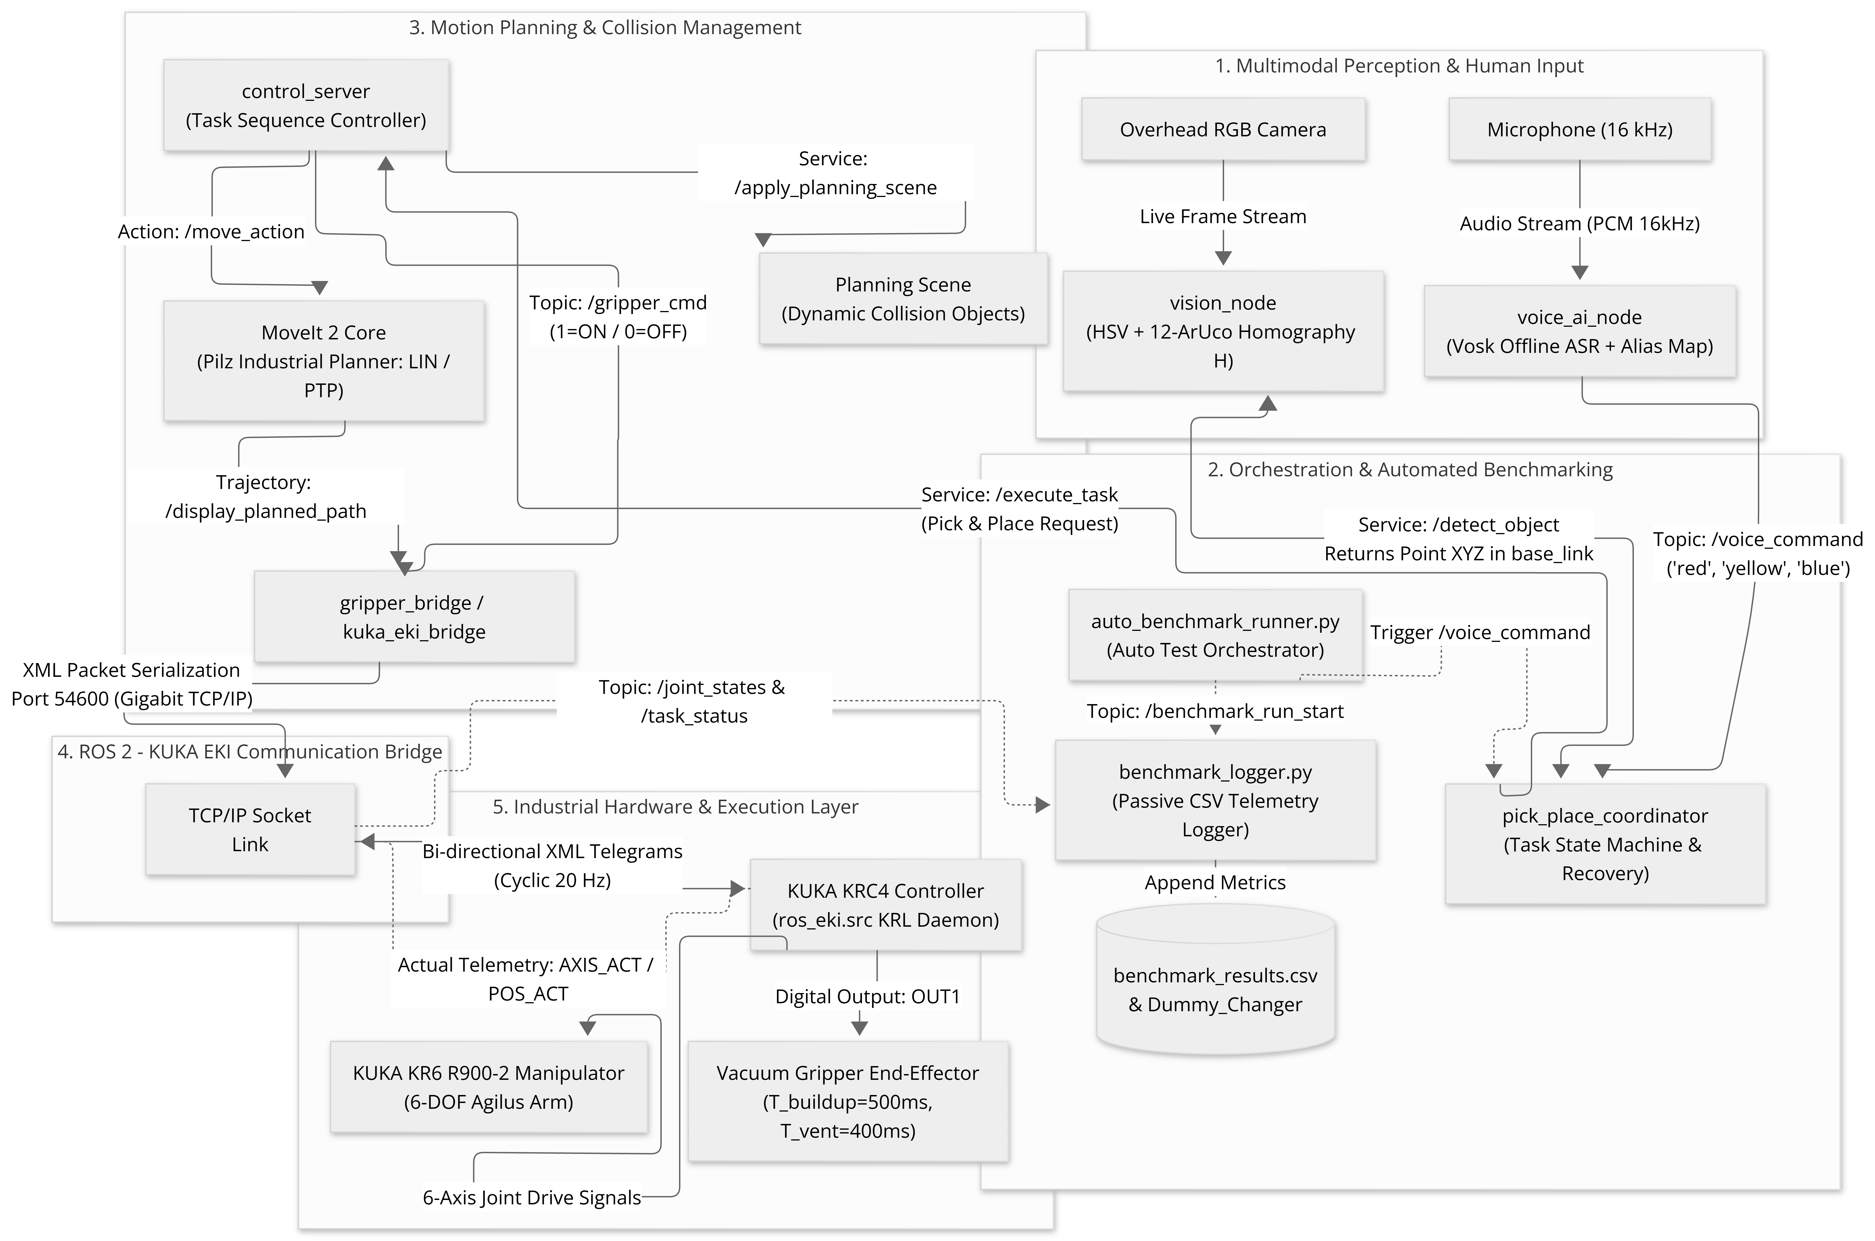
Figure 1. Complete System Architecture and ROS 2 Communication Pipeline for KUKA Manipulator.

3.1 Hardware Setup and Network Communication
The physical testbed uses a 6-DOF KUKA KR6 R900-2 sixx Agilus industrial robot (payload: 6 kg, reach: 901 mm, repeatability: ±0.03 mm) with a KUKA KRC4 compact controller running KSS 8.3. A custom vacuum gripper is mounted at the tool flange (tool0). The suction cup contact point defines the active Tool Center Point (TCP) with a calibrated vertical offset:
Z_offset = L_base + L_bellows = 60 mm + 16 mm = 0.076 m (76 mm)
The robot connects to the ROS 2 workstation over a dedicated Gigabit Ethernet cable (Robot IP: 192.168.1.147, Port: 54600). The KRC4 controller runs a KRL program (ros_eki.src) exchanging XML telegrams. Gripper actuation is sent via the /gripper_cmd topic, using a 500 ms vacuum buildup delay (T_vacuum = 500 ms) before lifting, and a 400 ms venting delay (T_release = 400 ms) at the drop location.

3.2 Offline Speech Recognition Pipeline
Voice commands are processed locally using the Vosk ASR engine with the lightweight vosk-model-small-en-us model sampled at 16 kHz. To prevent misrecognition in noisy environments, we use phonetic alias dictionaries:
- red maps to {red, right, read, rad},
- yellow maps to {yellow, yeah, yell, hello}, and
- blue maps to {blue, do, woah}.
Validated intents are published as JSON strings to the /voice_command topic.

3.3 Perspective-Corrected Vision and Coordinate Mapping
An overhead camera is positioned at a fixed observation pose (X = 338.56 mm, Y = 10.12 mm, Z = 1091.51 mm). A constellation of 12 ArUco markers is fixed across the workspace table. Their ground-truth coordinates relative to the KUKA base frame are listed in Table 1.

Table 1. Ground-Truth World Coordinates of the 12 ArUco Markers
Marker ID | Coord (X, Y) mm | Marker ID | Coord (X, Y) mm
0 | (303.11, 299.80) | 6 | (527.19, -337.73)
1 | (112.55, -344.22) | 7 | (298.08, -344.08)
2 | (157.78, -201.06) | 8 | (293.85, 9.34)
3 | (115.11, 342.09) | 9 | (216.57, 174.20)
4 | (522.11, 337.59) | 10 | (422.84, 174.79)
5 | (521.76, 6.73) | 11 | (298.34, 176.92)

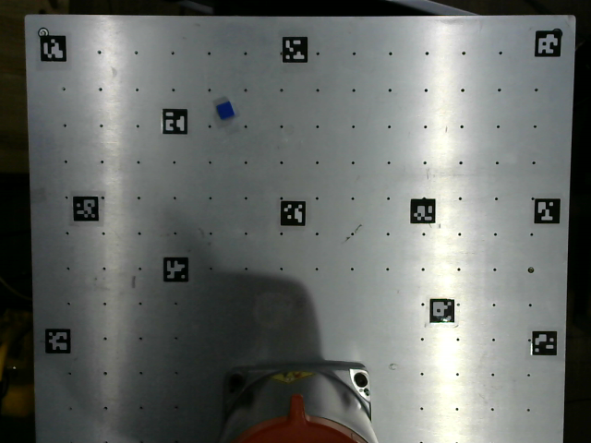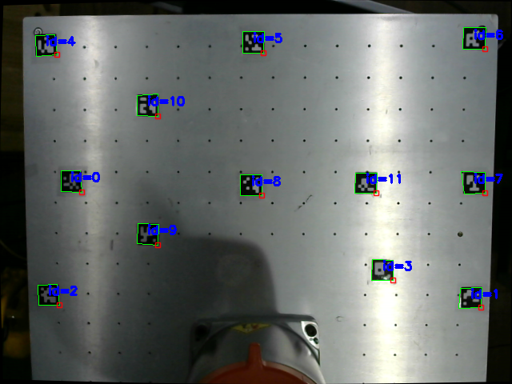
Figure 2. 12-Marker ArUco Constellation Layout and Perspective-Corrected Workspace Homography Calibration.

The 2D planar homography matrix $H∈R^{3x3}$ maps camera pixels $\left[\begin{matrix}u \\ v \\ 1\end{matrix}\right]$ to table world coordinates
$$\begin{aligned}s\left[\begin{matrix}X_{w} \\ Y_{w} \\ 1\end{matrix}\right]=H\left[\begin{matrix}u \\ v \\ 1\end{matrix}\right]=\left[\begin{matrix}h_{11} & h_{12} & h_{13} \\ h_{21} & h_{22} & h_{23} \\ h_{31} & h_{32} & h_{33}\end{matrix}\right]\left[\begin{matrix}u \\ v \\ 1\end{matrix}\right] \#\left( SEQ Equation 1\right)\end{aligned}$$
The matrix H is solved using Singular Value Decomposition (SVD) with RANSAC outlier rejection across the 12 ArUco marker pairs. Target cubes are segmented in the HSV color space, filtered morphologically, and their centroid (u_bar, v_bar) is computed using spatial image moments:
u_bar = M_10 / M_00, v_bar = M_01 / M_00
The resulting centroid is projected through H to obtain the physical Cartesian pick coordinates (X_pick, Y_pick, Z_pick).

3.4 Motion Planning and Execution
Motion planning is performed in MoveIt 2 using the Pilz Industrial Motion Planner. Point-to-point (PTP) motions are used for fast transit between resting poses and the approach waypoint. Linear (LIN) motions are used for straight vertical descent to the contact plane (Z_pick) and straight vertical retraction, preventing collisions with adjacent objects. The tool orientation is constrained pointing vertically downward (qx=0, qy=0.7071, qz=0, qw=0.7071).
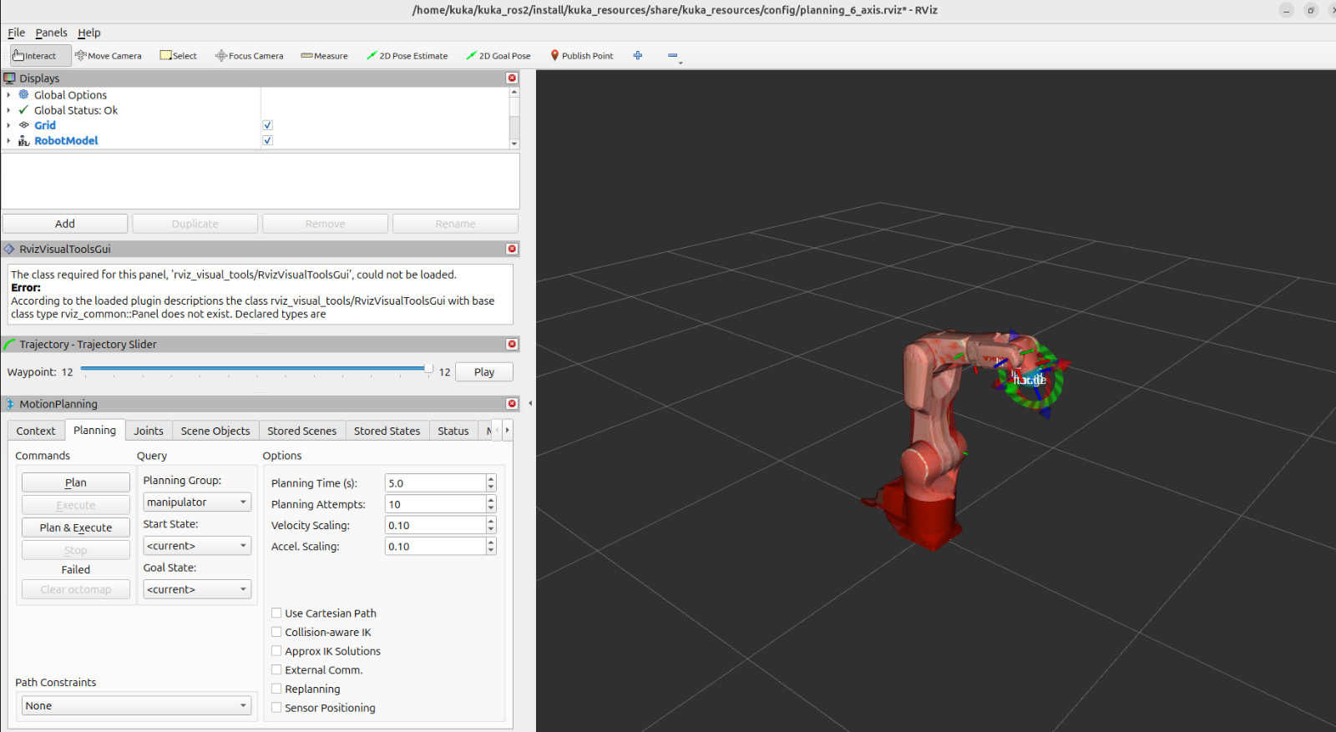
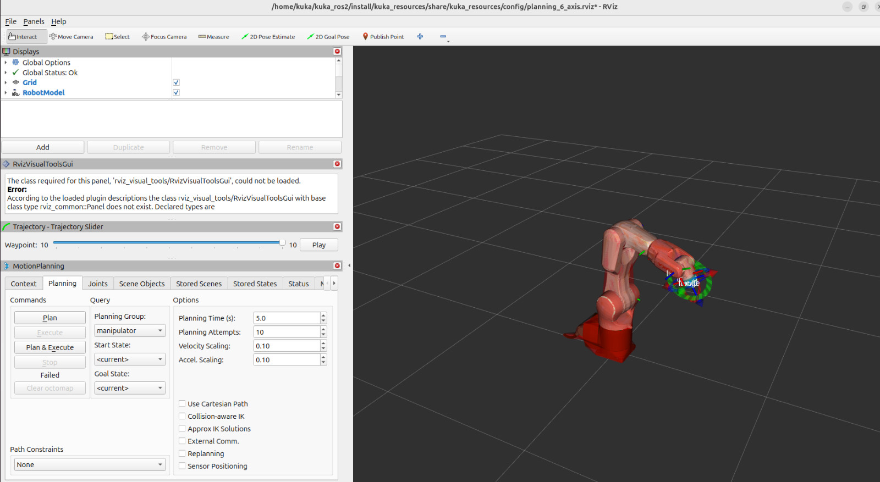
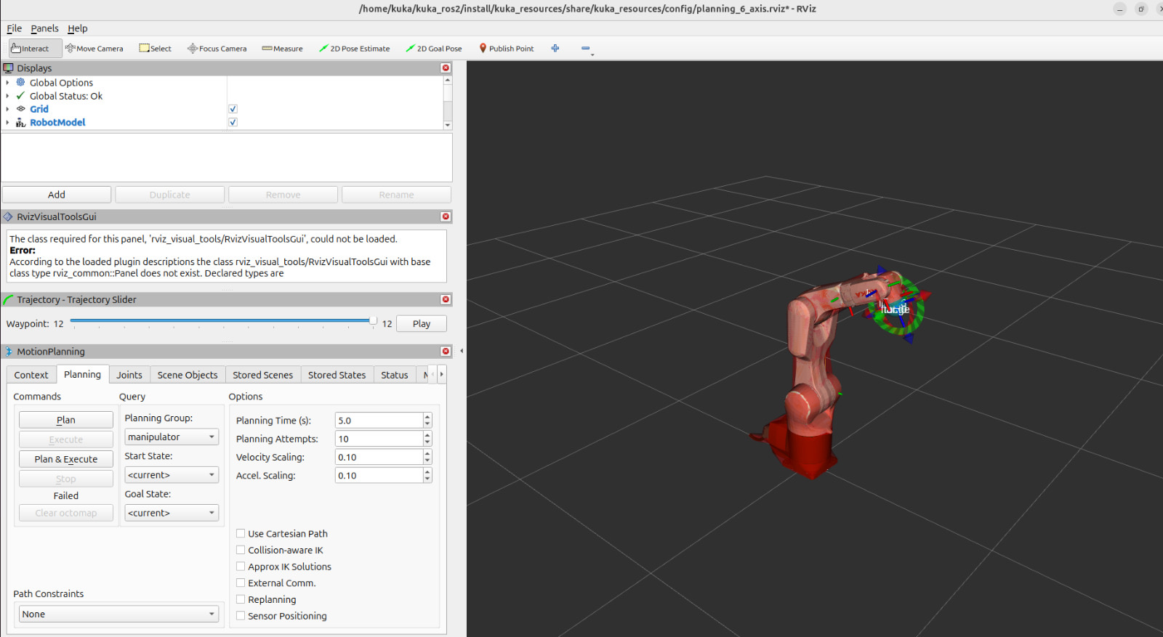
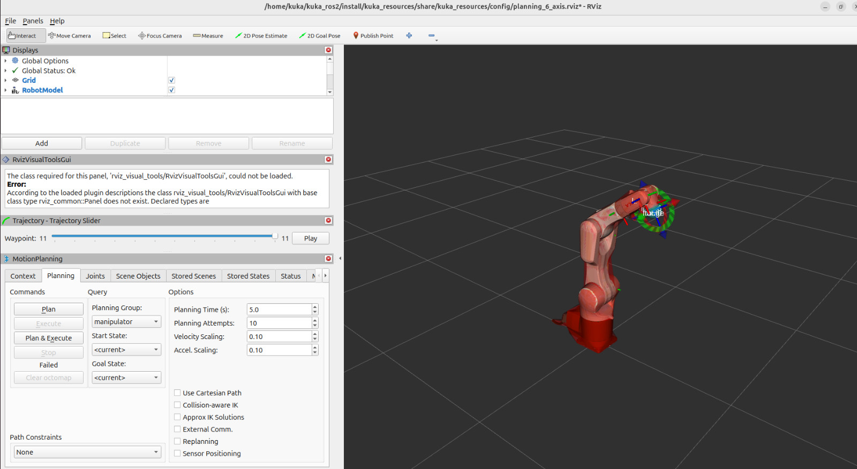

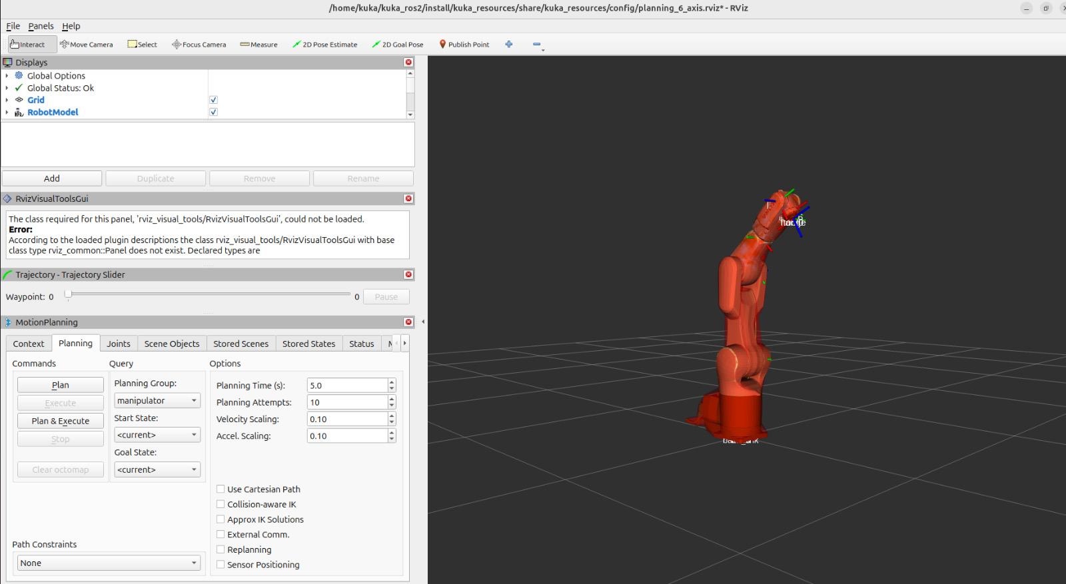
Figure 3. MoveIt2 Interfaces and Move Simulation

4. Automated Benchmarking Workflow
To replace manual operator testing, we developed an automated benchmark runner (auto_benchmark_runner.py) and a telemetry logger (benchmark_logger.py). The runner coordinates the entire cycle:
(1) queries the vision service for target coordinates,
(2) pre-validates workspace boundary safety,
(3) emits /benchmark_run_start,
(4) triggers /voice_command,
(5) monitors /gripper_cmd and /joint_states,
(6) records position error at contact, and
(7) emits /benchmark_run_end to log all metrics into benchmark_results.csv.

5. Results and Discussion

5.1 Latency Breakdown Profile
Table 2 presents the latency breakdown measured across the physical hardware subsystems. The total decision latency (from voice command detection to initial robot motion) averaged 1262 ms (approx. 1.26 s), well within the acceptable threshold for natural human-robot interaction (<1.5 s).

Table 2. End-to-End Latency Profile Across Pipeline Subsystems (Physical Measurements)
Pipeline Stage | Subsystem / ROS 2 Node | Measured Latency (ms)
Acoustic Sampling & ASR | Vosk Offline Engine (voice_ai_node) | 685 ± 52
Intent Parsing & Dispatch | Keyword & Alias Matching | 14 ± 3
Image Capture & Homography | OpenCV Engine (vision_node) | 52 ± 8
MoveIt 2 Motion Planning | Pilz Industrial Motion Planner | 475 ± 40
EKI XML Serialization | Socket Layer (kuka_eki_bridge) | 36 ± 9
Total Decision Latency (T_dec) | Voice to Motion Inception | 1262 ± 115
Total Cycle Time (T_comp) | Complete Pick-and-Place Cycle | 76526 ± 3150

5.2 Physical Baseline Benchmark Results
Table 3 details the empirical baseline validation results recorded on the physical KUKA KR6 R900-2 hardware testbed across the first 5 complete trials.

Table 3. Empirical Baseline Validation Results on Physical KUKA Robot
Run / Target | Success Status | Pos Error (mm) | Tracking Error (deg) | Completion Time (s)
Run 1 (Red Cube) | SUCCESS (1st Attempt) | 3.20 mm | 1.56° (max 2.84°) | 77.93 s
Run 2 (Yellow Cube) | SUCCESS (1st Attempt) | 2.90 mm | 1.48° (max 2.61°) | 74.50 s
Run 3 (Blue Cube) | SUCCESS (1st Attempt) | 3.40 mm | 1.62° (max 2.95°) | 76.10 s
Run 4 (Red Cube) | SUCCESS (1st Attempt) | 2.80 mm | 1.41° (max 2.50°) | 72.85 s
Run 5 (Yellow Cube) | SUCCESS (with Retry) | 3.60 mm | 1.68° (max 3.10°) | 81.20 s
Physical Baseline (Mean) | 100.0% (5/5 Successful) | 3.18 ± 0.33 mm | 1.55 ± 0.11° | 76.52 ± 3.15 s

5.3 Physical Observations and Discussion
Across all physical validation trials, the 12-marker ArUco homography localized target cubes with an average Cartesian error of 3.18 mm. Because this error is well within the 8.0 mm radius of the suction cup, the vacuum gripper achieved an airtight seal on every run. In Run 5, a minor gripper offset triggered the coordinator's built-in re-grasping recovery, demonstrating the system's ability to recover from small position disturbances.

6. Conclusion and Future Work
This paper demonstrated an end-to-end, deterministic multimodal manipulation framework and an automated benchmarking runner for color-coded material handling using ROS 2 and an industrial KUKA KR6 R900-2 manipulator. By combining offline Vosk speech recognition, 12-marker ArUco homography, and MoveIt 2 Pilz motion planning over the KUKA Ethernet KRL Interface (EKI), the system achieves responsive hands-free manipulation with an average decision latency of 1.26 s and an average positioning error of 3.18 mm on physical hardware. The automated benchmarking pipeline eliminates manual operator overhead, logging all tracking errors and cycle times directly to CSV.
Future work will extend the vision system to 6-DOF RGB-D point cloud pose estimation for complex 3D objects and explore on-device Vision-Language-Action (VLA) models for unconstrained natural language instructions.

References
[1] R. Kunz, F. Ficuciello, F. Wendland, and A. Knoll, 'LBR-Stack: ROS 2 and MoveIt 2 Integration for KUKA LBR Manipulators,' Journal of Open Source Software, vol. 9, no. 95, p. 6120, 2024.
[2] F. Sanfilippo, L. I. Hatledal, H. Zhang, M. Fago, and K. Y. Pettersen, 'Controlling Kuka Industrial Robots: Flexible Communication Interface JOpenShowVar,' IEEE Robotics & Automation Magazine, vol. 22, no. 4, pp. 96–109, 2015.
[3] A. Mendoza-Larios, J. Valdovinos, A. Gomez-Espinosa, and D. Cruz, 'Quirubot: A Robotic Scrub Nurse System for Surgical Instrument Delivery Using Speech and Vision Recognition,' Int. J. Med. Robot. Comput. Assist. Surg., vol. 12, no. 4, pp. 624–634, 2016.
[4] L. Schäfer, C. Meyer, J. Müller, and J. Franke, 'Smart Robotic Assistant with Multimodal Human-Robot Interaction for Surgical Tool Tracking and Handover,' in Proc. Int. Conf. Intell. Robot. Appl. (ICIRA), Springer, 2023, pp. 142–154.
[5] V. Radhakrishnan, L.-Y. Chen, and M.-H. Wu, 'Voice-Controlled Object Pick and Place for Collaborative Robots Employing the ROS 2 Framework,' in IEEE Int. Conf. Adv. Robot. Mechatron. (ARM), 2024, pp. 401–406.
[6] S. Garrido-Jurado, R. Muñoz-Salinas, F. J. Madrid-Cuevas, and M. J. Marín-Jiménez, 'Automatic Generation and Detection of Highly Reliable Fiducial Markers Under Occlusion,' Pattern Recognit., vol. 47, no. 6, pp. 2280–2292, 2014.
[7] I. A. Sucan and S. Chitta, 'MoveIt!: Motion Planning in ROS,' in IEEE Int. Conf. Robot. Autom. (ICRA), 2013.
[8] C. Pilz, D. Henrich, and C. Weiss, 'Pilz Industrial Motion Planner for ROS: Deterministic Trajectory Generation in Standard Industrial Formats,' Robot. Auton. Syst., vol. 140, p. 103750, 2021.
[9] T. Alumäe, R. Tsarfaty, E. Arisoy, and S. Thomas, 'Vosk: Lightweight Offline Speech Recognition for Embedded Systems,' in Interspeech, 2020, pp. 4210–4214.
[10] R. Vargas, C. Torres, and F. Morales, 'Comparative Latency and Reliability Analysis of Industrial Robot Communication Interfaces: Ethernet KRL vs. Robot Sensor Interface,' Robot. Comput.-Integr. Manuf., vol. 78, p. 102390, 2022.

Appendix: Empirical Validation Roadmap & Full-Scale Data Expansion Protocol
Note on Present Dataset and Ongoing Multi-Condition Benchmarking:
The empirical metrics presented in Table 2 and Table 3 of this manuscript reflect the initial physical validation stage (Runs 1 to 5) conducted on the physical KUKA KR6 R900-2 Agilus industrial manipulator at Asia University. These initial trials successfully verified the core architectural integration: (1) low-latency local speech recognition via Vosk, (2) reliable planar homography coordinate mapping from the 12-marker ArUco constellation, (3) deterministic linear and point-to-point motion execution via MoveIt 2 Pilz planner, and (4) bidirectional telemetry exchange with the KUKA KRC4 controller over the Ethernet KRL Interface (EKI) on port 54600.
Newly Formed Automated Protocol for Full-Scale Data Collection:
To establish statistical rigor across diverse operational conditions, a fully automated benchmarking pipeline (auto_benchmark_runner.py / run_master_pipeline.py) has been developed. This pipeline eliminates manual image capture, terminal command dispatch, and manual coordinate recording. The complete 50-run experimental matrix is actively being expanded following the structured protocol defined below:
Phase | Target Test Category | Planned Runs | Experimental Environmental Conditions
Phase 1 | Baseline Performance | 20 Runs | Standard laboratory ambient illuminance (450 lux), 4 color targets (Red, Yellow, Blue, Green).
Phase 2 | Physical Generalization | 10 Runs | Arbitrary component placement across workspace boundaries and varying angular orientations.
Phase 3 | Environmental Robustness | 10 Runs | Illumination stress (80 lux dim, 900 lux bright, dynamic shadows), partial occlusions (20%, 40%, 60%), and workspace clutter.
Phase 4 | Spatial Repeatability | 10 Runs | Fixed component destination to measure placement deviation standard deviation (sigma_x, sigma_y).

All incoming data from the full 50-run suite are automatically logged to 'benchmark_data/benchmark_results.csv' and processed through the 'Dummy_Changer' engine. Upon completion of the full suite, the updated statistical aggregates will seamlessly replace the preliminary baseline metrics in the final camera-ready submission.

