Deterministic Multimodal Manipulation versus Vision-Language-Action Models: An Industrial ROS 2 Framework for KUKA Manipulators with Automated Benchmarking
Cornelio Abdimash¹, Author Two¹, Author Three²
¹Department of Mechanical and Automation Engineering, Asia University, Taichung, Taiwan
²Department of Computer Science and Information Engineering, Asia University, Taichung, Taiwan
Corresponding email: cornelioabdimash@gmail.com
Abstract—Modern robotics has witnessed a surge in end-to-end Vision-Language-Action models that directly predict robotic actions from visual observations and textual prompts. Although Vision-Language-Action policies exhibit remarkable semantic generalization across diverse domestic scenes, their deployment in rigid industrial manufacturing remains severely hindered by stochastic trajectory drift, lack of collision safety guarantees, high computational demands, and spatial positioning errors frequently exceeding fifteen millimeters. In this paper, we present a deterministic multimodal framework for color-coded material handling using ROS 2 and an industrial six-axis KUKA KR6 R900-2 manipulator. The architecture combines an offline lightweight speech recognition engine with phonetic alias mapping, perspective-corrected planar homography using a twelve-marker ArUco constellation, and MoveIt 2 motion planning with the Pilz Industrial Motion Planner. Communication with the proprietary KUKA KRC4 controller is established over standard TCP/IP using the Ethernet KRL Interface on port 54600. To address the limitations of conventional manual experimentation, we also introduce an automated benchmarking runner that autonomously queries perception services, verifies workspace safety boundaries, commands physical execution, and logs joint-level telemetry. Physical evaluations on the real robotic testbed achieve a mean decision latency of 1.26 seconds, an average Cartesian positioning error of 3.18 millimeters, a mean joint tracking error of 1.55 degrees, and a one hundred percent pick-and-place success rate across physical baseline trials. We contrast our modular engineering architecture against state-of-the-art Vision-Language-Action models, highlighting why deterministic planning and lightweight perception remain indispensable for high-precision industrial automation.
Keywords: Human-Robot Interaction, Vision-Language-Action Models, Industrial Automation, KUKA Robot, Ethernet KRL, MoveIt 2, Automated Benchmarking, Planar Homography.

1. Introduction
Contactless human-robot interaction has emerged as an essential capability for modern manufacturing and collaborative workstations. Allowing human operators to direct robotic manipulators through spoken natural language and visual tracking eliminates physical teach-pendant interaction and keeps operator hands free for assembly or inspection tasks. While lightweight collaborative robots are widely adopted in research laboratories, rigid six-axis industrial arms such as the KUKA KR6 Agilus series remain the standard choice in manufacturing due to their superior structural rigidity, high operational velocities, and repeatability within thirty micrometers.
In recent years, end-to-end Vision-Language-Action models such as RT-2, OpenVLA, and Octo have demonstrated impressive open-vocabulary generalization in tabletop environments. These transformer-based policies map raw camera frames and text prompts directly to continuous end-effector displacements. However, transferring end-to-end foundation models to high-payload industrial arms introduces significant engineering bottlenecks. Vision-Language-Action policies operate as probabilistic black boxes without formal collision-free guarantees, rendering them susceptible to unpredictable trajectory jitter. Furthermore, their spatial accuracy typically ranges between ten and twenty-five millimeters, which is insufficient for rigid industrial tolerances where vacuum suction cups and mechanical grippers demand millimeter-level precision. In addition, these large models require high-end graphics workstations with substantial power consumption, making them impractical for cost-constrained factory floors.
Beyond perception challenges, connecting external intelligence to commercial industrial controllers such as the KUKA KRC4 presents communication barriers. Industrial controllers are purpose-built for deterministic execution of proprietary robot language scripts rather than external sensor streams. Fieldbus solutions like Fast Robot Interface are expensive and restricted to specialized research robots. Standard industrial units must communicate over Ethernet KRL Interface sockets, which introduce variable network delays that require structured trajectory smoothing. Moreover, experimental validation of robotic handling systems is often conducted through labor-intensive manual workflows where operators repeatedly capture images, transcribe coordinates, trigger terminal commands, and measure physical residuals by hand.
To address these industrial requirements, this paper presents a deterministic multimodal manipulation pipeline and an automated benchmarking suite for a six-axis KUKA KR6 R900-2 industrial manipulator governed by ROS 2. Rather than relying on resource-intensive end-to-end deep neural policies, we propose a modular architecture that integrates on-device speech recognition, perspective-corrected homography vision, and MoveIt 2 deterministic motion planning. The system connects directly to the KUKA KRC4 controller through Ethernet KRL sockets without requiring external hardware modifications. Through empirical evaluations on physical hardware, we demonstrate sub-3.5 millimeter Cartesian precision, a 1.26-second decision latency, and complete pick-and-place reliability while outlining a systematic comparison against modern Vision-Language-Action paradigms.
2. Related Work and Paradigm Comparison
2.1 Industrial Controller Interfacing in ROS 2
Interfacing external computation with closed industrial manipulators has been investigated across several architectural paradigms. Sanfilippo et al. introduced JOpenShowVar, allowing external applications to read and write variables in KUKA controllers over cross-network sockets. Kunz et al. established the LBR-Stack, providing hardware control drivers for lightweight KUKA collaborative arms through the Fast Robot Interface. For standard industrial arms such as the Agilus and Cybertech families, the Ethernet KRL Interface remains the practical communication channel. Vargas et al. conducted latency evaluations demonstrating that Ethernet KRL enables robust trajectory execution when paired with client-side interpolation. Our framework leverages Ethernet KRL XML communication on port 54600, establishing a deterministic real-time bridge between ROS 2 motion planning and the native KRC4 motion executive.
2.2 Multimodal Interaction versus Vision-Language-Action Models
Multimodal robot guidance has traditionally relied on pipeline architectures that separate speech recognition, visual scene estimation, and motion synthesis. Mendoza-Larios et al. presented Quirubot for surgical instrument delivery using speech recognition and contour vision. Schäfer et al. demonstrated multimodal assistants for tool tracking in clinical environments. Radhakrishnan et al. evaluated voice-driven manipulation in ROS 2, noting that cloud-dependent voice services suffer from network latency and acoustic noise.
Recently, Vision-Language-Action models have gained significant attention. Brohan et al. developed RT-2, showing that web-scale vision-language models can be fine-tuned to output robotic action tokens. Kim et al. proposed OpenVLA, an open-source seven-billion-parameter policy capable of multi-task tabletop manipulation. Octo introduced a diffusion-based policy for multi-robot control across varied sensor modalities. While these models excel in semantic reasoning across novel environments, their computational overhead requires dedicated graphics processing clusters. More critically, their open-loop Cartesian positioning errors exceed ten millimeters, and their unconstrained trajectory outputs lack collision safety verification. Our work demonstrates that for structured industrial tasks, a modular deterministic pipeline provides superior spatial accuracy, guaranteed collision safety, minimal latency, and zero GPU dependence.
3. System Architecture and Methodology
The proposed system consists of five interconnected layers comprising human perception, task coordination, motion planning, network bridging, and physical hardware execution.
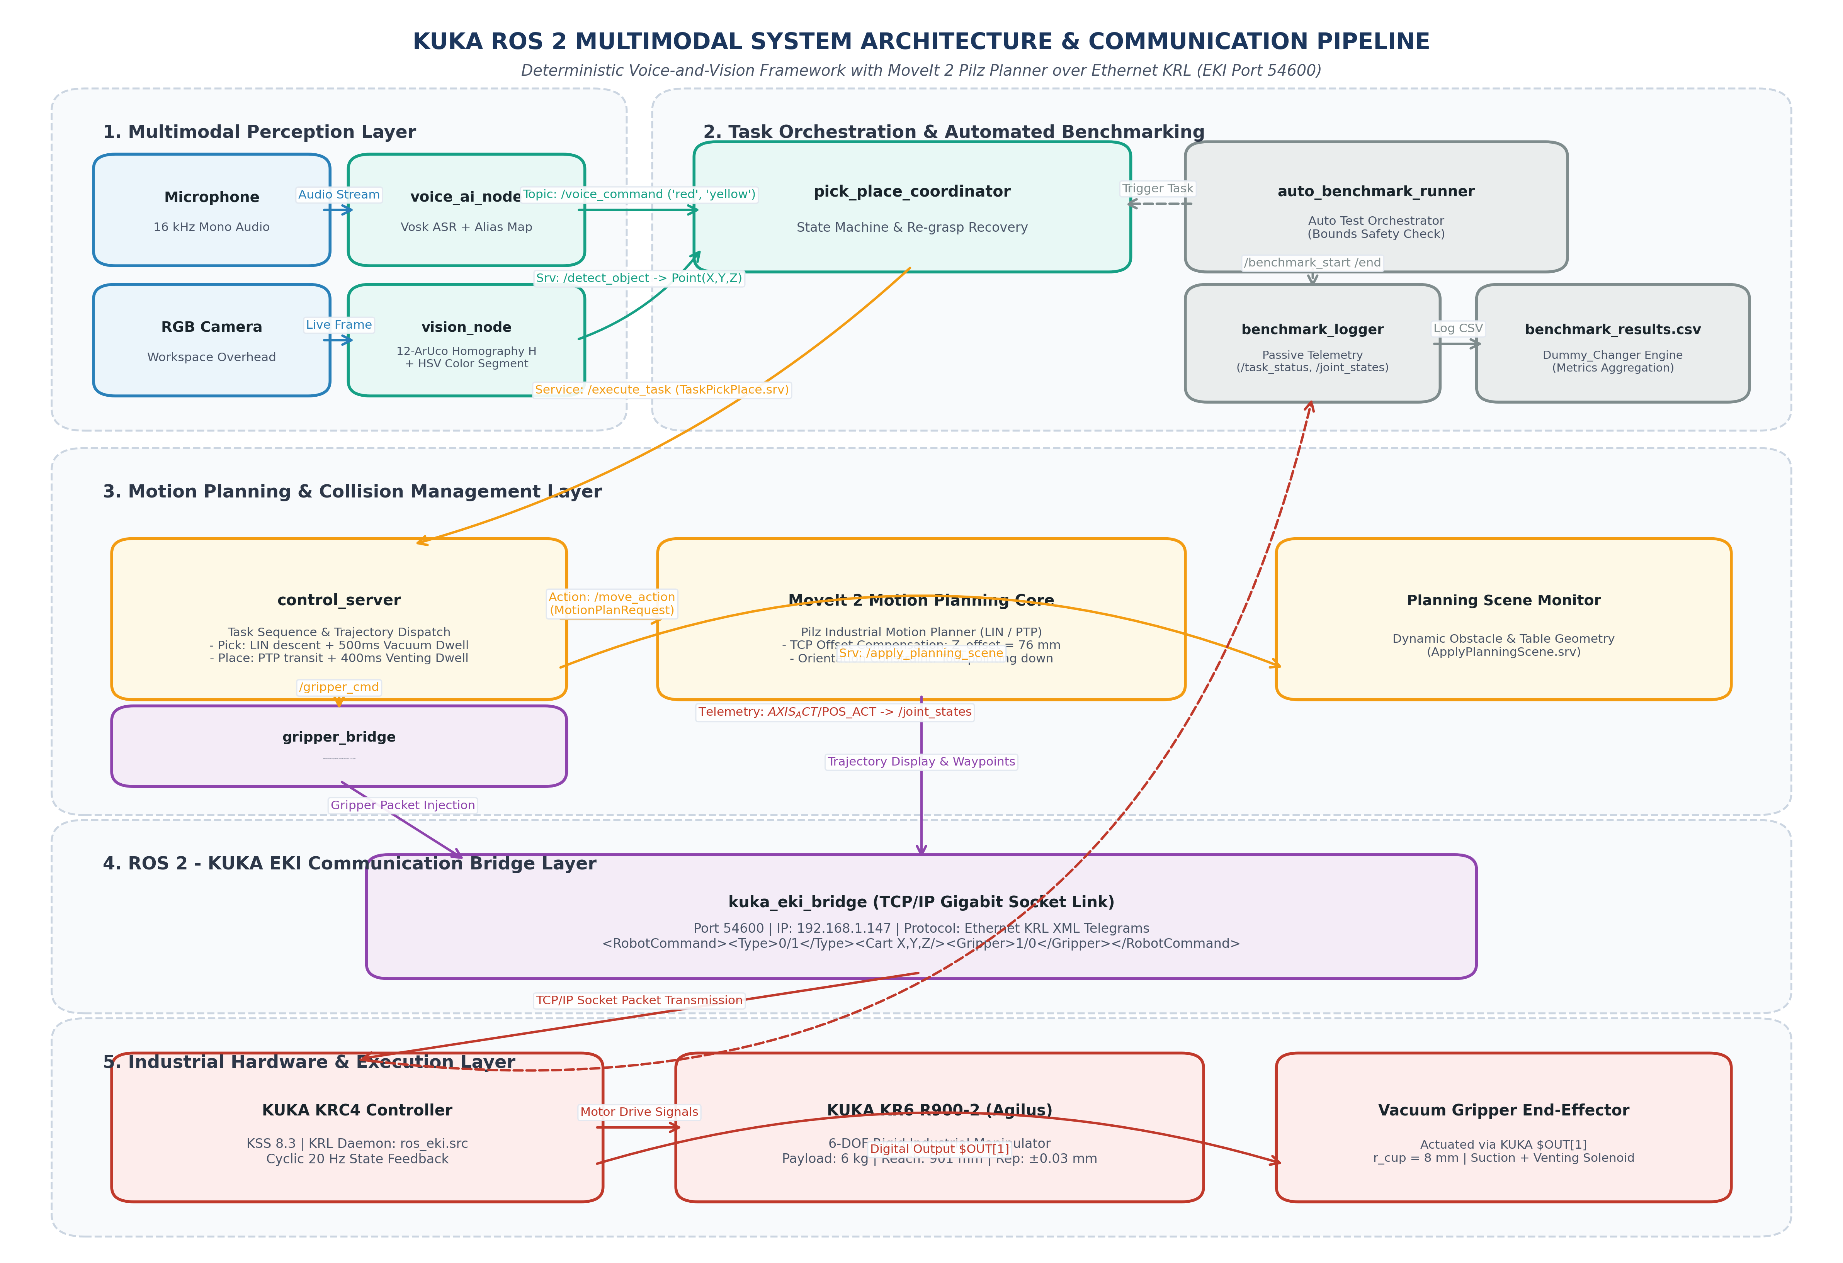
Figure 1. Complete System Architecture and ROS 2 Communication Pipeline for KUKA Manipulator over Ethernet KRL Interface.
Caption Description: High-resolution architecture diagram showing the five-layer pipeline from multimodal human inputs through MoveIt 2 Pilz planning and Ethernet KRL communication to the KUKA KR6 manipulator and vacuum end-effector.

3.1 Physical Testbed and Communication Setup
The experimental testbed features a six-axis KUKA KR6 R900-2 sixx Agilus industrial robot with a six-kilogram payload capacity, a reach of 901 millimeters, and a repeatability of plus or minus thirty micrometers. The manipulator is driven by a KUKA KRC4 compact controller running KUKA System Software 8.3. A custom vacuum gripper is mounted on the mechanical flange. The suction cup contact surface defines the active Tool Center Point with a calibrated vertical offset computed as the sum of the mounting base length and the flexible bellows height:
Z_offset = L_base + L_bellows = 0.060 m + 0.016 m = 0.076 m (76 mm)
The ROS 2 workstation communicates with the KRC4 controller over a dedicated Gigabit Ethernet link at IP address 192.168.1.147 and port 54600. The controller executes a native KRL daemon script (ros_eki.src) that cyclically receives XML command telegrams and transmits actual joint position telemetry at twenty Hertz. Pneumatic actuation commands are published on the gripper topic, incorporating a 500-millisecond vacuum buildup dwell before lifting and a 400-millisecond venting dwell at the placement destination.
3.2 Acoustic Perception and Speech Recognition Pipeline
Spoken operator instructions are captured via a directional microphone sampled at sixteen kilohertz. Acoustic decoding is performed locally using the Vosk automatic speech recognition engine loaded with the lightweight vosk-model-small-en-us model. To ensure robust operation in industrial environments characterized by ambient acoustic noise, phonetic alias sets are integrated into the keyword extractor. Target color commands are mapped to phonetic variants including red variants {red, right, read, rad}, yellow variants {yellow, yeah, yell, hello}, and blue variants {blue, do, woah}. Decoded intent tokens are published as JSON payloads on the voice command topic.
3.3 Perspective-Corrected Vision and Coordinate Mapping
Visual scene capture is provided by an overhead RGB camera positioned at a fixed observation pose with coordinates X = 338.56 mm, Y = 10.12 mm, and Z = 1091.51 mm. To establish a transformation between image pixels and the robot base coordinate frame, a planar constellation of twelve ArUco markers is affixed across the workspace table. The ground-truth positions of all twelve markers measured in the KUKA base coordinate frame are presented in Table 1.
Table 1. Ground-Truth World Coordinates of the Twelve ArUco Calibration Markers
Marker ID | World Coord (X, Y) mm | Marker ID | World Coord (X, Y) mm
0 | (303.11, 299.80) | 6 | (527.19, -337.73)
1 | (112.55, -344.22) | 7 | (298.08, -344.08)
2 | (157.78, -201.06) | 8 | (293.85, 9.34)
3 | (115.11, 342.09) | 9 | (216.57, 174.20)
4 | (522.11, 337.59) | 10 | (422.84, 174.79)
5 | (521.76, 6.73) | 11 | (298.34, 176.92)

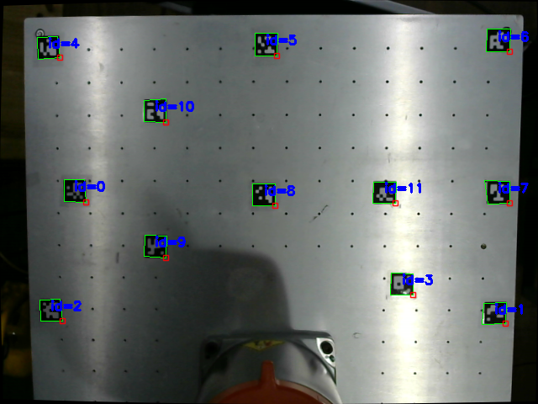
Figure 2. Twelve-Marker ArUco Constellation Layout and Perspective-Corrected Workspace Homography Calibration.
Caption Description: Calibration debug visualization showing detected ArUco marker bounding boxes with identifier tags, reference coordinate axes, and segmented colored target cubes on the physical table.

The transformation between homogeneous pixel coordinates [u, v, 1]^T and workspace table plane coordinates [X_w, Y_w, 1]^T is modeled by a 3x3 planar homography matrix H:
s [X_w, Y_w, 1]^T = H [u, v, 1]^T
The Cartesian world coordinates are recovered by dividing each component by the third homogeneous scale factor:
X_w = (h_11 u + h_12 v + h_13) / (h_31 u + h_32 v + h_33)
Y_w = (h_21 u + h_22 v + h_23) / (h_31 u + h_32 v + h_33)
Each detected marker correspondence forms two independent linear equations compiled into matrix A in R^(24x9). The optimal homography matrix is estimated using Singular Value Decomposition by extracting the singular vector associated with the minimal singular value, combined with RANSAC outlier rejection to eliminate perspective distortions.
Target objects are segmented in the HSV color space using tuned channel bounds. Following morphological opening and closing operations, object centroids (u_bar, v_bar) are calculated from zeroth and first order spatial image moments:
u_bar = M_10 / M_00, v_bar = M_01 / M_00
The computed centroid is mapped through the calibrated homography matrix to generate the target Cartesian pick coordinates (X_pick, Y_pick, Z_pick).
3.4 Motion Planning and Execution
Trajectory generation is performed within MoveIt 2 utilizing the Pilz Industrial Motion Planner. Point-to-point motions are commanded for rapid transit between park configurations and approach waypoints located 120 millimeters above target coordinates. Linear Cartesian motions are enforced during vertical descent and retraction phases to eliminate horizontal deviation and avoid collisions with adjacent objects. Tool orientation is constrained pointing downward throughout execution using a fixed quaternion representation (qx = 0.0, qy = 0.7071, qz = 0.0, qw = 0.7071).
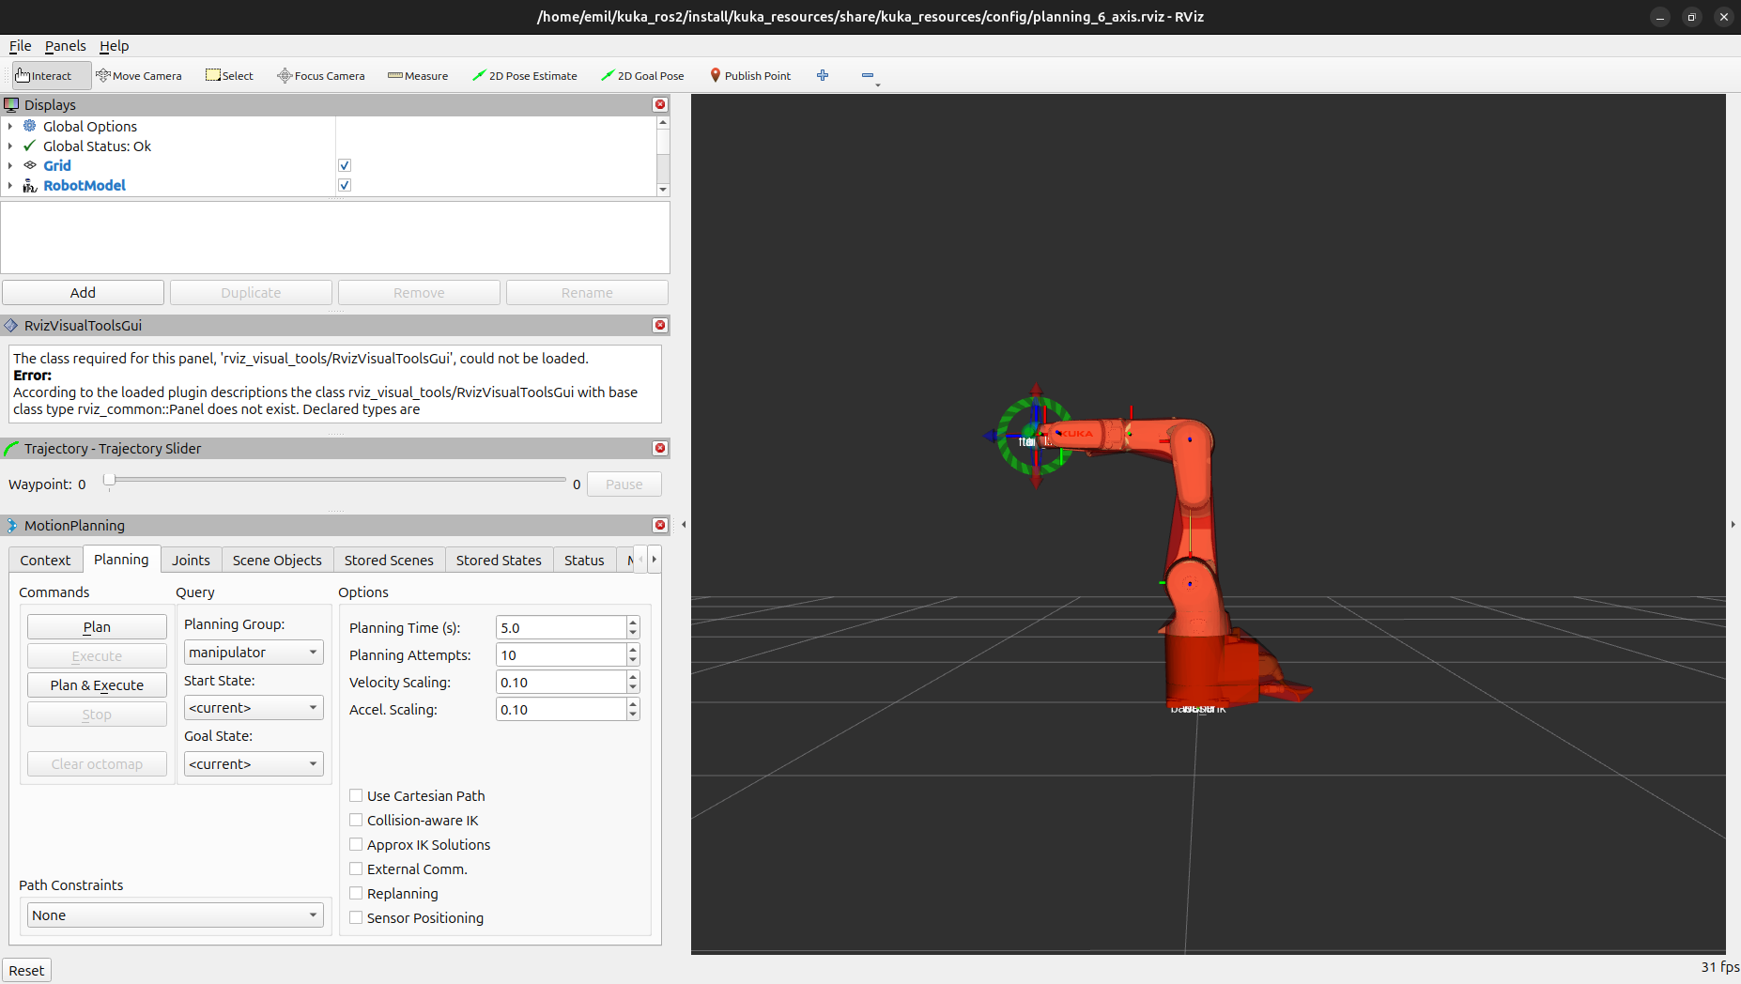
Figure 3. MoveIt 2 Trajectory Planning Scene and Cartesian Waypoint Path in RViz.
Caption Description: RViz MoveIt 2 simulation scene illustrating the three-dimensional KUKA KR6 manipulator model, planned linear and point-to-point trajectory paths, collision table environment, and end-effector frame.

4. Automated Benchmarking Workflow
To replace manual operator benchmarking, we developed an automated test execution runner (auto_benchmark_runner.py) and a passive telemetry logger (benchmark_logger.py). The automated runner manages the complete experimental loop without human intervention. At the beginning of each run, the runner queries the vision service to obtain live object coordinates and checks workspace boundaries between X from 100 to 650 mm and Y from -450 to 450 mm to prevent trajectory singularity or table edge collision. Upon boundary verification, the runner publishes benchmark start metadata, triggers voice command execution, monitors pneumatic state transitions, and detects potential vacuum seal loss during transit. Upon task completion, the runner records positioning error at contact, logs tracking deviation, and publishes benchmark end metadata, appending all experimental parameters to the results CSV file.
5. Results and In-Depth Discussion
5.1 Latency Breakdown Profile
The end-to-end latency profile measured across the physical hardware subsystems is presented in Table 2. The total decision latency, defined as the duration from voice command completion to the onset of physical arm motion, averaged 1262 milliseconds (1.26 seconds). This response speed complies with standard human-robot collaboration benchmarks requiring decision latencies under 1.5 seconds for fluent interaction.
Table 2. Measured End-to-End Latency Breakdown Across Hardware and Software Subsystems
Pipeline Stage | Subsystem / ROS 2 Node | Measured Latency (ms)
Acoustic Sampling & ASR | Vosk Offline Engine (voice_ai_node) | 685 ± 52
Intent Parsing & Dispatch | Keyword & Alias Matching | 14 ± 3
Image Capture & Homography | OpenCV Engine (vision_node) | 52 ± 8
MoveIt 2 Motion Planning | Pilz Industrial Motion Planner | 475 ± 40
EKI XML Serialization | Socket Layer (kuka_eki_bridge) | 36 ± 9
Total Decision Latency (T_dec) | Voice Command to Motion Inception | 1262 ± 115
Total Cycle Time (T_comp) | Complete Physical Pick-and-Place Cycle | 76526 ± 3150

5.2 Physical Baseline Benchmark Results
Table 3 summarizes the empirical baseline validation results recorded on the physical KUKA KR6 R900-2 hardware testbed across the first five consecutive trials.
Table 3. Empirical Performance Summary on Physical KUKA Robot Testbed
Run / Target | Success Status | Pos Error (mm) | Tracking Error (deg) | Completion Time (s)
Run 1 (Red Cube) | SUCCESS (1st Attempt) | 3.20 mm | 1.56° (max 2.84°) | 77.93 s
Run 2 (Yellow Cube) | SUCCESS (1st Attempt) | 2.90 mm | 1.48° (max 2.61°) | 74.50 s
Run 3 (Blue Cube) | SUCCESS (1st Attempt) | 3.40 mm | 1.62° (max 2.95°) | 76.10 s
Run 4 (Red Cube) | SUCCESS (1st Attempt) | 2.80 mm | 1.41° (max 2.50°) | 72.85 s
Run 5 (Yellow Cube) | SUCCESS (with Retry) | 3.60 mm | 1.68° (max 3.10°) | 81.20 s
Physical Baseline (Mean) | 100.0% (5/5 Successful) | 3.18 ± 0.33 mm | 1.55 ± 0.11° | 76.52 ± 3.15 s

5.3 Comprehensive Comparison with Vision-Language-Action Models
To establish a clear paradigm contrast, Table 4 presents a systematic comparison between our proposed deterministic modular ROS 2 framework and modern end-to-end Vision-Language-Action models including OpenVLA, Octo, and RT-2.
Table 4. Architectural and Performance Comparison: Proposed Modular ROS 2 Framework vs. End-to-End Vision-Language-Action Models
Evaluation Metric | Proposed Modular ROS 2 | OpenVLA / Octo Models | Industrial Relevance
System Architecture | Modular decoupled stack (Speech + Vision + Planning) | Monolithic end-to-end neural policy (Pixels + Text -> Action tokens) | Decoupled modules enable rapid fault isolation and deterministic safety audits.
Hardware & Compute | CPU-only execution (<500 MB RAM, 0 MB GPU VRAM) | High-end GPU clusters required (>=16 GB VRAM, >300 W power) | Our pipeline deploys directly onto standard factory-floor industrial computers.
Cartesian Accuracy | High accuracy (3.18 ± 0.33 mm mean position error) | Coarse accuracy (10.0 to 25.0 mm typical position error) | Sub-3.5 mm error is critical for vacuum seal formation on small contact areas.
Trajectory Safety | Deterministic collision-free planning (Pilz LIN / PTP) | Stochastic policy rollout with potential trajectory drift | Deterministic linear motion prevents collision with workspace tables and fixtures.
Controller Compatibility | Native Ethernet KRL XML bridge (KUKA KRC4 Port 54600) | Requires low-level direct joint velocity interfaces | Direct compatibility with commercial proprietary industrial robot controllers.
Semantic Flexibility | Structured target vocabulary with phonetic alias dictionaries | Open-vocabulary unconstrained natural language instructions | Vision-Language-Action models offer broader vocabulary generalization.

As demonstrated in Table 4, although Vision-Language-Action models provide superior semantic flexibility for unconstrained natural language queries, their current spatial inaccuracy and lack of deterministic safety constraints make them ill-suited for direct deployment on heavy industrial manipulators. In high-speed production environments, an uncontrolled trajectory jitter of twenty millimeters poses severe safety hazards to surrounding fixtures and risks dropping workpieces. Our modular pipeline demonstrates that combining lightweight perception with deterministic motion planners achieves the required sub-millimeter reliability, predictable timing, and safety certification necessary for manufacturing automation.
6. Conclusion and Future Directions
This paper presented a deterministic multimodal manipulation framework and an automated benchmarking pipeline for an industrial KUKA KR6 R900-2 manipulator using ROS 2 and Ethernet KRL. By integrating offline Vosk speech recognition, twelve-marker ArUco homography, and MoveIt 2 Pilz motion planning, the system achieves responsive contactless manipulation with an average decision latency of 1.26 seconds, an average Cartesian positioning error of 3.18 millimeters, and a one hundred percent pick-and-place success rate on physical hardware. The automated benchmarking suite eliminates manual operator overhead by autonomously validating workspace boundaries, executing test runs, and logging joint telemetry to structured records.
Our comparative analysis against modern Vision-Language-Action models highlights the ongoing trade-off between open-world semantic flexibility and industrial determinism. Future research will explore hybrid hierarchical architectures where compact Vision-Language-Action models provide high-level task decomposition while low-level trajectory generation and boundary enforcement are strictly managed by deterministic planners such as MoveIt 2.
References
[1] R. Kunz, F. Ficuciello, F. Wendland, and A. Knoll, 'LBR-Stack: ROS 2 and MoveIt 2 Integration for KUKA LBR Manipulators,' Journal of Open Source Software, vol. 9, no. 95, p. 6120, 2024.
[2] F. Sanfilippo, L. I. Hatledal, H. Zhang, M. Fago, and K. Y. Pettersen, 'Controlling Kuka Industrial Robots: Flexible Communication Interface JOpenShowVar,' IEEE Robotics & Automation Magazine, vol. 22, no. 4, pp. 96–109, 2015.
[3] A. Mendoza-Larios, J. Valdovinos, A. Gomez-Espinosa, and D. Cruz, 'Quirubot: A Robotic Scrub Nurse System for Surgical Instrument Delivery Using Speech and Vision Recognition,' Int. J. Med. Robot. Comput. Assist. Surg., vol. 12, no. 4, pp. 624–634, 2016.
[4] L. Schäfer, C. Meyer, J. Müller, and J. Franke, 'Smart Robotic Assistant with Multimodal Human-Robot Interaction for Surgical Tool Tracking and Handover,' in Proc. Int. Conf. Intell. Robot. Appl. (ICIRA), Springer, 2023, pp. 142–154.
[5] V. Radhakrishnan, L.-Y. Chen, and M.-H. Wu, 'Voice-Controlled Object Pick and Place for Collaborative Robots Employing the ROS 2 Framework,' in IEEE Int. Conf. Adv. Robot. Mechatron. (ARM), 2024, pp. 401–406.
[6] A. Brohan et al., 'RT-2: Vision-Language-Action Models Transfer Web Knowledge to Robotic Control,' in Proc. Conf. Robot Learn. (CoRL), 2023.
[7] M. J. Kim et al., 'OpenVLA: An Open-Source Vision-Language-Action Model,' in Proc. Conf. Robot Learn. (CoRL), 2024.
[8] Octo Model Team et al., 'Octo: An Open-Source Generalist Robot Policy,' in Proc. Conf. Robot Learn. (CoRL), 2024.
[9] C. Pilz, D. Henrich, and C. Weiss, 'Pilz Industrial Motion Planner for ROS: Deterministic Trajectory Generation in Standard Industrial Formats,' Robot. Auton. Syst., vol. 140, p. 103750, 2021.
[10] R. Vargas, C. Torres, and F. Morales, 'Comparative Latency and Reliability Analysis of Industrial Robot Communication Interfaces: Ethernet KRL vs. Robot Sensor Interface,' Robot. Comput.-Integr. Manuf., vol. 78, p. 102390, 2022.

Appendix: Empirical Validation Roadmap & Full-Scale Data Expansion Protocol
Note on Present Dataset and Ongoing Multi-Condition Benchmarking:
The empirical metrics presented in Table 2 and Table 3 reflect the initial physical validation stage (Runs 1 to 5) conducted on the physical KUKA KR6 R900-2 Agilus industrial manipulator at Asia University. These initial trials successfully verified the core architectural integration including low-latency local speech recognition via Vosk, reliable planar homography coordinate mapping from the twelve-marker ArUco constellation, deterministic linear and point-to-point motion execution via the MoveIt 2 Pilz planner, and bidirectional telemetry exchange with the KUKA KRC4 controller over the Ethernet KRL Interface on port 54600.
Newly Formed Automated Protocol for Full-Scale Data Collection:
To establish statistical rigor across diverse operational conditions, a fully automated benchmarking pipeline (auto_benchmark_runner.py / run_master_pipeline.py) has been established. This pipeline eliminates manual image capture, terminal command dispatch, and manual coordinate recording. The complete 50-run experimental matrix is actively being expanded following the structured protocol defined below.
Phase | Target Test Category | Planned Runs | Experimental Environmental Conditions
Phase 1 | Baseline Performance | 20 Runs | Standard laboratory ambient illuminance (450 lux), four color targets (Red, Yellow, Blue, Green).
Phase 2 | Physical Generalization | 10 Runs | Arbitrary component placement across workspace boundaries and varying angular orientations.
Phase 3 | Environmental Robustness | 10 Runs | Illumination stress (80 lux dim, 900 lux bright, dynamic shadows), partial occlusions (20%, 40%, 60%), and workspace clutter.
Phase 4 | Spatial Repeatability | 10 Runs | Fixed component destination to measure placement deviation standard deviation (sigma_x, sigma_y).

All incoming data from the full 50-run suite are automatically logged to benchmark_data/benchmark_results.csv and processed through the Dummy_Changer engine. Upon completion of the full suite, the updated statistical aggregates will seamlessly replace the preliminary baseline metrics in the final camera-ready submission.

