装配线产能评估管理标准
Management Standard for Assembling Line Capacity Assessment
1 范围
本标准规定了公司装配线产能评估的管理标准。
This standard specifies the management standards for evaluating the production capacity of the company's assembly line.
本标准适用于公司装配线产能评估的管理。
This standard is applicable to the management of production capacity evaluation of the company's assembly line.
本标准依据GLC140410的要求制定。
This standard is developed in accordance with the requirements of GLC140410.
2 规范性引用文件
GLC140407 架次流程图的编制与管理标准程序
Preparation and Management Procedure for GLC140407 Shipset Flow Chart
3 表格Forms
3.1规定表格Regulatory forms
FM140410-01工装生产能力表Tooling Production Capacity
FM140410-02设备生产能力表Table of Equipment Production Capacity
FM140410-03生产面积生产能力表Table of Production Area Capacity
FM140410-04装配线产能评估基础数据表Basic Data Table for Assembly Line Capacity Evaluation
4 术语和定义
4.1 产能评估Capacity Evaluation
是指在对各生产要素数据分析的基础上，对生产线产出能力的评价和估计。
It refers to the evaluation and estimation of production line output capacity based on the analysis of various production factor data.
4.2 工装标准产能Standard Capacity of Tooling
是指在生产线策划阶段，定义的工装单班生产能力。
It refers to the defined single-shift production capacity of tooling in the production line planning phase.
4.3 设备标准产能Standard capacity of equipment
是指外购设备技术经济论证报告中，定义的设备应达能力水平。
It refers to the defined capability level of the equipment as specified in the technical and economic feasibility study report for externally purchased equipment.
4.4 生产面积标准产能Standard Capacity of Production Area
是指工程项目技术经济论证报告中新建生产面积需求中的定义的生产能力。
It refers to the production capacity defined in the new production area requirement in the technical and economic demonstration report of the engineering project.
4.5 标准操作人数Standard number of Operators
指通过标准工时计算得到的操作人数，标准操作人数=标准工时/节拍周期。
It refers to the number of operators calculated through standard working hours, where standard number of operators equals standard working hours divided by cycle time.
4.6 生产面积Production Area
是指直接参与产品加工及产品性能试验、检验过程的基本工作地点。包括流水线上的检验站，工作地近旁的毛料堆放处、生产工区中分散的检验点，生产设备的进料及卸料面积，厂内部运输及工人行走的通道等均属生产面积。
It refers to the basic workplace directly involved in product processing, product performance testing, and inspection processes. Including inspection stations on the assembly line, wool material storage areas near the work site, scattered inspection points in the production area, feeding and unloading areas of production equipment, internal transportation and worker walking channels, all belong to the production area.
5 职责Responsiblities
5.1 各装配生产单位生产控制室计划员负责收集、整理、录入相关基础数据。
The production control room planners of each assembly production unit are responsible for collecting, organizing, and inputting relevant basic data.
5.2 各装配生产单位技术室工艺员负责分析产能差异并改进，负责编制产能评估报告并提交审签。
The process technicians in the technical department of each assembly production unit are responsible for analyzing production capacity differences and improving them, preparing production capacity evaluation reports, and submitting them for review and approval.
5.3 各装配生产单位技术室主任负责校对产能评估报告的数据准确性有效性。
The technical department directors of each assembly production unit are responsible for verifying the accuracy and effectiveness of the data in the capacity evaluation report.
5.4各装配生产单位技术厂长负责审核产能评估报告的完整性和数据准确性有效性。
The technical director of each assembly production unit is responsible for reviewing the completeness, accuracy, and effectiveness of the production capacity assessment report.
5.5 科技创新部技术办公室主任负责组织各装配生产单位开展装配线产能评估工作，负责批准产能评估报告。
The Director of the Technical Office of the Department of Science and Technology Innovation is responsible for organizing various assembly production units to carry out assembly line capacity assessment work and approving capacity assessment reports.
5.6规定Regulations
5.6.1 产能评估要求Capacity Assessment Requirements
5.6.1.1 装配线产能评估的输入条件主要包括架次流程图、工艺布置图、项目主进度计划等相关信息，各装配生产单位进行产能评估前，需要明确上述相关信息的准确性和适用性。
The input conditions for evaluating the production capacity of assembly lines mainly include relevant information such as ship flow charts, process layout diagrams, and project master schedules. Before conducting production capacity evaluations, each assembly production unit needs to clarify the accuracy and applicability of the above relevant information.
5.6.1.2 按照GLC140407《架次流程图的编制与管理程序》要求，各装配生产单位生产控制室计划员依据架次流程图确定需要开展产能评估的项目号和站位信息。
According to the requirements of GLC140407 "Preparationt and Management Procedure for Ship Flow Chart", the production control room planners of each assembly production unit determine the project numbers and station information that need to be evaluated for production capacity based on the ship flow chart.
5.6.1.3 各装配生产单位生产控制室计划员按照上年度10月份至本年度9月份（12个月）的评估周期开展基础数据采集工作，填写FM140410-01、FM140410-02、FM140410-03和FM140410-04，标准产能、实际产能和需求产能的单位需要统一。
The production control room planners of each assembly production unit carry out basic data collection work according to the evaluation cycle from October of the previous year to September of this year (12 months), and fill in FM140410-01, FM140410-02, FM140410-03, and FM140410-04. The units of standard capacity, actual capacity, and demand capacity need to be unified.
5.6.1.4 各装配生产单位技术室工艺员每年11月末之前完成产能评估报告的发放审批。
The process technicians of each assembly production unit shall complete the issuance and approval of the production capacity assessment report before the end of November each year.
5.6.1.5 各相关单位以产能评估报告作为调整生产能力建设的依据，支持各装配生产单位改进计划的实施。
Each relevant unit shall use the capacity assessment report as the basis for adjusting production capacity construction, and support the implementation of improvement plans by each assembly production unit.
5.6.2 产能评估方法以实际产能和需求产能数据为基础，分析标准产能与需求产能差异，制定改进计划；分析标准产能与实际产能差异，识别差异来源。
The capacity assessment method is based on actual capacity and demand capacity data, analyzing the difference between standard capacity and demand capacity, and developing improvement plans; Analyze the difference between standard production capacity and actual production capacity, and identify the source of the difference.
5.6.2.1 基础数据分析Basic data analysis
1) 各装配生产单位技术室工艺员依据FM140410-01、FM140410-03、FM140410-04绘制工装产能分析图。
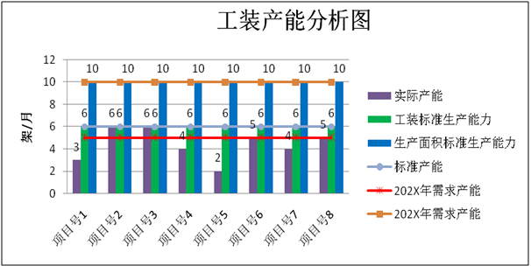
Technicians from each assembly production unit's technical department shall draw tooling production capacity analysis charts based on FM140410-01, FM140410-03, and FM140410-04.

图1 工装产能分析示意图
2) 各装配生产单位技术室工艺员依据FM2311-02绘制设备产能分析图。
Technicians from each assembly production unit's technical department shall draw equipment capacity analysis diagrams based on FM2311-02.
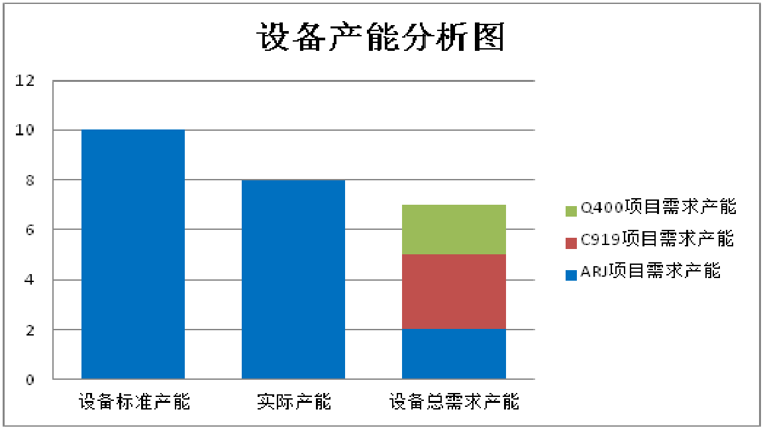

图2 设备产能分析示意图
5.6.3 产能评估报告的编制及审签Preparation and review of production capacity assessment report
5.6.3.1 各装配生产单位技术室工艺员按照附录提纲要求编写产能评估报告。
Technicians from each assembly production unit's technical department shall prepare a capacity assessment report in accordance with the requirements outlined in the appendix.
5.6.3.2 产能评估报告包括背景现状、基础数据、产能分析、评估结果和改进计划等主要章节，其余章节或内容按照实际情况增补。
The capacity assessment report includes main chapters such as background status, basic data, capacity analysis, evaluation results, and improvement plans, and other chapters or contents are supplemented according to the actual situation.
5.6.3.3 产能评估报告由生产单位技术室工艺员编制，技术室主任校对，技术厂长审核，科技创新部技术办公室主任批准后，在档案系统中保存产能评估报告。
The capacity assessment report is prepared by the process engineer of the production unit's technical department, proofread by the director of the technical department, reviewed by the technical factory director, and approved by the director of the technical office of the Ministry of Science and Technology Innovation. The capacity assessment report is then saved in the archive system.
6 标准图例说明Standard Legend Explanation
无
None
7 记录控制Control of Records
产能评估报告由装配生产单位、零件制造中心和科技创新部保存3年。
The production capacity planning report shall be kept by the assembly production unit, the parts manufacturing center, and the Department of Science and Technology Innovation for 3 years.

