编号 No. |  | 作业名称 Name |  |  |  |  |  |  | 版次 Rev. |  |  | B（5）
S3-BZZY9100-010 (1) |  | 35001 010工步Step 050：尾段终检前多余物清理要求(2)  FOD requirements before final inspection of tail section |  |  |  |  |  |  | 共2 (3) 页 第 1(4) 页 Page Of
标准作业指导书升版更改说明Standard Operation Guideline Change Description：（6）

作业简图 Sketch |  |  |  |  |  |  | 作业要求 Request |  |  |  |  |  | 工装、工量具 Tools,Cutters/Gauges
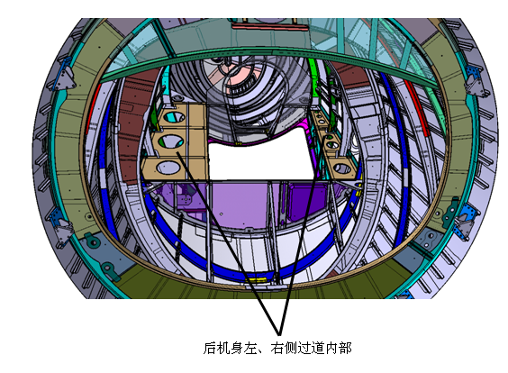（7） |  |  |  |  |  |  | 后机身左、右过道内部用手电筒和反光镜检查后机身左、右侧过道内部，尤其注意闭角处，检查是否存在钻屑、线痕、胶带纸、拆除的铆钉墩头、拧断的高锁螺母等多余物，若存在多余物，用吸尘器和ZPM6520揩布清理干净。确认无多余物后用胶带和白纸（或塑料纸）将后机身两侧过道上部开口封严。（8）  Inside the left and right gangways of the rear fuselage, use flashlights and mirrors to check the inside of the left and right gangways of the rear fuselage, pay special attention to the closed corners, and check whether there are drilling chips, thread marks, adhesive tape, removed rivet pier heads, twisted high lock nuts and other surplus objects. If there are surplus objects, clean them with a dust collector and ZPM6520 wiping cloth. After confirming that there is no surplus, use adhesive tape and white paper (or plastic paper) to seal the upper openings of the aisles on both sides of the rear fuselage. |  |  |  |  |  | 反光镜、手电筒  Reflector and flashlight（9）
编制Developed By | 张三  2021-11-29（10） |  | 校对Checked By | 李四  2021-11-30（11） | 审核Reviewed By | 王五  2021-11-30（12） |  | 质保 Q.A. |  | 王六  2021-11-30（13） | 批准Approved By |  |  | 王七  2021-11-30（14）

填写说明：Instructions for Filling：
（1）：标准作业指导书编号。
Fill in the Standard Operation Guideline No.
（2）：标准作业指导书名称，工艺员自定义。
Fill in the name of Standard Operation Guideline, customized by planner.
（3）：页次记录。
Page record.
（4）：页次记录。
Page record.
（5）：标准作业指导书的版次。
Version of Standard Operation Guideline
（6）：标准作业指导书升版更改说明：简要描述标准作业指导书更改的内容，并保留历史更改记录。
Description of Standard Operation Guideline upgrading and change: briefly describe the content of Standard Operation Guideline change, and keep the historical change record.
（7）：图片描述区域。
Picture description area.
（8）：文字描述区域，既需要详细描述操作者的操作过程，又应该描述要求的结果。
Text description area, which not only needs to describe the operator's operation process in detail, but also should describe the required results.
（9）：操作过程所需要的工装、工具和量具。
Tooling, tools and measuring tools required during operation.
（10）：编制人签名并注明日期。
Signed and dated by the preparer.
（11）：校对人签名并注明日期。
Signed and dated by the proofreader.
（12）：室主任签名并注明日期。
The office director shall sign and indicate the date.
（13）：质量工程室技术员/主任签名并注明日期。
The Engineer/Supervisor of the Quality Engineering Office shall sign and indicate the date.
（14）：生产单位技术厂长批准。
Approved by the Engineering director of the production unit.

