1 Technique sheet information技术单信息
技术单编号Technique Number | UTS 2140(1)
修订版次Revision | A(2)
修订日期Revision Date | 2022/12/07(3)
被代替技术单编号/版次  Replaced Technique Number/Revision | N/A(4)
更改信息Changed Instruction | 新发。(5)
编制Prepared by | 张三 (6)
校对Checked by | 李四 (7)
III级批准Level 3 Approved by | 孙五 (8)
客户批准Customer Approved by | 王六 (9)

2 Part information零件信息
零件编号Part Numbers | 5292C01000G43(10)
项目 Program | C919 APU舱门(11)
名称Description | APU舱门结构(左侧)面板(12)
材料Material | 碳纤FC CMS-CP-306, 40型,2类, 3K-285-5HS规格(13)
结构Structure | 夹层结构(14)
厚度范围Thickness Range | 2.4mm~3.9mm边缘部位  21.4mm芯子(15)
芯子规格Core specs. | 3/16in正六边形 (16)
表面处理Surface Finish | 固化表面(17)
制造状态Stage of MFG | 固化后并切完边(18)
零件等级Class | B区(19)
检验等级Inspection Class | N/A(20)

3 验收标准Acceptance Criteria：

E-C500JT001 (22)

4 检验方法Test method

自动穿透C扫描法 (23)

5 检验程序Inspection Procedure

顾客规范Customer Specification:CPS8210 (24)

指导文件Instruction:S19-I3500-33 (25)

6 验收闸门水平Acceptance Threshold Level

6.1宏观缺陷Macro Defect
6.1.1层压板区域参考6.3dB，夹层区域参考8.2dB. (26)

6.2 层压板孔隙率Porosity for Laminate Area
(27)

各检测区域的孔隙率门槛值按下述要求选择。Select the porosity threshold of each area to be inspected shall refer to the requirements as below.
检测区域  Inspected Area | 检测位置  Location | 厚度/mm  Thickness | 检测技术及对应的孔隙率曲线编号  Technique and corresponding Porosity Curve No.
所有层板区  All laminate | 1 | 3.024 | ATTU：CYCOM 970 T300 12K NT-C_scan A  MPE：CYCOM 970 T300 12K NT-A_scan A  详细的孔隙率曲线选择方法参见S-I3500-64表A.1。The detail method selecting porosity curve shall see Table A.1 in S-I3500-64.
所有层板区  All laminate | 2 | 2.592
所有层板区  All laminate | 3 | 3.888
所有层板区  All laminate | 4 | 2.160
7 仪器Equipment
Description名称 | Model/Version型号
自动C扫描系统  Automated C-scan system | SCM12Xi S680
超声波脉冲器/接收器  Ultrasonic pulser/receiver | PM30
报警装置  Alarming equipment | 集成在系统中  Integrated into system
电子距离振幅补偿  Electronic distance amplitude | 集成在系统中  Integrated into system
数据采集仪器  Data acquisition equipment | 集成在系统中  Integrated into system
仪器软件  Instrument software | USL Scanner version 4.47Oct 27 2014
数据采集软件  Data acquisition software | 集成在系统中  Integrated into system
评价软件  Data evaluation software | 集成在系统中  Integrated into system
水系统  Water system | 集成在系统中  Integrated into system
(28)
C扫系统C-scan system

8 参考试块Reference Standards
参考试块编号  Reference Standards No. | 技术单号  Technique Sheet No. | 阶梯  Step | 厚度  Thickness
NDI-C919-089 (29) | UTS 2135 (30) | ST1,ST2 (31) | 2.4mm,3.6mm (32)

(33)

8.1 参考试块NDI-C919-089用于零件层压区域，校准缺陷直径6.18mm。NDI-C919-089 is used to laminate area of parts, the calibration inserts diameter is 6.18mm.
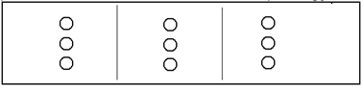

9 探头Transducers

(34)
C扫系统C-scan system
1号探头Transducer 1:
描述  Description: | 水浸  Immersion | 最佳  Preferred: | 是  Y
型号  Model: | 7588 | 编号  Serial No. | N/A
频率  Frequency: | 1.0MHZ  兆赫兹 | 直径  Diameter: | 19mm
有效声束直径  Eff. Beam diameter | 圆椎体直径  Cone ID | 传播类型  Trans.Type: | 水浸  Immersion
晶体材料  Crystal Mat: | 陶瓷  Ceramic | 声束角度  Beam Angle: | 0度  0 Degrees
阻尼  Damping: | 高  High | 延迟线  Delay Line: | N/A
焦距  Focal Length: | 平面  Flat | 功能  Function: | 发射器  Transmitter

10零件装夹Part Fixing

(35)
装夹车号  Fixture No.： | 01(03辅助) | 需要暂停  Pause Reqd.: | 是  Y

轨道位置Rail Pos.:
01臂 | 位置/mm | 02臂 | 位置/mm
X | N/A | X | 4472.0
Y | -77.7 | Y | -77.6
Z | 93.4 | Z | 232.5
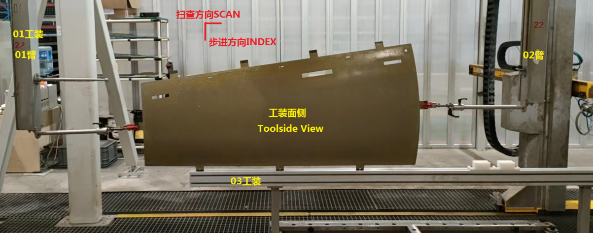

Note附注:

在检验前确保零件表面是干净的。Assure that part is clean prior to testing.

密封所有边缘开口分层。Seal all open edges delaminations.

夹头夹持在耳片位置，注意夹头应控制在耳片范围内。必要时，按S19-I3010-92进行A扫补充检测。Locate the fixture on the ear area and note that the fixture area shall be controlled within the ear area. If needed, inspect the fixture area using A-scan per S19-I3010-92 supplementarily.

必要时，将位置标记胶带贴在零件制袋侧表面上。Apply location markers on the bagside part surface as needed.

11SCM12Xi自动化信息Automated Information for SCM12Xi

(36)
 | 左Left | 右Right
圆锥体内径Cone ID | 0.236”(6mm) | 0.236”(6mm)
喷嘴水压water pressure | 50±10 | 50±10
表面距离Surface distance | （140±5）mm | （120±5）mm

12扫描信息Scanning Information
耦合方法  Coupling Method: | 喷嘴Squirter  (37) | 耦合剂  Couplant: | 水Water  (38)
传播波型  Propagation Mode: | 纵波Longtudinal  (39) | 闸门水平  Gate Level: | 模拟Analog(40)
扫描速率  Scan Rate: | 500mm/s(41) | 步进增量  Index Incr.: | 2mm(42)
脉冲重复频率  PRF: | 556Hz(43) | 电压  Voltage: | 400V(44)
扫描增益  ScanGain | 前置0dB Pre-Amp  登录18dB Linear(45) | 喷嘴设置  Nozzle Setup: | 单通道  Single(46)

13扫描计划 Scan Plan

(47)
13.1 C扫描 Laminate area by C-scan
- 扫查计划编号Scan Plan No.：UTP 2140 A
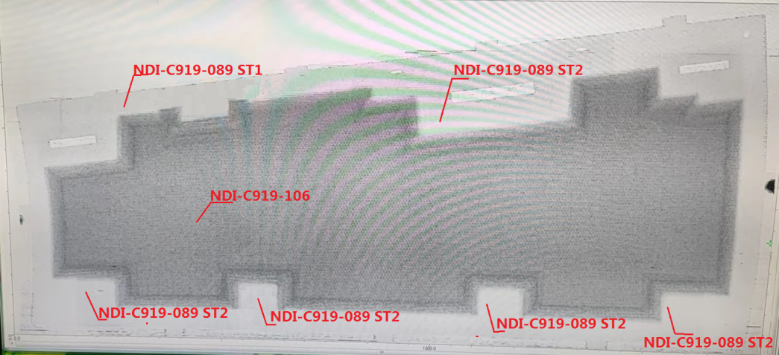
若存在，调出参考试块扫查计划图象，否则，联系三级人员，待其批准后，依据文件S-I3500-58进行设点仿形。 Take out scan plan image of the part if itexists. Otherwise it need to contact with Ⅲ level for approving, and then set points to imitate the part in accordance with S-I3500-58.
- 扫查参数编号Scan parameter No.：UTC 2140 A
13.2 A扫描A-scan
缘条、 R角区域和腹板C扫描未检测到的区域采用A扫描 Chord area, Radius area and web area that not detected by C-scan shall be inspected by A-scan.

警告: 没有III级人员的批准，不得改变系统设置和扫描描述参数。
Caution: Do not change scan description parameters without level Ⅲapproval.
填写说明Instructions for Filling：
- ：填写技术单编号。
Fill in the technical sheet number.
- ：填写技术单现行版次。
Fill in the current version of the technical sheet.
- ：填写现行版次的下发日期。
Fill in the issue date of the current version.
- ：填写现行版次技术单所替代的技术单编号和版次。
Fill in the number and revision of the technical sheet replaced by the current version of the technical sheet.
- ：填写技术单更改内容。
Fill in the update information of technique sheet.
- ：由有资质的II级及以上人员签字。
Signature by qualified Level 2 or above.
- ：校对人员签字
Signature by proofreaders.
- ：Ⅲ级人员签字。
Signature of Level 3 personnel.
- ：如需要，客户签字。
If required, signature by customer.
- ：填写零件编号。
Fill in the part number.
- ：填写零件的项目代号。
Fill in the item number of the part.
- ：填写零件名称。
Fill in the part name.
- ：填写零件典型材料。
Fill in typical materials of parts.
- ：填写零件典型结构。
Fill in the typical structure of the part.
- ：填写零件整体厚度范围。
Fill in the overall thickness range of the part.
- ：如需要，填写芯子规格。
If required, fill in the core specifications.
- ：填写零件表面处理状态。
Fill in the part surface treatment status.
- ：填写零件制造状态。
Fill in the part manufacturing status.
- ：填写零件等级。
Fill in the part grade.
- ：如需要，填写零件检测等级。
If required, fill in the part inspection level.
- ：填写技术单编号
Fill in the technique sheet number.
- ：填写零件验收所依据的文件编号。
Fill in the document number on which the part acceptance is based.
- ：填写检测零件所使用的技术。
Fill in the technique used to test the parts.
- ：填写零件检测所依据的客户规范编号。
Fill in the customer specification number on which the part inspection is based.
- ：填写零件检测所依据的内部典规编号。
Fill in the internal technique document number on which the part is based.
- ：如需要，根据参考试块鉴定所得不同区域的验收水平，填写零件上不同结构区域的宏观缺陷闸门水平。
If required, According to the acceptance level of different areas identified by the reference test block, fill in the gate level of the macro discrepancies in different structural areas on the part.
- ：如需要， 填写层压结构孔隙率评估信息， 如检测位置、厚度、孔隙率曲线编号等。
If required, fill in the porosity evaluation information for laminate structure, such as inspected area, thickness and porosity curve number, etc.
- 填写所用仪器相关信息。
Fill in the relevant information of the instrument used.
- ：填写所用参考试块编号。
Fill in the used reference standard number.
- ：填写所用参考试块对应的技术单编号。
Fill in the technique sheet number of the reference standards.
- ：填写参考试块上选用的阶梯等级。
Fill in the reference block number used. Fill in the ladder grade selected on the reference block.
- ：填写参考试块上选用阶梯的厚度大小。
Fill in the thickness of the selected step on the reference block.
- ：填写所用参考试块的信息，如校准缺陷尺寸、位置等。
Fill in the reference standard information, such as the calibration insert size and location,etc.
- ：填写所使用的探头信息，如编号、规格和参数等。
Fill in the information of the probes that used, such as serial number, specifications and parameters, ect.
- ：根据零件装夹时的实际情况，填写相应的装夹参数和注意事项，如零件表面状态，边缘开口密封，夹持盲区的辅助检测等。
According to the actual situation of parts clamping, fill in the corresponding clamping parameters and precautions, such as the part surface state, edge opening seal, auxiliary detection of clamping blind area, etc.
- ：如需要，填写自动自动化信息，如喷嘴直径、水压和水程等。
If required, fill in the automatic information, such as the diameter of the nozzle, the spray water pressure value and the water distance, etc.
- ：填写耦合方式，如水浸等。
Fill in coupling mode, such as water immersion.
- ：填写所用耦合剂。
Fill in the used couplant.
- ：填写超声传播类型，如纵波等。
Fill in the ultrasonic propagation type, such as longitudinal wave.
- ：填写闸门方式。
Fill in the gate level.
- ：填写超声扫描速率。
Fill in the ultrasonic scanning rate.
- ：填写步进增量。
Fill in the scanning index.
- ：填写脉冲重复频率。
Fill in the scanning PRF.
- ：填写扫描电压。
Fill in the scanning voltage.
- ：填写超声扫描增益。
Fill in the ultrasonic scanning gain.
- ：填写喷水模式，如双通道或单通道等。
Fill in the water spraying mode, such as dual channel or single channel.
- ：填写零件的扫查计划，描述如何按需求实现零件的检测。
Fill in the scanning plan of parts, and describe how to realize the inspection of parts as required.

