Bayesian Logistic Regression Analysis
Dependent Variable: Mild Physical Violence

1. Dataset Information
Number of observations: 2239
Number of predictors: 9
Dependent variable: Mild_violence
The dependent variable represents the binary outcome used for the Bayesian logistic regression model.

2. Distribution of Mild Physical Violence

Frequency and Percentage Distribution
Mild_violence | Frequency | Percentage
0.0 | 1406.0 | 62.8
1.0 | 833.0 | 37.2

3. Variables Included in the Model

Predictor Variables
Variable | Role
Age | Independent
Type_Residence | Independent
Religion | Independent
Education | Independent
Wealth | Independent
Alcohol | Independent
Fre_alcohol | Independent
Sex_violence | Independent
Severe_violence | Independent

4. ADVI Convergence
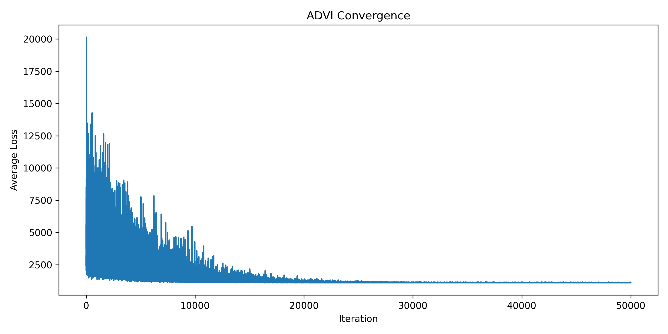
Final ADVI loss: 1128.9145

5. Bayesian Posterior Summary

Posterior Estimates
index | mean | sd | hdi_2.5% | hdi_97.5% | mcse_mean | mcse_sd | ess_bulk | ess_tail | r_hat
alpha | -0.579 | 0.06 | -0.699 | -0.467 | 0.001 | 0.001 | 1921.0 | 1854.0 | nan
beta[0] | -0.042 | 0.057 | -0.147 | 0.077 | 0.001 | 0.001 | 2062.0 | 1848.0 | nan
beta[1] | 0.11 | 0.036 | 0.039 | 0.179 | 0.001 | 0.001 | 1774.0 | 1757.0 | nan
beta[2] | -0.005 | 0.009 | -0.021 | 0.014 | 0.0 | 0.0 | 1987.0 | 1618.0 | nan
beta[3] | -0.006 | 0.019 | -0.042 | 0.032 | 0.0 | 0.0 | 1634.0 | 1794.0 | nan
beta[4] | -0.118 | 0.017 | -0.151 | -0.086 | 0.0 | 0.0 | 1920.0 | 1921.0 | nan
beta[5] | -0.583 | 0.06 | -0.704 | -0.468 | 0.001 | 0.001 | 1925.0 | 1785.0 | nan
beta[6] | 0.084 | 0.037 | 0.009 | 0.157 | 0.001 | 0.001 | 1949.0 | 1848.0 | nan
beta[7] | 1.504 | 0.195 | 1.125 | 1.878 | 0.004 | 0.003 | 2299.0 | 1881.0 | nan
beta[8] | 3.085 | 0.161 | 2.775 | 3.409 | 0.004 | 0.003 | 1986.0 | 1962.0 | nan

6. Bayesian Logistic Regression Results

Posterior Coefficients and Odds Ratios
Variable | Posterior_Mean | Posterior_SD | Lower_95_CrI | Upper_95_CrI | Odds_Ratio | OR_Lower_95_CrI | OR_Upper_95_CrI
Age | -0.042 | 0.057 | -0.147 | 0.077 | 0.9589 | 0.8633 | 1.08
Type_Residence | 0.11 | 0.036 | 0.039 | 0.179 | 1.1163 | 1.0398 | 1.196
Religion | -0.005 | 0.009 | -0.021 | 0.014 | 0.995 | 0.9792 | 1.0141
Education | -0.006 | 0.019 | -0.042 | 0.032 | 0.994 | 0.9589 | 1.0325
Wealth | -0.118 | 0.017 | -0.151 | -0.086 | 0.8887 | 0.8598 | 0.9176
Alcohol | -0.583 | 0.06 | -0.704 | -0.468 | 0.5582 | 0.4946 | 0.6263
Fre_alcohol | 0.084 | 0.037 | 0.009 | 0.157 | 1.0876 | 1.009 | 1.17
Sex_violence | 1.504 | 0.195 | 1.125 | 1.878 | 4.4997 | 3.0802 | 6.5404
Severe_violence | 3.085 | 0.161 | 2.775 | 3.409 | 21.8675 | 16.0386 | 30.235

7. Posterior Probability of Positive Effect

Posterior Probability P(beta > 0)
Variable | P(beta > 0)
Age | 0.2345
Type_Residence | 0.9975
Religion | 0.28
Education | 0.3865
Wealth | 0.0
Alcohol | 0.0
Fre_alcohol | 0.9885
Sex_violence | 1.0
Severe_violence | 1.0

8. Posterior Distributions
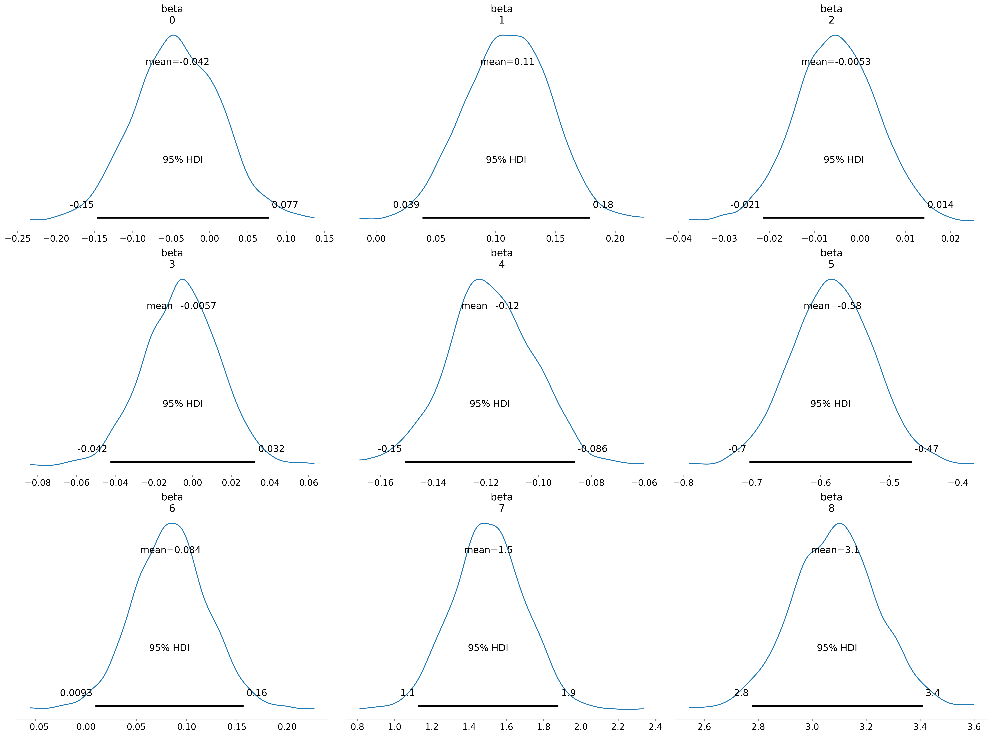

9. Predicted Probabilities

First 20 Predicted Observations
Actual_Mild_Violence | Predicted_Probability | Predicted_Class
1.0 | 0.1746 | 0.0
0.0 | 0.1782 | 0.0
0.0 | 0.1903 | 0.0
0.0 | 0.1737 | 0.0
0.0 | 0.1895 | 0.0
0.0 | 0.2048 | 0.0
1.0 | 0.187 | 0.0
0.0 | 0.1864 | 0.0
0.0 | 0.2041 | 0.0
1.0 | 0.835 | 1.0
0.0 | 0.1813 | 0.0
1.0 | 0.8458 | 1.0
1.0 | 0.2032 | 0.0
0.0 | 0.2164 | 0.0
1.0 | 0.2257 | 0.0
1.0 | 0.9713 | 1.0
0.0 | 0.2445 | 0.0
0.0 | 0.8983 | 1.0
0.0 | 0.2205 | 0.0
0.0 | 0.2455 | 0.0

10. Model Performance

Classification Performance
Metric | Value
Accuracy | 0.799
Precision | 0.8426
Recall/Sensitivity | 0.5654
Specificity | 0.9374
F1 Score | 0.6767
ROC-AUC | 0.7922

11. Confusion Matrix

Confusion Matrix
Actual | Predicted 0 | Predicted 1
Actual 0 | 1318 | 88
Actual 1 | 362 | 471

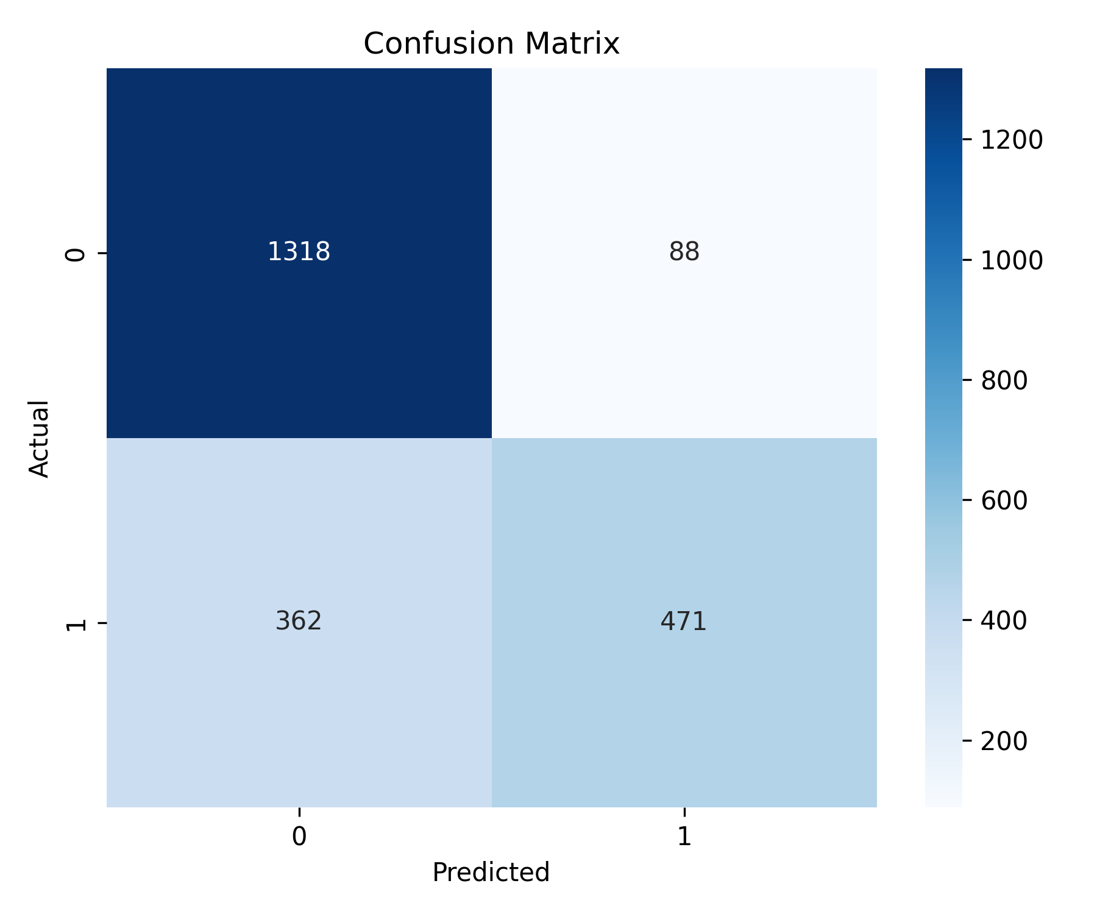

12. ROC Curve
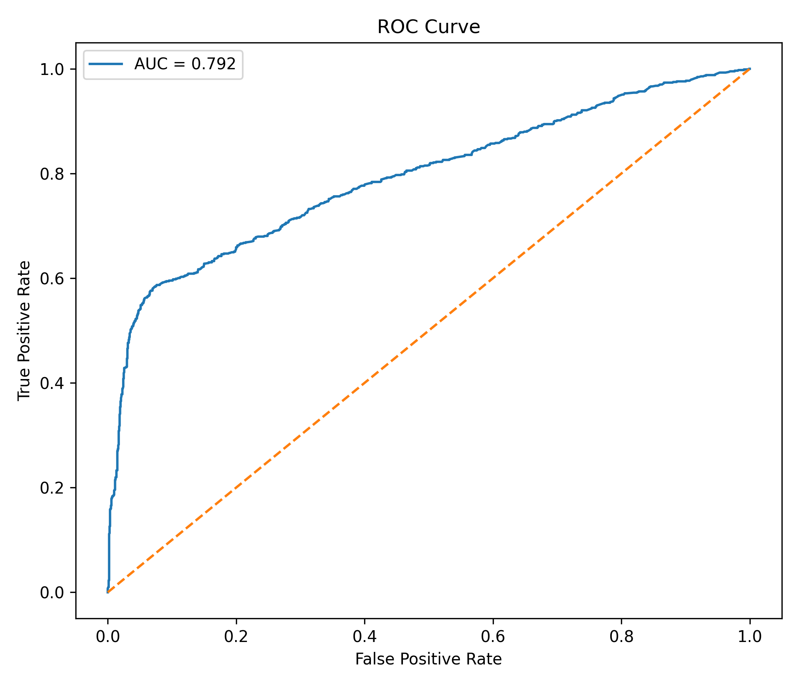
The area under the ROC curve (ROC-AUC) is 0.7922.

13. Bayesian Logistic Regression Model Specification
The Bayesian binary logistic regression model estimates the probability of experiencing mild physical violence as a function of the selected explanatory variables.
The dependent variable is Mild_violence, while the predictors are Age, Type_Residence, Religion, Education, Wealth, Alcohol, Fre_alcohol, Sex_violence and Severe_violence.
The model was estimated using Bayesian inference with Automatic Differentiation Variational Inference (ADVI).

