**Mathematics Problem Set 4**

|  |  |
| --- | --- |
| Problem 1 | • Lorem ipsum dolor sit amet, consectetur adipiscing elit. Ut enim ad minim veniam. |
| Problem 2 | **•** Lorem ipsum dolor sit amet, consectetur adipiscing elit. Ut enim ad minim veniam. |
| Problem 3 | **•** Lorem ipsum dolor sit amet, consectetur adipiscing elit. Ut enim ad minim veniam. |

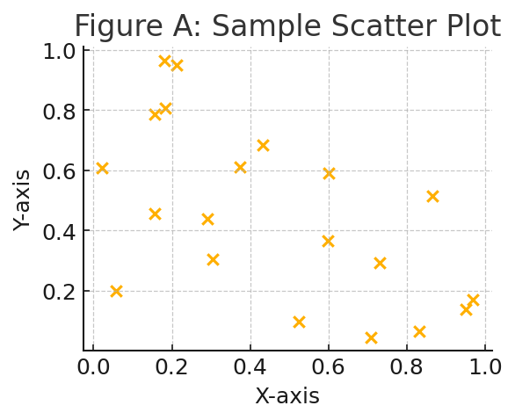

*Figure A: Sample Scatter Plot*