Name: **Marking Manager**

Type: **Block**

Moodle version required: **2.5**

Git Repository: <https://github.com/fernandooliveira/moodlefn-marking-manager25>

Support and Feedback: [www.moodlefn.knet.ca](http://www.moodlefn.knet.ca)

* Recommended: The following plugins were created to work alongside the Marking Manager:

* + Tabs Course Format: <https://github.com/fernandooliveira/moodlefn-tabs25/blob/master/MoodleFN_Tabs_with_ATS_25.pdf>
  + My Progress block: <https://github.com/fernandooliveira/moodlefn-myprogress25/raw/master/MoodleFN_My_Progress_25.pdf>

Contents of this document:

1. Installation Instructions
2. Overview of Marking Manager Block
3. Simple Gradebook **(NEW)**
4. Overview of Marking Manager Interface
5. **Installation Instructions:**
6. Click on the following link to download the files for this plug-in: <https://github.com/fernandooliveira/moodlefn-marking-manager25/archive/master.zip>
7. Unzip the downloaded file and rename top directory to **fn_marking**
8. Copy the **fn_marking** directory to **yourmoodlesite/blocks/**

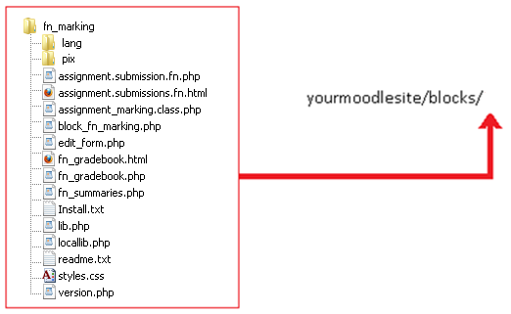

1. **Overview of Marking Manager Block**

The Marking Manager Block provides teachers with the following features:

* A quick overview of the number of Assignments and Forums with the following status: Require Grading, Graded , Not Submitted and Draft. Clicking on any of these status links within the block will open the Marking Interface, which is desbribed below in part D.
* The block also contains links to the *Gradebook* and *Reports*, for quick access.
* At the bottom of part of the block, a status report shows the number of students that:
  + have not logged in for x days
  + not submitted actities for x days
  + have a overall grade less than x percent

This block can be add and configure at the course level as shown below:

|  |  |
| --- | --- |
|  |  |

|  |  |
| --- | --- |
|  |  |

1. **Simple Gradebook**

The Simple Gradebook (located in the Marking Manager block) provides a quick overview of student progress, as shown below.

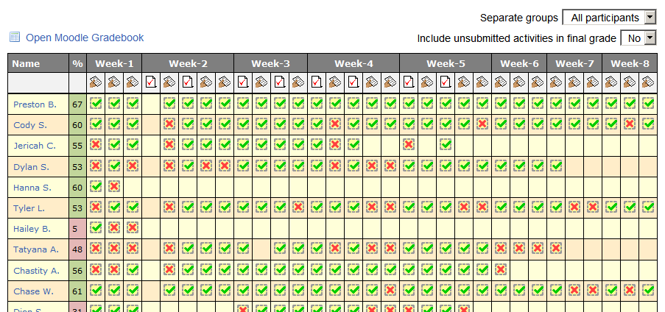

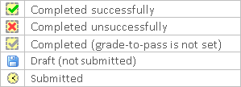

1. **Overview of Marking Manager Interface**

The marking interface allows teachers to grade Assignments and Forums within a single interface. This interface consists of a left section, where activites are selected, and and right section, where activties are graded.

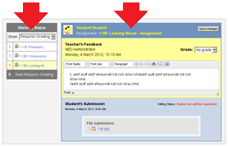

The left section (Marking Status) contains a “Show” dropdown menu that allows teachers to filter the list of activities based on the following criteria:

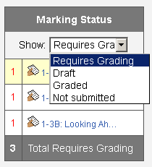

Below the drowdown menu, the left column shows the **number** of activities in question (ie. X number of activities Require Grading) and the right column allows the teacher to navigate between the various activites.

The remainder of this document contains screenshots that show the Marking Manager in action.

Show **Required Grading**:

* Lists all Assignment submissions and Forum posts that are waiting for a grade.
* Teacher may provide grade and feedback directly on this interface.
* Note that there is *View: Less/More* dropdown menu (shown in screenshot below) located on the top-right corner of the screen. When the *Less* option is selected, activities with a zero count will not be shown. For example, if Activity A does not have any unmarked submissions, it will not be listed when the *Not Marked* menu option is selected.

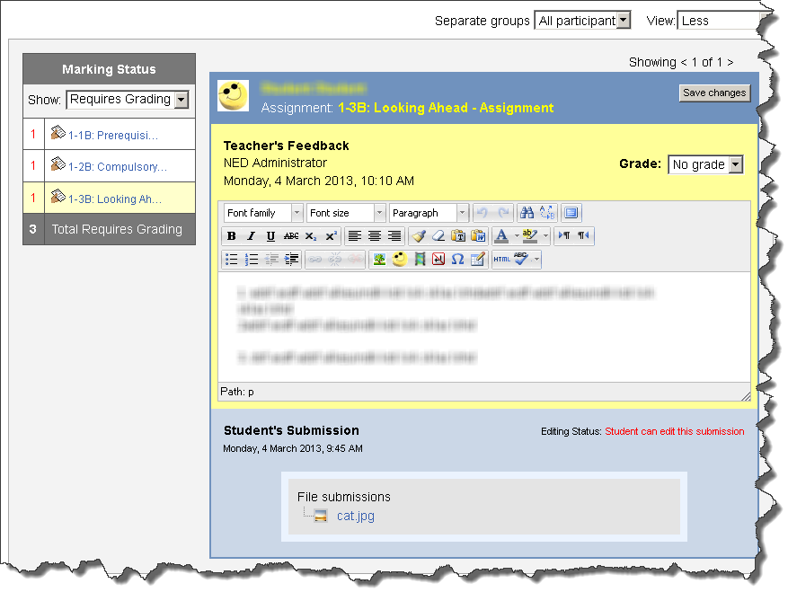

Show **Graded** – List all submissions:

* Lists all submissions that have been graded. The expand icon on the right side (Assignment) will open the submission in a new window.
* Green checkmark indicates that the activity was successfully completed (as determined by the grade-to-pass setting)
* Red checkmark indicates that the activity was not successfully completed.
* The name of the student and activity act as links (new window)

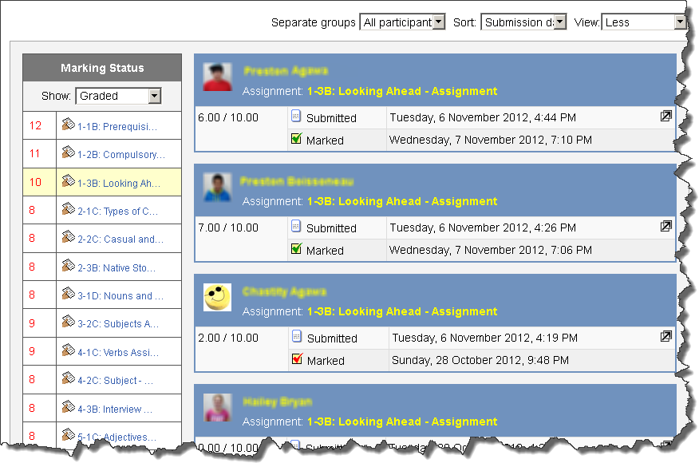

Show **Graded** – List individual submission

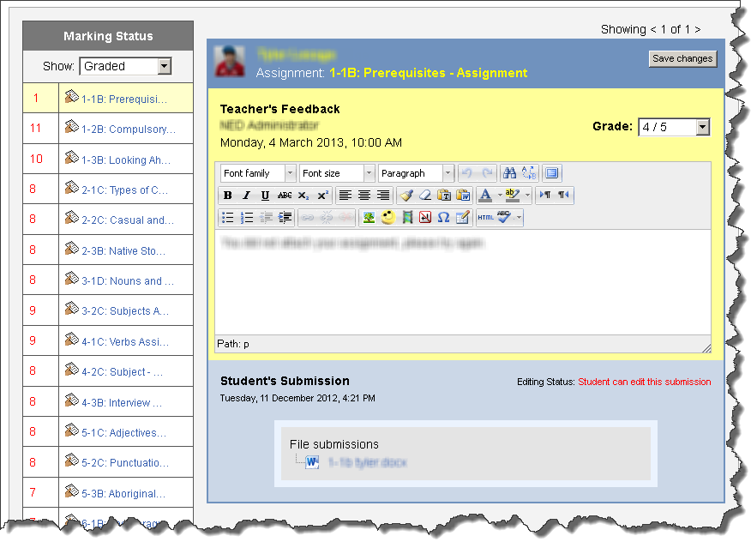

Show **Not Submitted**: Display a list of students that have not submitted a particular Assignment or Forum

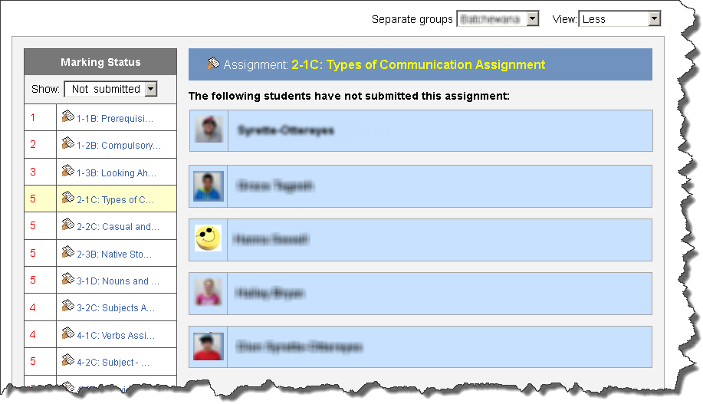

***Optional:***  
If you want to hide blocks when viewing the Marking Manager interface (i.e. less cluttered look), then add this code to ***yourmoodlesite/theme/base/config.php***  
  
// Hide left and right block columns when viewing the Marking Manager  
'markingmanager' => array(  
        'file' => 'general.php',  
        'regions' => array(),  
        'options' => array('noblocks'=>true),