GTest测试MFC_DLL方法
- 测试对象为DataImport_JSYG_TPK.dll (MFC DLL)

创建一个MFC Application
Application 为DialogBase，静态链接库（use MFC in a static Library）

Additional include diretories
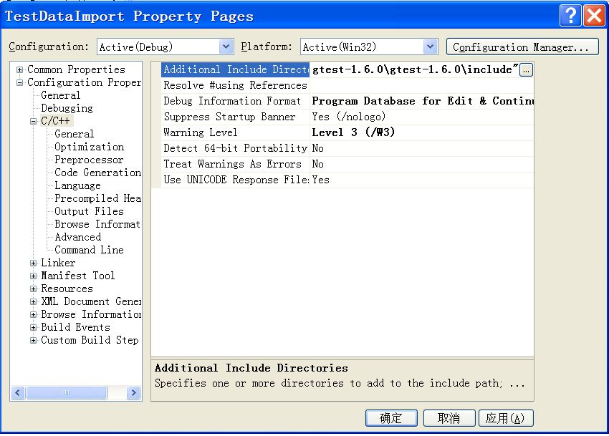

Addtional dependencies
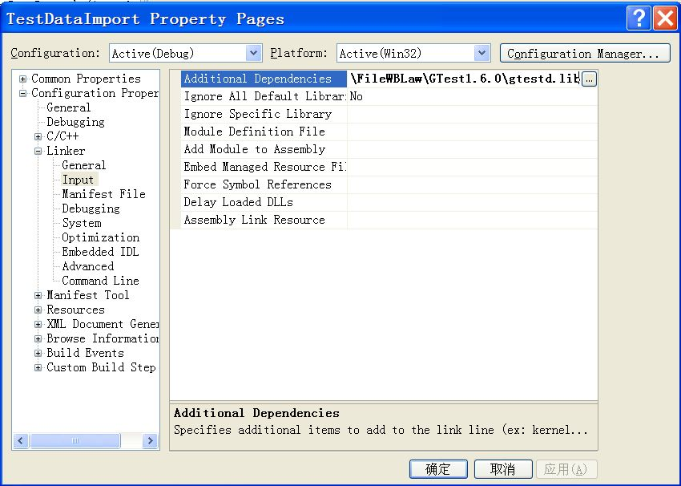

添加头文件
// TestDataImport.cpp
#include <conio.h>
#include <fcntl.h>
#include <io.h>
#include <gtest/gtest.h>
#include "DataAdapter.h"
#include "DataImport_JSYG_TPK.h"
#pragma comment(lib,"F:\\DRMP_install\\excute package\\DRMP\\bin\\DataAdapter.lib")
#pragma comment(lib,"F:\\DRMP_install\\excute package\\DRMP\\bin\\DataImport_JSYG_TPK.lib")

添加Console类
class CConsole
{
public :
CConsole(void );
virtual ~CConsole(void );
private :
};
CConsole::CConsole(void )
{
AllocConsole();
int hCrun;
hCrun = _open_osfhandle((long )GetStdHandle(STD_OUTPUT_HANDLE), _O_TEXT);
FILE* hFile = _fdopen(hCrun, "w" );
// use default stream buffer
setvbuf(hFile, NULL, _IONBF, 0);
*stdout = *hFile;

//test
//_cprintf("test console by _cprintf/n", 0);
//std::cout << "test console by std::out/n";
}
CConsole::~CConsole(void )
{
FreeConsole();
}

把Console窗口移到前台
把Console窗口移到前台，并通过MessageBox阻止程序退出，便于查看控制台的输出。代码如下,红色为添加代码：
//// TestDataImport.cpp
BOOL CTest_MFCApp::InitInstance()
{
#if 1
CConsole cc;
int argc = 0;
TCHAR* argv = _T("" );
testing::InitGoogleTest(&argc, &argv);
RUN_ALL_TESTS();
HWND hwnd = GetConsoleWindow();
SetWindowPos(hwnd, HWND_TOP, 0, 0, 0, 0, SWP_NOMOVE|SWP_NOSIZE);
AfxMessageBox(_T("about to exit!" ));
return FALSE;
#else
INITCOMMONCONTROLSEX InitCtrls;
InitCtrls.dwSize = sizeof(InitCtrls);
...
#endif
return FALSE;
}

添加测试代码
extern __int32 WINAPI InitDataImport(OUT char* cErrTxt);
extern __int32 WINAPI PersoProcess(char* cBatchId,char* cTKIndex, char* cDataFile, int iDataFileType, OUT char* cErrTxt);

TEST(ExplicitTest, PersoProgress)
{
char cErrTxt[256]={'\0'};
char * cBatchId="508";
int actual=0,iBatchNum=0,iRetCode=0;
PROC_DXHPEPIS_PARA *pProcDxhpPara=new PROC_DXHPEPIS_PARA;
strcpy(pProcDxhpPara->pProcDRMPPara.cDataBaseUser,"vpsuser");
strcpy(pProcDxhpPara->pProcDRMPPara.cDataBasePassword,"developer");
strcpy(pProcDxhpPara->pProcDRMPPara.cDataBaseName,"DRMP2KB");
actual=InitDataAdapter(pProcDxhpPara,cBatchId,&cErrTxt[0]);
EXPECT_EQ(actual,0);
actual=1;
actual=PersoProcess(cBatchId,"","C:\\Documents and Settings\\Administrator\\桌面\\2000_TPK.TXT",0,&cErrTxt[0]);
EXPECT_EQ(actual,0);
SUCCEED();
}

测试结果
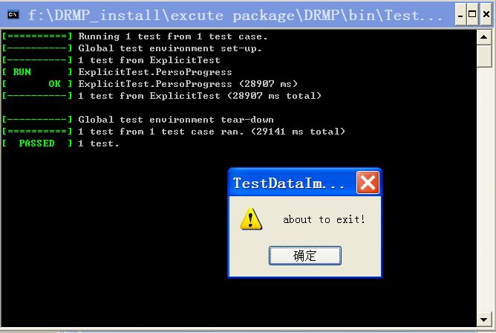

评价
此方法运行较快，不浪费内存，但需把输出路径设置到DRMP.exe目录下，而且无法进入被测代码段进行调试。

