# Answer # 1

## Object Originated Programming

The object originated programming language is generally refer to those programming languages which consist of four Abstraction, Inheritance, Encapsulation and Polymorphism. There are different modern and newest languages having the characteristics of object originated programming as comparatively others traditional languages like C language, which is known as structural and modular programming language, but C language do not exist any component of OOP. But latest popular language python supports the all four Major components of OOP and python also known as object and class supportable language in which programmer can create different type of classes and objects, let an example of object, the object is nothing but called an copy of the class which has two characteristics state and behavior. The classes further classified with different types of access modifiers named as public, static and protected.

# Answer # 2

## The benefits of OOP listed below

* The major benefit of object OOP is for programmer who can write, read, understand and reuse the program.
* OOP also provide exception handling and exact address of line where the error.
* In python programming OOP provides the Security, Design, Maintenance and flexibility for developer to create efficient program by using their four major components as explained in (Ans 1).

# Answer # 3

## Difference of function and method in python

Method and a function are the same, with different terms. A method is a procedure or function in object-oriented programming.

A function is a group of reusable code which can be called anywhere in your program. This eliminates the need for writing the same code again and again. It helps programmers in writing modular codes.

# Answer # 4

## Given Four terms are defined below

1. **Class and Object:** - The class defines attributes and the behavior of the object, while the object, on the other hand, represents the class.
2. **Attribute and Behavior:** - Every class contains attributes and behaviors. Attributes are the characteristics of the class that help to distinguish it from other classes. Behaviors are the tasks that an object performs. In python, attributes are called properties and behaviors are called functions.

# Answer # 5

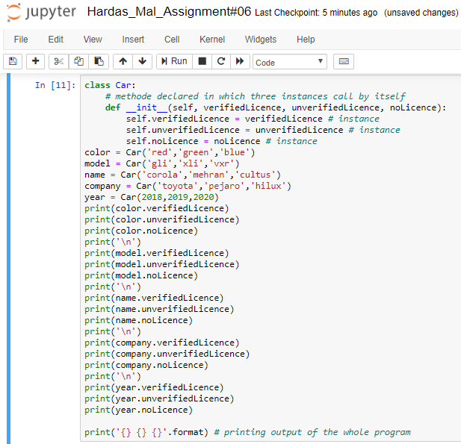

Go to the link

<https://github.com/Hardas-Khatri/Assignment-1/blob/master/Hardas_Mal_Assignment%2306.ipynb> to check code and output in python file.