Document type

Document name

Date

Document control

Departmental approvals

Revision | Issued Date | Description / Nature of Revision | Approved by
1.1 | 23 October 2025 | Issued for ECI Phase | Timothy Poole
2.0 | 1 December 2025 | Revision for ECI Phase | Timothy Poole

Prepared by | Department of Transport and Main Roads
Title | Exhibit 1 – Project Scope and Technical Requirements  Annexure A – Scope Requirements
District & Region | State-wide (Metropolitan and South Coast Region)
Branch & Division | Rail Infrastructure Delivery Office (RIDO)
Project/program | New Albion Station Project
Project number | 02928811
Project location | Albion
Status | Draft
DMS ref. no. | DOC25/219955

Introduction
This is the document introduction. Expect here to find some context elements. The introduction is useful to have a better understanding of the requirements.

Purpose
This specification generally follows the format described in IEEE 830 for a system specification.
Verification methods and when verification is to be performed for each requirement should be provided.

Product Scope
This specification establishes the development and qualification requirements for a Cool Medical Device, hereafter referred to at the CMD. The CMD provides medical capabilities to support mobile and Bedroom operations.

Standards and References
The following table lists the applicable documents that contain the standards and specifications pertaining to the program development.
Table 1. Standards and Specifications Documents

Document Conventions
"S h a l l" is used whenever the specification expresses a provision that is binding. “S h o u l d" is used to express a non-mandatory provision. “May” is used to express an implementation option or requirement exception and is not itself a requirement. "Will" is used to express a declaration of purpose on how the end item will be used or designed and is not a requirement. Non-requirement statements are shown in italics.

Customer Requirements

TEST_00030
Testing for levelling

TEST_00040
Testing for deep levelling

TEST_0060
Testing for deepest

TEST_0020
Health personnel must be able to maneuver the equipment within the hospital.
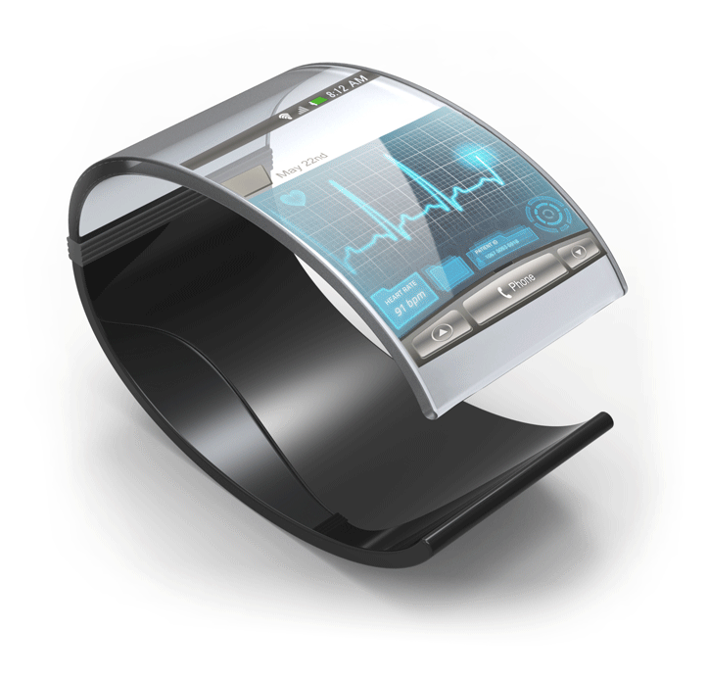
Figure 1-Cool Medical Device

TEST_0021
The surgeon shall reuse a certain configuration of the overall equipment.

TEST_0022
The system shall not weight more than 6 kg

TEST_0023
The equipment shall be used in Hospitals in North America, including US, Canada and Mexico.

TEST_0024
The equipment shall be capable of being calibrated by a technician with a maximum of 10 hours of training.

TEST_00010 Testing this requirement for the levelling

TEST_00020
Testing under 2.1.1

Marketing Requirements

TEST_0026
On each product we develop our company logo must be visible.

The minimum size of the logo is: 60 mm x 30 mm

TEST_0027
The colour to be used for all cases RGB (240, 240, 180)

Figure 1-Corporate color

TEST_0028
All screens should support HD (high definition).

Standards

TEST_0030
A unit load device, or ULD, is a container used to load luggage, freight, and mail on wide-body aircraft and specific narrow-body aircraft. It allows a large quantity of cargo to be bundled into a single unit. Since this leads to fewer units to load, it saves ground crews time and effort and helps prevent delayed flights. Each ULD has its own packing list (or manifest.) so that its contents can be tracked.
ULD containers, also known as cans and pods, are closed containers made of aluminum or combination of aluminum (frame) and Lexan (walls), which, depending on the nature of the goods to be transported, may have built-in refrigeration units. Sizes of common ULDs and their specifics are listed below.

Table 1-Air Transportation - Maximum sizes
Container type | Volume | Linear dimensions  (base width / overall width × depth × height) | Remarks
LD1 | 4.90 m³ (173 cu ft) | 156 / 214 × 153 × 163 cm | contoured, half width
 |  | (61.5 / 92 × 60.4 × 64 in)
LD2 | 3.40 m³ (120 cu ft) | 119 / 156 × 153 × 163 cm | contoured, half width
 |  | (47 / 61.5 × 60.4 × 64 in)
LD3 | 4.50 m³ (159 cu ft) | 155 / 201 × 153 × 163 cm | contoured, half width, dimension according to IATA;  available at 45" height for loading on Airbus A320 family
 |  | (61 / 79 × 60.4 × 64 in)
LD6 | 8.95 m³ (316 cu ft) | 320 / 407 × 153 × 163 cm | contoured, full width, equivalent to 2 LD3s
 |  | (125 / 160 × 604 × 64 in)
LD8 | 6.88 m³ (243 cu ft) | 244 / 318 × 153 × 163 cm | contoured, full width, equivalent to 2 LD2s; DQF-prefix
 |  | (96 / 125 × 60.4 × 64 in)
LD11 | 7.16 m³ (253 cu ft) | 318 × 153 × 163 cm | same as LD-6 but without contours; rectangular
 |  | (125 × 60.4 × 64 in)

TEST_0031
The following document describes the container Requirements of the IATA.

Business Requirements

TEST_0033
The system shall support Security Requirements Version 1.2.

TEST_0034
The system shall update information within 24 hours.

