MOTT MACDONALD
T3PP Brisbane Airport — Design Consultancy Services

Systems Engineering
Management Plan
  - Brisbane Airport Terminal 3 Precinct Program (T3PP)
Working Draft | Version 0.A | Pre-mobilisation
Reference: BAC-T-25-445
Issue date: 03 May 2026

Item | Detail
Client | Brisbane Airport Corporation (BAC)
Project | Terminal 3 Precinct Program (T3PP)
Tender reference | BAC-T-25-445 — T3PP Design Consultancy Services
Lead Consultant | Mott MacDonald Australia Pty Ltd (with Grimshaw)
Document type | Systems Engineering Management Plan (SEMP) — DRAFT
Document owner | Engineering Manager, T3PP
Author | Requirements Engineering Lead, T3PP (Mott MacDonald)
Status | DRAFT — for internal review and discussion only
Distribution | Mott MacDonald T3PP project team

Note: This is a pre-mobilisation working draft prepared by the Requirements Engineering Lead for internal Mott MacDonald discussion. T3PP project objectives, stakeholder requirements, scope boundaries and contractual obligations are not yet finalised. Content will be updated, reviewed and re-issued as the project moves into Concept Design and as BAC inputs are received.

Document Control
Revision history
Rev | Date | Author | Reviewer / Approver | Summary of changes
0.A | 03 May 2026 | Requirements Engineering Lead | Engineering Manager (TBC) | Initial working draft for internal Mott MacDonald review.

Approvals (to be completed when Mott MacDonald T3PP organisation chart is finalised)
Role | Name | Signature / Date
Project Director | TBC
Engineering Manager | TBC
Requirements Lead (author) | TBC (this author)
Quality Manager | TBC

Distribution
- Mott MacDonald T3PP Project Director and Engineering Manager
- Mott MacDonald T3PP Discipline Leads
- Sub-consultant engineering leads (Grimshaw, RBG, GHD, BNP — for information once endorsed)
Status note: This SEMP is drafted ahead of receipt of the formal BAC project objectives, Reference Design hand-back package and stakeholder requirements. References to specific T3PP scope, milestones, deliverables and reviews are framed as the expected approach and are to be confirmed at project mobilisation.

Table of Contents
When the document is opened in Microsoft Word, right-click the area below and select “Update Field” to populate the table of contents.
(right-click → Update Field to populate)

1. Introduction

1.1 Purpose
This Systems Engineering Management Plan (SEMP) describes how Mott MacDonald, as Lead Design Consultant for the Brisbane Airport Corporation (BAC) Terminal 3 Precinct Program (T3PP), will apply a structured systems engineering (SE) approach to manage technical complexity, deliver a coherent design, and provide engineering assurance to BAC across the design lifecycle.
The SEMP provides:
- A summary of the SE strategy and lifecycle that Mott MacDonald will follow on T3PP, tailored to BAC's Concept Design progression (Steps 1–6) and downstream design stages.
- An outline of the key SE processes — requirements management, architecture, interface management, verification and validation, system safety, RAM and human factors — and how they support the T3PP Design Consultancy deliverables.
- The roles and responsibilities for SE activities within the Mott MacDonald T3PP organisation and the interfaces with BAC and sub-consultants.
- A list of subordinate management plans that will further define each SE sub-discipline.
This SEMP is not a contractual document and does not specify deliverables on behalf of BAC; those are defined in the Tender Documents (BAC-T-25-445) and any executed Services Agreement.

1.2 Audience
This document is intended:
- To be developed and maintained by the Mott MacDonald T3PP Requirements Engineering Lead, under the direction of the Engineering Manager.
- To be reviewed and implemented by Mott MacDonald T3PP discipline leads and embedded engineering team members.
- To be endorsed by the Mott MacDonald T3PP Project Director.
- To be shared with sub-consultant engineering leads to align their SE activities with the Mott MacDonald approach.
- To be available to BAC for transparency, to demonstrate how Mott MacDonald is approaching engineering management of the T3PP design.

1.3 Scope
This SEMP applies to all SE activities undertaken by Mott MacDonald and its sub-consultants in support of the T3PP Design Consultancy Services. It covers Mott MacDonald's role from pre-Concept validation through Concept Design (Steps 1–6), Schematic / PSA, Detailed Design / IFC, and design support during construction, testing and commissioning, until handover and operational readiness of the T3PP precinct.
The SEMP is a living document. It will be re-issued at the start of Concept Design when the BAC project objectives, stakeholder requirements set, and detailed scope are confirmed, and thereafter at major lifecycle transitions or when significant project events warrant.

1.4 Document status and limitations
This is Working Draft v0.A. At the time of writing, BAC has not yet shared the consolidated T3PP project objectives or a formal stakeholder requirements set with the Mott MacDonald engineering team. The structure, processes and roles described here therefore reflect industry best practice (INCOSE SE Handbook v4, ISO/IEC/IEEE 15288, IATA ADRM, NAS), the Reference Design context, and the expected concept-stage scope set out in the BAC tender (BAC-T-25-445). They will be confirmed and refined as inputs are received.

2. T3PP Project Context

2.1 The Terminal 3 Precinct Program
Brisbane Airport (BNE) is reaching an inflection point on its 100th anniversary. The Terminal 3 Precinct Program (T3PP) is BAC's once-in-a-generation programme to define a new passenger terminal precinct that will accommodate growth from approximately 18 million passengers per annum (mppa) to a future capacity in excess of 40 mppa, while delivering a modular, stageable, flexible and efficient precinct that will serve domestic and international travellers and create a civic legacy for Brisbane and South-East Queensland.
The Reference Design stage (10% maturity) has been completed. Concept Design and subsequent design stages will progressively refine the precinct definition into an integrated set of buildings, infrastructure and operational systems.

2.2 Mott MacDonald and Grimshaw role
Mott MacDonald, with Grimshaw and a network of specialist sub-consultants (Robert Bird Group, GHD, BNP, Aspect Studios, Blight Rayner, Burrundi Design Studio, DCLA, McKenzie Group, Solis, Gatehouse, Philip Chun, Bennett & Bennett, Moment Factory and others), is the Lead Design Consultant for T3PP under tender BAC-T-25-445. The team brings continuity from the Reference Design stage and integrated multidisciplinary capability across architecture, engineering, planning, sustainability, terminal planning, BHS, MEP, ICT, landscape and constructability.

2.3 Programme drivers
- Capacity growth: scalable precinct from current ~18 mppa to >40 mppa.
- Operational continuity: maintain existing T1/T2 service levels throughout staged delivery.
- Modularity, stageability and efficiency, supporting prefabrication and progressive opening.
- Civic legacy: a new gateway to Brisbane and SEQ; reflect Turrbal Country and SEQ identity.
- Sustainability and carbon: in-house carbon-twin and carbon-portal tools, integrated with model-based asset management.
- Olympic and Paralympic Games 2032: ensure precinct readiness and avoid construction conflicts during the Games window.
- Regulatory compliance: CASA, Airservices Australia, Australian Border Force, biosecurity, BCA / NCC, and Queensland building and planning frameworks.

2.4 Programme phases (Mott MacDonald scope)
Drawing on the Concept Design Progression set out in the tender response, the Mott MacDonald engagement is structured around the following sequential stages, each of which has SE activities described in Section 6:
Stage | Description
Pre-Concept / Validation | Lessons-learned workshop, airport tour, validation of the Reference Design, stakeholder alignment and confirmation of brief and ConOps.
Concept Options Development | Global Design Competition / options generation across pier and terminal module, MEP, BHS, modularity and buildability. Multi-Criteria Analysis (MCA) of options.
Concept Design (Steps 1–6) | Validation; Vision and Concept Strategies; Preliminary Concept Design; Developed Concept Design; Refined Concept Design; Documentation and Evaluation, culminating in a Gate Review.
Schematic Design / PSA | Pre-Schematic Architecture / Schematic Design level packages, supporting BAC procurement decisions and Work Breakdown Structure refinement.
Detailed Design / IFC | Detailed design across all disciplines, leading to Issue for Construction packages.
Construction & Commissioning Support | Design support during construction, RFI / NCR responses, factory and site acceptance test support, commissioning and integrated systems testing assistance.
Handover & Operational Readiness | Support BAC and Operations teams in trial operations, training, ORAT and final handover.

3. Systems Engineering Objectives

3.1 Why apply systems engineering on T3PP
T3PP is a large, complex, multi-disciplinary precinct programme with hundreds of stakeholders, demanding airside-landside interfaces, evolving regulatory requirements, and a long delivery horizon spanning the Olympic and Paralympic Games. A disciplined SE approach gives the Mott MacDonald team a single, traceable thread between BAC's strategic objectives, stakeholder needs, design decisions, and verified delivery. It supports good engineering judgement, transparent change control, and an auditable evidence base for BAC gateway reviews.

3.2 Three engineering assurance viewpoints
Adapting the SRL East SEMP framing to T3PP, three viewpoints are used to organise SE activities and to ensure no critical assurance angle is missed:
- Operator, maintainer and user integration — the precinct is being designed for airlines, ABF, Airservices, BAC operations and maintenance teams, ground handlers, retail and F&B tenants, and most importantly, passengers and meet-and-greeters.
- Programme delivery assurance — the design matures to time, cost and scope expectations and is fit for BAC gateway reviews, board approvals and procurement decisions.
- Systems integration — T3PP subsystems integrate cleanly with each other and with existing BNE assets (T1/T2, BHS, ICT/AODB, utilities, kerbside and roads, public transport).
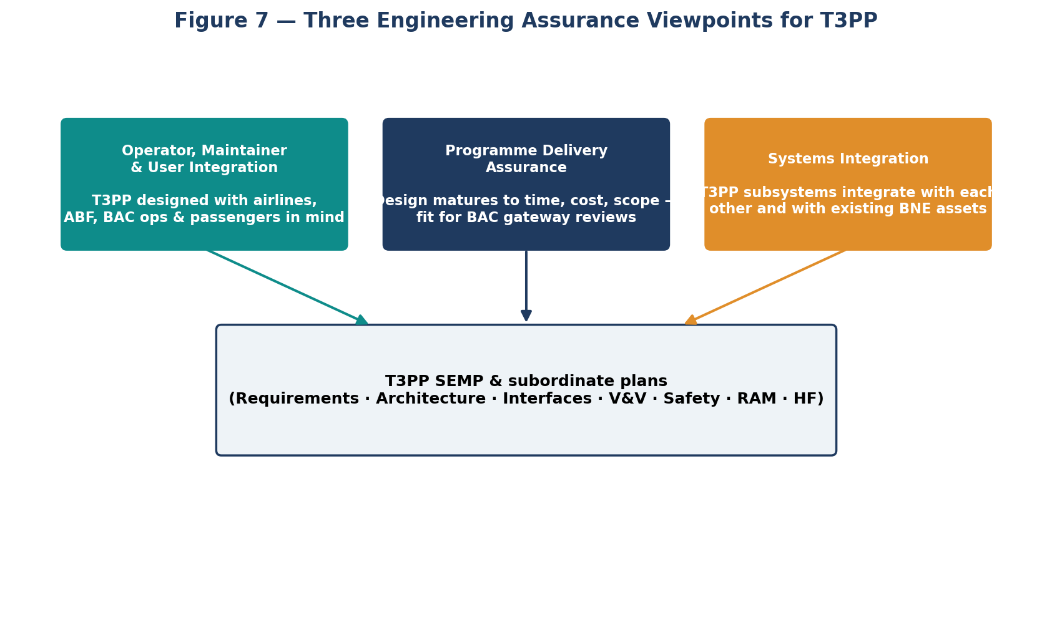
Figure 7 — Three engineering assurance viewpoints for T3PP.

3.3 SE objectives at-a-glance
The figure below summarises the inputs that the Mott MacDonald engineering team draws upon, the SE processes applied across T3PP, and the principal outputs delivered.
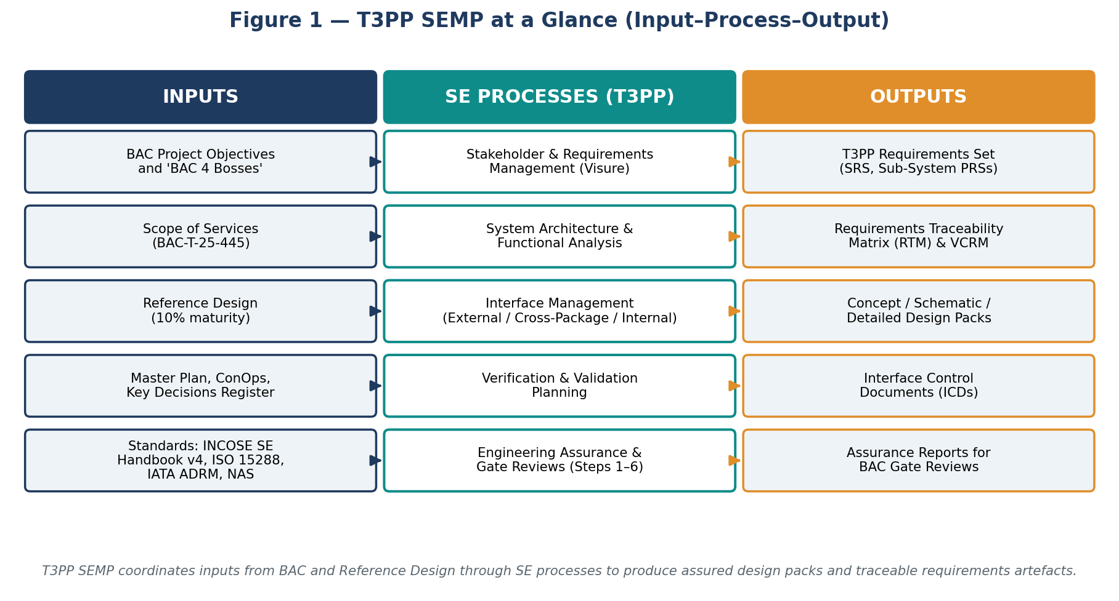
Figure 1 — T3PP SEMP at a glance (Input–Process–Output).

3.4 Objectives statements
ID | Objective
O-1 | Provide BAC with a coherent, traceable engineering basis for T3PP design decisions from concept through to handover.
O-2 | Capture and manage stakeholder and system requirements in a single, controlled requirements management tool (Visure) with full bidirectional traceability.
O-3 | Define and maintain a precinct-level system architecture that decomposes T3PP into manageable subsystems and work packages.
O-4 | Identify, document and control all external, cross-package and internal interfaces via Interface Control Documents (ICDs).
O-5 | Plan and evidence verification and validation of design outputs against requirements at each stage gate, using a Verification Cross-Reference Matrix (VCRM).
O-6 | Embed system safety, RAM, human factors, sustainability and security considerations into the design from the earliest stages.
O-7 | Enable transparent change control and impact assessment so that requirement, design, interface and verification changes are managed coherently.
O-8 | Demonstrate engineering assurance to BAC at each gate review through an auditable evidence trail (RTM, VCRM, ICDs, design reports, review minutes).

4. T3PP System Overview

4.1 System context and boundary
The T3PP system boundary, for the purpose of this SEMP, encompasses the new pier and terminal module, associated apron and airside works, the baggage handling system (BHS), passenger processing and boarding systems, retail/F&B and back-of-house spaces, MEP systems, ICT and operational systems (FIDS, AODB, security, BMS, fire), landside circulation, forecourt and connections to existing BNE assets, plus the enabling and pre-construction works necessary to deliver them.
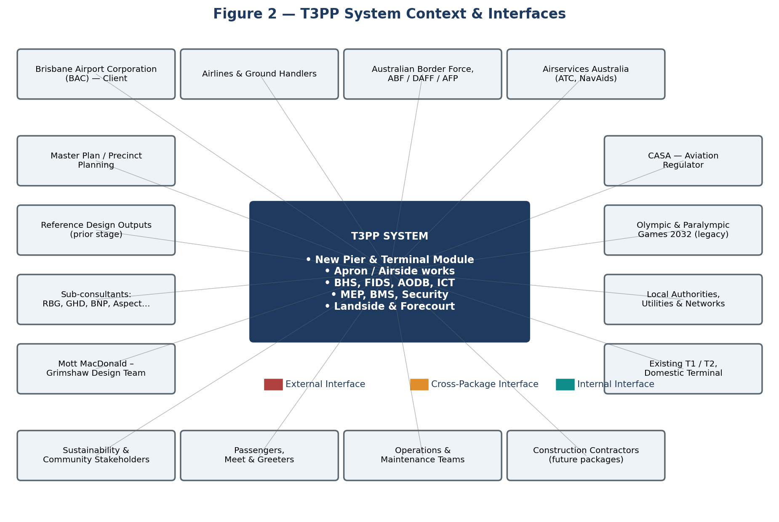
Figure 2 — T3PP system context and external stakeholders/systems.

4.2 Subsystems and work packages (indicative)
The architecture model maintained by the Mott MacDonald engineering team will decompose T3PP into the indicative subsystems below. Final decomposition will follow the Work Breakdown Structure (WBS) developed during Concept and Schematic stages and refined to suit BAC's procurement and packaging strategy.
Subsystem / Work Package | Indicative scope
Pier | Aircraft contact/non-contact stands, fixed links, vertical transport, gate lounges, services.
Terminal Module | Departures and arrivals halls, processors (check-in, security, immigration, customs), retail/F&B, lounges.
Baggage Handling System | Inbound/outbound BHS, hold-baggage screening, sortation, make-up, reclaim, controls and IT.
MEP | HVAC, electrical, hydraulics, fire, vertical transport, BMS, energy and resilience.
ICT and Operational Systems | AODB, FIDS, common-use systems, PA/VA, SACS/CCTV, biometrics, network, data centre.
Apron / Airside | Pavements, lighting, fuelling, GSE routes, drainage, marking, RESA.
Landside | Forecourt, kerbsides, roads, parking, public transport interchange, active transport.
Enabling Works | Demolition, utility relocations, temporary services, construction logistics, hoarding.
Sustainability / Carbon | Carbon-twin model, energy performance, waste, water, biodiversity, resilience.
Digital Engineering / BIM | Federated BIM model, model-based asset information, 4D construction sequencing, digital twin handover.

4.3 Interface taxonomy
Interfaces are categorised, captured and managed in line with industry best practice. The T3PP interface register (held in Visure or a linked tool) will use the following types:
- External interfaces — between T3PP and any external system, project or stakeholder outside the T3PP boundary (e.g. existing T1/T2 BHS, Airservices ATC systems, BAC airfield, public transport networks, utilities providers).
- Cross-package interfaces — between T3PP work packages within the BAC procurement strategy (e.g. Pier ↔ Terminal Module, BHS ↔ MEP).
- Internal interfaces — between subsystems within a single work package (e.g. AODB ↔ FIDS).

4.4 SE framework — architecture-centric
Following industry best practice (and consistent with the architecture-centric approach used on comparable major rail and infrastructure programmes), the Mott MacDonald engineering team will treat the T3PP system architecture model as the single source of truth that links together stakeholder needs, functional analysis, performance allocations, physical decomposition, interfaces and verification. Where appropriate, the ARCADIA method will be used to structure functional and architectural analyses, tailored to the airport-precinct context.
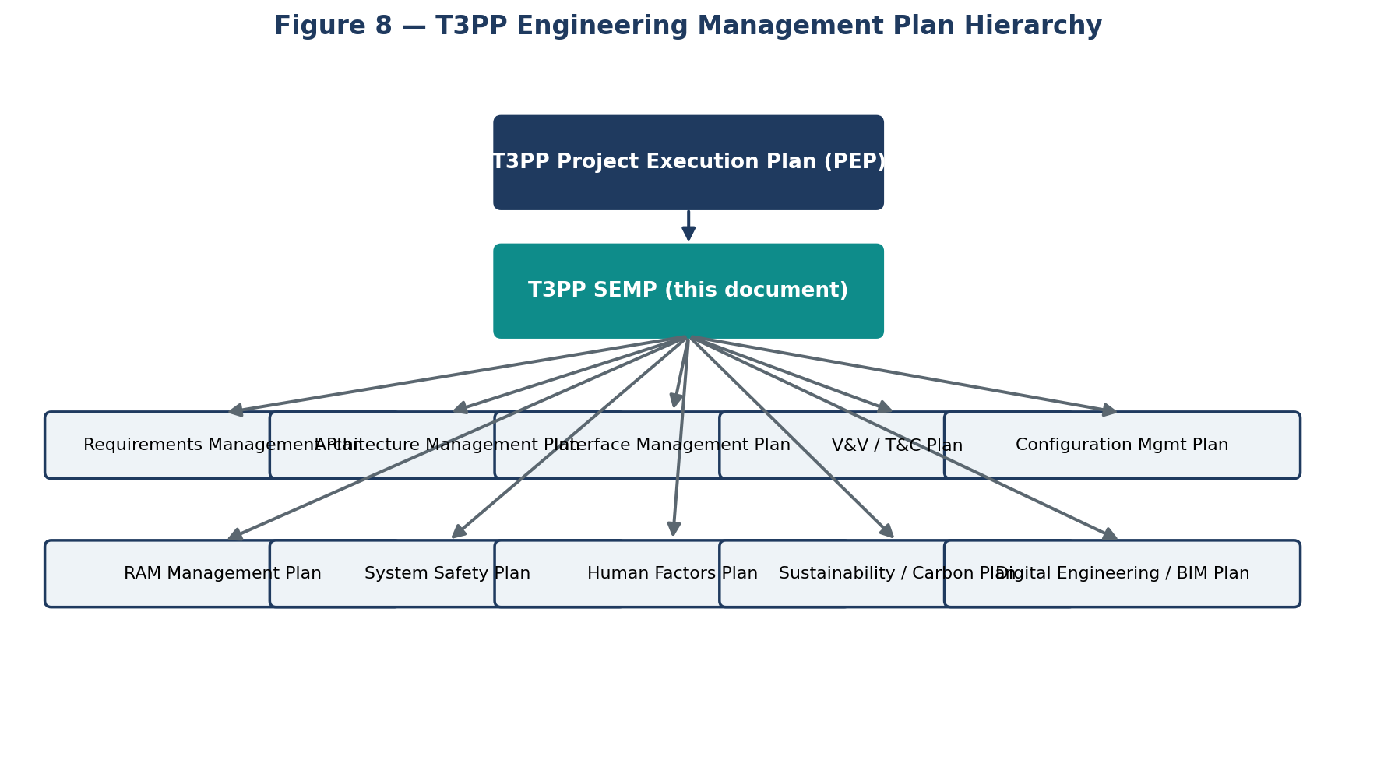
Figure 8 — T3PP engineering management plan hierarchy: SEMP and subordinate plans.

5. T3PP Adapted V-Lifecycle
The figure below shows the V-lifecycle adapted to the Mott MacDonald T3PP design consultancy scope. The descending (left) leg is definition and decomposition; the ascending (right) leg is realisation, verification and validation. Verification activities trace back to the corresponding stage on the left.
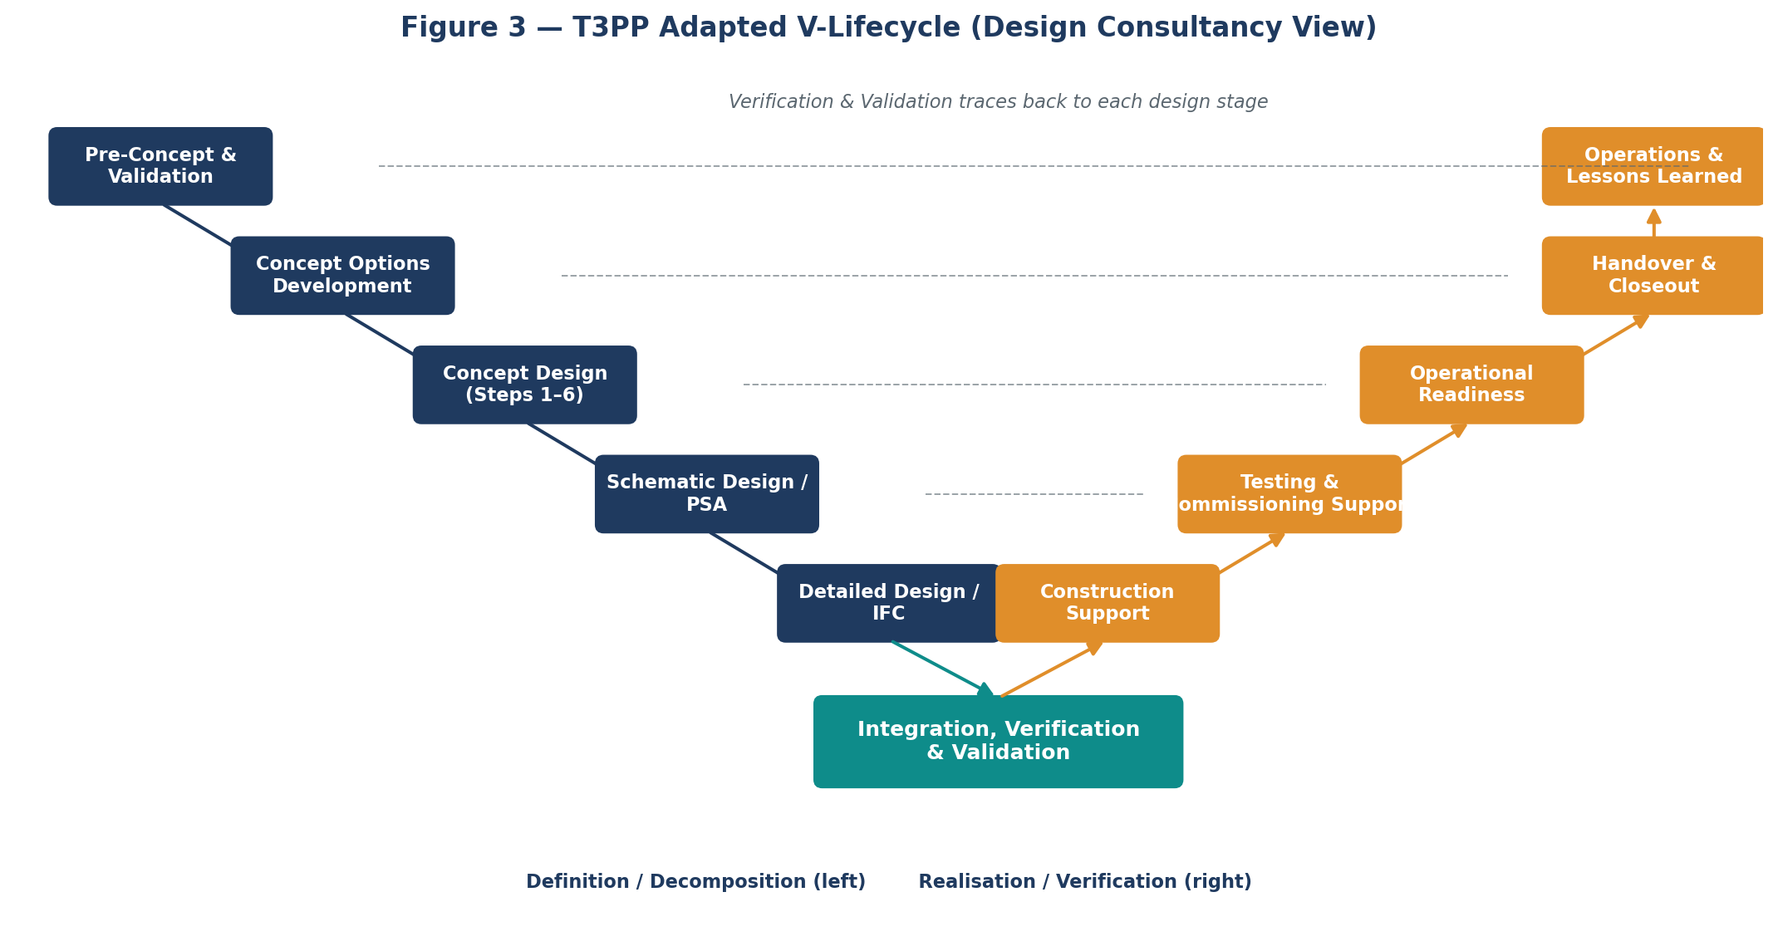
Figure 3 — T3PP adapted V-lifecycle (design consultancy view).
Each stage of the V is supported by gate reviews. The early-stage gates are aligned to BAC's Concept Design progression (Validation → Vision/Concept Strategies → Preliminary CD → Developed CD → Refined CD → Documentation & Evaluation → Gate Review Workshop). Schematic / PSA, Detailed Design and IFC stages will use comparable internal Mott MacDonald gate reviews aligned to BAC's procurement and approvals process.

6. Engineering Assurance Strategy by Stage
For each stage, this section sets out the purpose, principal inputs, the SE approach to be applied by Mott MacDonald, and the engineering assurance outputs. These are described in indicative form and will be confirmed once BAC's project objectives and the executed scope of services are clear.

6.1 Pre-Concept and Validation
Purpose. Validate that the team's understanding of the brief, ConOps and Reference Design is correct and complete; capture lessons learned and stakeholder expectations.
Inputs.
- Reference Design package (10% maturity)
- BAC project objectives and 'BAC 4 Bosses'
- Existing master plan, ConOps, key decisions register
- Outputs of airport tour and lessons-learned workshop
SE approach.
- Run early lessons-learned workshop with BAC and stakeholders.
- Confirm scope, ConOps and assumptions; capture clarifications.
- Initialise the requirements management tool (Visure) with stakeholder needs and CRD-equivalent inputs.
- Set up architecture model skeleton and stakeholder map.
Outputs.
- Validation report
- Initial stakeholder requirements list (Visure baseline 0)
- Updated risk, assumption, issue, decision (RAID) log
- Confirmed engineering team mobilisation plan

6.2 Concept Options Development
Purpose. Generate, evaluate and shortlist credible concept options for pier, terminal module and supporting systems through structured options analysis.
Inputs.
- Validated brief, stakeholder requirements (StRD)
- Reference Design constraints
- Programme, cost and constructability constraints
SE approach.
- Run Global Design Competition / internal options workshops.
- Establish multi-criteria analysis (MCA) framework, weight and score options.
- Begin functional analysis and capacity / passenger-flow simulation.
- Maintain options trade-off log and architectural sketches in the model.
Outputs.
- Concept Options Report
- MCA scoring and shortlisted concepts
- Updated architecture model with options
- Initial T3PP system requirements (SRS draft)

6.3 Concept Design (Steps 1–6)
Purpose. Mature the selected concept(s) into a developed and refined concept design that is fit for BAC's gate review and supports decisions on procurement and packaging.
Inputs.
- Shortlisted concept(s)
- T3PP SRS draft, stakeholder requirements baseline
- Architecture model and indicative WBS
SE approach.
- Step 1 Validation; Step 2 Vision & Concept Strategies; Step 3 Preliminary CD; Step 4 Developed CD; Step 5 Refined CD; Step 6 Documentation & Evaluation.
- Iterate requirements, architecture, interfaces and verification matrix.
- Conduct preliminary hazard, RAM and human factors analyses; feed back to design.
- Manage interfaces via Interface Register and emerging ICDs.
Outputs.
- Concept Design package per Step
- Updated SRS, RTM and VCRM in Visure
- Interface register, draft ICDs
- Sustainability / carbon-twin baseline assessment
- Gate Review Workshop pack

6.4 Schematic Design / PSA
Purpose. Translate the endorsed concept into a schematic-level design and pre-schematic architecture (PSA) that supports BAC procurement decisions and work-package definition.
Inputs.
- Endorsed concept design
- Confirmed WBS and packaging strategy
- BAC procurement direction
SE approach.
- Refine architecture, requirements and interfaces by package.
- Issue subsystem / package PRSs from the SRS.
- Develop ICDs to a level suitable for tender packaging.
- Run targeted V&V workshops and update VCRM.
Outputs.
- Schematic / PSA design pack
- Subsystem PRSs (Pier, Terminal Module, BHS, MEP, ICT, Apron, Landside, Enabling)
- ICD set v1
- Updated RTM / VCRM

6.5 Detailed Design / IFC
Purpose. Develop a fully co-ordinated detailed design suitable for issue for construction (IFC).
Inputs.
- Schematic / PSA design pack
- Subsystem PRSs
- ICDs v1
SE approach.
- Detailed design across all disciplines.
- Close out interface actions with package designers / contractors.
- Execute V&V activities and reviews; track open verification items.
- Maintain configuration baseline of design and requirements.
Outputs.
- IFC design package
- ICD set issued for construction
- Verification reports against SRS and PRSs
- Configuration baseline at IFC

6.6 Construction & Commissioning Support
Purpose. Provide design support during construction, factory and site acceptance testing and system commissioning.
Inputs.
- IFC design package
- Construction RFIs and field changes
- Test plans and commissioning programmes
SE approach.
- Respond to RFIs and NCRs; manage design changes via configuration control.
- Witness FATs/SATs as required; review test results against requirements.
- Update VCRM with verification evidence; close requirements progressively.
Outputs.
- RFI / NCR responses, design changes
- Witnessed FAT/SAT records
- Verification evidence and progressive RTM closure

6.7 Handover and Operational Readiness
Purpose. Support BAC and the Operations team in achieving operational readiness, trial operations and final handover of T3PP.
Inputs.
- Verified system, completed VCRM
- Operational readiness plans, training material
- Handover dossiers (O&M manuals, asset data)
SE approach.
- Support trial operations and ORAT activities.
- Close out residual verification and validation actions.
- Provide design input to lessons-learned and post-completion review.
Outputs.
- Validation report
- Final RTM / VCRM closure
- Handover engineering pack and lessons-learned report

7. Requirements Management
Requirements management is the foundation of the SE approach on T3PP and the focus of the Mott MacDonald Requirements Engineering Lead. This section describes the process, the requirements hierarchy, the role of the Visure Requirements ALM tool, and the key outputs.

7.1 Process at a glance
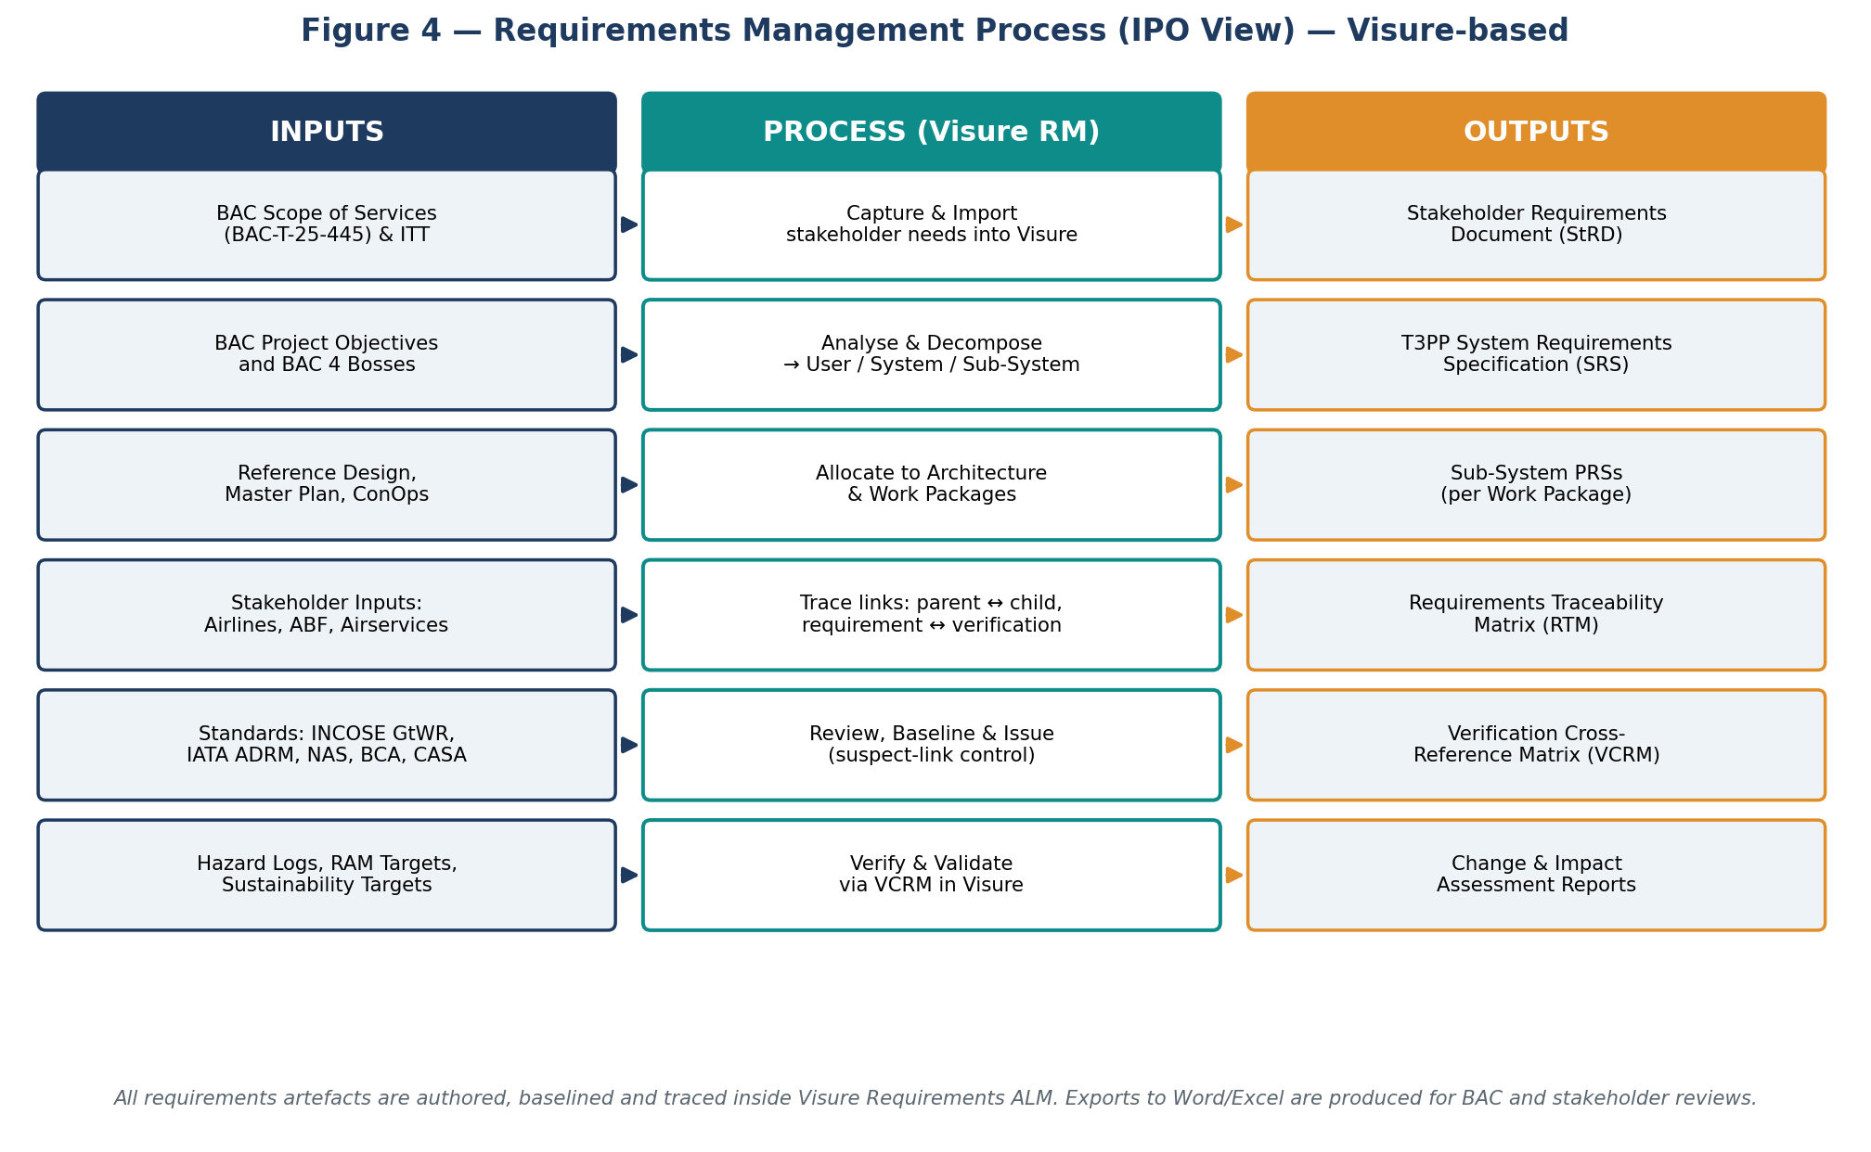
Figure 4 — Requirements management process (IPO view) — Visure-based.

7.2 Requirements hierarchy and traceability
The T3PP requirements set is organised in a hierarchy that flows from BAC's strategic objectives down to component-level specifications, with bidirectional traceability maintained in Visure. Verification evidence is associated with the requirements it satisfies via the VCRM.
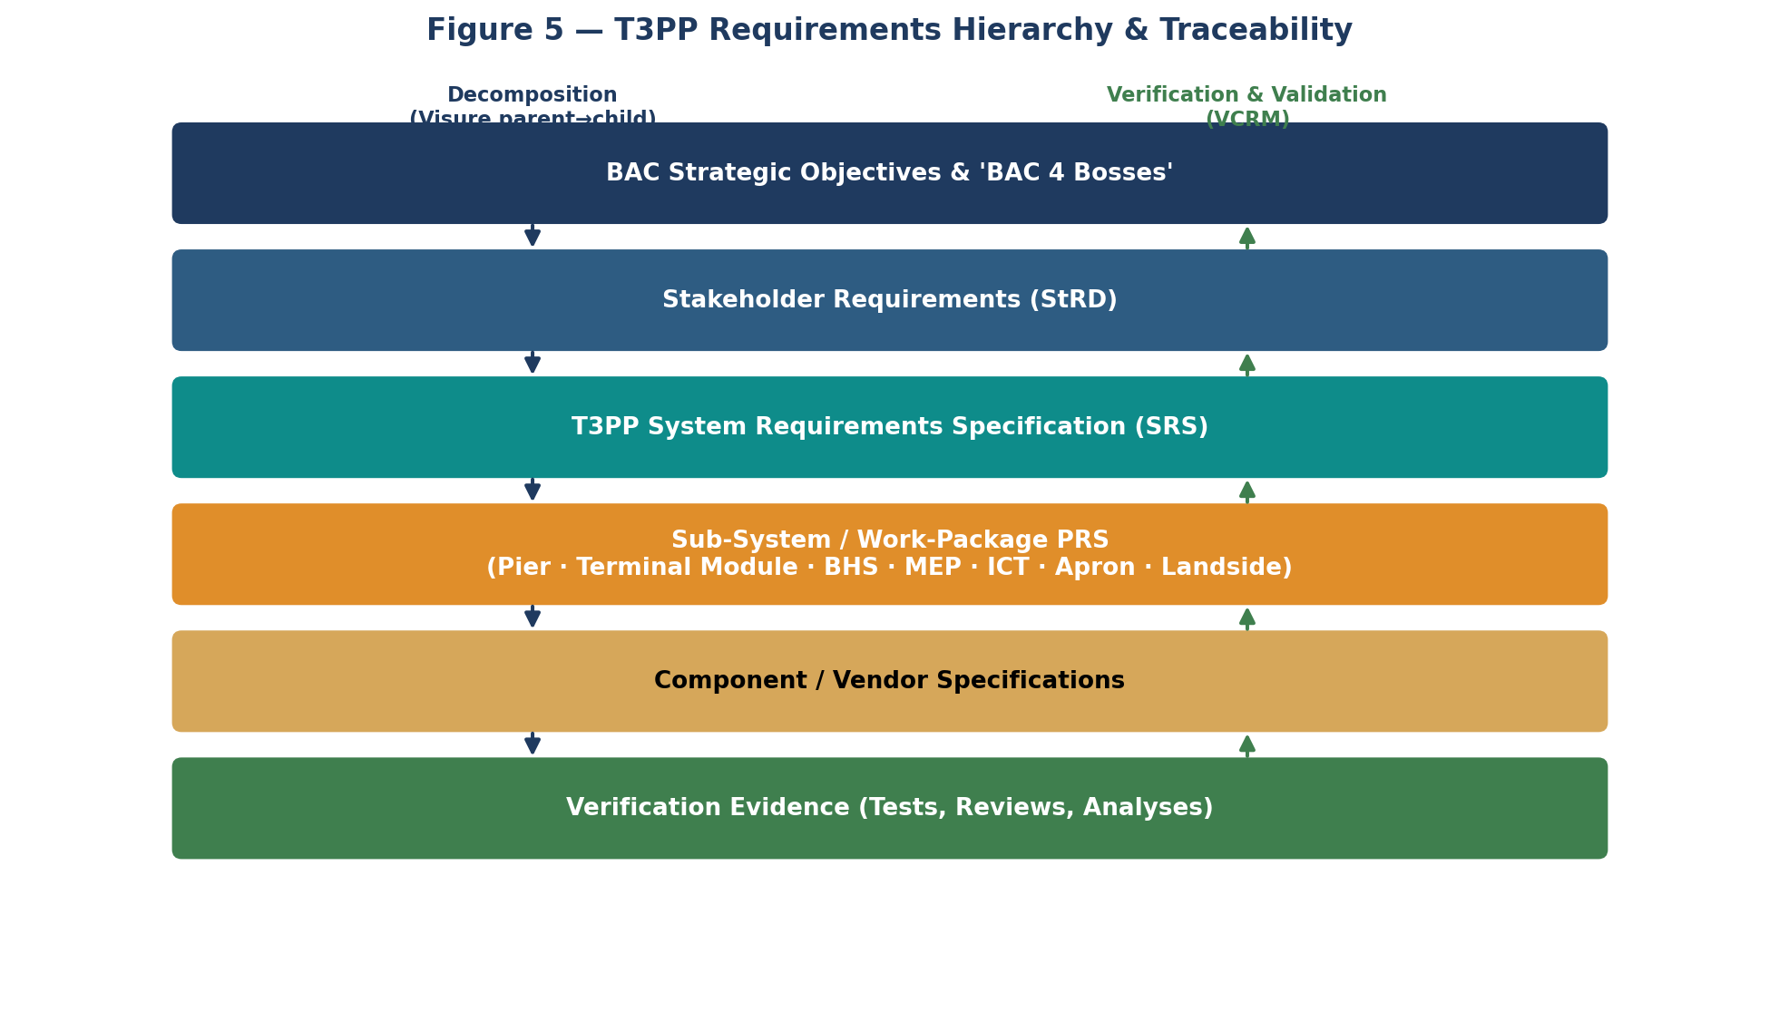
Figure 5 — T3PP requirements hierarchy and traceability.

7.3 Requirements management tool — Visure
Mott MacDonald's enterprise requirements management tool, Visure Requirements ALM, will be used as the authoritative environment for T3PP requirements. Visure provides:
- Centralised authoring, baselining and version control of requirements.
- Configurable schemas (modules, attributes) so requirements can be tagged with type, priority, source, owner, verification method, status and discipline.
- Bidirectional trace links between requirements at different levels and between requirements and verification, test, design and risk artefacts.
- Suspect-link management — when a parent requirement changes, dependent links flag for review.
- Reuse libraries — helpful where T3PP can leverage standard airport requirements (IATA ADRM, NAS, BAC engineering standards).
- Reporting — RTM, VCRM, coverage and impact reports exportable to Word and Excel for client review.
- INCOSE Guide for Writing Requirements rules can be enforced via Visure's quality analyser.

7.4 Visure setup (planned)
Aspect | Approach
Project structure | Single T3PP project with modules per requirement type (Stakeholder, System, Pier PRS, Terminal Module PRS, BHS PRS, MEP PRS, ICT PRS, Apron PRS, Landside PRS, Enabling PRS, Verification, Glossary).
Attributes | ID, Title, Text, Source, Owner, Discipline, Type (Functional, Performance, Interface, Constraint), Priority, Verification Method, Status (Draft / Reviewed / Baselined / Verified / Validated / Closed), Risk, Allocation.
Baselines | End of each Concept Step (1–6); end of Schematic / PSA; end of Detailed Design; IFC; Verification Complete; Validation Complete.
Trace types | Parent ↔ Child decomposition; Satisfies; Verifies; Allocated to (architecture element); Conflicts with; References.
Access control | Read/write per discipline group; sub-consultants given limited read/comment access via federated views or controlled exports.
Quality rules | Atomic, testable, unambiguous, no compound 'and/or', defined actor + action + condition + criterion, INCOSE-aligned.
Change control | Requirements changes raised via Change Request linked to the requirement; impact assessed across trace links before approval.

7.5 Requirement quality criteria
All T3PP requirements are written in accordance with the INCOSE Guide for Writing Requirements. As a working rule, every requirement should be:
- Necessary — describes a need the system must satisfy; no gold-plating.
- Singular — one requirement, one obligation; no compound 'and/or'.
- Unambiguous — interpretable in only one way by all readers.
- Verifiable — testable by inspection, analysis, demonstration or test.
- Feasible — achievable within technical, cost and schedule constraints.
- Traceable — linked to a parent need and to the artefact(s) that verify it.
- Consistent — does not conflict with other requirements.

7.6 Requirements deliverables
Deliverable | Description / lifecycle
Stakeholder Requirements Document (StRD) | Captured stakeholder needs, baselined at end of Concept Step 1 (Validation).
T3PP System Requirements Specification (SRS) | Top-level system requirements, baselined progressively through Concept Steps 2–6.
Subsystem PRSs (per WBS package) | Allocated requirements per work package, issued at Schematic / PSA stage and re-baselined at Detailed Design / IFC.
Requirements Traceability Matrix (RTM) | Live RTM exported from Visure for each major review; closure tracked through to handover.
Verification Cross-Reference Matrix (VCRM) | Live VCRM linking requirements to verification methods and evidence; populated through design, FAT/SAT and ITP execution.
Requirements Management Plan (RMP) | Detailed sub-plan derived from this SEMP, describing process, tool configuration, workflows, roles, baselines and metrics.

7.7 Reviews and baselines
Requirements are reviewed via a Requirements Working Group (RWG) chaired by the Requirements Engineering Lead, with discipline leads, the Engineering Manager, BAC engineering representatives, and sub-consultant leads as needed. Baselines are issued at the end of each major stage and held under configuration control in Visure.

8. Subordinate Engineering Plans
The SEMP is supported by a suite of subordinate plans that detail individual SE sub-disciplines. Each plan follows a standard structure: Inputs, Process, Roles & Responsibilities, Tools, Deliverables and Outputs. The list below is indicative and will be confirmed at mobilisation.
Subordinate plan | Scope and owner
Requirements Management Plan (RMP) | Detailed implementation of Section 7. Owner: Requirements Engineering Lead.
Architecture Management Plan | Architectural method, model structure, views, ARCADIA tailoring, configuration. Owner: System Architect / Engineering Manager.
Interface Management Plan | Interface identification, ICD template, register management, change control. Owner: Interface Manager (within engineering team).
Verification & Validation Plan (V&V Plan) | Methods, levels, planning, evidence and acceptance criteria. Aligned to BAC review gates. Owner: V&V Lead / Engineering Manager.
System Safety Plan | Hazard identification (HAZID/HAZOP), risk assessment, ALARP demonstration, safety case (if required). Owner: Safety Lead.
RAM Management Plan | Reliability, availability and maintainability targets and analyses, including modelling. Owner: RAM Lead.
Human Factors Plan | Passenger experience, wayfinding, accessibility, operator/maintainer ergonomics. Owner: Human Factors Lead (often combined with terminal planning / customer experience).
Configuration Management Plan | Baselines, change control, identification, status accounting and audits across requirements, design and interface artefacts. Owner: Configuration Manager.
Sustainability / Carbon Plan | Sustainability targets, carbon assessment, integration with carbon-twin tool. Owner: Sustainability Lead.
Digital Engineering / BIM Execution Plan | BIM uses, model federation, model-based asset information, digital twin handover. Owner: Digital Engineering Lead.
Cyber Security Plan | Cyber risk for OT/IT systems (AODB, BHS controls, BMS, security). Owner: Cyber Lead.

9. Interface Management (Summary)
Interface management is summarised here for completeness; the full process will sit in the Interface Management Plan.
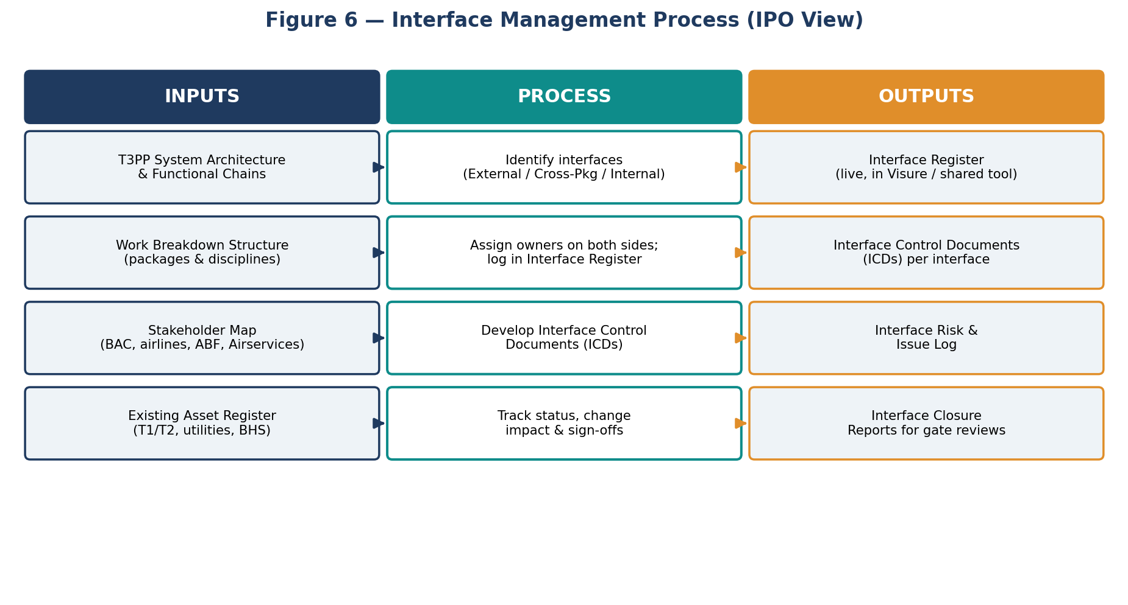
Figure 6 — Interface management process (IPO view).

10. Roles and Responsibilities
The roles below describe how SE responsibilities are organised within the Mott MacDonald T3PP team. Names are not yet confirmed and will be added at mobilisation.
Role | Key responsibilities
Project Director | Accountable for overall delivery of the T3PP design consultancy services. Endorses the SEMP and engineering strategy. Chairs senior governance forums with BAC.
Engineering Manager | Owns the SEMP and the engineering management of T3PP. Responsible for engineering performance across all disciplines, gate readiness, design integrity, and the engineering interface to BAC and sub-consultants.
Requirements Engineering Lead | Author of this SEMP and owner of the RMP. Responsible for capturing, decomposing, baselining and tracing T3PP requirements in Visure; chairing the RWG; producing RTM/VCRM deliverables; and supporting V&V planning.
System Architect | Maintains the T3PP architecture model. Allocates requirements to architectural elements and supports interface and integration analyses.
Interface Manager | Maintains the Interface Register and ICDs; coordinates interface owners; supports change control on interfaces.
V&V Lead | Plans and oversees verification and validation activities; maintains the VCRM.
Discipline Leads | Architects and engineers across terminal planning, structures, MEP, BHS, ICT, airside, landside, sustainability, fire, security, cost. Author and verify discipline content; consume requirements and contribute verification evidence.
Sub-consultant Leads | Equivalent leads within Grimshaw, RBG, GHD, BNP, Aspect Studios and others. Support the Mott MacDonald engineering team within their discipline and follow this SEMP.
Quality Manager | Ensures SEMP and subordinate plans comply with Mott MacDonald quality management system.

10.1 RACI overview
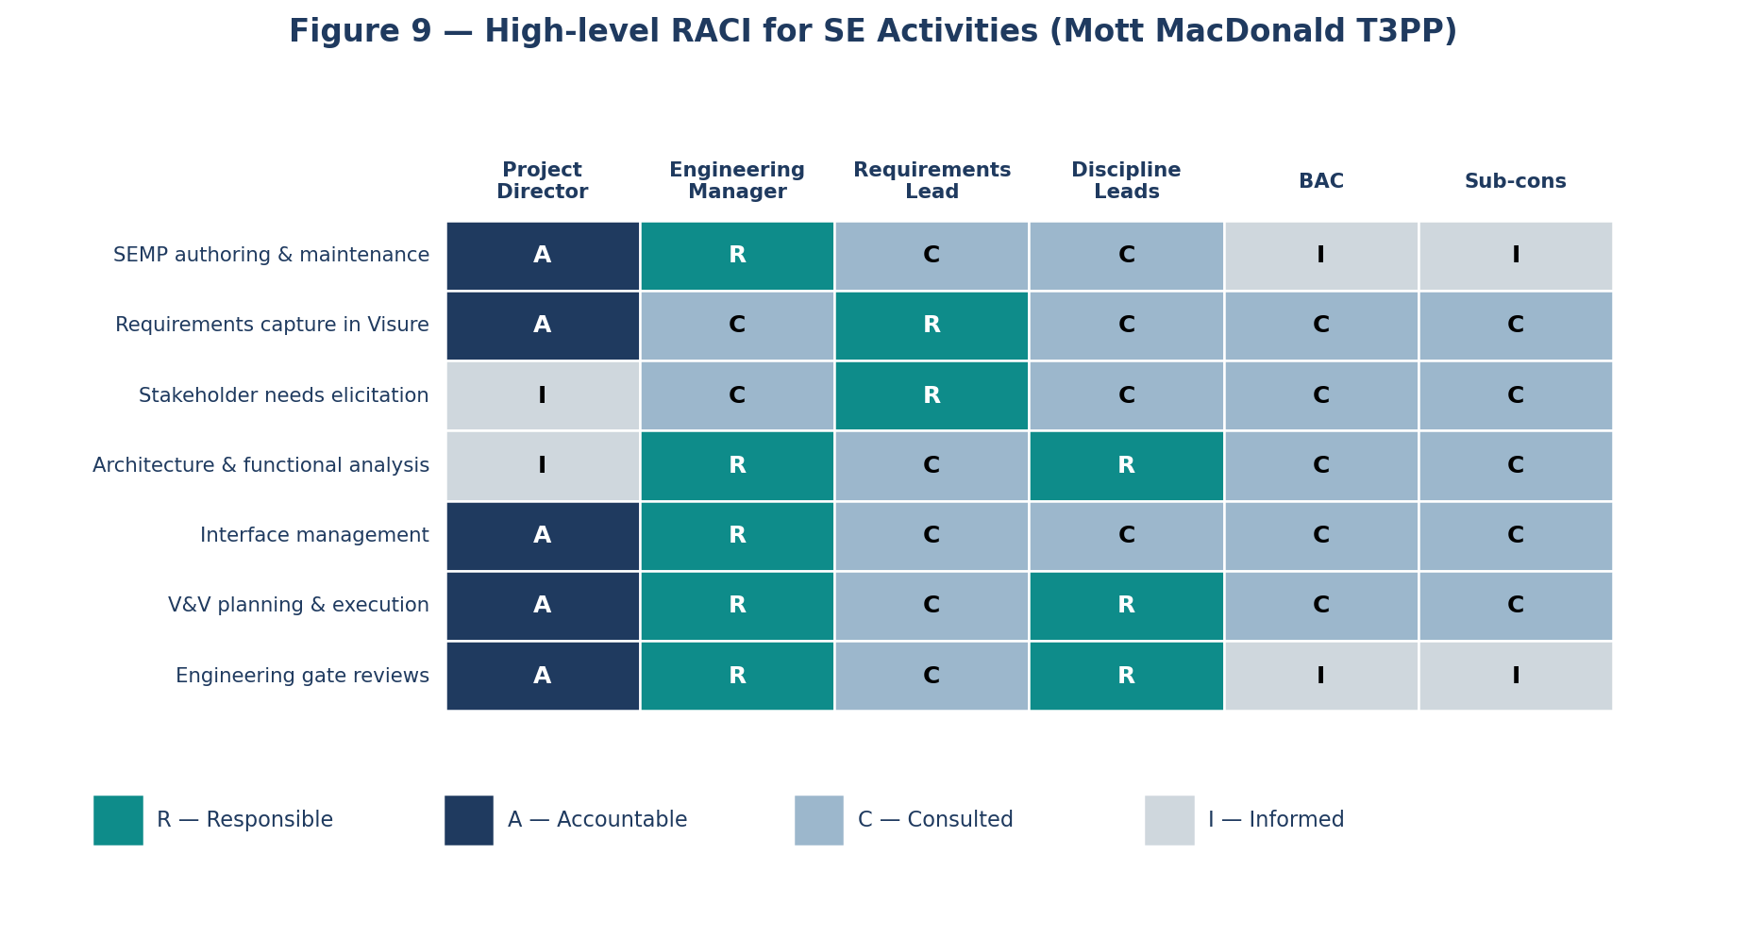
Figure 9 — High-level RACI for T3PP SE activities (indicative).

11. Governance
Engineering governance for T3PP is organised through a hierarchy of working groups and review forums. Final composition and cadence will be agreed with BAC at mobilisation.
Forum | Composition and remit
Engineering Leadership Team (ELT) | Project Director, Engineering Manager, Design Director, key Discipline Leads. Weekly. Owns engineering strategy, key decisions, escalations.
Requirements Working Group (RWG) | Requirements Engineering Lead (chair), Engineering Manager, Discipline Leads, BAC engineering rep, sub-consultant leads. Bi-weekly initially. Endorses requirements baselines.
Operations & Airport Working Group (OAWG) | Engineering Manager, Terminal Planning Lead, BAC operations / airline / ABF / Airservices reps as needed. Bi-weekly. Confirms ConOps and operational scenarios.
Architecture & Design Working Group | System Architect, Discipline Leads. Weekly during Concept; fortnightly thereafter. Owns architecture and key design decisions.
Interface & Integration Forum | Interface Manager (chair), package leads, BAC interface owners. Bi-weekly. Owns interface register and ICD progression.
V&V / Assurance Forum | V&V Lead (chair), Engineering Manager, Quality, Safety, Discipline Leads. Monthly. Tracks VCRM closure and gate readiness.
BAC Gate Reviews | BAC-led milestone reviews (e.g. end of each Concept Step). Mott MacDonald presents evidence pack including RTM/VCRM exports, design reports and minutes.

12. Quality and Continuous Improvement
All SE activities are conducted within Mott MacDonald's certified Quality Management System (ISO 9001). The Engineering Manager and Quality Manager review the effectiveness of SE processes at each major gate, and lessons learned are captured and fed back into this SEMP and the subordinate plans. Specific KPIs will be defined in the RMP and other subordinate plans (e.g. requirements quality scores, RTM coverage, ICD closure rate, verification burn-down).

13. Glossary
Acronym | Meaning
ABF | Australian Border Force
ADRM | Airport Development Reference Manual (IATA)
AODB | Airport Operational Database
ARCADIA | Architecture Analysis and Design Integrated Approach
BAC | Brisbane Airport Corporation
BCA | Building Code of Australia
BHS | Baggage Handling System
BIM | Building Information Modelling
BMS | Building Management System
BNE | Brisbane Airport (IATA code)
CASA | Civil Aviation Safety Authority
CD | Concept Design
ConOps | Concept of Operations
FAT | Factory Acceptance Test
FIDS | Flight Information Display System
HAZID / HAZOP | Hazard Identification / Hazard and Operability study
IATA | International Air Transport Association
ICD | Interface Control Document
IFC | Issued for Construction
INCOSE | International Council on Systems Engineering
MCA | Multi-Criteria Analysis
MEP | Mechanical, Electrical and Plumbing
mppa | Million passengers per annum
NAS | (US FAA) National Airspace System reference / equivalent national standards
NCR | Non-Conformance Report
ORAT | Operational Readiness and Airport Transfer
PRS | Package / Sub-system Requirements Specification
PSA | Pre-Schematic Architecture
RAID | Risks, Assumptions, Issues, Decisions
RAM | Reliability, Availability, Maintainability
RFI | Request for Information
RTM | Requirements Traceability Matrix
RWG | Requirements Working Group
SAT | Site Acceptance Test
SE | Systems Engineering
SEMP | Systems Engineering Management Plan
SRS | System Requirements Specification
StRD | Stakeholder Requirements Document
T3PP | Terminal 3 Precinct Program
VCRM | Verification Cross-Reference Matrix
V&V | Verification and Validation
WBS | Work Breakdown Structure

14. Related Documents and References
Ref | Document
[1] | Brisbane Airport Corporation, BAC-T-25-445 — T3PP Design Consultancy Services, Tender documents, 2025.
[2] | Mott MacDonald & Grimshaw, T3PP Design Consultancy Services Tender Response, October 2025.
[3] | Mott MacDonald, Brisbane Airport T3 Delivery Kickoff (deck), 2026.
[4] | INCOSE, Systems Engineering Handbook, v4 / v5 (current edition).
[5] | INCOSE, Guide for Writing Requirements (GtWR), current edition.
[6] | ISO/IEC/IEEE 15288:2023 — Systems and software engineering — System life cycle processes.
[7] | IATA, Airport Development Reference Manual (ADRM), current edition.
[8] | BCA / NCC — National Construction Code, current edition (Volumes 1 & 2).
[9] | CASA Manual of Standards (MOS) Part 139 — Aerodromes, current edition.
[10] | Visure Solutions, Visure Requirements ALM — User Documentation.
[11] | ARCADIA Method — Capella documentation (reference for architecture method).
[12] | SRL East Systems Engineering Management Plan, SRL-PWD-SRL-NAP-MPL-XSE-AIM-0002 (reference example).

15. Appendices

Appendix A — Figures index
Figure | Title
Figure 1 | T3PP SEMP at a glance (IPO)
Figure 2 | T3PP system context and stakeholders
Figure 3 | T3PP adapted V-lifecycle
Figure 4 | Requirements management process (IPO) — Visure
Figure 5 | T3PP requirements hierarchy and traceability
Figure 6 | Interface management process (IPO)
Figure 7 | Three engineering assurance viewpoints
Figure 8 | Engineering management plan hierarchy
Figure 9 | High-level RACI for SE activities

Appendix B — Suggested next steps for the T3PP engineering team
- Confirm with BAC the format and content of the project objectives and 'BAC 4 Bosses' statement to be used as the top of the requirements hierarchy.
- Establish the Mott MacDonald T3PP Visure project, modules and attributes per Section 7.4 and import Reference Design and Tender requirements as the initial backlog.
- Run the pre-Concept lessons-learned workshop and confirm stakeholders, ConOps and Reference Design context.
- Issue the Requirements Management Plan (RMP) v0.A as the first subordinate plan.
- Stand up the Requirements Working Group (RWG) and Interface & Integration forum cadences.
- Re-issue this SEMP at v0.B once BAC inputs are received and the engineering team is mobilised.

Appendix C — Open questions for BAC and Mott MacDonald leadership
- What is BAC's preferred cadence and format for engineering gate reviews?
- Will BAC supply consolidated stakeholder requirements or are these to be elicited by Mott MacDonald via workshops?
- What level of access does BAC require to the Visure project (read-only views, exports, federated workspace)?
- How are interfaces with non-T3PP BAC programmes (e.g. T1/T2, master plan works) to be managed contractually?
- What are the agreed sustainability and carbon targets to be embedded as requirements?
— End of working draft —

