# Churn by Gender

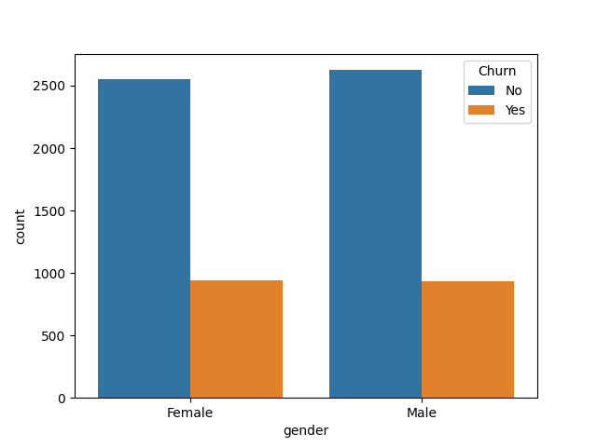

# Churn by Internet Service

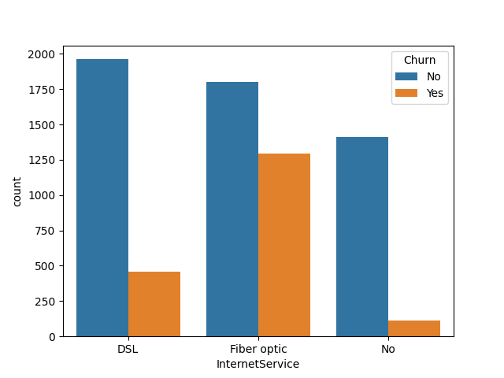

# Churn by Numeric Features

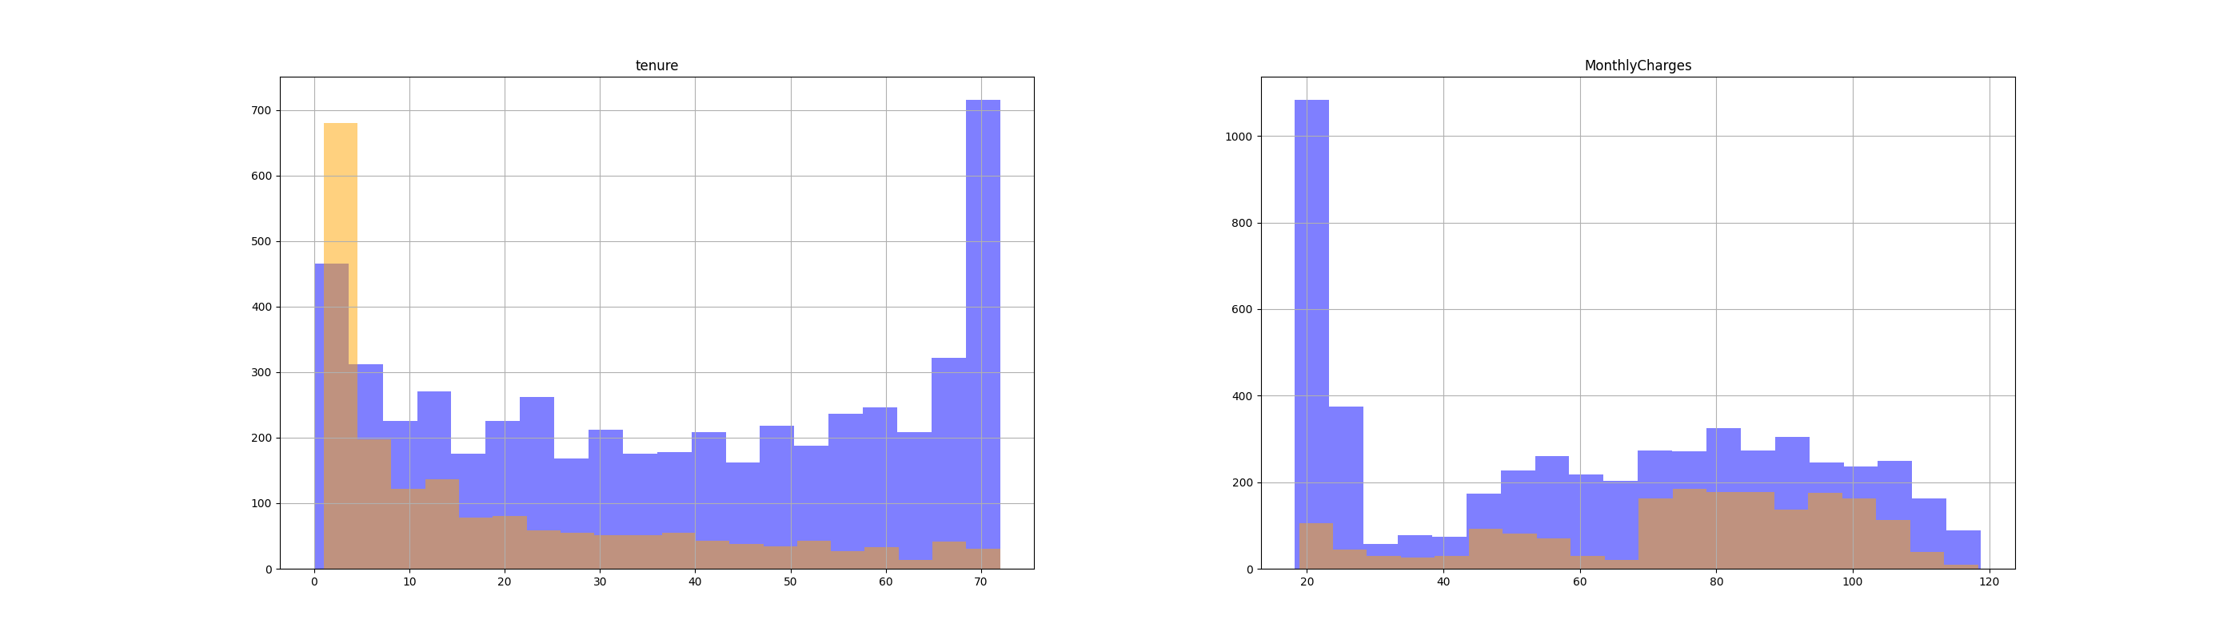

# Classification Report

precision recall f1-score support  
  
 0 0.85 0.91 0.88 1036  
 1 0.69 0.56 0.62 373  
  
 accuracy 0.82 1409  
 macro avg 0.77 0.74 0.75 1409  
weighted avg 0.81 0.82 0.81 1409

# Confusion Matrix

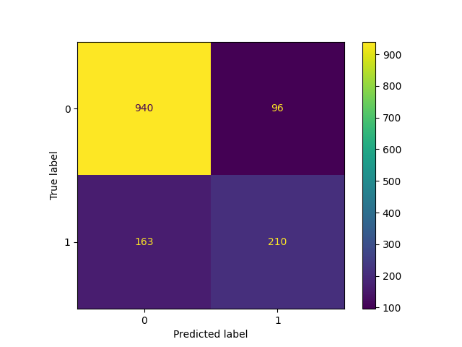

# New Customer Predictions

Customer 1024-GUALD: Predicted Churn - Yes

Customer 0484-JPBRU: Predicted Churn - No

Customer 3620-EHIMZ: Predicted Churn - No

Customer 6910-HADCM: Predicted Churn - Yes

Customer 8587-XYZSF: Predicted Churn - No

Customer 6818-WOBHJ: Predicted Churn - Yes

Customer 3082-YVEKW: Predicted Churn - No

Customer 4737-AQCPU: Predicted Churn - No

Customer 4853-RULSV: Predicted Churn - No

Customer 5766-ZJYBB: Predicted Churn - No

# Comparison of Predictions with Exploratory Analysis

Percentage of customers predicted to stay: 70.00%

Percentage of customers predicted to churn: 30.00%

Percentage of customers actually stayed (exploratory): 73.46%

Percentage of customers actually churned (exploratory): 26.54%