GEO SPATIAL WEB SOLUTION

A Project Report
Submitted in partial fulfilment for the award of the degree
Of

Master of Science
In
Information Technology
By
Hardeep Singh Negi
14MIN2566

Under the guidance of
Prof. Deva Rajasekhar
VIT University




School of Information Technology and Engineering
August, 2018


School of Information Technology and Engineering

DECLARATION BY THE CANDIDATE

I hereby declare that the project report entitled “Geo Spatial Web Solution” submitted by me to Vellore Institute of Technology, Vellore in partial fulfillment of the requirement for the award of the degree of Master of Science in Information Technology is a record of bonafide project work carried out by me under the guidance of Prof. Deva Rajaskhar. I further declare that the work reported in this project has not been submitted and will not be submitted, either in part or in full, for the award of any other degree or diploma in this institute or any other institute or university.

Place: Hyderabad Signature of the Candidate

Date: 11/8/2018

School of Information Technology and Engineering

BONAFIDE CERTIFICATE

This is to certify that the project report entitled “Geo Spatial Web Solution” submitted by Hardeep Singh Negi to Vellore Institute of Technology, Vellore in partial fulfilment of the requirement for the award of the degree of Master of Science in Information Technology is a record of bonafide work carried out by him under my guidance. The project fulfills the requirements as per the regulations of this Institute and in my opinion meets the necessary standards for submission. The contents of this report have not been submitted and will not be submitted either in part or in full, for the award of any other degree or diploma and the same is certified.

Signature of the Guide

Prof. Deva Rajasekhar

Internal Supervisor,

VIT, UNIVERSITY.

Internal Examiner (s) External Examiner

Abstract

Local bodies are classified into Municipal Corporations, Municipalities of different grades depending upon the population and income of the Urban Local Body. These Urban Local Bodies have been constituted with the objective of discharging certain

The existing system is a manual system. Here the employees needs to save the information in the form of excel sheets or Disk Drives. There is no sharing is possible if the data is in the form of paper or Disk drives. The manual system gives us very less security for saving data; some data may be lost due to is management. It’s a limited system and fewer users friendly. Searching of particular information is very critical it takes lot of time. Gathering information of different sources is not an easy job, data will be mismanaged. Calculating different bills manually going to be as a process of mistake. There is no interface to provide various bills in the existing system. In the existing system citizen get the bills information manually, in various authorities like water board, electricity department, property tax department etc.
The development of this new system contains the following activities, which try to automate the entire process keeping in the view of database integration approach. User Friendliness is provided in the application with various controls provided by system Rich User Interface. The system makes the overall project management much easier and flexible. It can be accessed over the Intranet. The proposed system using web services, a web service can get the information from other sources also. There no burden of calculating water, electric, house tax bills in this system, by sending a request to the particular authority via web service we can get all the information regarding these issues.

Administration is the main person of this system. He can have all the privileges to do anything in this system. Admin can get the information regarding citizen’s water bills, electric bills, and municipal taxes from various sources. For that administrator need to send a request for that particular authority throw web services.

People who are living in that municipality area are called as citizens. Citizens need to pay water bill, electricity bill, property tax for a certain of intervals. By using this system interface citizen’s know their different bill amounts, pending bills, due dates etc.

Table of Contents
1 Introduction 1
2 Literature Survey 1
2.1 PROBLEMS IN THE EXISTING SYSTEM 1
2.2 SOLUTION OF THESE PROBLEMS 2
3 PROPOSED SYSTEM 3
4 DETAILED DESIGN OF THE SYSTEM 3
4.1 Product Perspective 3
4.2 Product Functions 4
4.3 User Characteristics 6
4.4 General Constraints 6
4.5 Assumptions and Dependencies 7
4.6 External Interface Requirements 7
5 IMPLEMENTATION OF THE SYSTEM 12
5.1 Use case diagram 12
5.2 Class Diagrams 15
5.3 Non-Functional Requirements 20
5.4 Inverse Requirements 21
5.5 Design Constraints 21
5.6 Logical Database Requirements 22
5.7 Other Requirements 22
5.8 Sequence Diagrams 22
5.9 State-Transition Diagrams (STD) 29
5.10 Data Flow Diagrams (DFD) 33
5.11 Data Dictionary 38
6 TESTING 45
6.1 Introduction 45
6.1.1 Strategic Approach to Software Testing 45
6.2 Unit Testing 47
6.2.1 White Box Testing 47
6.2.2 Basic Path Testing 47
6.2.3 Conditional Testing 48
6.2.4 Data Flow Testing 48
6.2.5 Loop Testing 48
6.3 Test Cases 49
6.4 Test Case Review 58
6.4.1 Test case Standards 58
6.4.2 Test Case Name 58
6.5 Approach and Execution Strategy 59
6.5.1 ENTRY AND EXIT CRITERIA: 59
6.6 Defect Management 59
6.6.1 Defect Lifecycle: 60
6.7 Test Report 60
7 Conclusion and Future Work 61
8 REFERENCES 62

Introduction

Local bodies are classified into Municipal Corporations, Municipalities of different grades depending upon the population and income of the Urban Local Body. These Urban Local Bodies have been constituted with the objective of discharging certain.
Obligatory functions like
- Supply of Drinking Water
- Providing Water connection to houses
- Sending water bills to houses
- Public Street Lighting
- Calculating and sending Electric Bills
- Maintaining sanitation and hygiene of public places
- Municipal Library maintenance.
- Calculate and sending Municipal tax and house taxes.
Local bodies like municipalities need collect different kind of taxes from the citizens. Every citizen need to pay Water Bills and Electricity Bills to the particular authorities. Actually a citizen want to pay his municipal tax means he should go to municipal office and collect the necessary bill, pay there only. Same as water and electricity bills also. This is not an easy job to get all these tax information in different authorities now days.

Literature Survey

PROBLEMS IN THE EXISTING SYSTEM

- The existing system is a manual system. Here the employees needs to save the information in the form of excel sheets or Disk Drives.
- There is no sharing is possible if the data is in the form of paper or Disk drives.
- The manual system gives us very less security for saving data; some data may be lost due to mismanagement.
- It’s a limited system and fewer users friendly.
- Searching of particular information is very critical it takes lot of time.
- Gathering information of different sources is not an easy job, data will be mismanaged.
- Calculating different bills manually going to be as a process of mistake.
- There is no interface to provide various bills in the existing system.
- In the existing system citizen get the bills information manually, in various authorities like water board, electricity department, property tax department etc.

SOLUTION OF THESE PROBLEMS

The development of this new system contains the following activities, which try to automate the entire process keeping in the view of database integration approach.
- User Friendliness is provided in the application with various controls provided by system Rich User Interface.
- The system makes the overall project management much easier and flexible.
- It can be accessed over the Intranet.
- The employee information can be stored in centralized database which can be maintained by the system.
- This can give the good security for user information because data is not in client machine.
- Authentication is provided for this application only registered Users can access.
- There is no risk of data management at any level while the project development is under process.
- The automated system will provide to the employees for reliable services.
- The proposed system using web services, a web service can get the information from other sources also.
- There no burden of calculating water, electric, house tax bills in this system, by sending a request to the particular authority via web service we can get all the information regarding these issues.

PROPOSED SYSTEM

The development of this new system contains the following activities, which try to automate the entire process keeping in the view of database integration approach.
- User Friendliness is provided in the application with various controls provided by system Rich User Interface.
- The system makes the overall project management much easier and flexible.
- It can be accessed over the Intranet.
- The employee information can be stored in centralized database which can be maintained by the system.
- This can give the good security for user information because data is not in client machine.
- Authentication is provided for this application only registered Users can access.
- There is no risk of data management at any level while the project development is under process.
- The automated system will provide to the employees for reliable services.
- The proposed system using web services, a web service can get the information from other sources also.
- There no burden of calculating water, electric, house tax bills in this system, by sending a request to the particular authority via web service we can get all the information regarding these issues.

DETAILED DESIGN OF THE SYSTEM

Product Perspective

The existing system is a manual system. Here the employees needs to save the information in the form of excel sheets or Disk Drives. There is no sharing is possible if

the data is in the form of paper or Disk drives. The manual system gives us very less security for saving data; some data may be lost due to mismanagement. It’s a limited system and fewer users friendly. Searching of particular information is very critical it takes lot of time. Gathering information of different sources is not an easy job, data will be mismanaged. Calculating different bills manually going to be as a process of mistake. There is no interface to provide various bills in the existing system.

Product Functions

In this system, there are 11 different modules designed:

- Administrator
- Citizen’s
- Web Services
- Citizen’s Bill Information
- Search
- Reports
- Authentication
- Default
- Contact Us
- About Us
- Logout

Administrator
Administration is the main person of this system. He can have all the privileges to do anything in this system. Admin can get the information regarding citizen’s water bills, electric bills, and municipal taxes from various sources. For that administrator need to send a request for that particular authority throw web services.

Citizens
People who are living in that municipality area are called as citizens. Citizens need to pay water bill, electricity bill, property tax for a certain of intervals. By using this system interface citizen’s know their different bill amounts, pending bills, due dates etc.

Web Services
Web Services can collect the tax information from different authorities based on the house no’s and owner name by using Web Services and stores the data in our own database. For getting the information regarding taxes citizens need to register first. The bills are calculating on different modes like annual, half yearly, quarterly etc.

Citizen’s Bill Information
The system interface is going to show the Bill information of different authorities. The bills mainly going to these types
- Water Bills
- Electricity Bills
- Property Taxes
These interface also shows the
- Pending Bills
- Penalties
- Due Dates

Search
Administrator can search the various citizens’ information based on the area.

Reports
Administrator can generate the reports based on the information required in the report.

Authentication
In this module, the registered user will be authenticated to confirm that only genuine users are accessing the information.

Default
This page will be homepage of the application. Whenever a user visits the application, requests will be redirected to this page
Contact Us
This page will contain the contact information of the organization.

About Us
This page will contain the details about the organization.

Logout
After using the application, user will be successfully able to logout from the website and will be redirected to the homepage of the website.

User Characteristics

Now a user in the system will be of two types:
- Admin
- Citizen.
Admin will be able to keep all the detailed track of various taxes based on the citizen’s area of residence. Citizen will register in the application by providing the details of their residence. After registering they will be able to see the details of their various taxes information on the single platform.

General Constraints

The current system is only limited to municipality taxes of which can be extended across departments. Every user should register first in the site to become a registered member. The information of all the registered users should be stored in the database. When the user performs a record update query, it will be stored in the database and is fetched from a database for view also. Only registered users will be authorized to use the services.

Assumptions and Dependencies

It is assumed that the requirements described in this document have different levels of priority. Internet connection is must so that the user is able to access the application through internet. Also, if a user is registered then only he is able to access the resources, otherwise he is able to see only the homepage of the website.

External Interface Requirements

    - User Interfaces

- Following are the Web pages designed in this system.
- Home
- Admin
- Registration
- Login Form
- Login Button
- Contact Us
- About Us
- Logout

- Every Webpage will have a descriptive title and information about the menus present in the webpage.
- The application is very user-friendly and easy to navigate between the different web pages.
- All the fields have the required validations. The password field is in encrypted format and the user should also be able to remember his password while logging.
- Home page has the information about the application what it is intended to.
- Registration page will help the users to register for the website so that they can access the resources.
- Login form will request the necessary details of the registered user viz. username and password. After validating details, user should be able to login to the website.
- Contact us will provide the necessary contact details of the owners of the application so that users who want to communicate came to know the contact details from the application. ‘Contact us’ menu will give information about how the system works and also whom to report in case of any issues. It also has a customer care number which enables the user to contact the team in an easy way.
- About Us will help the user to know details about the site, its history and the services they are offering.
- Login button will enable the user to login to the site with the valid username and password. If he is not a registered user, he can register in the home page by clicking on Register link. Once he is registered, these credentials are used to login to the site.
- After successful login, user will be redirected to its home page. This UI will contain various buttons like Show House Information, Building Taxes, Electrical Meter Reading Details, Municipalty taxes, Search and Sign out with their relevant features.
- Logout menu will successfully logoff the user and after giving confirmation it will close the session and will redirect him to the homepage.

    - Hardware Interfaces

This system uses the following hardware requirements.

- SYSTEM : Pentium IV 2.4 GHz
- Operating System : Windows, Mac, Android
- HARD DISK : 40 GB
- FLOPPY DRIVE : 1.44 MB
- MONITOR : 15 VGA colour
- MOUSE : Logitech.
- RAM : 512 MB

    - Software Interfaces

Geo Spatial Web Solution is developed by using the technology ASP.NET and the programming language used is C#.NET. The .NET Framework introduces a completely new model for the programming and deployment of applications. .NET is Microsoft's vision of "software as a service", a development environment in which you can build, create, and deploy your applications and the next generation of components, the ability to use the Web rather than your own computer for various services.

.NET Framework is a software framework developed by Microsoft that runs primarily on Microsoft Windows. It included a large class library named Framework Class Library (FCL) and provides language interoperability (each language can use code written in other languages) across several programming languages.

.Net Framework is a platform or development environment to seamlessly create web-applications that are accessible through client machines from across the globe. These web-applications adopt open standards such as eXtensible Markup Language (XML), Hyper Text Transfer Protocol (HTTP), and Simple Object Access Protocol (SOAP) to interact with applications that are available in other platforms. It involves the concepts of Hypertext Markup Language (HTML) for designing the static web pages and along with Cascading Style Sheets for making a rich good looking interface.

HyperText Markup Language(HTML) is the standard markup language for creating webpages and web applications. With Cascading Style Sheets(CSS) and Javascript it forms a triad of cornerstone technologies for the World Wide Web. Browsers receive HTML documents from a webserver or from local storage and render them into multimedia web pages.
HTML describes the structure of a web page semantically and originally included cues for the appearance of the document.

JavaScript is used to make the webpages more interactive and user friendly which gives the feel that the user is interacting with the application. JavaScript is a high-level, dynamic, untyped, and interpreted programming language. Alongside HTML and CSS, JavaScript is one of the three core technologies of World Wide Web content production: the majority of websites employ it, and all modern Web browsers support it without the need of plugins.

jQuery library is also used for some dynamic content presentation as it contained all the modules of JavaScript. Asp.Net Web forms should be used using the master pages.
jQuery is a cross-platform JavaScript library designed to simplify the client-side scripting of HTML. jQuery’s syntax is designed to make tit easier to navigate a document, Select DOM elements, create animations, handle events, and develop Ajax application. jQuery also provides capabilities for developers to create plug-ins on top of JavaScript library.

    - Communications Interfaces

The web money application system will have a database server which is preferably a MySQL or SQL server which is a web based server. The server will store the usernames, their passwords, expenditure details and will also used to retrieve the information about the expenditure only but not about the usernames and the password. MySQL is an open
relational database management system (RDBMS). Microsoft SQL Server is a relational database management system developed by Microsoft. As a database server, it is a software product with primary function of storing and retrieving data as requested by other software applications-which may run either on the same computer or on another computer across a network. Depending upon the webserver, appropriate database should be selected.

  - Functional Requirements

The main functions of the Geo Spatial Web Solution are

- Home - This presents the homepage of the website where the user will be directed when the user hit’s URL of the website.

- Registration – This provides the Citizen’s to give their information to become a registered as well as an active member of the application. The information provided is related to their user name, date of birth, contact details, their area of residence etc. They can create their own passwords which are used for future purposes.

- Login - This function will provide visitors of the site with a form which has username and password fields. If the user enters a valid username/password combination, they will be granted access to additional resources on website.

- Security Information – This will retrieve the information of users and validate them against the database. If the user is not a registered user, then he should not be able to login to the website. Moreover, if a user is registered and forgot his/her username, then he will be redirect to the password reset page using the confirmation sent to his/her mail.

- Show House Information– This will provide the registered user will be able to give the details about their house information like their area of residence, locality
building no etc.

- Building Taxes – This will provide the registered user to give the details about their building taxes that they are going to pay accordingly their area of residence as different area of residence have different building taxes.

- Electrical Meter Reading Details– This will provide the registered user about the details of their current meter reading details based on that the upcoming payment of their electricity bill can also be shown to the user.

- Municipality Taxes– This will provide the registered user about the details of their municipal taxes that they are going to pay including water bill, property taxes, electricity bill etc.

- Search – This will provide the registered user about the details of their municipal all tax pay details based on their date selection from particular date to a specific date. In the same way electrical bill details can be searched using date selection method.

- Logout – After using the website, user will be successfully able to logout from the website and will be redirected to the homepage of the website

IMPLEMENTATION OF THE SYSTEM

Use Cases

Use case diagram

It shows a set of use cases and actors (a special kind of class) and their relationships. Use case diagrams address the static use case view of a system. These diagrams are especially important in organizing and modeling the behaviors of a system. It is a diagram at its simplest is a representation of a user’s interaction with the system that shows the relationship between the user and the different use cases in which the user is involved. A use case diagram can identify the different types of users of a system and the different use cases will often be accompanied by other types of diagrams as well.

The Over View Use case diagram of the system is as follows:

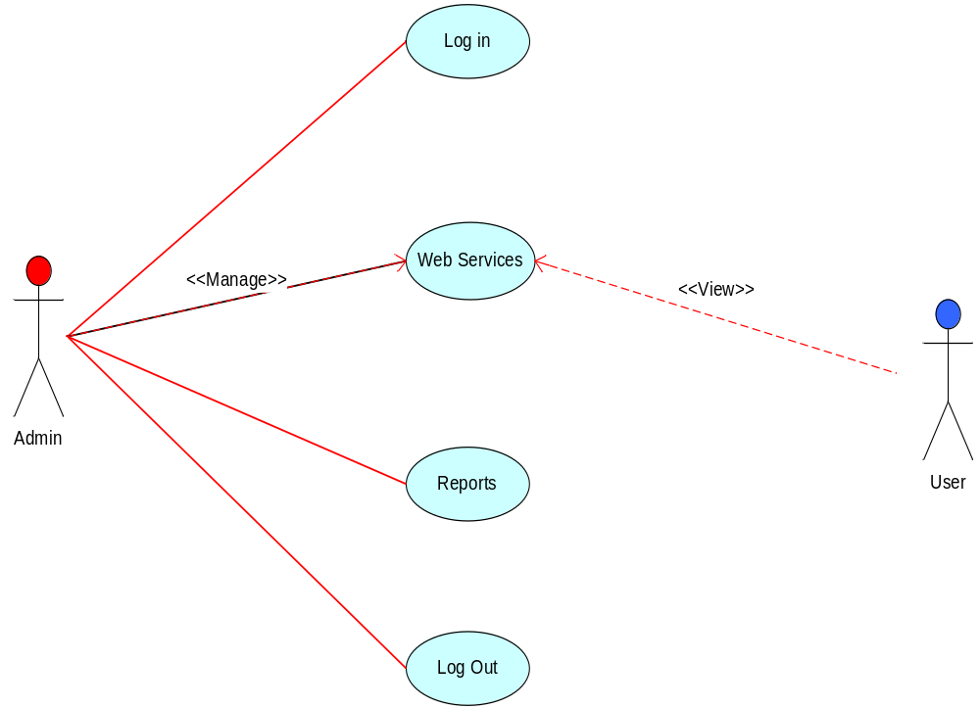
Figure 1

Admin Use Case Diagram

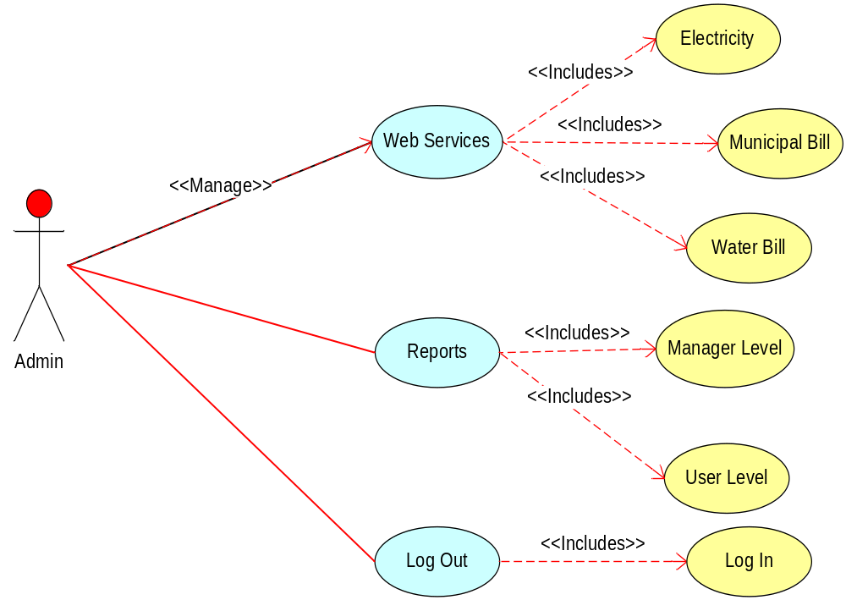
Figure 2

User Use Case Diagram

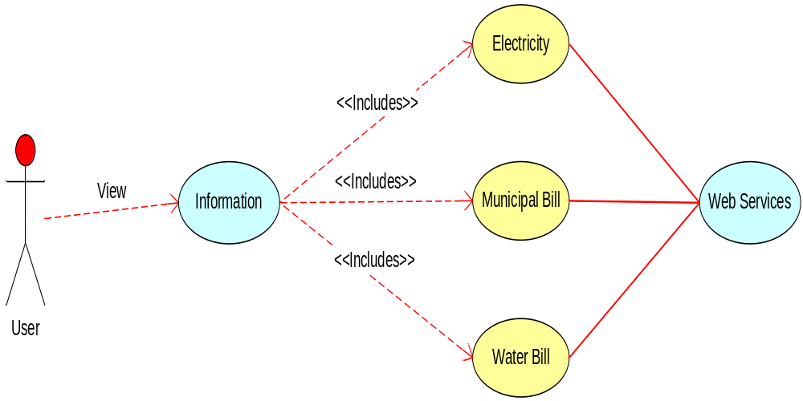
Figure 3

Class Diagrams

A class diagram is an illustration of the relationships and source code dependencies among classes in the Unified Modeling Language (UML). In this context, a class defines the methods and variables in an object, which is a specific entity in a program or the unit of code representing that entity.
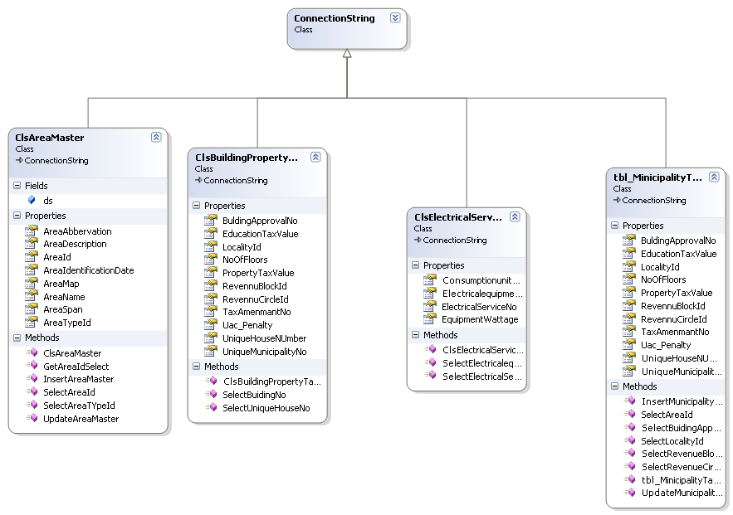
Figure 4

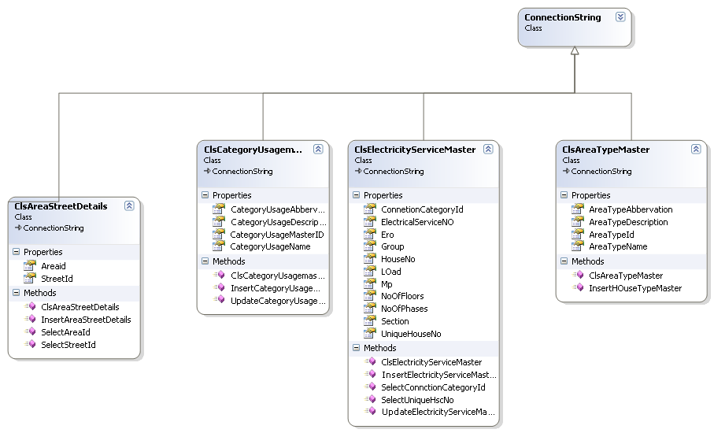
Figure 5

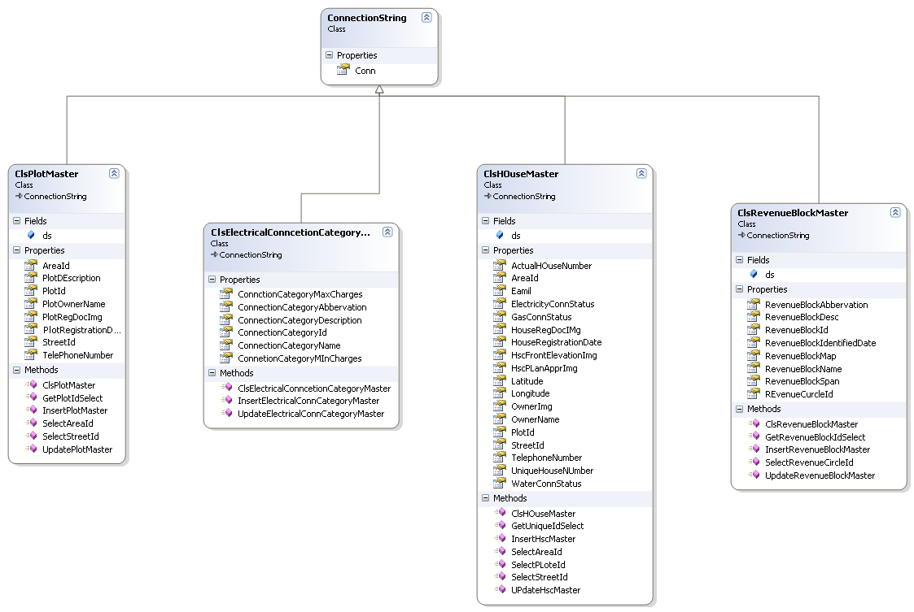
Figure 6

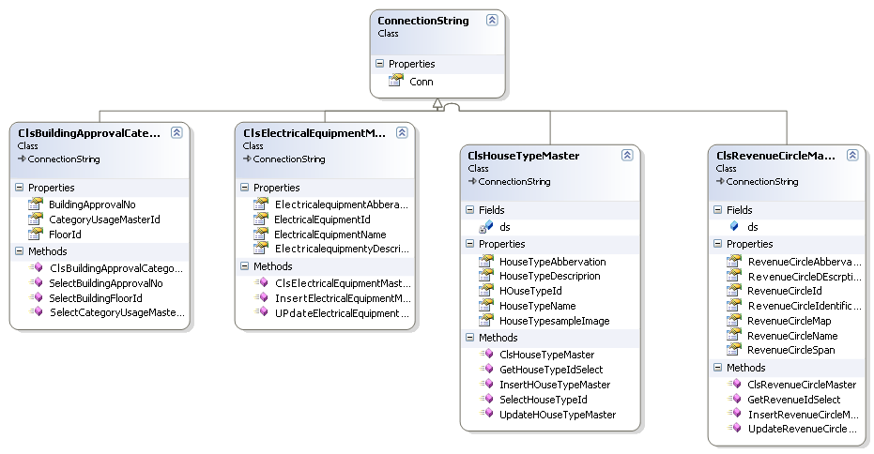
Figure 7

Non-Functional Requirements

    - Performance
Performance is the speed of execution of the computer program with accuracy. This project must be completely dependent on the performance. The performance of the system should be consistent in both the normal and peak times.
    - Reliability
Reliability is the ability of a system to perform its required functions under stated conditions for a specific period of time. The principle for maximizing usability is to employ iterative design, which progressively refines the design through evaluation from the early stages of design. To ensure reliability and correctness, there will be zero or minimum tolerance for errors in the algorithm that detects the fraudulent cases.

    - Availability
This Web money application system should be available at any time for all the users who are registered as well as for non-registered users. Any number of users can use the application at a time.

    - Security
Only authorized users should be able to login to the application. Security should be maintained so that unauthorized users cannot be able to access the data. Also ensure the integrity of the system from accidental or malicious damage. All the access permissions should be handled by the system administrator. It should cover all the aspects of security like access, integrity, privacy, audit, and immunity.

    - Maintainability
The system is easy to extend. The code should be written in a way that it favors implementation of new functions. The test environments should be built for the system to allow testing of the applications for different functions for testability. The code should be written in such a way that it is easy to maintain, support and should be easily adapted by other platforms. Maintainability requirements look at the long term lift of the proposed system. Requirements should take into consideration any expected changes in the software system, any changes of the computer hardware configuration.
    - Portability
The designed application should be portable so that it can run on any of the familiar
Platforms. This system can run on any operating system like Windows, Mac, Android etc.

Inverse Requirements

Inverse requirements can be functional or non functional. For example, when a customer specifies that something must not be done. For example: User name should not include digits. In this system there are no Inverse requirements.

Design Constraints

The current system is only limited to municipality taxes of which can be extended across departments. Every user should register first in the site to become a registered member. The information of all the registered users should be stored in the database. When the user performs a record update query, it will be stored in the database and is fetched from a database for view also. Only registered users will be authorized to use the services.

Logical Database Requirements
The database used in this system is Microsoft SQL Server 2008. Microsoft SQL Server is a relational database management system developed by Microsoft. As a database server, it is a software product with the primary function of storing and retrieving data as requested by other software applications which may run either on the same computer or on another computer across a network (including the Internet).
Microsoft markets at least a dozen different editions of Microsoft SQL Server, aimed at different audiences and for workloads ranging from small single-machine applications to large Internet-facing applications with many concurrent users.

Other Requirements
Some requirements can be identified in the later stages of the project and those can be incorporated with the business approval.

Sequence Diagrams
A Sequence diagram is an interaction diagram that shows how processes operate with one another and in what order. A sequence diagram shows object interactions arranged in time sequence. It depicts the objects and classes involved in the scenario and the sequence of messages exchanged between the objects needed to carry out the functionality of the scenario. Sequence diagrams are typically associated with use case realizations in the Logical View of the system under development.
A sequence diagram shows, as parallel vertical lines (lifelines), different processes or objects that live simultaneously, and, as horizontal arrows, the messages exchanged between them, in the order in which they occur. This allows the specification of simple runtime scenarios in a graphical manner.

Admin Login Sequence Diagram

Admin
LoginPage
BL:Cls_Login()
DAL:SqlHelper()
Database
1 : Admin Login
2 : ValidateUser()
3 : ExecuteNonQuery()
4 : ExecuteComand()
5 : Return QueryResult()
6: ResponseForValidateUser()
Figure 8

Sequence Diagram for add municipal taxes

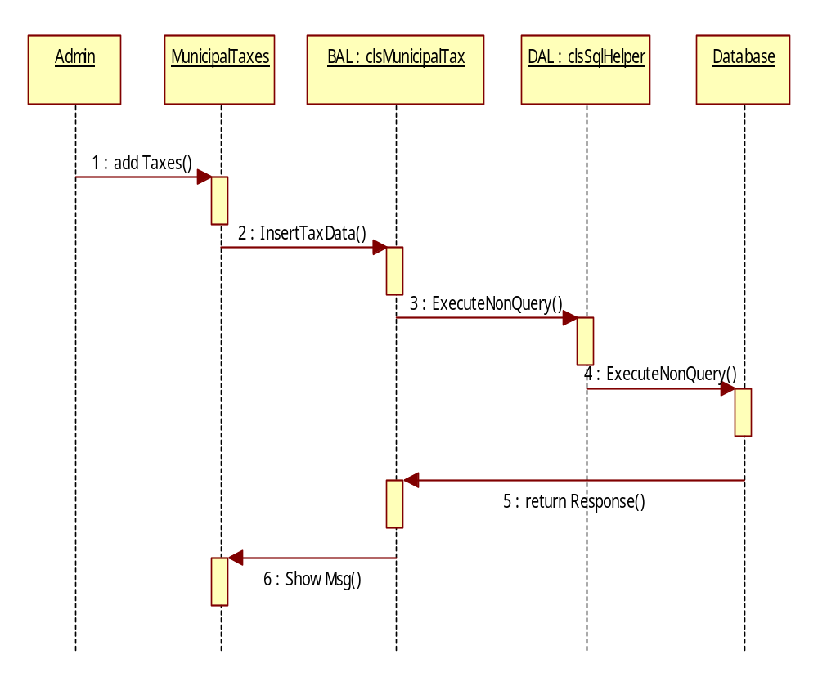
Figure 9

Sequence diagram for Manage Local Data

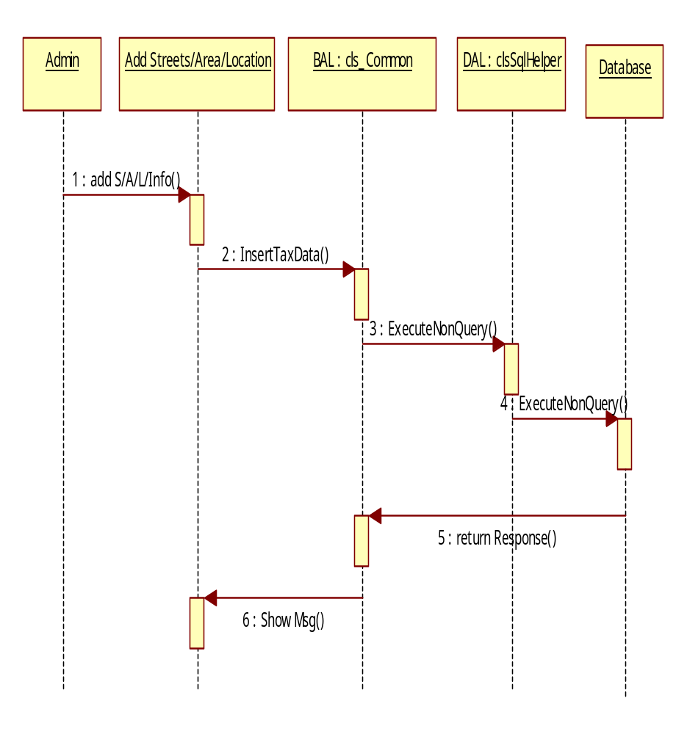
Figure 10

Sequence Diagram for Building Approvals

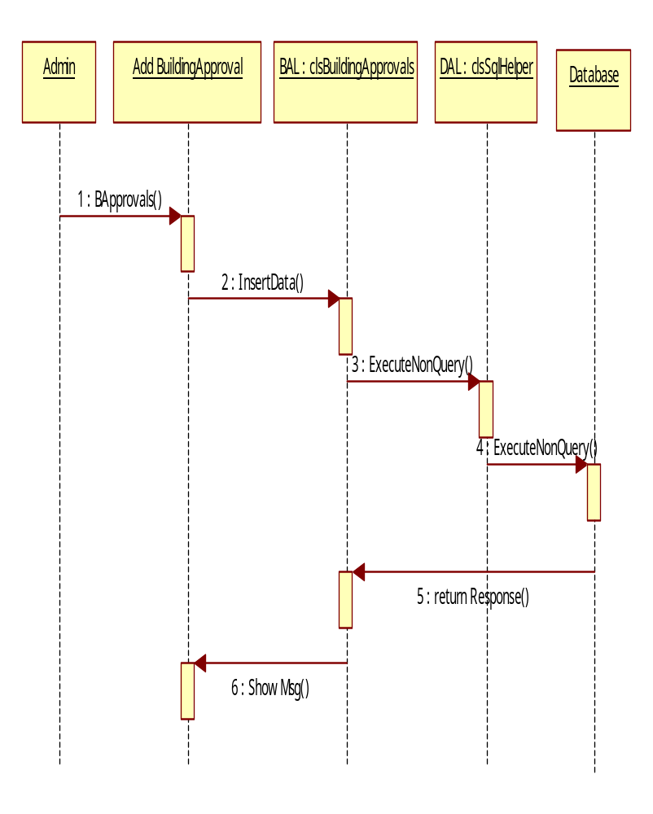
Figure 11
Sequence Diagram for Users Municipal Bills
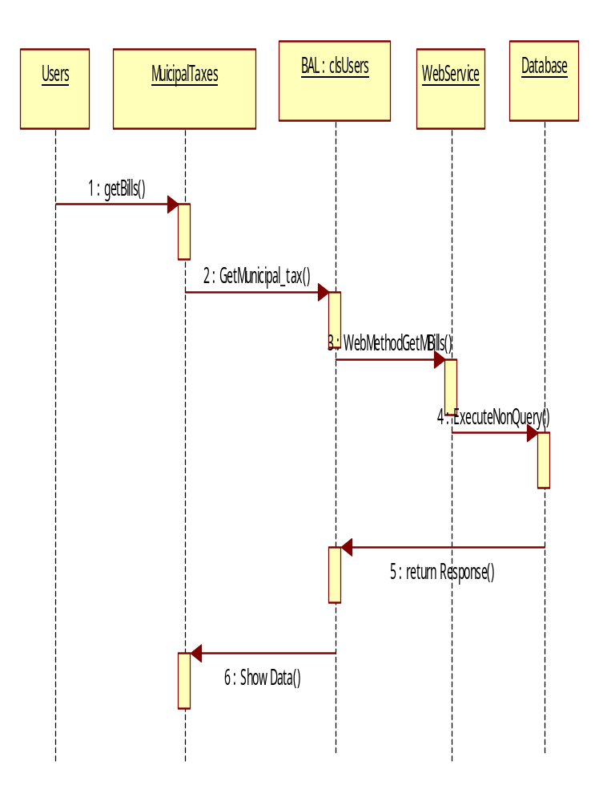
Figure 12

Sequence Diagram for Users Electricity Bills

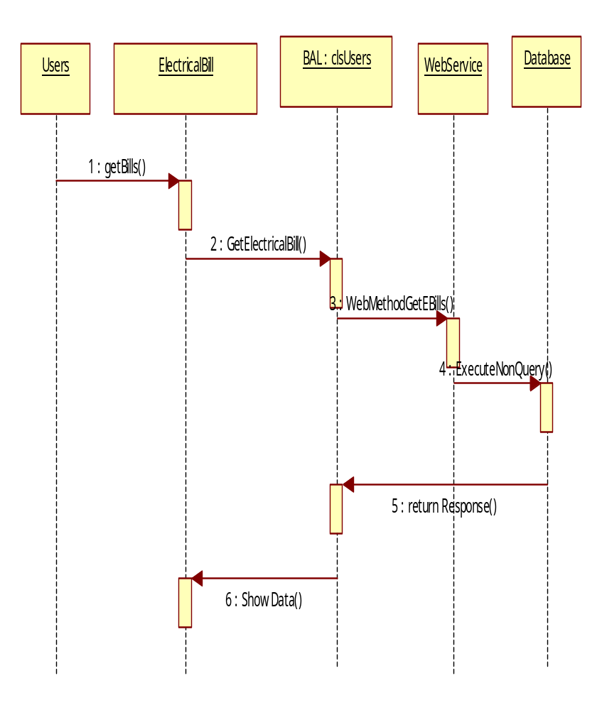
Figure 13

State-Transition Diagrams (STD)
State diagrams are used to give an abstract description of the behavior of a system. This behavior is analyzed and represented as a series of events that can occur in one or more possible states. State diagrams can be used to graphically represent finite state machines.
Each diagram usually represents objects of a single class and tracks the different states of its objects through the system. State diagrams have very few elements. The basic elements are rounded boxes representing the state of the object and arrows indicting the transition to the next state. The activity section of the state symbol depicts what activities the object will be doing while it is in that state.

Registration Diagram

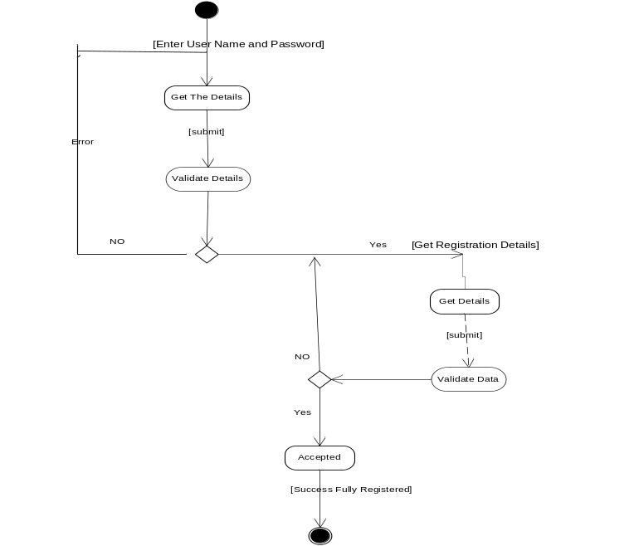
Figure 14

Login Activity Diagram

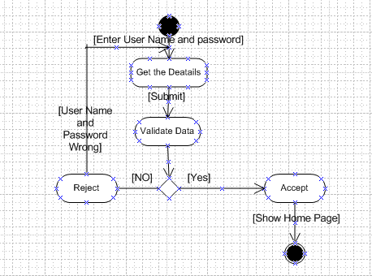
Figure 15

Admin Activity Diagram

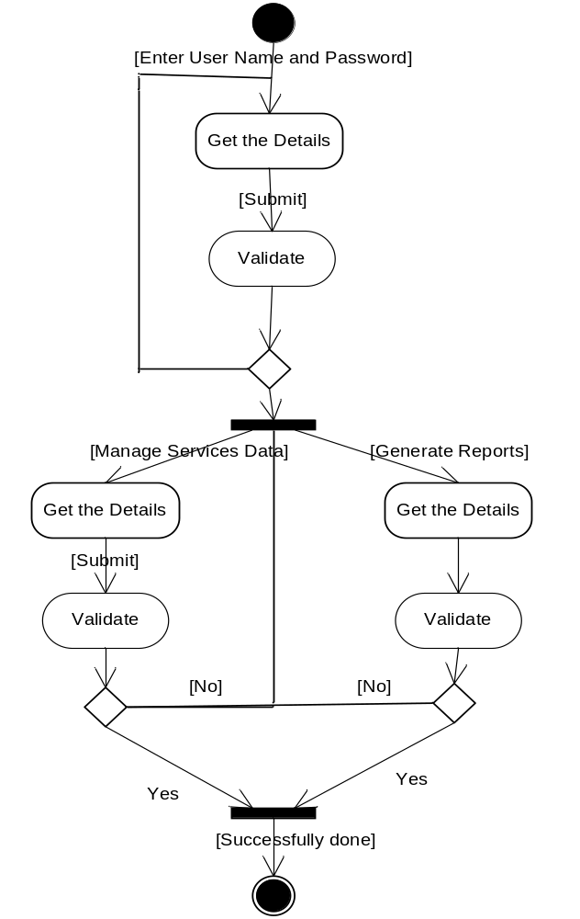
Figure 16

User Activity Diagrams

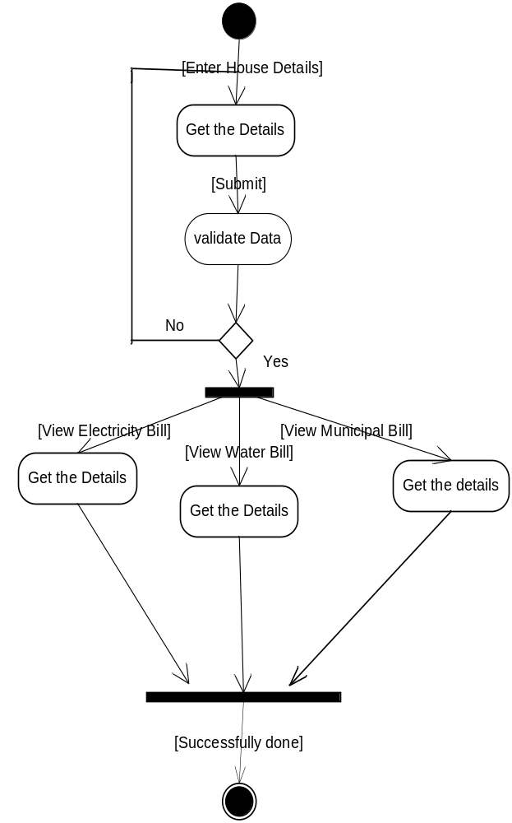
Figure 17

Data Flow Diagrams (DFD)
A data flow diagram (DFD) is a graphical representation of the "flow" of data through an information system, modeling its process aspects. A DFD is often used as a preliminary step to create an overview of the system. DFDs can also be used for the visualization of data processing (structured design).
A DFD shows what kind of information will be input to and output from the system, where the data will come from and go to, and where the data will be stored. It does not show information about the timing of process or information about whether processes will operate in sequence or in parallel.

Context 0th Level Diagram

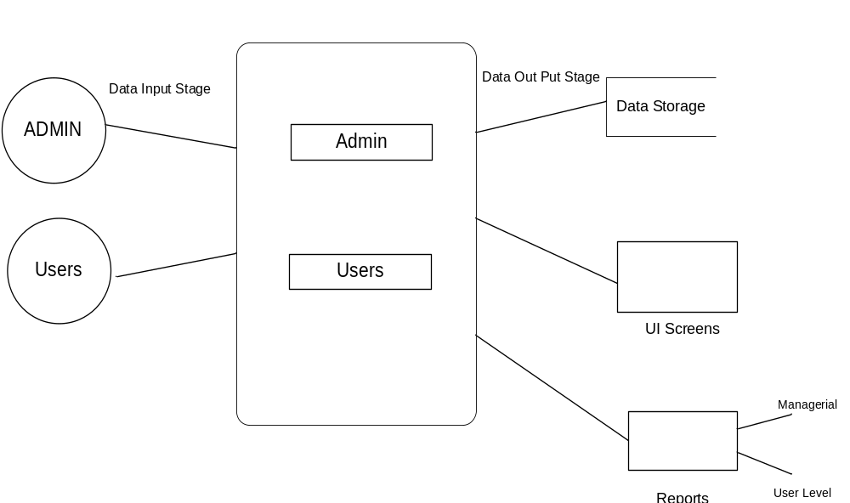
Figure 18

Login Data Flow Diagram

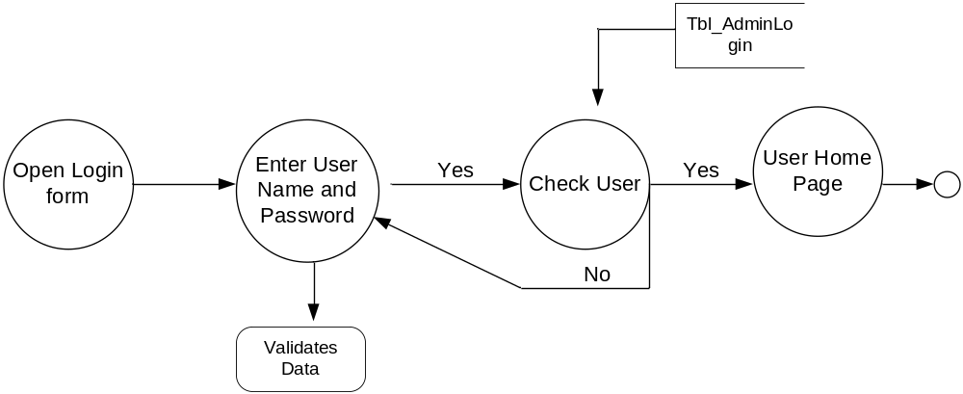
Figure 19

Admin Details Data Flow Diagram
1th Level Diagram

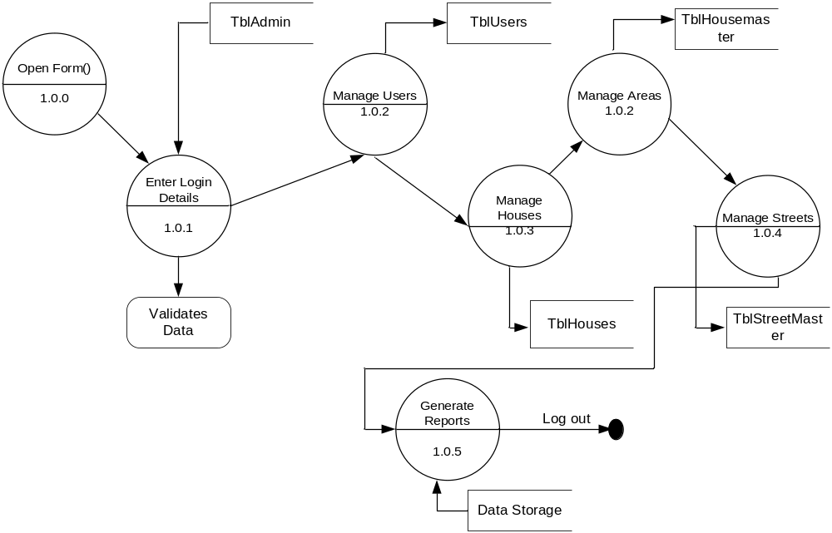
Figure 20

2nd Level Diagram

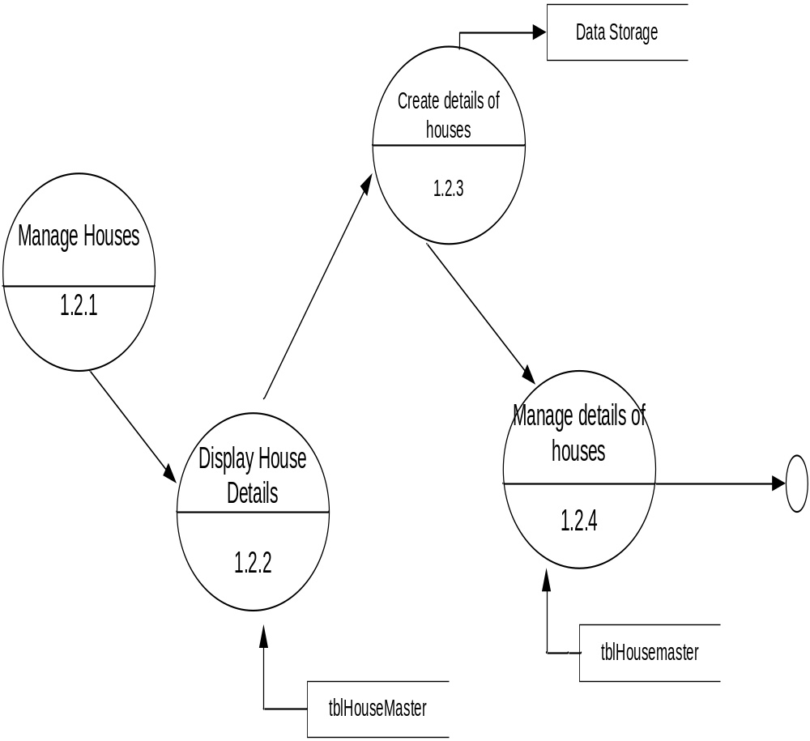
Figure 21

User Details Data Flow Diagram
1th Level Diagram

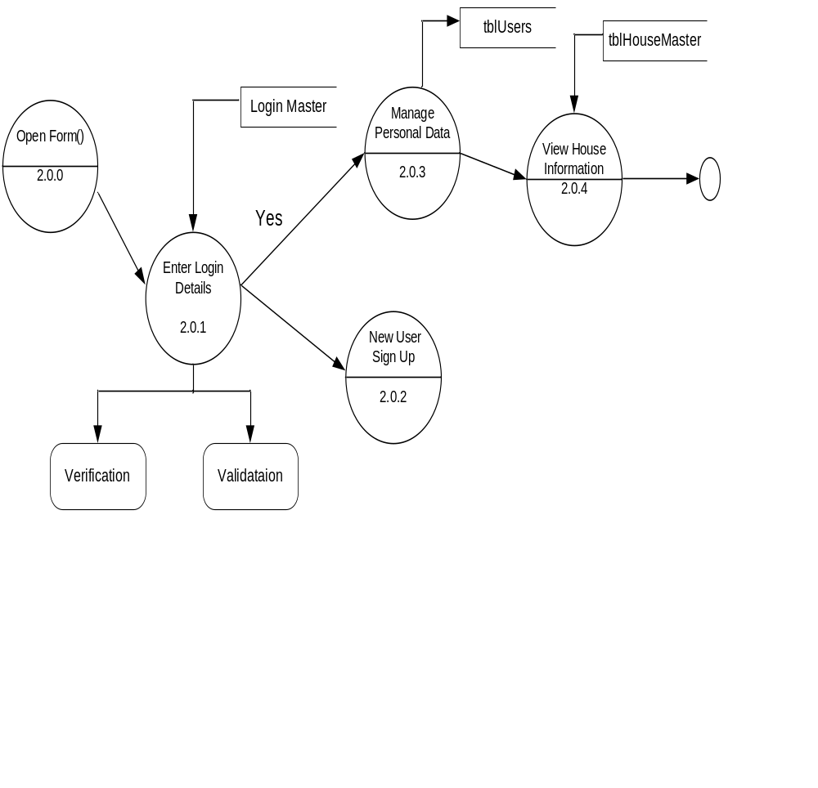
Figure 22

2nd Level Diagram

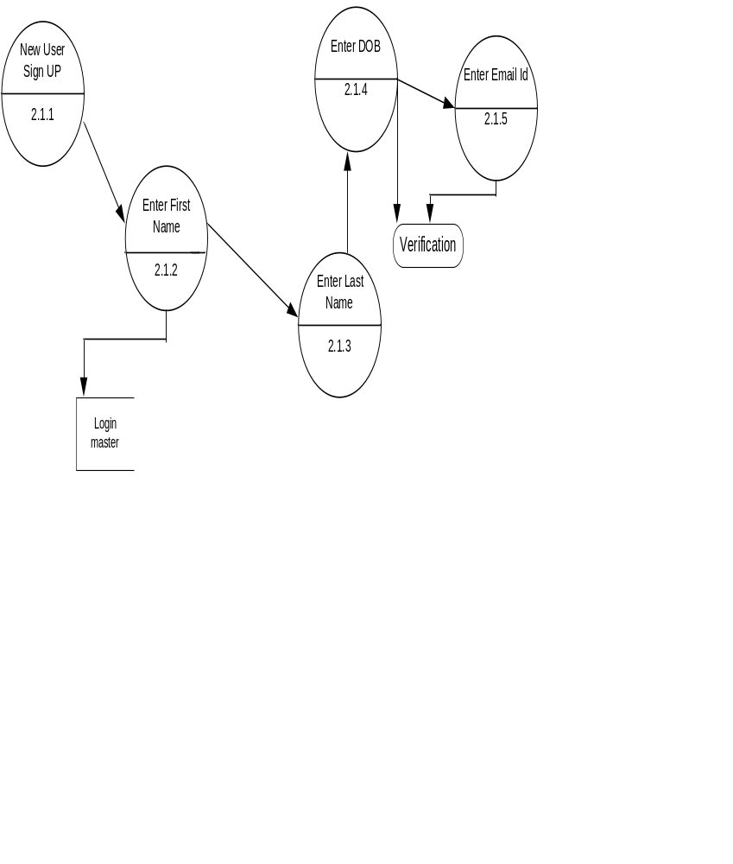
Figure 23

Data Dictionary

After carefully understanding the requirements of the client the entire data storage requirements are divided into tables. The below tables are normalized to avoid any anomalies during the course of data entry.

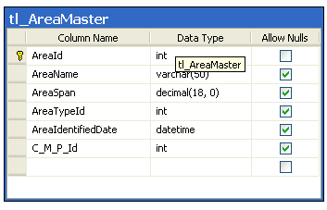
Figure 24

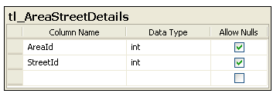
Figure 25

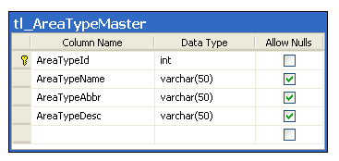
Figure 26

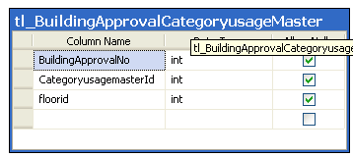
Figure 27

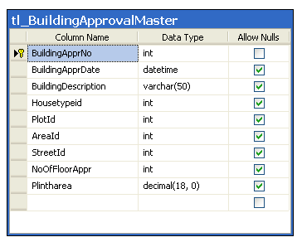
Figure 28

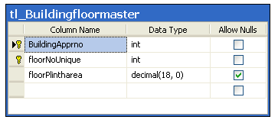
Figure 29

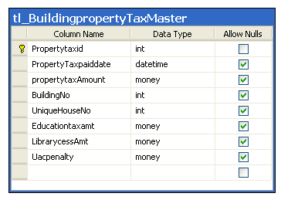
Figure 30

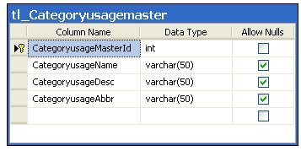
Figure 31

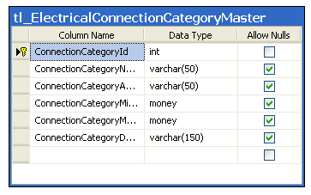
Figure 32

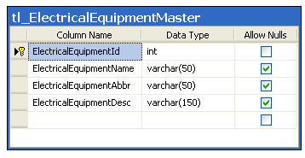
Figure 33

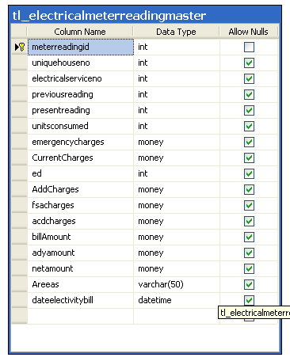
Figure 34

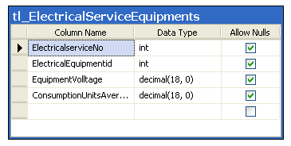
Figure 35

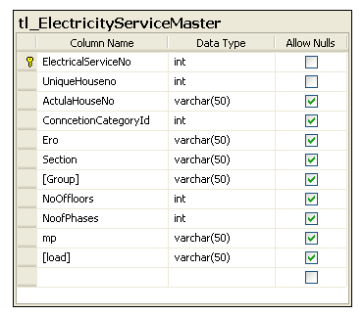
Figure 36

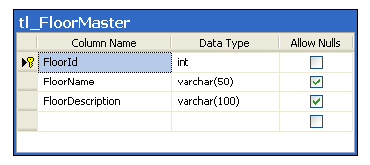
Figure 37

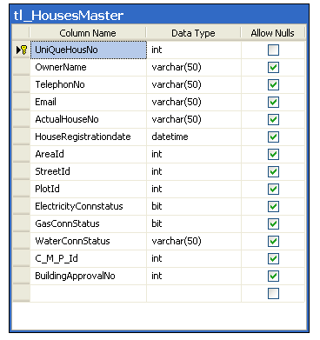
Figure 38

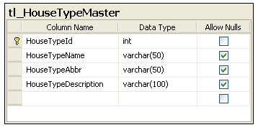
Figure 39

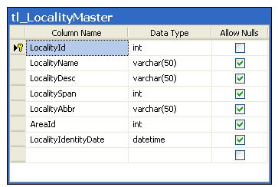
Figure 40

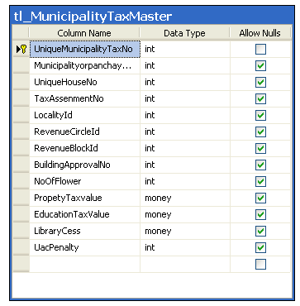
Figure 41

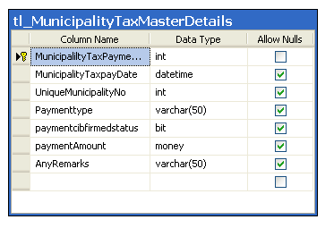
Figure 42

TESTING

Introduction

Software testing is a critical element of software quality assurance and represents the ultimate review of specification, design and coding. In fact, testing is the one step in the software engineering process that could be viewed as destructive rather than constructive.
A strategy for software testing integrates software test case design methods into a well-planned series of steps that result in the successful construction of software. Testing is the set of activities that can be planned in advance and conducted systematically. The underlying motivation of program testing is to affirm software quality with methods that can economically and effectively apply to both strategic to both large and small-scale systems.

Strategic Approach to Software Testing

The software engineering process can be viewed as a spiral. Initially system engineering defines the role of software and leads to software requirement analysis where the information domain, functions, behavior, performance, constraints and validation criteria for software are established. Moving inward along the spiral, we come to design and finally to coding. To develop computer software we spiral in along streamlines that decrease the level of abstraction on each turn.
A strategy for software testing may also be viewed in the context of the spiral. Unit testing begins at the vertex of the spiral and concentrates on each unit of the software as implemented in source code. Testing progress by moving outward along the spiral to integration testing, where the focus is on the design and the construction of the software architecture. Talking another turn on outward on the spiral we encounter validation testing where requirements established as part of software requirements analysis are validated against the software that has been constructed. Finally we arrive at system testing, where the software and other system elements are tested as a whole.

UNIT TESTING

MODULE TESTING

SUB-SYSTEM TESING

SYSTEM TESTING

ACCEPTANCE TESTING
Component Testing
Integration Testing
User Testing

Unit Testing

Unit testing focuses verification effort on the smallest unit of software design, the module. The unit testing we have is white box oriented and some modules the steps are conducted in parallel.

White Box Testing

This type of testing ensures that
- All independent paths have been exercised at least once
- All logical decisions have been exercised on their true and false sides
- All loops are executed at their boundaries and within their operational bounds
- All internal data structures have been exercised to assure their validity.
To follow the concept of white box testing we have tested each form .we have created independently to verify that Data flow is correct, All conditions are exercised to check their validity, All loops are executed on their boundaries.

Basic Path Testing

Established technique of flow graph with Cyclomatic complexity was used to derive test cases for all the functions. The main steps in deriving test cases were:
Use the design of the code and draw correspondent flow graph.
Determine the Cyclomatic complexity of resultant flow graph, using formula:
V(G)=E-N+2 or
V(G)=P+1 or
V(G)=Number Of Regions
Where V(G) is Cyclomatic complexity,
E is the number of edges,
N is the number of flow graph nodes,
P is the number of predicate nodes.
Determine the basis of set of linearly independent paths.

Conditional Testing

In this part of the testing each of the conditions were tested to both true and false aspects. And all the resulting paths were tested. So that each path that may be generate on particular condition is traced to uncover any possible errors.

Data Flow Testing

This type of testing selects the path of the program according to the location of definition and use of variables. This kind of testing was used only when some local variable were declared. The definition-use chain method was used in this type of testing. These were particularly useful in nested statements.

Loop Testing

In this type of testing all the loops are tested to all the limits possible. The following exercise was adopted for all loops:
All the loops were tested at their limits, just above them and just below them.
All the loops were skipped at least once.
For nested loops test the inner most loop first and then work outwards.
For concatenated loops the values of dependent loops were set with the help of connected loop.
Unstructured loops were resolved into nested loops or concatenated loops and tested as above.
Each unit has been separately tested by the development team itself and all the input have been validated.

Test Cases

Test Case ID | Description | Expected Result | Status
TC-EPP-01 | To verify that the home page of the application is visible  - Go to the url of the application  - Click on home button | verify user is able to see the home page of the application | Pass
TC-EPP-02 | To verify that the about us page of the application is visible  - Go to the url of the application  - Click on About us button | verify user is able to see the About Us page of the application | Pass
TC-EPP-03 | To verify that the contact us page of the application is visible  - Go to the url of the application  - Click on About us button | verify user is able to see the contact Us page of the application | Pass
TC-EPP-03 | To verify admin is able to login to the application with valid username and password.  - go to the url of the application  - Click on Admin page  - Enter valid username and password  - Click on login button | Verify that admin is navigated to the home page of the application and a welcome message appears to the screen | Pass
TC-EPP-04 | To verify admin is not able to login to the application with invalid username and password.  - go to the url of the application  - Click on Admin page  - Enter invalid username and password  - Click on login button | Verify that incorrect username and password error appears on the screen | Pass
TC-EPP-05 | To verify that admin is able to add the category details  - Login to Application using valid admin credentials  - under building details, click on category details.  - click on insert button | - Admin must be able to login into the application  - category details should be inserted successfully | Pass
TC-EPP-06 | To verify that admin is able to add the building approver details  - Login to Application using valid admin credentials  - under building details, click on building approver details  - Enter the necessary details  - Click on submit | - admin must be able to login into the application  - admin must be able to add the building approver details | Pass
TC-EPP-07 | To verify that admin is able to add the building floor details  - Login to Application using valid admin credentials  - under building details, click on building floor details  - Enter the necessary details  - Click on submit | - admin must be able to login into the application  - admin must be able to add the building floor details | Pass
TC-EPP-08 | To verify that admin is able to add the building approval categories  - Login to Application using valid admin credentials  - under building details, click on building approval categories.  - Enter the necessary details  - Click on submit | - User must be able to login into the application  - Home Page screen must be displayed properly.  - Necessary actions performed on the applications must be saved.  - admin is able to save the building approval category details. | Pass
TC-EPP-09 | To verify that admin is able to add the building property taxes  - Login to Application using valid admin credentials  - under building details, click on building property taxes.  - Enter the necessary details  - Click on submit | - admin must be able to login into the application  - Home Page screen must be displayed properly.  - Necessary actions performed on the applications must be saved.  - tax details should be added successfully. | Pass
TC-EPP-10 | To verify that admin is able to add the area type  - Login to Application using valid admin credentials  - under area and street details, click on add and edit area type  - click on add area master  - Enter the necessary details  - Click on submit | - admin must be able to login into the application  - Home Page screen must be displayed properly.  - Necessary actions performed on the applications must be saved.  - admin should be able to add the area type details | Pass
TC-EPP-11 | To verify that admin is able to add the street type  - Login to Application using valid admin credentials  - under area and street details, click on add and edit street type  - click on add area master  - Enter the necessary details  - Click on submit | - admin must be able to login into the application  - Home Page screen must be displayed properly.  - Necessary actions performed on the applications must be saved.  - admin should be able to add the street type details | Pass
TC-EPP-12 | To verify that admin is able to add the house details  - Login to Application using valid admin credentials  - under area and street details, click on add and house type  - click on add house details  - Enter the necessary details  - Click on submit | - admin must be able to login without any issues  - home Page should be displayed properly.  - All the details must be saved successfully.  - admin should be able to add the house type details | Pass
TC-EPP-13 | To verify that admin is able to add the revenue circle details  - Login to Application using valid admin credentials  - under municipality house details, click revenue circle  - Enter the necessary details  - Click on submit  . | - admin must be able to login without any issues  - home Page should be displayed properly.  - All the details must be saved successfully.  - admin should be able to add revenue circle details | Pass
TC-EPP-14 | To verify that admin is able to add the revenue circle details  - Login to Application using valid admin credentials  - under municipality house details, click revenue block details  - Enter the necessary details  - Click on submit | - admin must be able to login without any issues  - home Page should be displayed properly.  - All the details must be saved successfully.  - admin should be able to add revenue block details. | Pass
TC-EPP-15 | To verify that admin is able to add the municipality details  - Login to Application using valid admin credentials  - under municipality house details, click revenue block details  - Enter the necessary details  - Click on submit | - admin must be able to login without any issues  - home Page should be displayed properly.  - All the details must be saved successfully.  - admin should be able to add municipality details. | Pass
TC-EPP-16 | To verify that admin is able to add the electrical details  - Login to Application using valid admin credentials  - under electrical details, click on electrical category details.  - Enter the necessary details  - Click on submit | - admin must be able to login without any issues  - home Page should be displayed properly.  - All the details must be saved successfully.  - admin should be able to add electrical details. | Pass
TC-EPP-17 | To verify that admin is able to print the house, property and building tax details  - Login to Application using valid admin credentials  - under reports , click on the house/property/municipality tax  - click on print | - admin must be able to login without any issues  - home Page should be displayed properly.  - print dialog box should appears | Pass
TC-EPP-18 | To verify that admin is able to logout to the application  - Login to Application using valid admin credentials  - click on signout | - admin must be able to login without any issues  - admin should be logged out  - sign out message should be displayed | Pass
TC-EPP-19 | to verify new user is able to register to the application  - Go to the url of the application  - Click on users button  - click on new user sign up  - give the necessary details  - click on submit | - signup page should be displayed properly  - user should get registration message successfully | Pass
TC-EPP-20 | to verify new user is able to login to the application with valid credentials  - Go to the url of the application  - Click on users button  - enter username and password  - click on submit | Verify that user is navigated to the home page of the application and a welcome message appears to the screen | Pass
TC-EPP-21 | to verify user is able to show the house information  - login to the application  - click on show house information | - user must be able to login without any issues  - house information should be displayed | Pass
TC-EPP-22 | to verify user is able to show the building taxes details  - login to the application  - click on building taxes | - user must be able to login without any issues  - building taxes should be displayed | Pass
TC-EPP-23 | to verify user is able to show the municipality taxes details  - login to the application  - click on municipality taxes | - user must be able to login without any issues  - municipality taxes should be displayed | Pass
TC-EPP-24 | to verify user is able to search the municipality taxes details  - login to the application  - under search click on municipal tax pay  - select dates  - click on submit | - user must be able to login without any issues  - municipality taxes should be displayed | Pass
 | To verify that user is able to logout to the application  - Login to Application using valid user credentials  - click on signout | - user must be able to login without any issues  - user should be logged out  - sign out message should be displayed | Pass

Test Case Review

All test cases must be reviewed by Test Lead, Business Analyst and Project Quality Manager.
Reviewed comments must be incorporated into the test case document and then finally it must be sent for approval.
Only the approved document is taken as the base line for system integration testing.

Test case Standards
Test Cases will be named based on following standard naming conventions as specified below

Test Case Name
< Test Case > - < Application shot form > - < Test Case ID >* •
Unique short name for the test cases

Approach and Execution Strategy

Test Strategy defines the rules the test will be based on including start and end dates assumptions and the descriptions of the project to setup a valid entry and exit criteria
Creation of the test cases task to perform scheduling and data strategy
It also describes how the test will be performed to identify and report defects and to implement fixes
Test management process handles the logistics of the test and all the events that come up during the execution

ENTRY AND EXIT CRITERIA:

- The entry criteria Refers to the desirable conditions in order to start test execution, only the migration of the codes and fixes needs to be assessed at the end of each cycle.
- Exit criteria are the desirable conditions that need to be met in order to proceed with the implementation
- Entry and exit criteria are flexible bench marks .If they are not met , the test team will assess the risk , identify mitigation action and provide a recommendation or this is input to the project manager for a final go or NO go decision
- Entry criteria to start the execution phase of the test: the activities listed in the test execution of the schedule are 100% completed.

Defect Management

Test execute all the scripts in each of the cycle to identify possible gaps in the scripts.
If a gap is identified the scripts will updated and the defect logged against the scripts, the defects will be tracked until they are fixed and re tested again. This part of the testing phase is called as regression testing.

Defect Lifecycle:

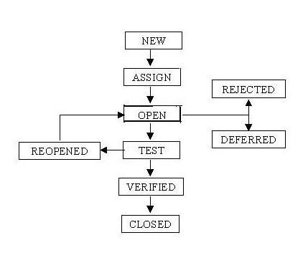
Figure 43

Severity of Defects:

Severity | Description
1 – critical | This bug is critical enough to crash the system, because file corruption, or cause potential data loss.  It causes an abnormal return to their operating system
2 – High | IT causes a lack of vital programme functionality with work around
3 – Medium | Bug will degrade the quality of the system  It prevents other areas of the product from being tested
4 – Low | There is an insufficient or unclear error message which has minimum impact

Test Report

Exit Criteria | Test Team | Technical Team | Notes
100% Test Scripts executed
95% pass rate of Test Scripts
No open Critical and High severity defects
95% of Medium severity defects have been closed
All remaining defects are either cancelled or documented as Change Requests for a future release
All expected and actual results are captured and documented with the test script
All test metrics collected based on reports from HP ALM
All defects logged in HP ALM
Test Closure Memo completed and signed off
Test environment cleanup completed and a new back up of the environment

Passed Failed

Conclusion and Future Work
The Change Management is the process of managing proposed changes to approved business requirements and design specifications. The business can ask for the change in the existing requirement or for a new requirement to develop. To incorporate ad hoc changes in the requirements and to see if proper changes to the system meet the requirements, change management process will be done iteratively with all the activities.
The Stakeholder will identify a new requirement or a modification in a requirement and communicate it to the team lead via email or to the entire team in a meeting. The team will assess the feasibility of the proposed change considering the time constraints and structural constraints of the implemented modules and develop an implementation strategy and submit it to the mentor for approval. A change plan will be created for the implementation of the change and following sequences of the changes is determined. The team will then continue implementing the new requirements. Then testing will be done on the new programmed system. During the testing phase, the product will be tested for satisfying the requested changes. After the changes have been done, update will be made to documentation also. The changes will then be verified for the last time, and a new system release is made.

REFERENCES

IEEE.IEEE Std 830-1998 IEEE Recommended Practice for Software Requirements Specifications. IEEE Computer Society, 1998.

Thomas Powell, HTML:The Complete Reference by Osborne

Jeff Wandling Dynamic HTML Black Book by Coriolis

Andy Shafran, Creating Your Own Web Pages, 2nd Ed. By

Javascript Programmer’s Reference (Alexie White 2009)

Javascript Quick Reference (Rick Darnell, 1996)

ASP.NET 3.5 Unleashed, by Stephen Walther

SQL Server MVP Deep Dives,by Paul Nielson

High Performance MySQL: Optimization, Backups, Replication, and More, by Baron Schwartz, Peter Zaitsev, Vadim Tkachenko, Jeremy Zawodny, Arjen Lentz, Derek J. Balling

https://www.w3schools.com/

https://www.asp.net/

https://dev.mysql.com/

https://www.tutorialspoint.com/.

