EIE4432 Lab report

Student Name: Liu Jiahao

Student ID:21096764D

Github Website:

https://github.com/HarderFasterBetterStronger/EIE4432_lab1.git

Please declare the use of GenAI tools and how they have been used in the appendix

page similar to the following:

○ I declare that Generative AI tools have been used to prepare the submitted

work. The Generative AI tools used and the manner in which they were used

are as follows:

_None________________________________________________________.

○ You must reference them in according with the accepted academic conventions

(e.g. IEEE or APA styles).

The System date&time is shown in right-bottom corner and student ID is shown in folder name in every screen captures.

Lab1.1-code

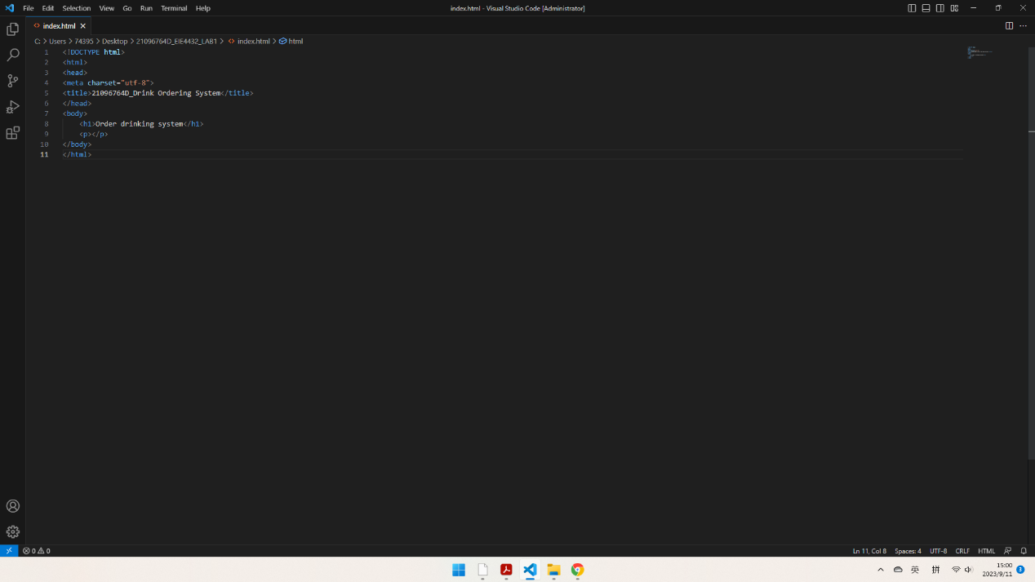

LAB1.1-browser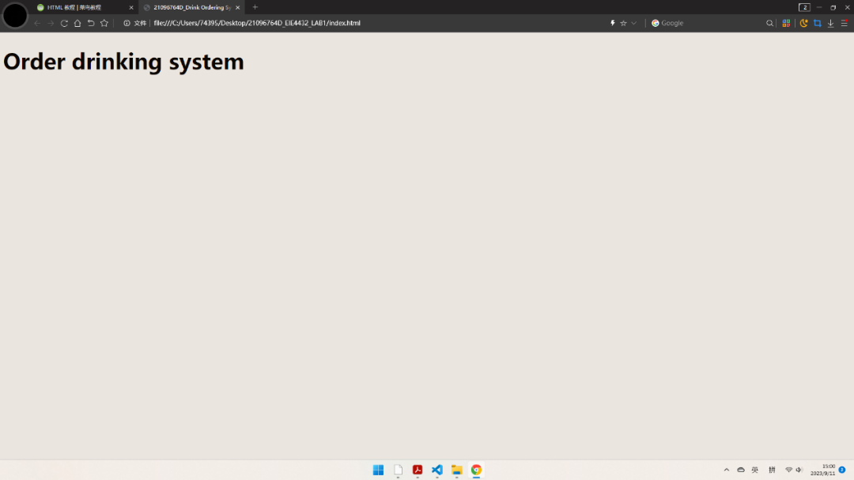

Lab1.2-browser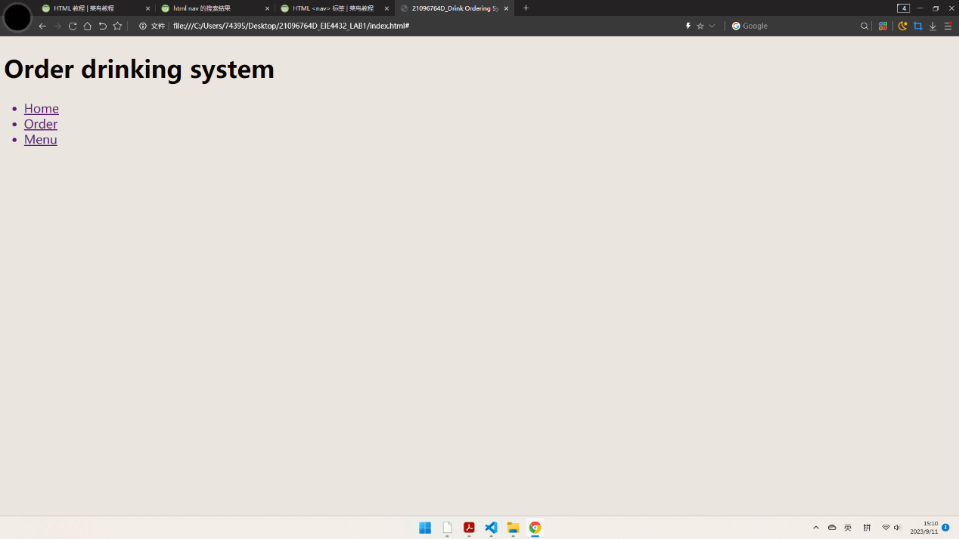Lab1.2-code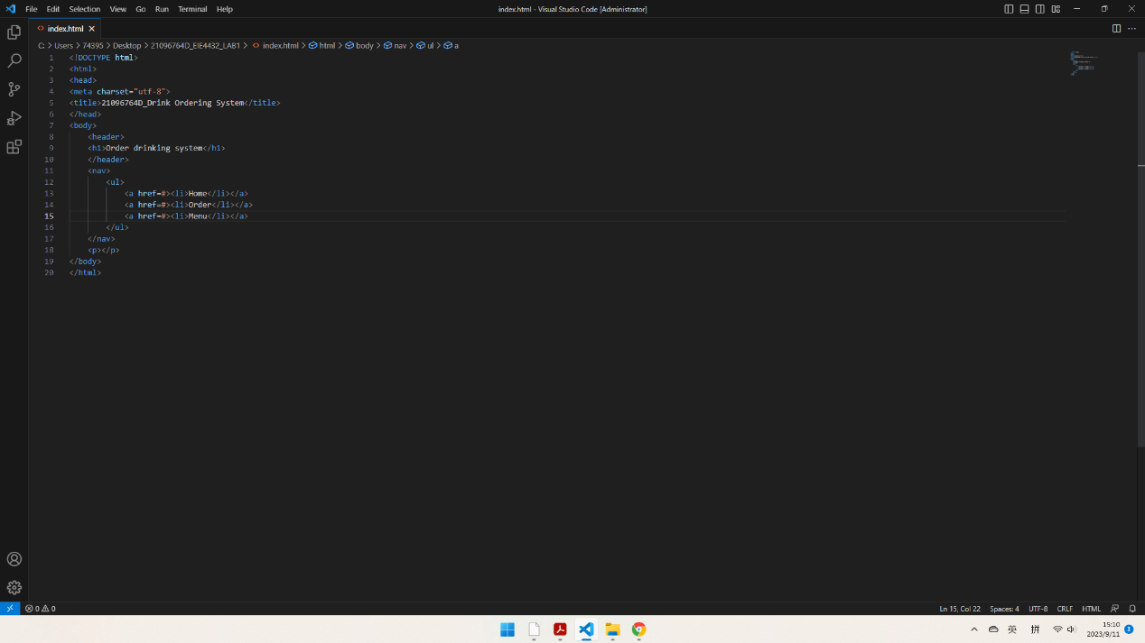Lab1.3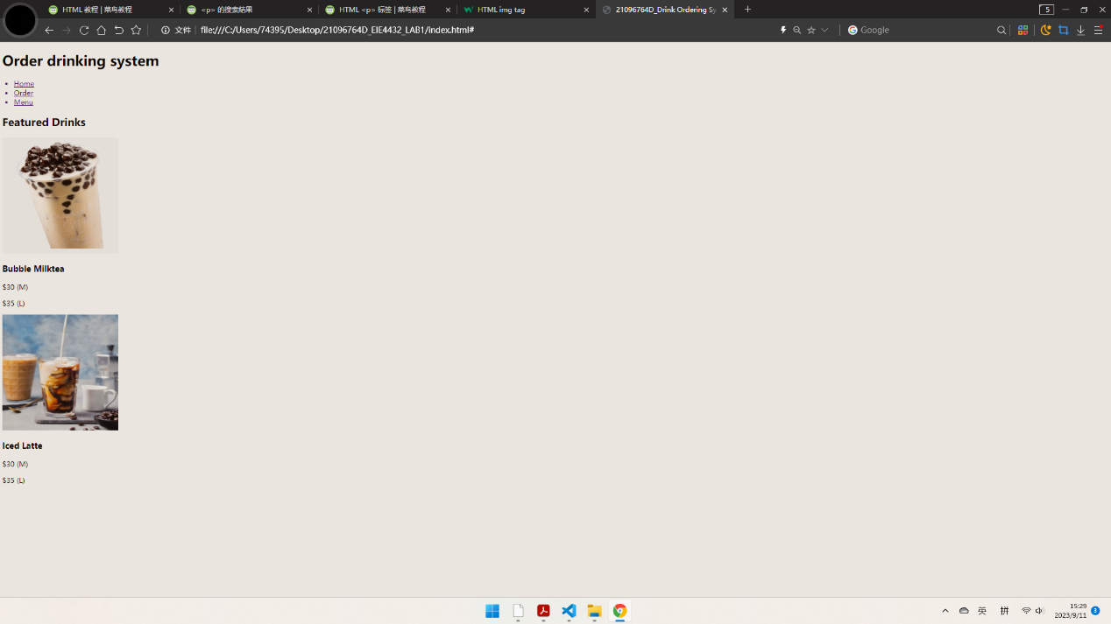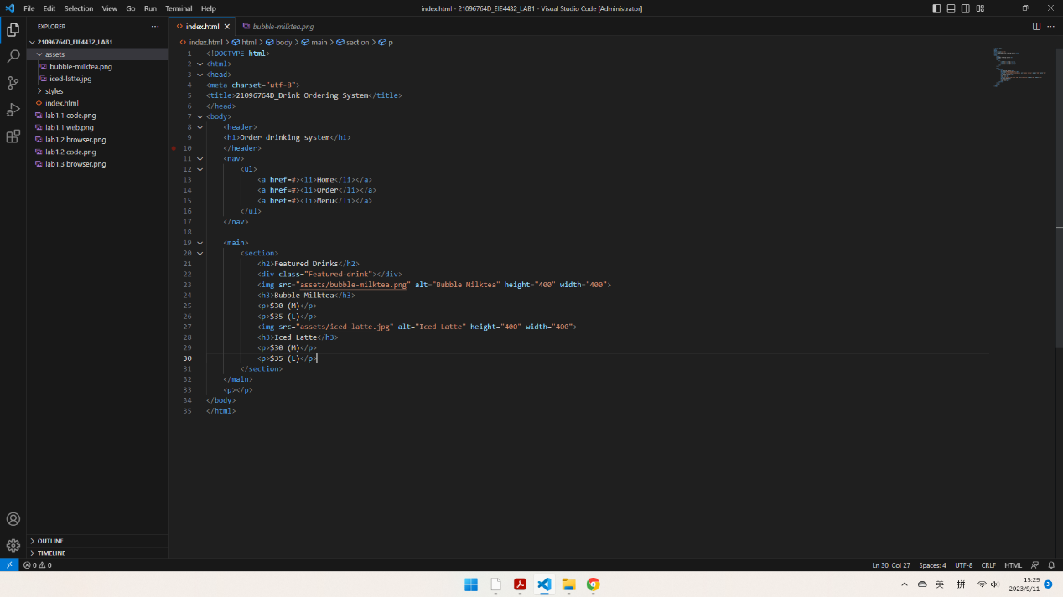Lab1.4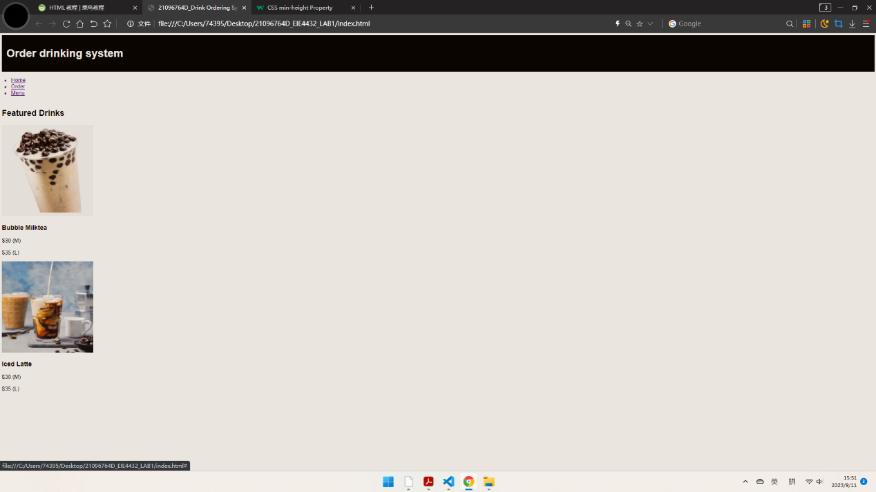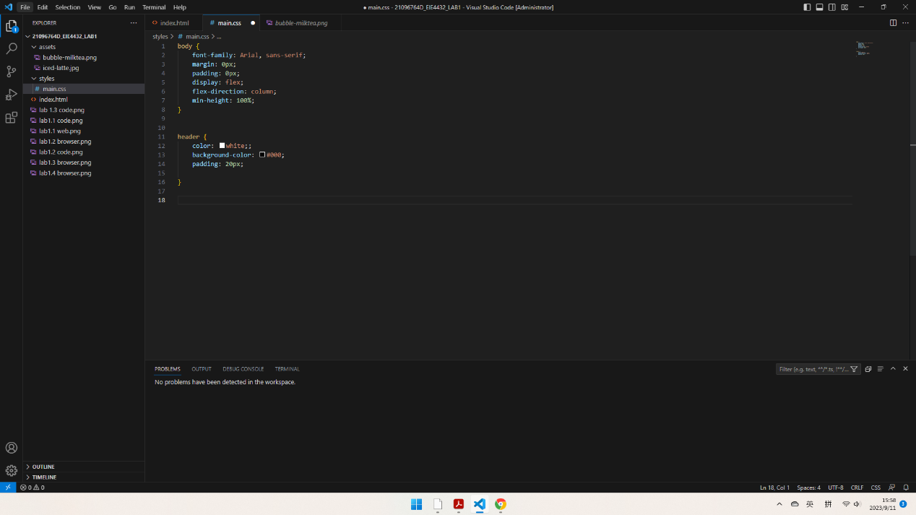Lab1.5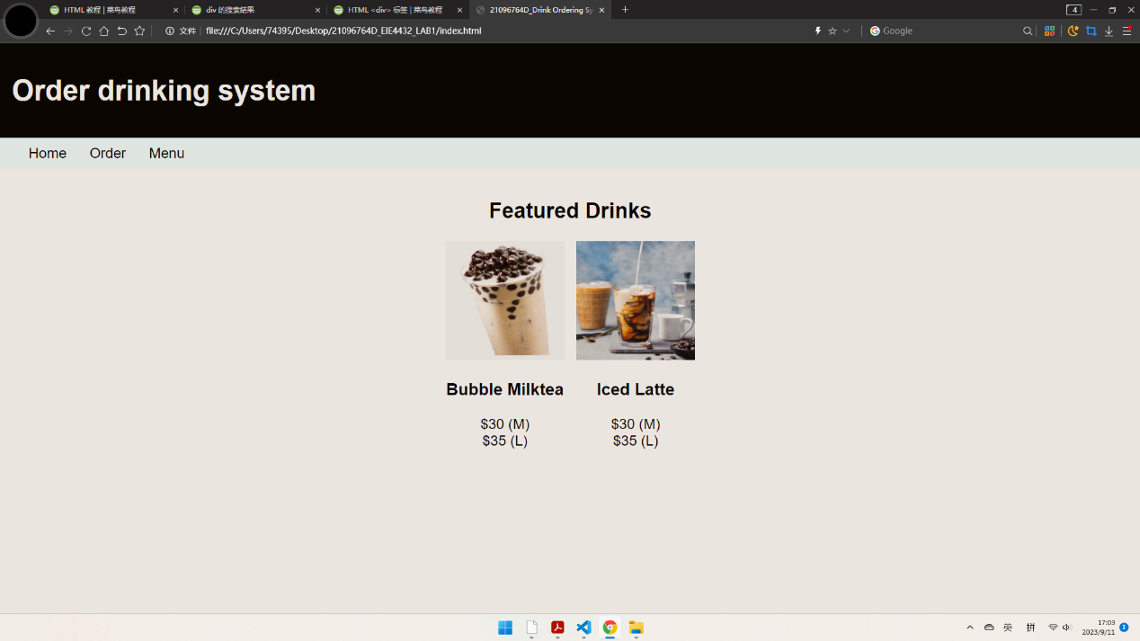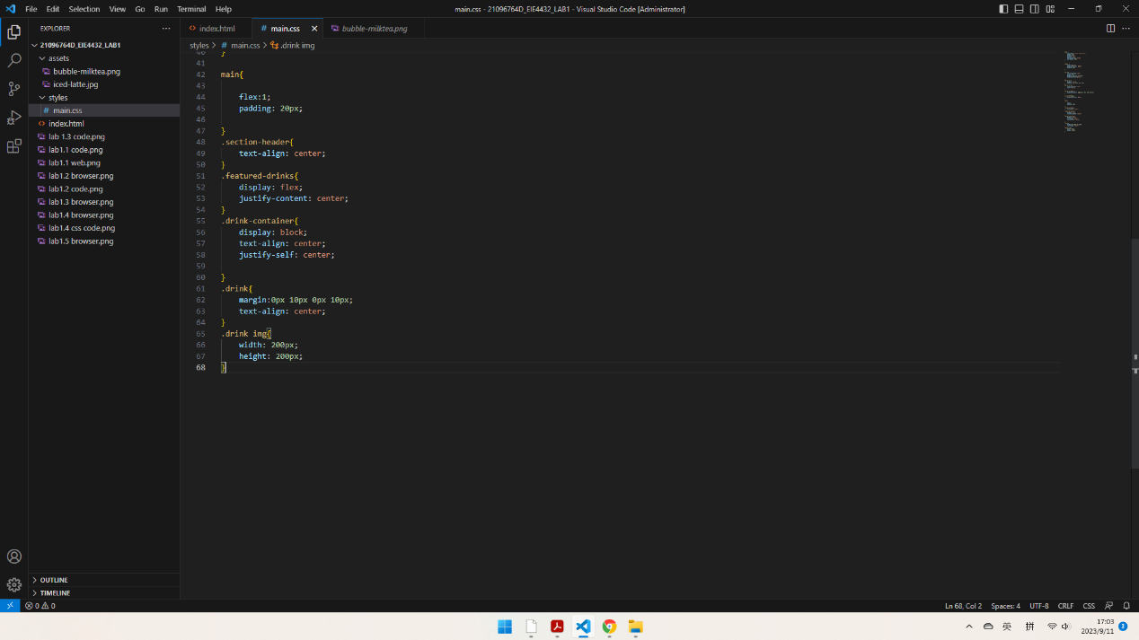Lab1.6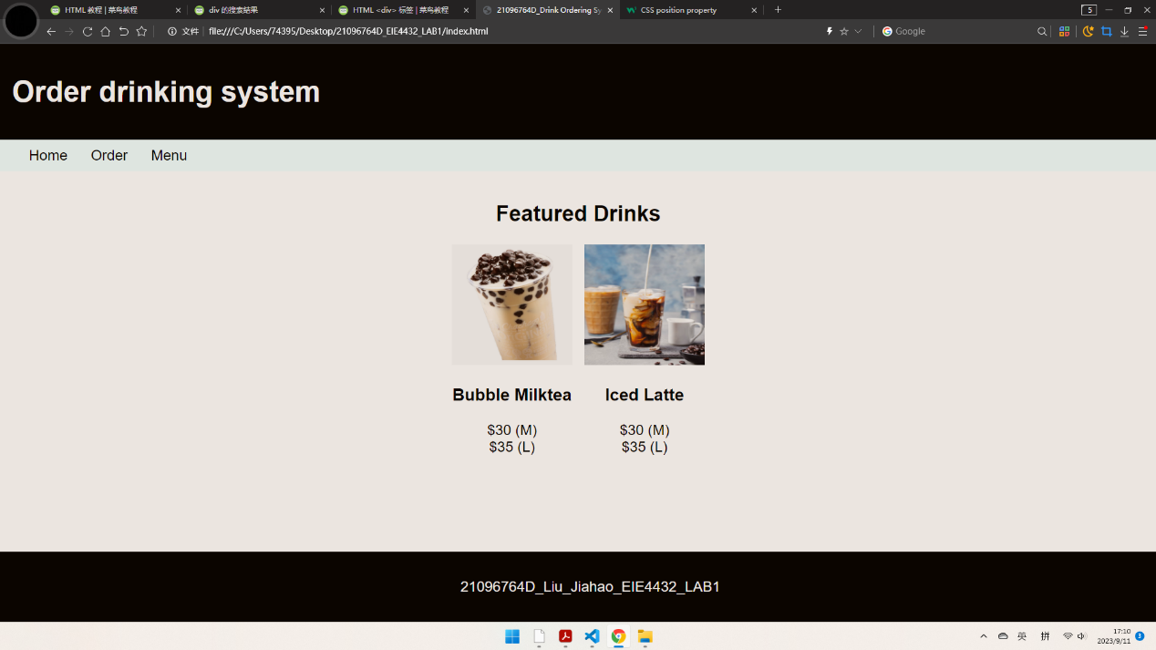L=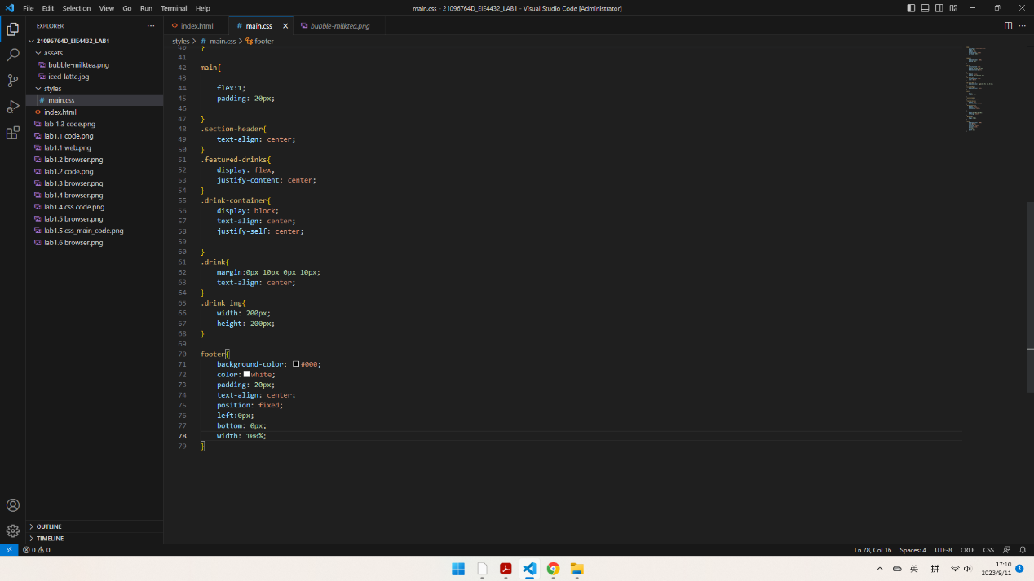Lab2.1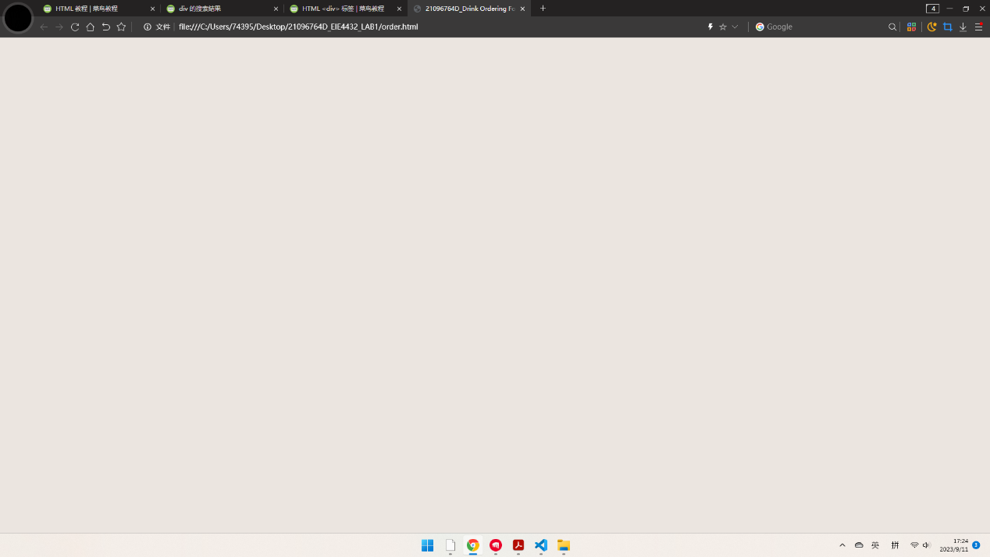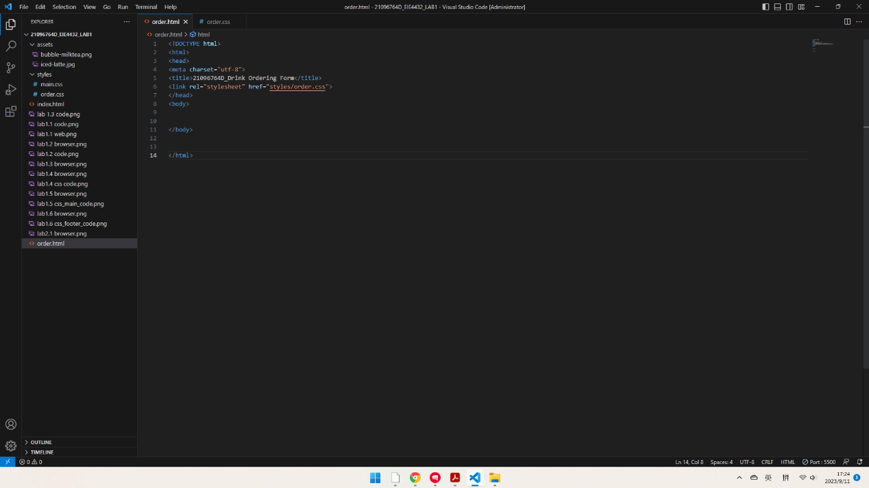Lab2.2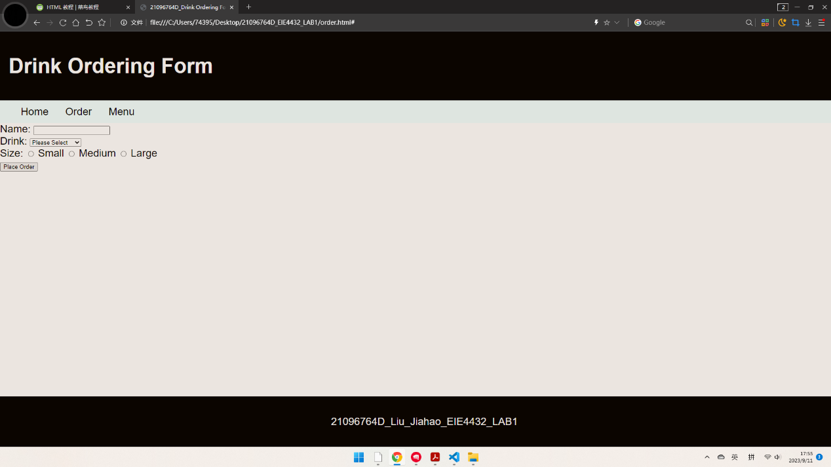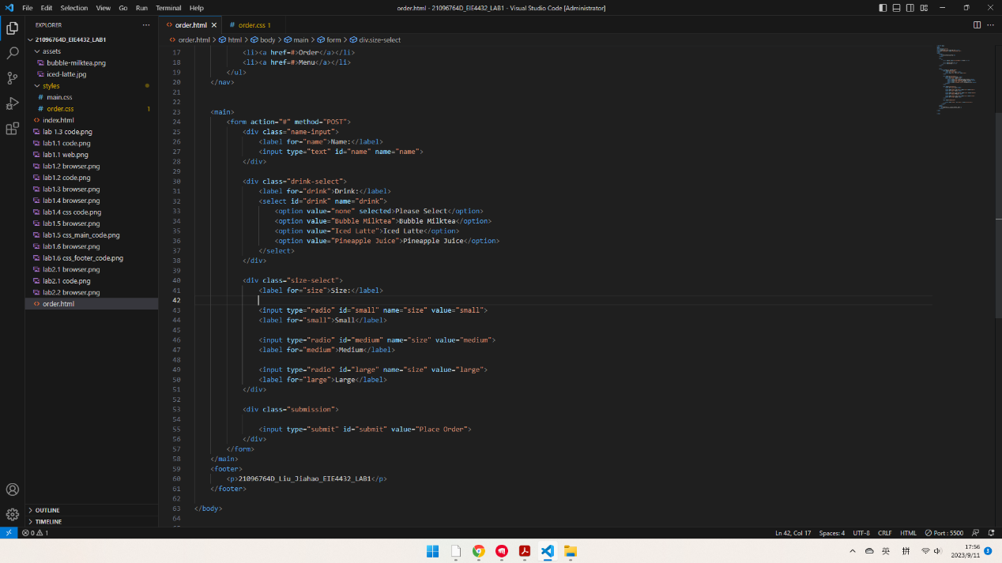Lab2.3