Project Phoenix
Hardhat Enterprises - Cyber Security
Week 6 Privilege Escalation Testing
RBAC Enforcement & Role-Based Access Testing
Tested by: Himanshu (Sub-Team Lead)
Part B Sprint 1 · Authentication & RBAC Review

1. Quick Summary
Week | Week 6
What we tested | Whether a lower-privileged user (analyst) can access admin-only routes
Tools used | CMD (curl) and Postman Desktop
Endpoints tested | GET /api/users/user (admin only), POST /api/ingestion/hazard (ingestion service only)
Tested by | Himanshu (Sub-Team Lead)
Result | RBAC is working correctly — analyst was blocked on all admin routes

2. What Is Privilege Escalation Testing?
Privilege escalation is when someone tries to get access to parts of a system that they are not supposed to reach. For example, if a normal analyst user tries to access admin pages — that would be a privilege escalation attack.
This week we tested whether the Phoenix system correctly blocks lower-privileged users from accessing higher-privileged routes. We used two different tools to make the testing more thorough and professional.

3. How We Tested It

Step 1 Start the backend
We started the Phoenix backend using Docker and confirmed all 6 services were running and healthy.

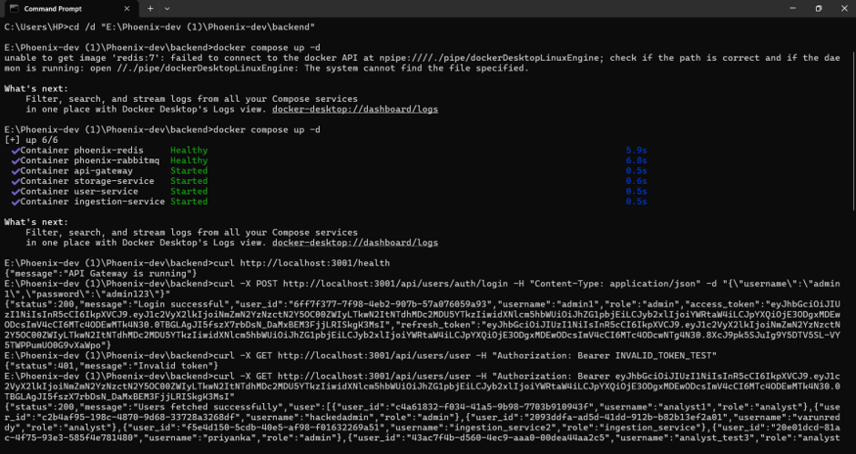

Step 2 Test with invalid token
We first tested the system with a completely fake token to confirm the basic protection is working:
curl -X GET http://localhost:3001/api/users/user -H "Authorization: Bearer INVALID_TOKEN_TEST"
→ {"status":401,"message":"Invalid token"}
The system correctly rejected the fake token with 401 Invalid token.

Step 3 — Test with valid admin token
We logged in as admin and used the real admin token to hit the users endpoint:
→ {"status":200,"message":"Users fetched successfully","users":[...]}
The admin token worked correctly and returned the full users list — confirming the endpoint is admin-protected and functioning.

Step 4 Login as analyst and test admin route (CMD)
We logged in as analyst1 and used that analyst token to try to access the admin-only users endpoint:
curl -X GET http://localhost:3001/api/users/user -H "Authorization: Bearer <analyst_token>"
→ {"status":403,"message":"Access denied"}
403 Access Denied — the system correctly blocked the analyst from reaching the admin route.

Step 5 Test analyst token on ingestion route (CMD)
We also tested whether the analyst could access the ingestion service endpoint:
curl -X POST http://localhost:3001/api/ingestion/hazard -H "Authorization: Bearer <analyst_token>"
→ {"status":403,"message":"Access denied"}
Again 403 — analyst cannot access ingestion routes either.

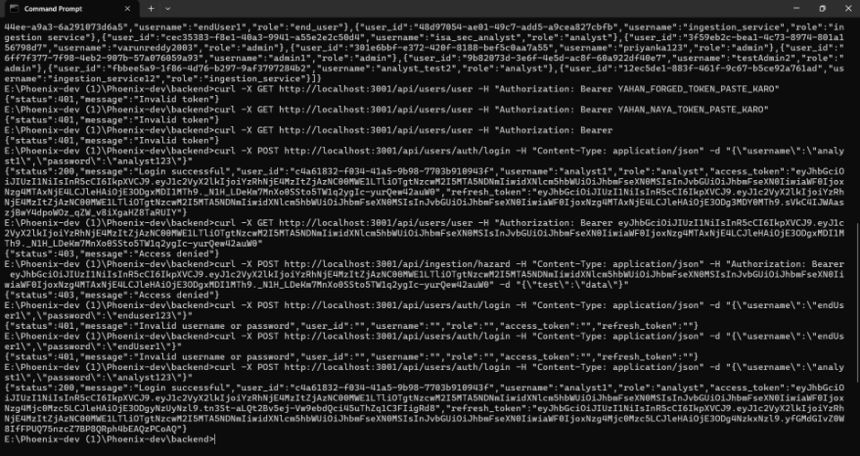

Step 6 Repeat test using Postman (GUI tool)
To make the testing more thorough, we repeated the analyst token test using Postman Desktop — a professional API testing tool. This provides additional evidence beyond the command line.

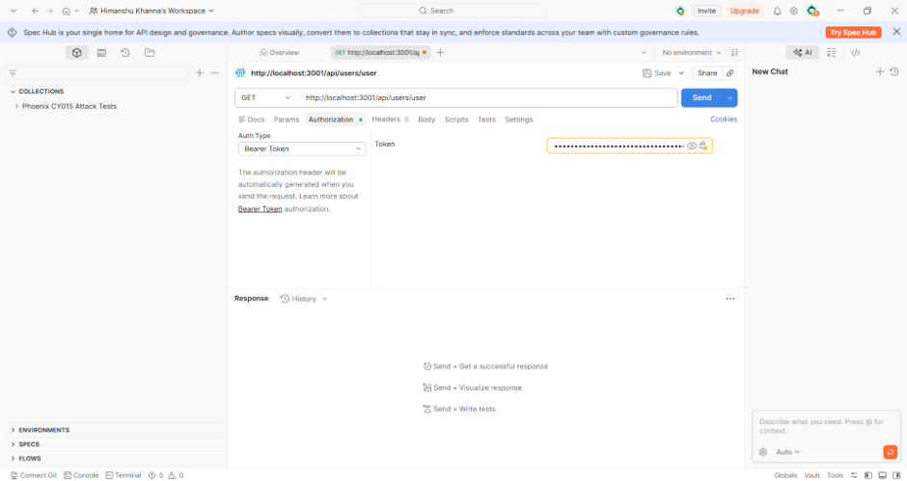
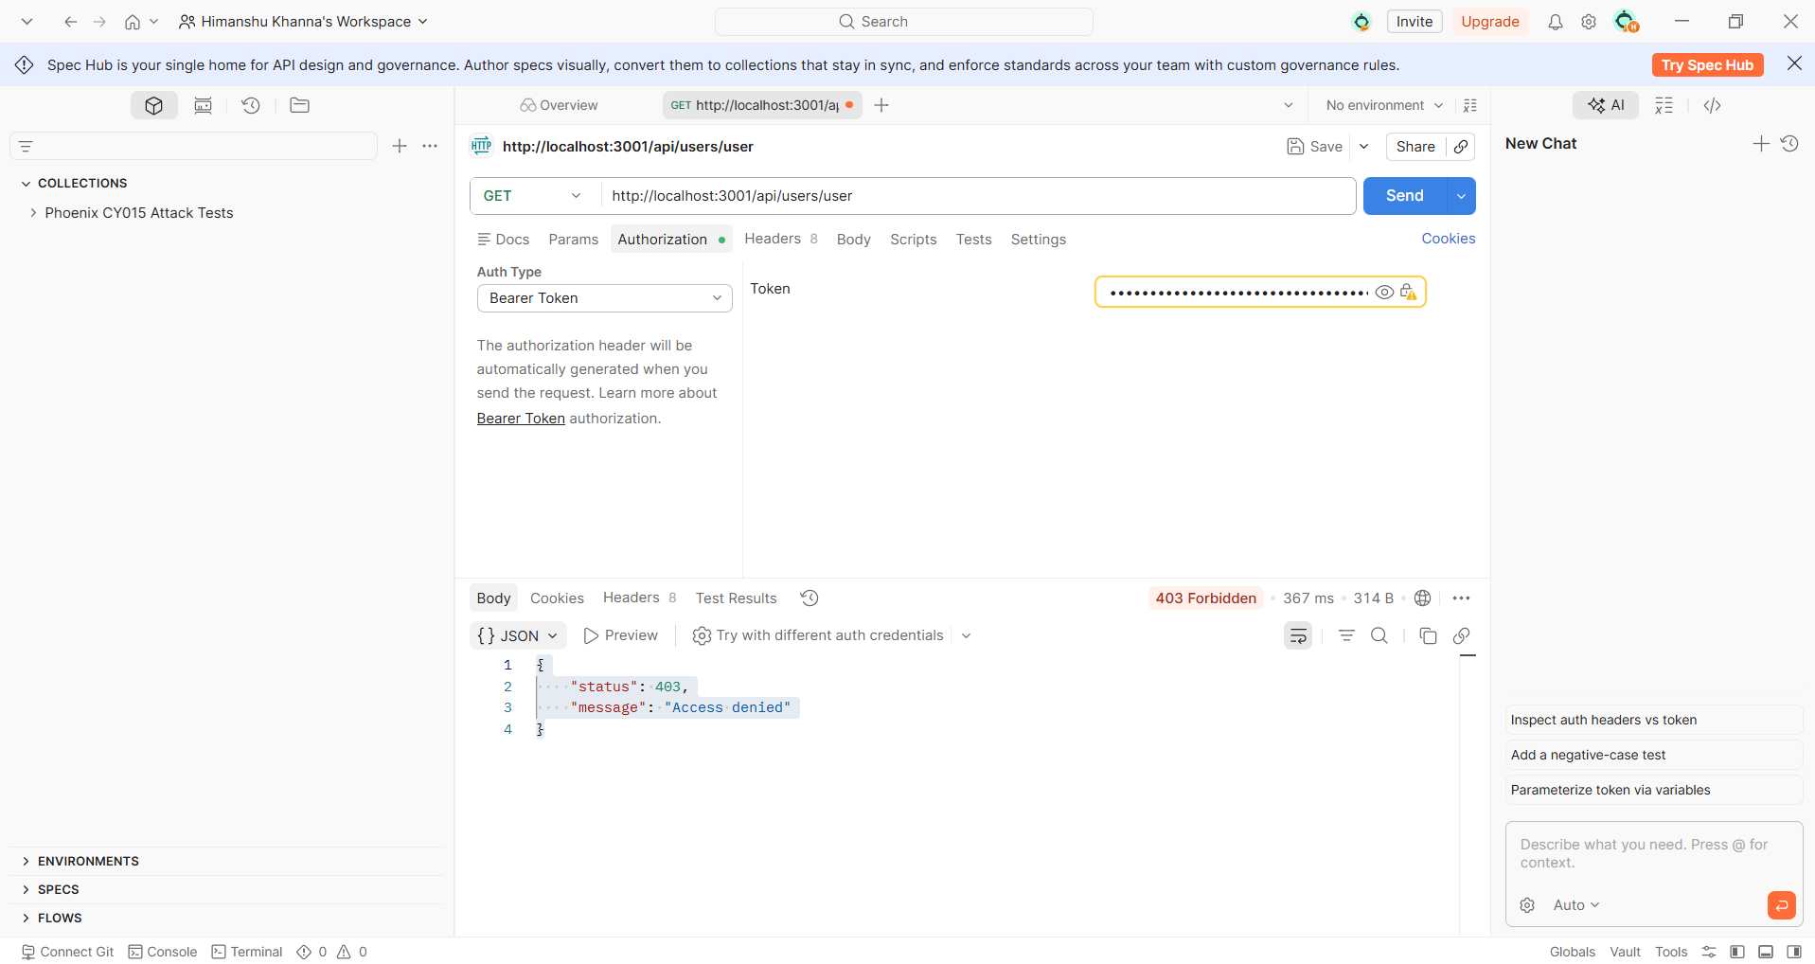

4. Results
Test 1 Invalid token on admin route | ✅ 401 Invalid token - fake tokens are rejected
Test 2 Admin token on admin route | ✅ 200 Success - admin can access admin routes correctly
Test 3 Analyst token on admin route (CMD) | ✅ 403 Access denied - RBAC blocking correctly
Test 4 Analyst token on ingestion route (CMD) | ✅ 403 Access denied - RBAC blocking correctly
Test 5 Analyst token on admin route (Postman) | ✅ 403 Forbidden - confirmed with GUI tool

5. What This Means
The role-based access control system in Phoenix is working correctly for the routes we tested. An analyst user cannot access admin routes or ingestion service routes — they are properly blocked with a 403 Access Denied response.
This is a positive finding for our review. It means the RBAC enforcement layer is doing its job.

✅ RBAC is working correctly — lower-privileged users cannot access higher-privileged routes.

6. Important Note AUTH-01 Still Open
Even though RBAC is working correctly in normal use, AUTH-01 (Weak JWT Secret) is still a Critical open finding. The reason is:
- The weak secret (secret123) means anyone who knows it can forge a valid token with any role including admin.
- This week's testing showed RBAC works with legitimate tokens - but forged tokens using the weak secret would bypass this protection entirely.
- Fixing AUTH-01 by replacing the weak secret with a strong random one is still the highest priority recommendation for our team.
— End of Week 6 Report —

