Project Phoenix
Code Review Report - Week 4

Password Storage Review and SQL Injection Testing

1. Quick Summary
Week | 4
Task | Review of password storage + SQL Injection Testing
File reviewed | user-service/src/services/user.service.ts
Tested endpoint | POST /api/users/auth/login
Tested by | Himanshu (Sub-Team Lead)
Summary | Passwords are securely stored. SQL injection is safe.
Findings | No critical issues identified in this area 2 positive confirmations

2. Our Actions
This week we looked at two things, how Phoenix stores passwords, and if the login page is vulnerable to SQL Injection. Both were put to the test by reading the real code and running a live test on the running backend.

3. Part 1 — Confirming Password Storage
What we were looking for
When a user registers, his password must be stored securely. The wrong way. Save as plain text. (Anyone who sees the database can read it.) The correct way is to hash it, such as with a strong hashing algorithm like bcrypt, so that if the database is stolen the passwords can't be read.

What we were after
We checked password handling, main user service file (user.service.ts):
import bcrypt from 'bcrypt'; const password_hashed = await bcrypt.hash(dto.password , 10); On login: const validPassword = await bcrypt.compare(dto.password, user.password_hashed);

What this means
- We are using bcrypt the industry standard for password hashing.
- Work factor 10 the hash is slow to compute so brute force attacks are very difficult
- Passwords are never stored in plain text
- Password comparison during login, using bcrypt.compare() for safety.

Screenshot Code review
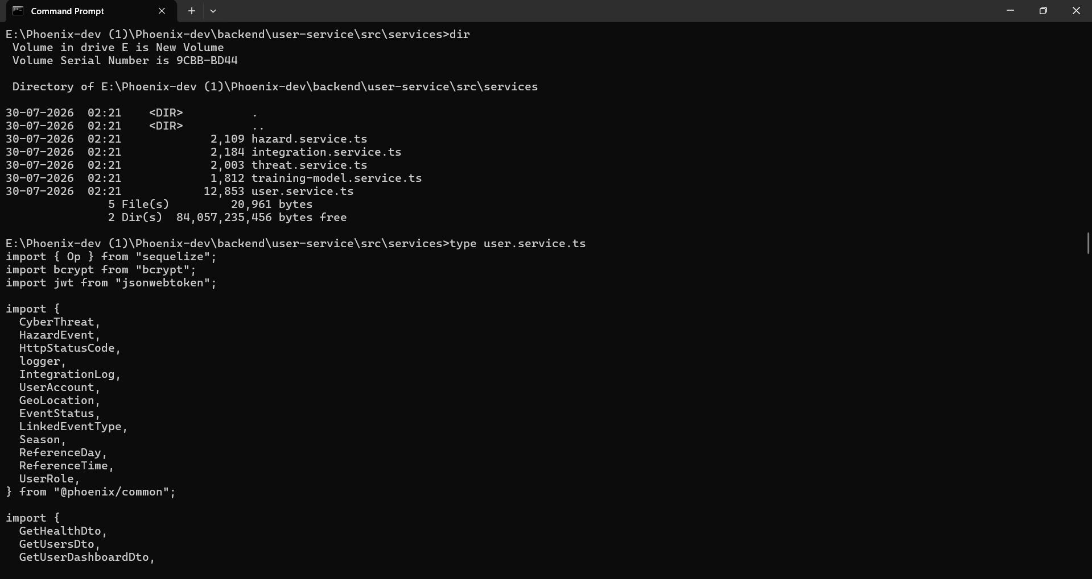

Result
Password storage is SECURE - bcrypt with work factor 10. No issues detected.

4. Part II SQL Injection Testing
What is SQL Injection ?
SQL injection is where an attacker types special characters into a login box to fool the database into letting them in. For example typing something like ' OR '1'='1 sometimes makes a system log in without a real password. This is one of the most popular web attacks.

Testing We tested it
We sent a login query to the live backend with a classic SQL injection payload in the username field:
curl -X POST http://localhost:3001/api/users/auth/login \
-H "Content-Type: application/json" \
-d "{\"username\":\"' OR '1'='1' --\",\"password\":\"anything\"}"

What happened
{"status":401,"message":"Invalid username or password"}

T he system responded with a 401 Unauthorized – it didn't buy the injection. This is because the backend uses Sequelize ORM (Object Relational Mapper) that automatically uses parameterized queries. This means user input is never directly into the SQL query, so injection attacks will not work.

Screenshot code for logout + sql test
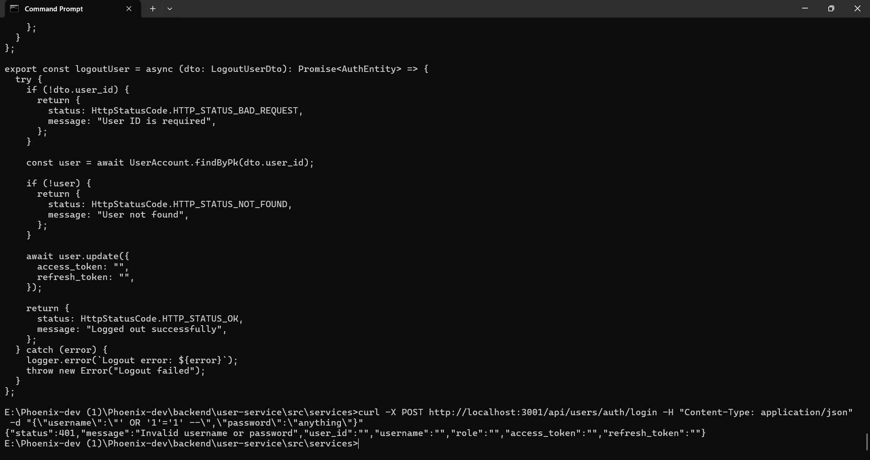

Result
SQL Injection is BLOCKED - Sequelize ORM is protected from injection. No problems found.

5. Other things we saw in the code

During the review of the code, we observed several other important points to note:
Logout removes tokens | When the user logs out, both access token and refresh token are set empty in database. This means old tokens can't be reused after log out.
DB-checks refresh token | When someone tries to refresh their session , the token is checked in the database . If it doesn’t match, access is denied.
B-02 (role on register) | The register function still takes a 'role' value from the client but now there is a validation check to ensure it is a proper role. This is better than last trimester. Muath will verify that the escalation issue is completely fixed.
Token expiration times | Access tokens expire in 15 minutes, refresh tokens in 7 days. These are reasonable numbers.

6. Week 4 Summary Result
Password hashing | Secure - bcrypt, work factor 10
SQL injection | Protected - Sequelize ORM
Logout behaviour | Cleaned tokens on logout
Refresh token security | Validated in DB, cannot be reused
B-02 role increase | Partially resolved - Muath to confirm
New critical results | None - good implementation in this area

