Project Phoenix
Hardhat Enterprises - Cyber Security
Week 5 Testing & Code Review Report
Unauthenticated Endpoint Test & Login Check Code Review
Tested by: Himanshu (Sub-Team Lead)
Part B Sprint 1 · Authentication & RBAC Review

1. Quick Summary
Week | Week 5
What we did | Tested if certain pages can be accessed without logging in, and read the code that checks logins and user roles
Files reviewed | ingestion.routes.ts and auth.middleware.ts
Pages tested | The data ingestion pages and the users page
Who did it | Himanshu (Sub-Team Lead)
Result | Old problem (B-03) is now fixed. Login checks are working well with one small note.

2. Part 1 Testing the Data Pages (B-03)

B-03 is:
In our last trimester review (Part A) we observed that some of the data pages in Phoenix could be accessed without even logging in. This is a problem because those pages are meant to be accessible only to trusted systems. It was categorized as B-03, High severity issue .
We tested this week if that problem has been fixed in the current version of the system.

What we found in the code
We opened the file that listed the data ingestion pages and checked whether they need a login. Here is what we discovered:
• Hazard page login required AND Ingestion Service role
• Cyber page requires login AND the Ingestion Service role
• Core page login required
• Health check page no login needed (this is normal, and to be expected – it just checks that the system is up)

How we tested it
We sent requests to the hazard and cyber pages without a login token, as an outsider trying to get in:

curl -X POST http://localhost:3001/api/ingestion/hazard
→ {"status":401,"message":"No token provided"}

curl -X POST http://localhost:3001/api/ingestion/cyber
→ {"status":401,"message":"No token provided"}

Both requests were immediately blocked by the system with the message 'No token provided'. This is precisely what it should be.

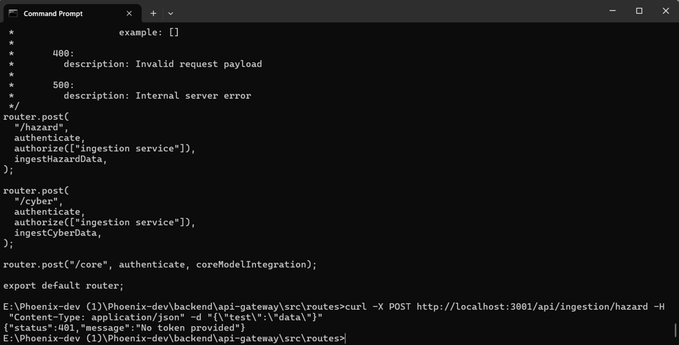

B-03 is FIXED - The data pages are now asking for a login. The Part A High severity issue has been fixed.

3. Part 2 Reading Login Check Code

What did we witness?
So when someone tries to get to a protected page. The system runs a piece of code that tests: " Is this person logged in ? And are they entitled to be here?' This code is in a file called auth.middleware.ts
We will go thru this file in detail, to see exactly how it works, and if there are any weak points.

How the login check works - step by step
- When a request comes in, the code checks first: is there a login token attached? If not, it immediately rejects the request with a 401 error.
- If a token exists, verify that the token is a valid by checking its signature.
- Then it looks for the user in the database to make sure the account is real.
- It also determines if the token that is in the request is the same as the token in the database. That means old tokens (before a logout) are automatically rejected.
- If everything is ok, the request is passed thru. If there’s anything wrong, it’s blocked.

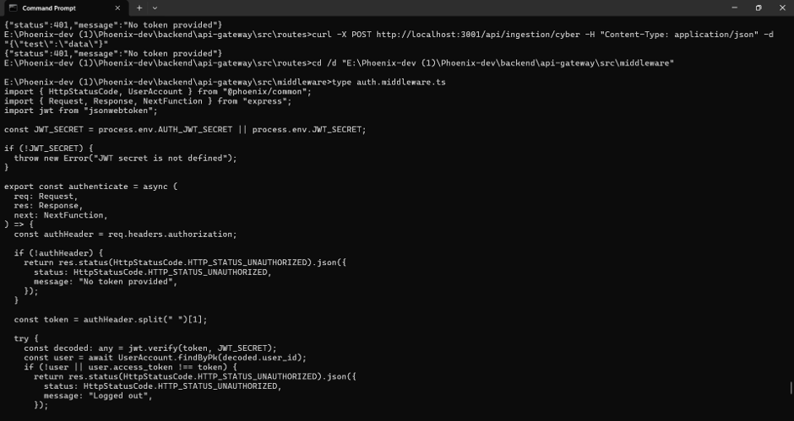

How the role check works
Once a person is confirmed as logged in, a second check decides what they are allowed to do. This is based on their role (for example, Admin, Analyst, or End User).
- The code looks at the role stored in the login token.
- It checks whether that role is in the list of roles allowed to access that page.
- If the role is not on the list, the request is blocked with a 403 Access Denied message.

One thing we noticed
The role comes directly from the login token it is not re-checked against the database. This means:
- If someone forges a token with a different role (using the weak secret we found in Week 3 - AUTH-01), the role check will trust the fake role.
- This is not a new problem on its own. It is directly linked to the AUTH-01 finding we already reported. Fixing the weak secret key will close this as well.

There is also a self-access function
The code has a special rule that lets a user access their own account information even if they don't have a high-level role. This is normal and expected. However, we need to test whether a user could change the ID in the request to try to see someone else's account. This test (called an IDOR test) is planned for Week 6 by Muath.

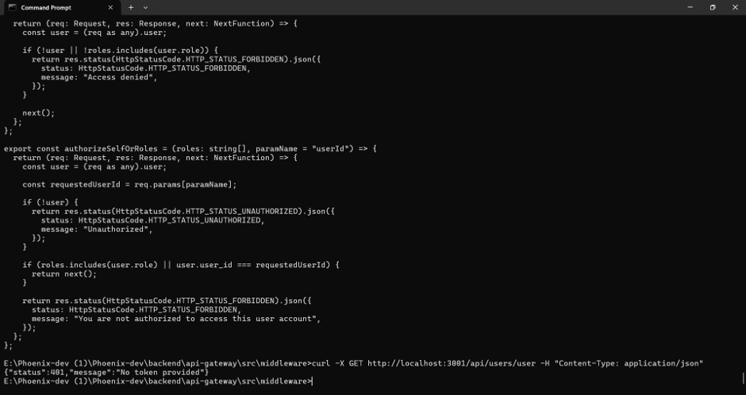

4. Extra Test Users Page
We also tested the main users page to make sure it is protected:
curl -X GET http://localhost:3001/api/users/user
→ {"status":401,"message":"No token provided"}
The users page is protected blocked without a login token.

5. Overall Result for Week 5
B-03 data pages | Fixed - login required on each page
No token = rejected | Works as expected - 401 came back right away
Checks in the database | Works - user looked up in the database on every request
Old token after logout | Rejected - token must match what is in the database
Role check | Working - wrong role gets 403 Access Denied
Role from token only | Noted - role not re-checked against database (linked to AUTH-01)
Self-access IDOR test | coming in Week 6 - Muath will test
Users page | Protected - 401 without token

