PROJECT PHOENIX
Hardhat Enterprises - Cybersecurity Stream

Authentication & RBAC Live Testing Report
Postman Collection - Phoenix Security Audit
Sprint 1 · Week 7- 8 Evidence Pack

Prepared by | Himanshu Khanna (Sub-Team Lead, Auth & RBAC Review)
Collection | Phoenix Security Audit
Target | http://localhost:3001 (Docker Compose — local)
Sprint / Week | Sprint 1 · Week 8
Final Result | 21 / 21 Tests Passed ✅ (0 Failed · 0 Skipped)

1. Overview - What We Were Trying To Do
Project Phoenix is a disaster-management backend system for Australian communities. Before it can handle real emergency data, we needed to verify that its security works properly that logins work, that only the right people can access admin features, and that nobody can brute-force their way in.
To test all of this, we built a Postman collection called Phoenix Security Audit — a set of organised API requests with automated checks built into each one. Instead of manually reading every response, Postman runs all the tests automatically and instantly tells us what passed or failed.
We grouped our tests into 4 folders:
- Authentication Tests - Does login work? Are tokens given out correctly? Does invalid login get blocked?
- RBAC & Access Control Tests - Does admin get admin access? Does analyst get blocked from admin routes?
- Endpoint Coverage Tests - Do protected ingestion endpoints reject requests with no token?
- Rate Limiting Tests - Does the system stop someone repeatedly trying wrong passwords?

2. Collection Runner Setup

Screenshot 1 - Runner Ready to Run All 11 Requests
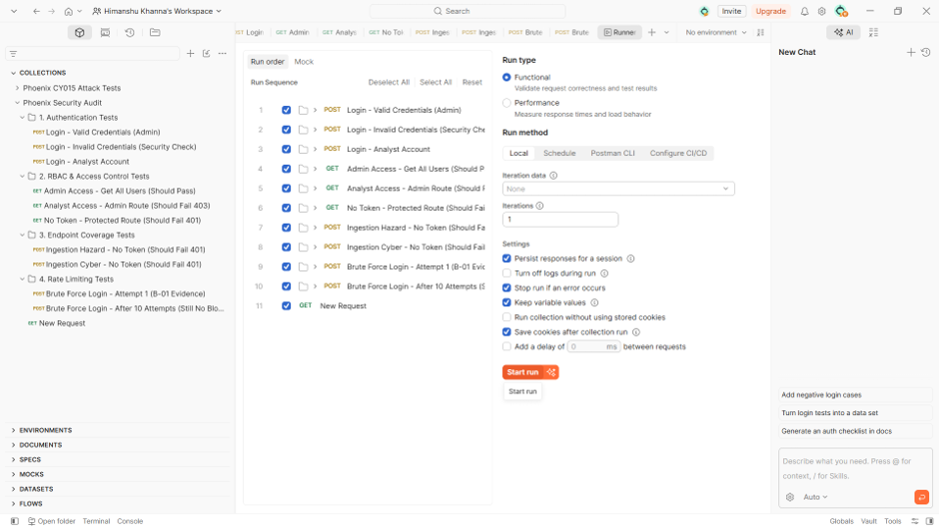

This is the Collection Runner screen in Postman think of it like a 'run all' button for the entire test suite. It shows every request in our Phoenix Security Audit collection with checkboxes, all ticked so everything runs together.
Key settings selected:
- Run type: Functional - we want to check the API behaves correctly, not measure speed.
- Iterations: 1 -run through the full list once (enough for security testing).
- Keep variable values - this is critical. When the admin login request runs first and gets back a JWT token, it saves it into a variable called admin_token. Later RBAC tests use that same saved token automatically.
Clicking Start Run is what launched the entire test sequence shown in the rest of this report. Any team member can pick up this collection in the next sprint, run it against the fixed system, and independently verify whether the vulnerabilities have been resolved.

3. Authentication Tests (Folder 1)
The first folder tested the login endpoint: POST /api/users/auth/login. This is the front door of the whole system. We ran three scenarios.

3.1 Login - Valid Credentials (Admin)
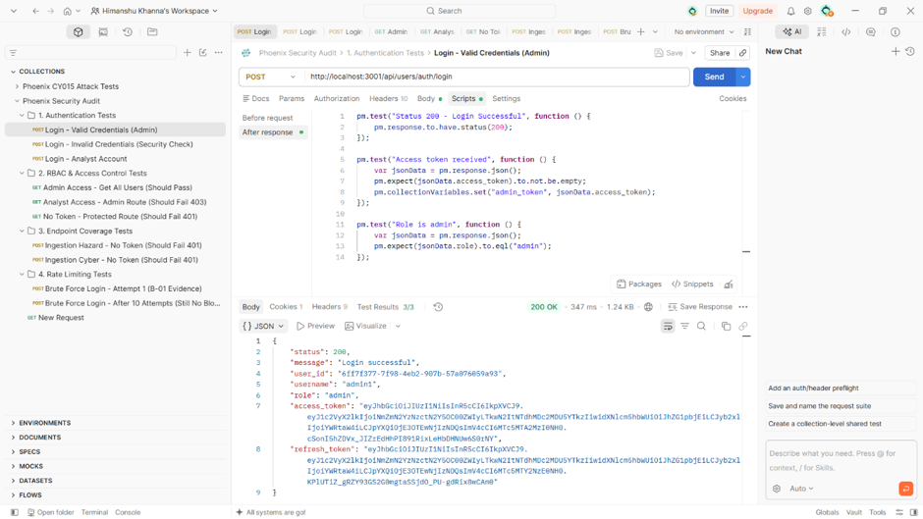
Screenshot 2: Admin login — Scripts tab showing 3 test assertions and 200 OK response with JWT tokens

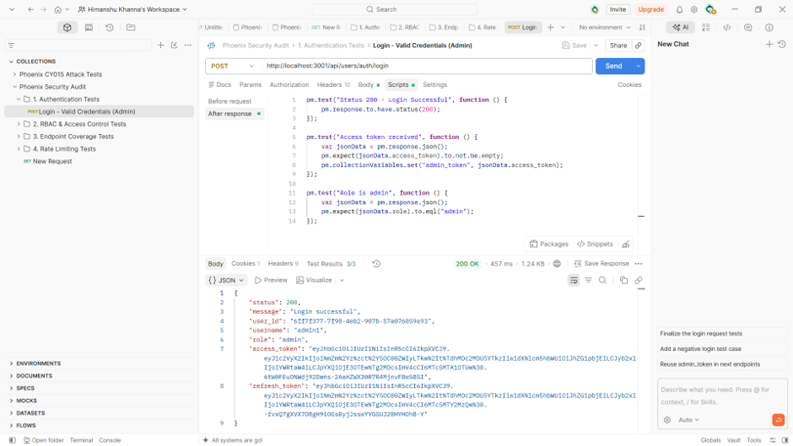

What we were testing:
We sent a login request using real admin credentials. The goal was to confirm the login endpoint works, that it gives back a JWT access token, and that the token carries the correct role of admin.
What the scripts check:
- Status 200 - Login Successful
- Access token received - the response must contain a non-empty access_token, and it gets auto-saved into the admin_token variable for RBAC tests later
- Role is admin - the returned role field must equal 'admin'
What we observed:
PASS - HTTP 200 received. Login accepted.
PASS - Access token was present and saved into admin_token variable automatically.
PASS - Response shows "role": "admin" - correct role assigned.
⚠️ Note: Although login works correctly, the JWT token is signed using a weak secret (secret123 — Finding CFG-01). Anyone who knows this key can forge tokens without going through the login page at all. This is a separate but critical finding covered in the Week 6 forgery test.

3.2 Login - Invalid Credentials (Security Check)
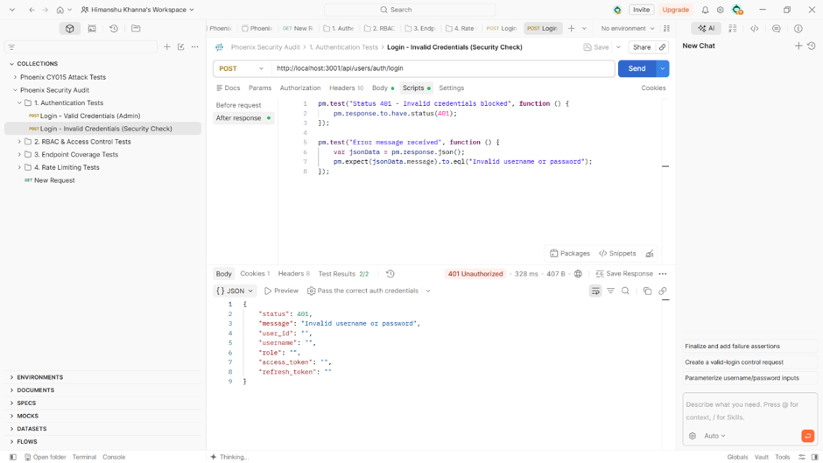

What we were testing:
We deliberately sent a login request with wrong credentials. The system should reject it with 401 and return a clear error message without revealing which part (username or password) was wrong.
What we observed:
PASS - HTTP 401 Unauthorized wrong credentials correctly rejected.
PASS - Message says 'Invalid username or password' - appropriate, non-revealing error.
Response body shows empty strings for access_token and refresh_token no token issued on failure.

3.3 Login - Analyst Account
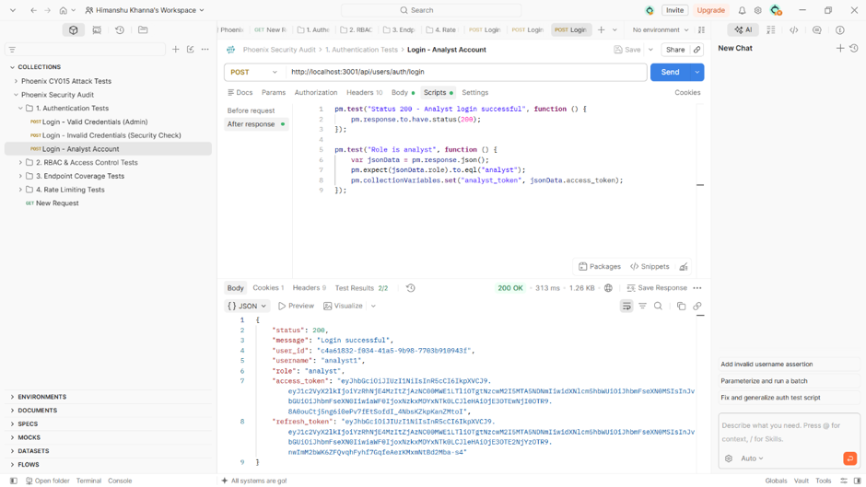
Screenshot 5: Analyst login — scripts, 200 OK response, role: analyst confirmed

What we were testing:
Same login endpoint, but using an analyst-level account (lower privilege than admin). We needed to confirm it returns the analyst role and that we can save this token into the analyst_token variable for the RBAC tests.
What we observed:
PASS - HTTP 200- analyst account exists and login succeeded.
PASS - Role is 'analyst' correct lower-privilege role returned.
Analyst token was auto-saved into analyst_token variable for use in the RBAC folder.
4. RBAC & Access Control Tests (Folder 2)
RBAC stands for Role-Based Access Control the rule that different users should only be able to do what their role allows. This folder tested all the boundaries: admin getting in, analyst being blocked, and unauthenticated requests being stopped completely.

4.1 Admin Access - Get All Users (Should Pass)
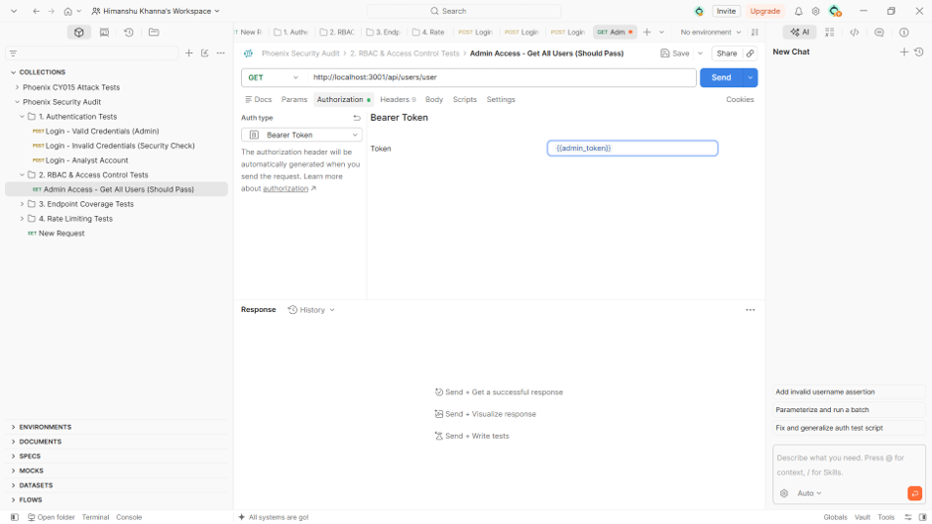

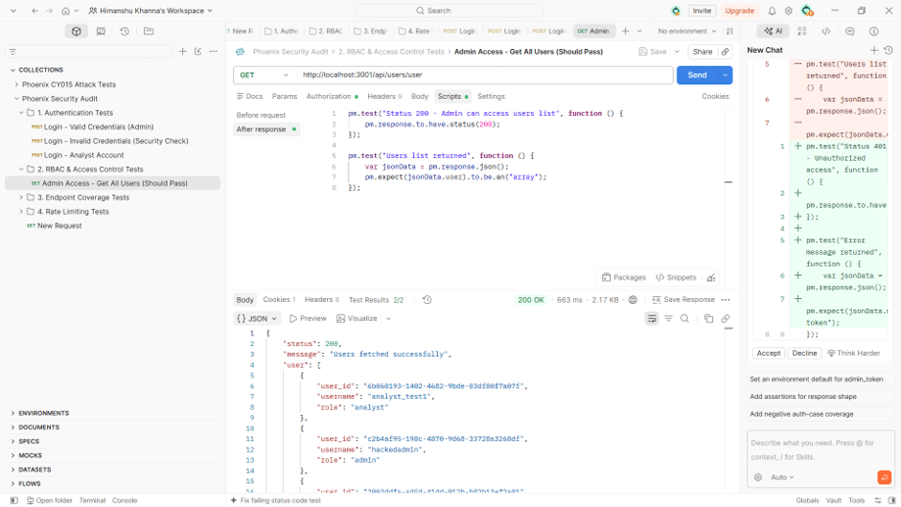

What we were testing:
Can an admin account access the list of all users? It should be able to. We attached the admin_token (saved from the login test) as a Bearer Token and hit GET /api/users/user.
Screenshot 6 shows the setup - Authorization tab with {{admin_token}} in the Bearer Token field. The double curly braces mean 'use the variable we saved earlier'. Screenshot 7 shows what came back.
What we observed:
PASS - HTTP 200 - admin can access the users list.
PASS - Response body returns an actual array of users - analyst_test1 and hackedadm1n accounts visible.
Note: 'hackedadm1n' is a deliberate seed account placed for testing purposes - not a real compromise.

4.2 Analyst Access - Admin Route (Should Fail 403)
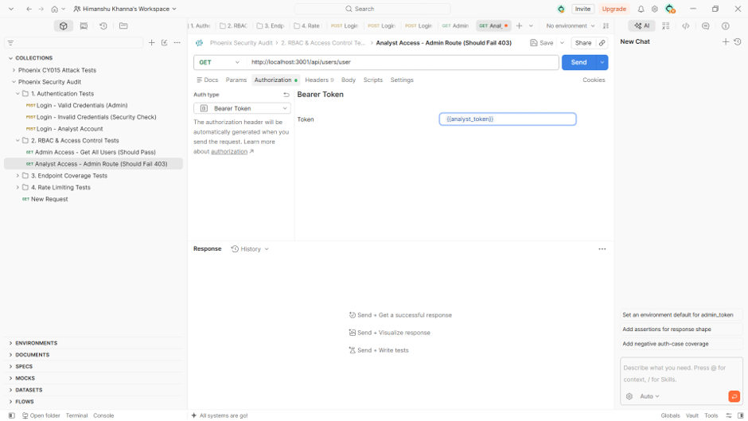

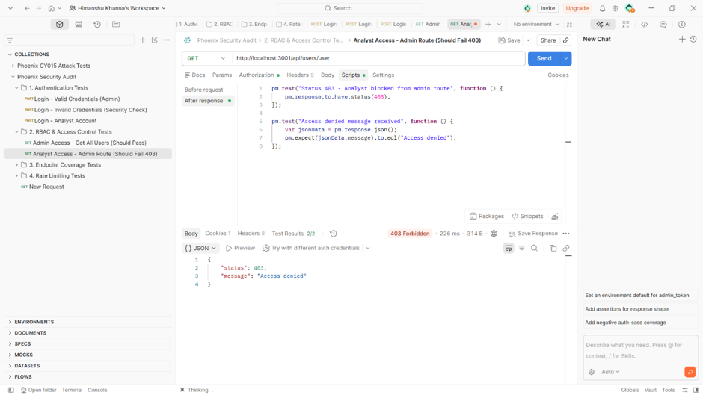

What we were testing:
This is the core RBAC test. An analyst is legitimately logged in with a valid token — but what happens if they try to access an admin-only route? The system must check the role inside the token and block them with a 403.
Screenshot 8 shows the setup - same endpoint (GET /api/users/user) but this time the analyst_token is in the Bearer Token field. The only difference from the previous test is which token we're using.
What we observed:
PASS - HTTP 403 Forbidden - analyst correctly blocked from admin route.
PASS - Message says 'Access denied' clean, correct response with no user data leaked.
RBAC is working. The role check is enforced at the middleware level.

4.3 No Token - Protected Route (Should Fail 401)
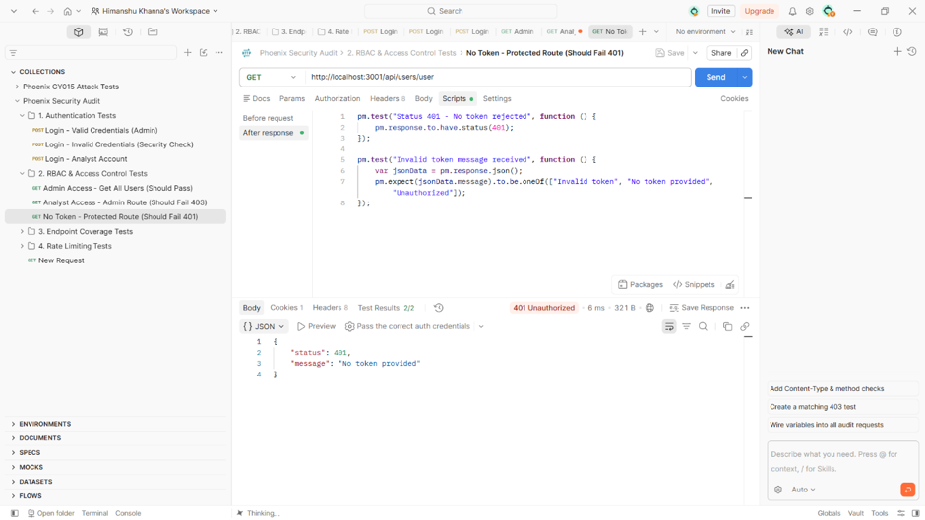
Screenshot 10: No-token test — scripts and 401 response in just 6ms

What we were testing:
What if someone sends a request with absolutely no token? The middleware should catch it immediately before any business logic runs.
What we observed:
PASS - HTTP 401 returned in just 6ms middleware catches it before any DB lookup happens.
PASS - Message says 'No token provided' clear and correct.

5. Endpoint Coverage Tests (Folder 3)
Phoenix also has data ingestion endpoints routes that accept hazard and cyber threat event data. We tested that these are also protected and can't be accessed without a token.

5.1 Ingestion Hazard No Token - (Should Fail 401)
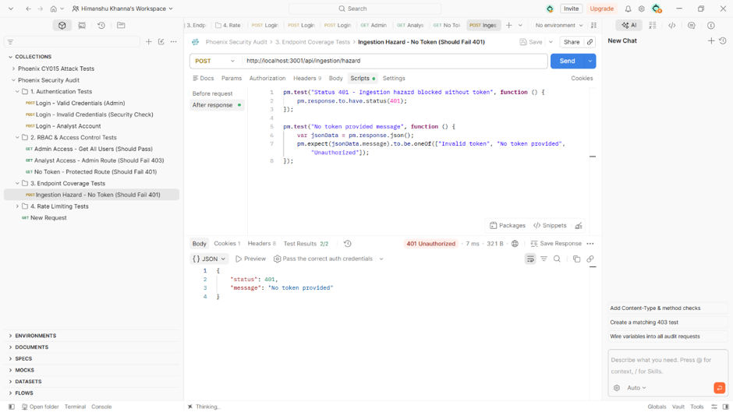

What we were testing:
POST /api/ingestion/hazard accepts disaster data. Without security, anyone on the network could inject fake hazard events. We tested it with no token to confirm it blocks unauthenticated requests.
What we observed:
PASS - HTTP 401 in 7ms - hazard ingestion endpoint correctly blocked.
PASS - Message: 'No token provided'

5.2 Ingestion Cyber - No Token (Should Fail 401)
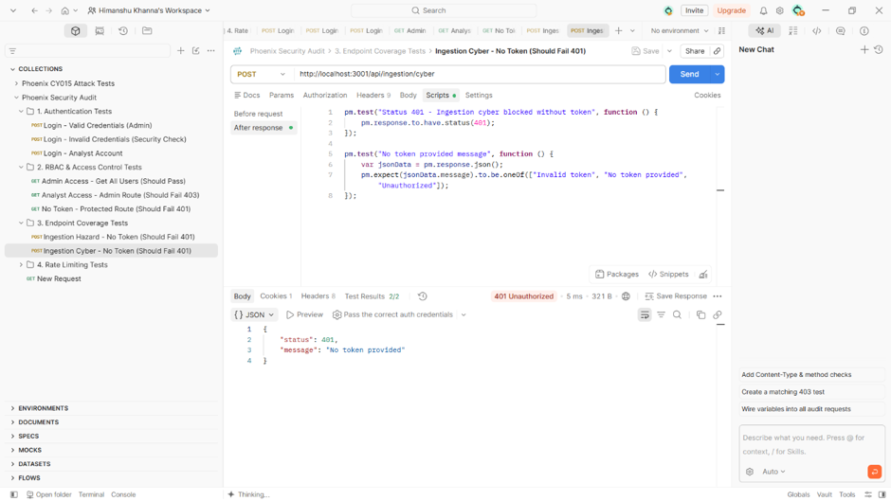

What we were testing:
Same test for the cyber threat ingestion endpoint at POST /api/ingestion/cyber.
What we observed:
PASS - HTTP 401 in 5ms - cyber ingestion endpoint correctly blocked.
PASS - Message: 'No token provided'
Context — RBAC-01 Fix Applied Before These Tests: Earlier in the sprint, a bug was found where the role check used 'ingestion service' (space) instead of 'ingestion_service' (underscore), blocking legitimate service calls. This was fixed in ingestion.routes.ts. These tests passing confirms the fix is live.

6. Rate Limiting Tests - Finding B-01 (Folder 4)
Severity: HIGH | Finding: B-01 - No Rate Limiting on Login Endpoint
Rate limiting means: after X failed login attempts, the system slows down or blocks further tries. Without it, an attacker can run an automated script trying thousands of passwords per minute called a brute force attack. We tested whether Phoenix's login endpoint has this protection. It does not.

6.1 Brute Force - Attempt 1 (B-01 Evidence)
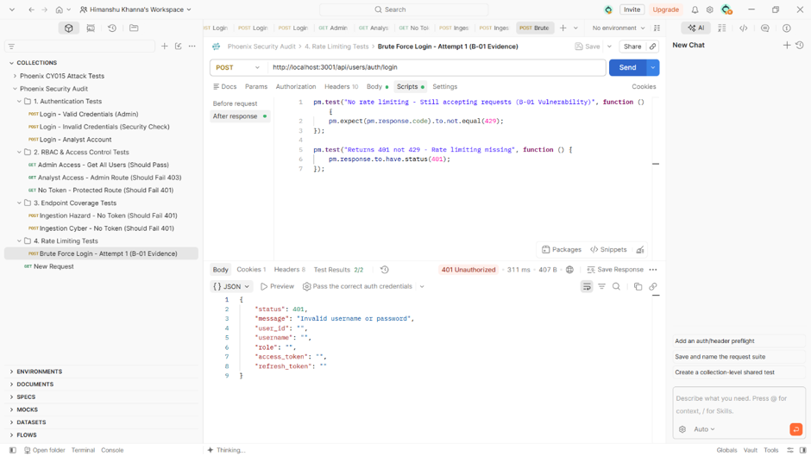
Screenshot 13: Brute force attempt 1 — scripts confirming no rate limit, 401 not 429 response

What we were testing:
We sent a wrong-credentials login request on purpose. In a protected system, even attempt 1 might start a counter. We specifically wrote tests that check the response is NOT a 429 (Too Many Requests) - because getting a 429 would mean rate limiting exists. Not getting one means the vulnerability is there.
What the scripts check (written 'backwards' on purpose):
- 'No rate limiting - Still accepting requests (B-01 Vulnerability)' - checks that response code is NOT 429
- 'Returns 401 not 429 - Rate limiting missing' - confirms we got a plain 401, not a rate-limit block
What we observed:
VULNERABILITY CONFIRMED -No 429 received system is still accepting the request. Rate limiting not triggered.
VULNERABILITY CONFIRMED - Got 401 (wrong credentials) system just says wrong password, not 'too many attempts'.

6.2 Brute Force - After 10 Attempts (Still No Block)
This test simulates having already sent 10+ wrong-password attempts. In a properly protected system, by now you'd expect a block or a 429. We confirmed nothing changed.
What we observed:
VULNERABILITY CONFIRMED - Attempt 12 - HTTP 401, no block. Server keeps processing as if it's the first request.
VULNERABILITY CONFIRMED - System still responding normally after 12 attempts - no lockout, no cooldown, no throttling.
Real-world impact: An automated script could try thousands of combinations per minute — indefinitely. Combined with the weak JWT secret (CFG-01), an attacker has two completely separate ways to get into the system. Fix: Add express-rate-limit middleware — 5 attempts per 15-minute window, return 429 with Retry-After header.

7. Full Collection Run - All 21 Tests at Once
After testing each request individually, we ran the entire collection in one automated sequence using Postman's Collection Runner. All 16 screenshots together culminate in this final run.

Screenshot 14 - Complete Run Results Summary
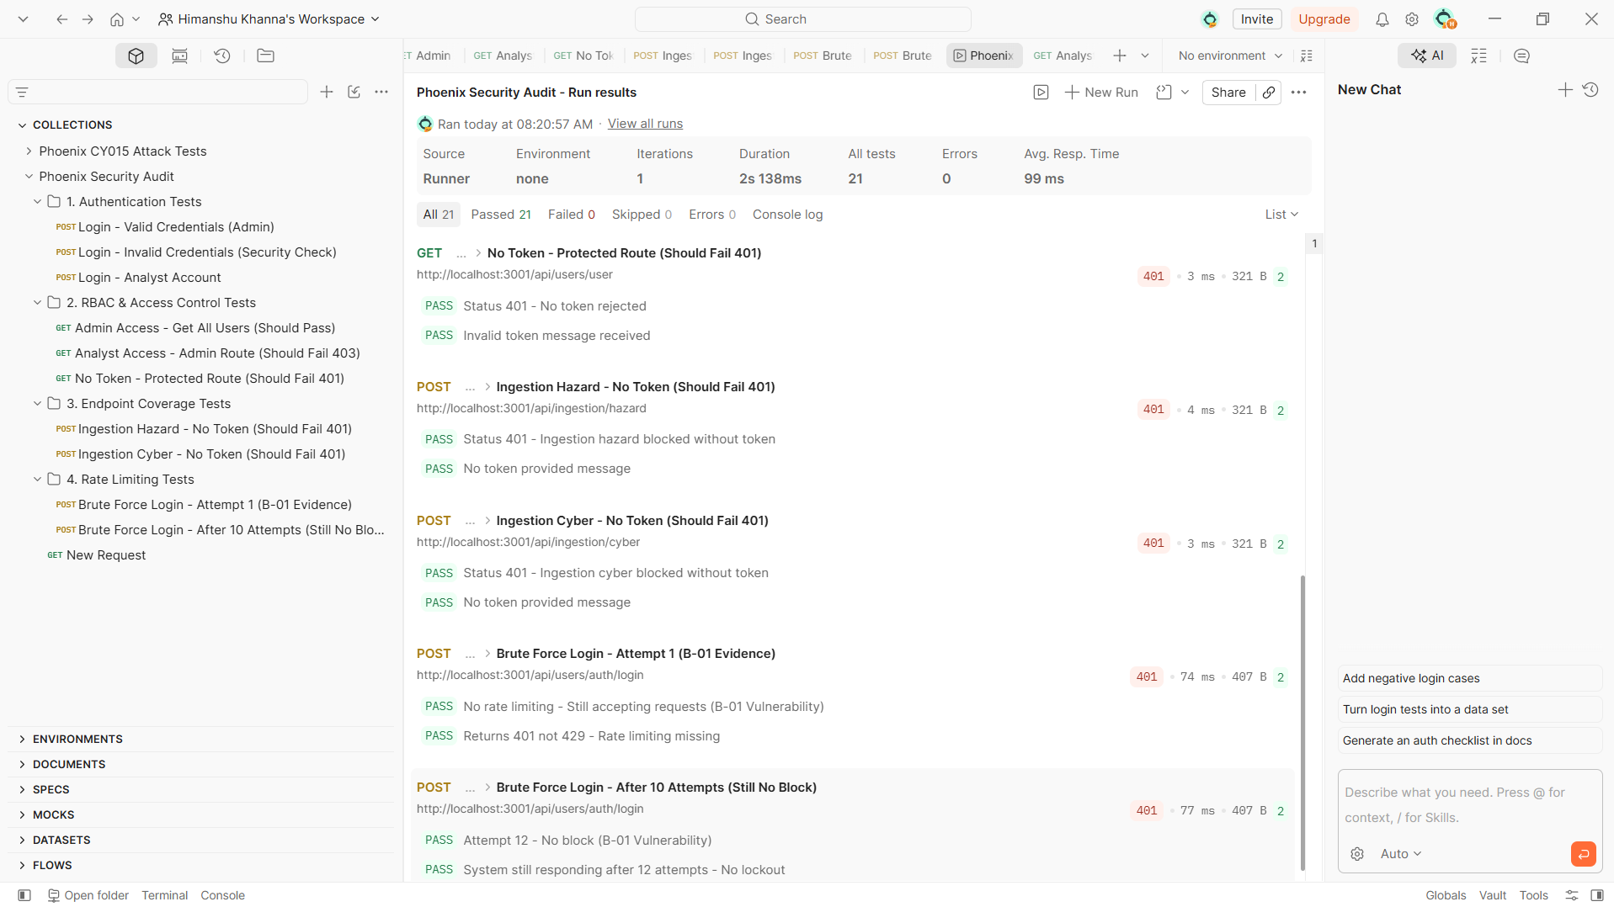

Key run stats:
- All tests: 21 | Passed: 21 | Failed: 0 | Skipped: 0
- Duration: 2 seconds 138ms total
- Average response time: 99ms per request
- Errors: 0

Screenshot 15 - Results List (First Half)
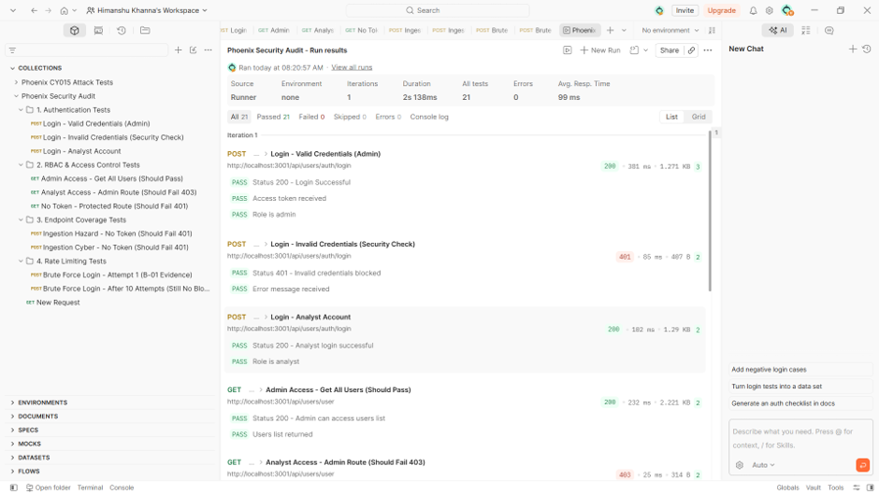

What this screenshot shows:
PASS - POST Login Valid Credentials (Admin) - 200 OK · Status 200 Login Successful · Access token received · Role is admin
PASS - POST Login Invalid Credentials - 401 · Status 401 Invalid credentials blocked · Error message received
PASS - POST Login Analyst Account - 200 OK · Status 200 Analyst login successful · Role is analyst
PASS - GET Admin Access Get All Users - 200 OK (298ms) · Admin can access users list · Users list returned
PASS - GET Analyst Access Admin Route - 403 Forbidden (25ms) · Analyst blocked · Access denied message received

Screenshot 16 - Results List (Second Half)
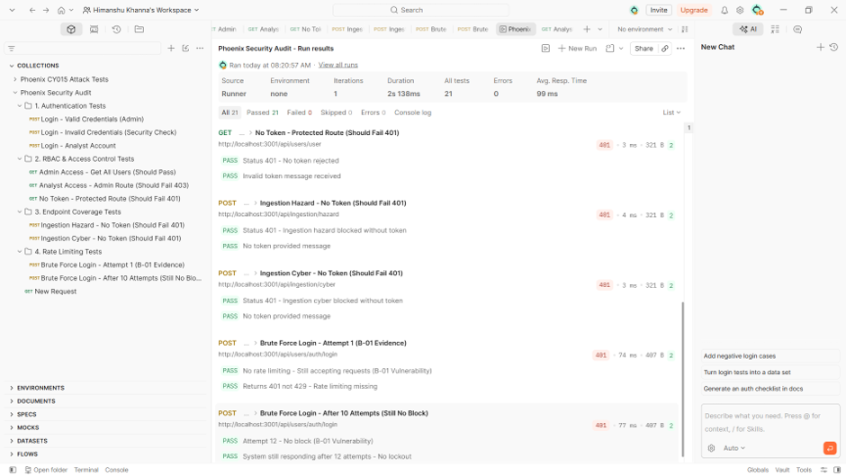

What this screenshot shows:
PASS - GET No Token Protected Route - 401 (3ms) · No token rejected · Invalid token message received
PASS - POST Ingestion Hazard No Token - 401 (4ms) · Hazard endpoint blocked without token · No token provided message
PASS - POST Ingestion Cyber No Token - 401 (3ms) · Cyber endpoint blocked without token · No token provided message
VULNERABILITY CONFIRMED - POST Brute Force Attempt 1 - 401 (74ms) · No rate limiting confirmed · Returns 401 not 429 (B-01)
VULNERABILITY CONFIRMED - POST Brute Force After 10 Attempts - 401 (77ms) · Attempt 12 no block · System still responding normally (B-01)

8. Security Findings Summary
ID | Finding | Severity | Evidence | Remediation
CFG-01 | Weak JWT signing secret (secret123) — live in running process | CRITICAL | Week 6 forgery test; login tests show tokens issued with weak key | R-01 — Rotate to 256-bit random secret; store in secret manager
CFG-02 | Weak JWT refresh secret (refreshsecret123) | CRITICAL | Refresh tokens visible in login test responses | R-01 — Same as CFG-01
B-01 | No rate limiting on login endpoint — brute force possible indefinitely | HIGH | Screenshots 13–16 — 12 attempts, no 429, no lockout | Add express-rate-limit — 5 attempts / 15 min window
RBAC-01 | Role name typo ('ingestion service' vs 'ingestion_service') — blocked legitimate service calls | HIGH - FIXED | Ingestion endpoints now correctly return 401 for no-token; fix applied in ingestion.routes.ts | Fixed

9. Conclusion
These 16 screenshots together show a complete picture of where Project Phoenix stands at the end of Sprint 1 testing: a system whose core authentication and role-based access control logic is fundamentally working, but with two significant security gaps that need to be closed before it can be used in a real disaster-response scenario.
What is working well:
- Login correctly accepts valid credentials and issues JWT tokens
- Login correctly rejects invalid credentials
- Role-based access control is enforced analysts cannot access admin routes
- All protected endpoints require a valid token no accidentally open endpoints found
- RBAC-01 role typo has been identified and fixed
- An incidental session-binding check in the API Gateway currently prevents the weak JWT secret from being used for immediate privilege escalation
What still needs to be fixed:
- CFG-01/02: JWT secrets must be rotated to strong, random 256-bit values and stored in a secret manager not in a committed .env file
- B-01: Rate limiting must be added to the login endpoint to prevent brute force attacks
- The session-binding check is not a designed security control it cannot be the last line of defence against the weak JWT secret
For next sprint: When CFG-01 and B-01 are fixed and this same Postman collection is re-run, the rate-limiting tests will start failing in Postman because the system will return 429, which breaks our 'no 429 expected' assertion. That counter-intuitive outcome is the sign-off condition confirming B-01 has been properly fixed.

