Software Development 2
BSCH-SD2

TDD Project
Date

Table of Contents
1. Overview 3
1.1 Goals 3
2. Development Process 3
2.1 Research 3
2.2 Versioning Approach 3
3. External Packages 3
4. Project Setup 3
5. Milestone 1 3
5.1 Goals 3
5.2 Unit Tests 3
5.3 Commit Logs 3
5.4 Full Log Details 3
6. Milestone 2 4
6.1 Goals 4
6.2 Unit Tests, Integration tests 4
6.3 Full Log Details 4
7. Milestone 3 4
7.1 Goals 4
7.2 Unit Tests Integration 4
7.3 Commit List & Branches Tree 4
7.4 Full Log Details 4
8. Bibliography 4

Student name: | Student 1: Hardik rathee  Student 2: Akshay jolly  Student 3: John jose Pullan  Student 4: Syril Chereiyan
Student number: | Student 1: 3173940  Student 2: 3165312  Student 3: 3153228  Student 4: 3158072
Faculty: | Computing Science
Course: | BSCH |  |  | Stage/year: | 2
Subject: | Software Development 2
Study Mode: | Full time |  |  | Part-time
Lecturer Name: | Haseeb Younis
Assignment Title: | SD2 Project - Final Documentation
Date due: | 31-03-2026
Date submitted: | 31-03-2026
Plagiarism disclaimer:
I understand that plagiarism is a serious offence and have read and understood the college policy on plagiarism. I also understand that I may receive a mark of zero if I have not identified and properly attributed sources which have been used, referred to, or have in any way influenced the preparation of this assignment, or if I have knowingly allowed others to plagiarise my work in this way.

I hereby certify that this assignment is my own work, based on my personal study and/or research, and that I have acknowledged all material and sources used in its preparation. I also certify that the assignment has not previously been submitted for assessment and that I have not copied in part or whole or otherwise plagiarised the work of anyone else, including other students.
Signed: Hardik Date: 30/03/2026
Signed: Akshay Date: 30/03/2026
Signed: John Date: 30/03/2026
Signed: Syril Date: 30/03/2026
Please note: Students MUST retain a hard / soft copy of ALL assignments as well as a receipt issued and signed by a member of Faculty as proof of submission.

Overview

Goals
The aim of this project is to develop a simple 2D racing game called “Racing Legends” using Java Swing. The project follows Test-Driven Development (TDD) principles, ensuring that all functionalities are tested before and after implementation.
Game Rules
- The player controls a car using W, A, S, D keys
- The car must stay within the track boundaries
- If the car hits the boundary, it stops
- The game continuously updates position and movement
Features
- Smooth car movement (Up, Down, Left, Right)
- Track with boundaries and lane lines
- Collision detection system
- Real-time FPS counter
- UI showing controls and car position
- Image-based rendering (car and track)
- Full unit testing using JUnit

Development Process
Game Rules
- The player controls a car using W, A, S, D keys
- The car must stay within the track boundaries
- If the car hits the boundary, it stops
- The game continuously updates position and movement
Features
- Smooth car movement (Up, Down, Left, Right)
- Track with boundaries and lane lines
- Collision detection system
- Real-time FPS counter
- UI showing controls and car position
- Image-based rendering (car and track)
- Full unit testing using JUnit

Research
During the project, the following technologies were researched:
- Java Swing (javax.swing) for GUI
- Graphics2D for rendering
- JUnit 5 for testing
- Game loop implementation using threads
- Image handling using BufferedImage and ImageIO

External Packages
The project uses:
- JUnit 5 → for unit testing
- Java Swing (built-in) → GUI rendering
- AWT Graphics → drawing UI and objects
No external APIs were used

Project Setup
Folder Structure
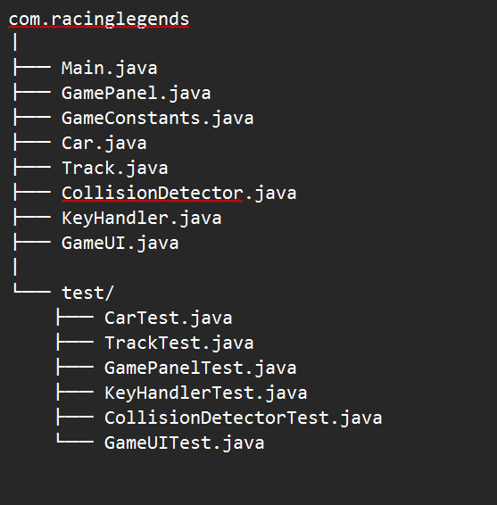
Class Diagram
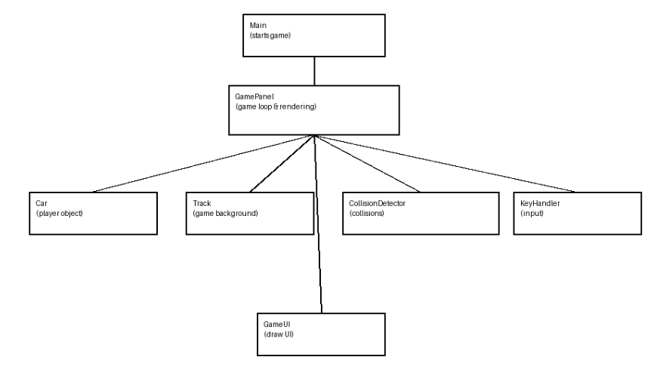

Milestone 1

Goals
The aim of Milestone 1 was to build the basic foundation of the Racing Legends game. This includes setting up the game window, implementing player movement, and handling keyboard input.
Objectives:
- Create the main game window using Java Swing
- Implement a player-controlled car
- Add keyboard controls (W, A, S, D)
- Enable basic movement logic
- Set up initial project structure

Achievements
- Successfully created the game window using JFrame and JPanel
- Implemented the Car class with position and movement logic
- Added KeyHandler class to capture keyboard input
- Enabled smooth movement in all four directions
- Set up GamePanel with a basic game loop
- Defined constants using GameConstants class

Issues
- Initial difficulty in handling keyboard input properly
- Movement logic caused unexpected behavior before fixing velocity updates
- Game loop timing required adjustment for smoother movement
- Understanding Java Swing rendering (paintComponent) took time

Testing
Explanation of Tests Added
The following unit tests were implemented to ensure correctness:
Car Tests
- Test initial position of the car
- Test movement:
  - Move up
  - Move down
  - Move left
  - Move right
- Test stop functionality
- Test bounds update when position changes
- Why?
To ensure the car moves correctly and updates its position properly.

KeyHandler Tests
- Test W key press (move up)
- Test S key press (move down)
- Test A key press (move left)
- Test D key press (move right)
- Test key release functionality
- Test reset functionality
- Why?
To ensure user input is correctly captured and controls work as expected.

GamePanel Tests
- Test GamePanel creation
- Test window size and focusability
- Test game constants
- Why?
To ensure the game initializes correctly and core settings are valid.

Commit Logs & Branches Tree

Milestone 2

Goals
Milestone aims:
- Add collision detection between cars (preparation for multiplayer).
- Introduce a second player (Player 2) with arrow key controls.
- Display basic UI with instructions and car position.
- Expand unit tests to cover new collision logic.

Achievements:
- Enhanced CollisionDetector with checkCarCollision() method and tests.
- Added GameUI class to centralise UI drawing.
- Updated GamePanel to create and update a second car (Player 2) with separate keys.
- Both players can move simultaneously, and collisions are detected.
- All existing tests pass; new tests added for collision scenarios.

Issues:
- Concurrent key presses sometimes caused “stuck” movement; resolved by resetting all direction flags on key release.
- Collision detection triggered too often when cars overlapped; we implemented a simple response (both cars stop) but deferred proper collision response to Milestone 3.
- The UI overlapped the track when car positions were displayed; moved UI to a dedicated corner.

Testing
Explanation of what tests were added and why.
- CollisionDetectorTest
  - testCarCollision() – Checks that two overlapping cars return true (collision detected).
  - testCarNoCollision() – Checks that non-overlapping cars return false (no collision).
- KeyHandlerTest
  - Tests Player 2 key mappings: arrow keys (up, down, left, right).
  - Verifies that key releases correctly reset the corresponding flags.
  - Confirms that the reset() method clears all keys for both players.
- GameUITest
  - testDrawControlsBoxDoesNotThrow() – Ensures the UI drawing method executes without crashing.
  - testDrawUIHandlesNullCar() – Verifies that the UI safely handles a null car reference (no exception).
- GamePanelTest
  - Added a test to confirm that two cars are created when the game panel is initialised.
  - Verifies that the game loop updates both cars each frame.

Commit Logs & Branches Tree
- b2c3d4e – Add CollisionDetector with car‑car collision method
- c3d4e5f – Extend KeyHandler for Player 2 (arrow keys)
- d4e5f6g – Create GameUI class and move UI drawing out of GamePanel
- e5f6g7h – Add second car to GamePanel; update game loop to handle both players
- f6g7h8i – Implement collision detection between players (stop both cars on collision)
- g7h8i9j – Add unit tests for new collision and UI features
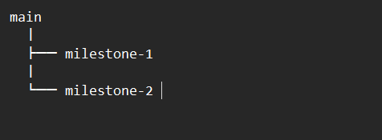

Milestone 3

Goals
Milestone aims:
Achievements:
Issues:

Testing
Explanation of what tests were added and why.

Commit Logs & Branches Tree

Bibliography

End of Document

