**MODULE – 5**

**(DBMS Assignment)**

**• Topics Covered Basics of Database**

1. **What do you understand By Database**

**Answer:** A database is an organized collection of structured information, or data, typically stored electronically in a computer system. A database is usually controlled by a database management system (DBMS).

1. **What is Normalization?**

**Answer:** Normalization is the process of organizing data in a database. It includes creating tables and establishing relationships between those tables according to rules designed both to protect the data and to make the database more flexible by eliminating redundancy and inconsistent dependency.

**3. What is Difference between DBMS and RDBMS?**

**Answer:** The main differences are: RDBMS stores data in the form of tables, whereas DBMS stores data in the form of files. Single users are supported by DBMS, whereas multiple users are supported by RDBMS. Client-server architecture is not supported by DBMS, although it is supported by RDBMS.

**4.What is MF Cod Rule of RDBMS Systems?**

**Answer:**

Codd’s rules are proposed by a computer scientist named Dr. Edgar F. Codd and he also invent the relational model for database management. These rules are made to ensure data integrity, consistency, and usability. This set of rules basically signifies the characteristics and requirements of a relational database management system ([RDBMS](https://www.geeksforgeeks.org/rdbms-full-form/)). In this article, we will learn about various Codd’s rules.

**Codd’s Rules in DBMS**

**Rule 1: The Information Rule**

All information, whether it is user information or metadata, that is stored in a database must be entered as a value in a cell of a table. It is said that everything within the database is organized in a table layout.

**Rule 2: The Guaranteed Access Rule**

Each data element is guaranteed to be accessible logically with a combination of the table name, primary key (row value), and attribute name (column value).

**Rule 3: Systematic Treatment of NULL Values**

Every Null value in a database must be given a systematic and uniform treatment.

**Rule 4: Active Online Catalog Rule**

The database catalog, which contains metadata about the database, must be stored and accessed using the same relational database management system.

**Rule 5: The Comprehensive Data Sublanguage Rule**

A crucial component of any efficient database system is its ability to offer an easily understandable data manipulation language ([DML](https://www.geeksforgeeks.org/dml-full-form/)) that facilitates defining, querying, and modifying information within the database.

**Rule 6: The View Updating Rule**

All views that are theoretically updatable must also be updatable by the system.

**Rule 7: High-level Insert, Update, and Delete**

A successful database system must possess the feature of facilitating high-level insertions, updates, and deletions that can grant users the ability to conduct these operations with ease through a single query.

**Rule 8: Physical Data Independence**

Application programs and activities should remain unaffected when changes are made to the physical storage structures or methods.

**Rule 9: Logical Data Independence**

Application programs and activities should remain unaffected when changes are made to the logical structure of the data, such as adding or modifying tables.

**Rule 10: Integrity Independence**

Integrity constraints should be specified separately from application programs and stored in the catalog. They should be automatically enforced by the database system.

**Rule 11: Distribution Independence**

The distribution of data across multiple locations should be invisible to users, and the database system should handle the distribution transparently.

**Rule 12: Non-Subversion Rule**

If the interface of the system is providing access to low-level records, then the interface must not be able to damage the system and bypass security and integrity constraints.

**5. What do you understand ByData Redundancy?**

**Answer:** Data redundancy occurs when the same piece of data exists in multiple places, whereas data inconsistency is when the same data exists in different formats in multiple tables.

**6. What is DDL Interpreter?**

**Answer:** DDL Interpreter interprets the DDL statements and records the generated statements in the table containing metadata.

**7. What is DML Compiler in SQL?**

**Answer:**

**DML Commands in SQL**

**DML is an abbreviation of Data Manipulation Language.**

The DML commands in Structured Query Language change the data present in the SQL database. We can easily access, store, modify, update and delete the existing records from the database using DML commands.

**Following are the four main DML commands in SQL:**

1. SELECT Command
2. INSERT Command
3. UPDATE Command
4. DELETE Command

**8. What is SQL Key Constraints writing an Example of SQL Key Constraints**

**Answer:**

**SQL Constraints**

In a database table, we can add rules to a column known as constraints. These rules control the data that can be stored in a column.

* **NOT NULL**
* **UNIQUE**
* **PRIMARY KEY**
* **FOREIGN KEY**
* **CHECK**
* **DEFAULT**
* **CREATE INDEX**

**NOT NULL Constraint**

The NOT NULL constraint in a column means that the column cannot store NULL values. For example,

CREATE TABLE Colleges (

college_id INT NOT NULL,

college_code VARCHAR(20) NOT NULL,

college_name VARCHAR(50)

);

Here, college_id the college_id and the college_code columns of the Colleges table won't allow NULL values.

**UNIQUE Constraint**

The UNIQUE constraint in a column means that the column must have unique value. For example,

CREATE TABLE Colleges (

college_id INT NOT NULL UNIQUE,

college_code VARCHAR(20) UNIQUE,

college_name VARCHAR(50)

);

Here, the value of the college_code column must be unique. Similarly, the value of college_id must be unique as well as it cannot store NULL values.

**PRIMARY KEY Constraint**

The PRIMARY KEY constraint is simply a combination of NOT NULL and UNIQUE constraints. It means that the column value is used to uniquely identify the row. For example,

CREATE TABLE Colleges (

college_id INT PRIMARY KEY,

college_code VARCHAR(20) NOT NULL,

college_name VARCHAR(50)

);

Here, the value of the college_id column is a unique identifier for a row. Similarly, it cannot store NULL value and must be UNIQUE.

**FOREIGN KEY Constraint**

The FOREIGN KEY (REFERENCES in some databases) constraint in a column is used to reference a record that exists in another table. For example,

CREATE TABLE Orders (

order_id INT PRIMARY KEY,

customer_id int REFERENCES Customers(id)

);

Here, the value of the college_code column references the row in another table named Customers.

It means that the value of customer_id in the Orders table must be a value from the id column of the Customers table.

**CHECK Constraint**

The CHECK constraint checks the condition before allowing values in a table. For example,

CREATE TABLE Orders (

order_id INT PRIMARY KEY,

amount int CHECK (amount >= 100)

);

Here, the value of the amount column must be **greater than or equal to 100**. If not, the SQL statement results in an error.

**DEFAULT Constraint**

The DEFAULT constraint is used to set the default value if we try to store NULL in a column. For example,

CREATE TABLE College (

college_id INT PRIMARY KEY,

college_code VARCHAR(20),

college_country VARCHAR(20) DEFAULT 'US'

);

Here, the default value of the college_country column is **US**.

If we try to store the NULL value in the college_country column, its value will be **US**.

**CREATE INDEX Constraint**

If a column has CREATE INDEX constraint, it's faster to retrieve data if we use that column for data retrieval. For example,

-- create table

CREATE TABLE Colleges (

college_id INT PRIMARY KEY,

college_code VARCHAR(20) NOT NULL,

college_name VARCHAR(50)

);

-- create index

CREATE INDEX college_index

ON Colleges(college_code);

Here, the SQL command creates an index named college_index on the Colleges table using college_id column.

**Note:** We cannot see the speed difference with less records in a table. However, we can easily notice the speed difference between using indexes and not using indexes.

**9. What is save Point? How to create a save Point write a Query?**

**Answer:**

**Savepoint in SQL**

* Savepoint is a command in SQL that is used with the rollback command.
* It is a command in Transaction Control Language that is used to mark the transaction in a table.
* Consider you are making a very long table, and you want to roll back only to a certain position in a table then; this can be achieved using the savepoint.
* If you made a transaction in a table, you could mark the transaction as a certain name, and later on, if you want to roll back to that point, you can do it easily by using the transaction's name.
* Savepoint is helpful when we want to roll back only a small part of a table and not the whole table. In simple words, we can say savepoint is a bookmark in SQL.

Let us see the practical examples to understand this concept more clearly. We will use the MySQL database for writing all the queries**.**

**10. What is trigger and how to create a Trigger in SQL?**

**Answer:**

**Triggers in SQL Server**

A trigger is a set of SQL statements that reside in system memory with unique names. It is a specialized category of stored procedure that is called automatically when a database server event occurs. Each trigger is always associated with a table.

A **trigger is called a special procedure** because it cannot be called directly like a stored procedure. The key distinction between the trigger and procedure is that a trigger is called automatically when a data modification event occurs against a table. A stored procedure, on the other hand, must be invoked directly.

**The following are the main characteristics that distinguish triggers from stored procedures:**

* We cannot manually execute/invoked triggers.
* Triggers have no chance of receiving parameters.
* A transaction cannot be committed or rolled back inside a trigger.

**SQL Queries**

1. **Create Table Name : Student and Exam**

**Create Table:**

CREATE TABLE student

(Rollno int PRIMARY KEY, Name varchar(50),Branch varchar(50));

**Insert Data:**

INSERT INTO student values

(1,"Jay","ComputerScience"),

(2,"Suhani","Electronicand Com"),

(3,"Kriti","Electronic and Com");

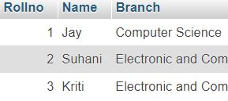

**Create Table:**

CREATE TABLE Exam

(Rollno int,S_code varchar(50), Marks int, P_code varchar(50),

 FOREIGN KEY (Rollno) REFERENCES student (Rollno));

**Insert data:**

insert into Exam values

 (1, "CS11", 50, "CS"),

 (1, "CS12", 60, "CS"),

 (2, "EC101", 66, "EC"),

(2, "EC102", 70, "EC"),

(3, "EC101", 45, "EC"),

(3, "EC102", 50, "EC");

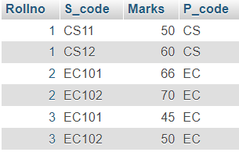**(Q-2)1.Create table given below: Employee and IncentiveTable**

**Create table:**

create table Employee (Employee_id int, First_name

varchar(50), Last_name varchar(50), Salary int,

Joining_date DateTime, Department varchar(50));

**Insert Data:**

INSERT INTO Employee VALUES

(1, 'John', 'Abraham', 1000000, '2013-01-012:00:00 AM', 'Banking'),

(2, 'Michael', 'Clarke', 800000, '2013-01-05 12:00:00 AM', 'Insurance'),

(3, 'Roy', 'Thomas', 700000, '2013-01-07 12:00:00 AM', 'Banking'),

(4, 'Tom', 'Jose', 600000, '2013-01-07 12:00:00 AM', 'Insurance'),

(5, 'Jerry', 'Pinto', 650000, '2013-01-09 12:00:00 AM', 'Insurance'),

(6, 'Philip', 'Matthew', 750000, '2013-01-08 12:00:00 AM', 'Services'),

 (7, 'TestName1', '123', 650000, '2013-01-12 12:00:00 AM', 'Services'),

(8, 'TestName2', 'LnameTest', 600000, '2013-01-12 12:00:00 AM', 'Insurance');

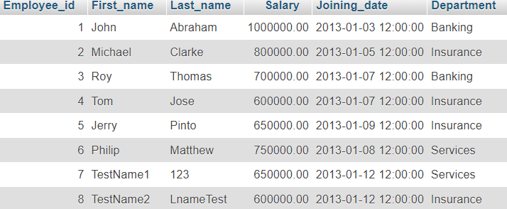

**2.Table Name : Incentive**

**Create table:**

CREATE TABLE Incentive

( Employee_ref_id INT, Incentive_date DATE, Incentive_amount

 DECIMAL(10, 2), FOREIGN KEY (Employee_ref_id) REFERENCES

 Employee(Employee_id) );

**Insert Data:**

INSERT INTO Incentive VALUES

(1, '2013-02-01', 5000),

(2, '2013-02-01', 3000),

(3, '2013-02-01', 4000),

(1, '2013-01-01', 4500),

(2, '2013-01-01', 3500);

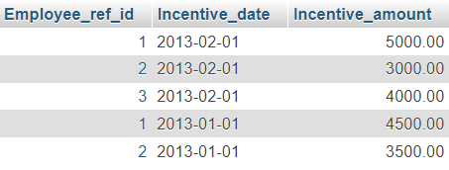

**3.Get First_Name from employee table using Tom name “Employee Name”**

**Select Query:**

SELECT First_name from employee WHERE First_name = 'Tom';

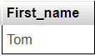

**4.Get FIRST_NAME, Joining Date, and Salary from employee table.**

select First_name, Joining_date, Salary from employee;

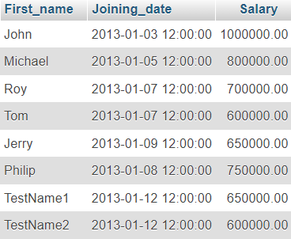

**5. Get all employee details from the employee table order by First_Name Ascending and Salary descending?**

SELECT * FROM Employee ORDER BY First_name;

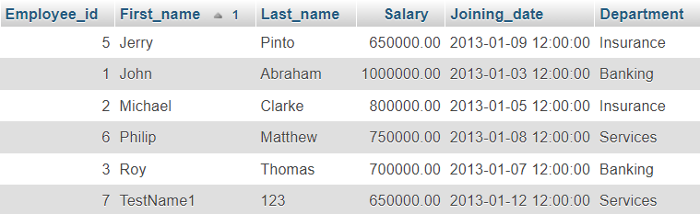

**6.Get employee details fromemployee table whose first name contains ‘J’.**

**Select Query:**

SELECT * FROM employee WHERE First_name LIKE 'J%';

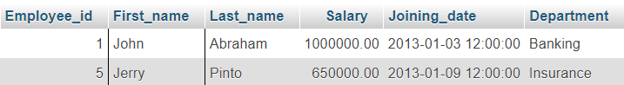

**7. Get department wise maximum salary from employee table order by**

SELECT Department, MAX(Salary) AS Max_Salary FROM Employee GROUP BY Department;

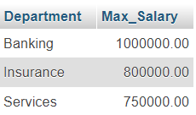

**8. salaryascending?**

SELECT * FROM Employee ORDER BY Salary ASC;

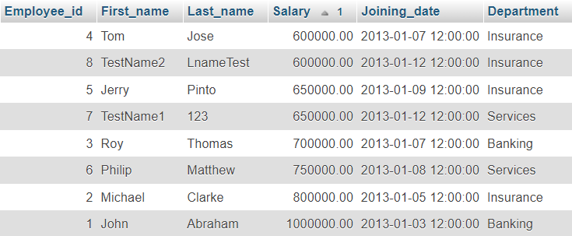**9. Select first_name, incentive amount from employee and incentives table forthose employees who have incentives and incentive amount greater than3000**

SELECT e.First_name, i.Incentive_amount FROM Employee e JOIN Incentive i ON e.Employee_id = i.Employee_ref_id WHERE i.Incentive_amount > 3000;

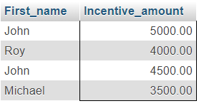

**10. Create After Insert trigger on Employee table which insert records inviewtable**

**Create Table:**

CREATE TABLE ViewTable (Employee_id INT,

First_name VARCHAR(100),Last_name VARCHAR(100),

Inserted_at DATETIME);

**Create Trigger:**

DELIMITER $$

CREATE TRIGGER after_employee_insert

AFTER INSERT ON Employee

FOR EACH ROW

BEGIN

INSERT INTO ViewTable (Employee_id, First_name, Last_name, Inserted_at)

VALUES (NEW.Employee_id, NEW.First_name, NEW.Last_name, NOW());

END$$

**DELIMITER ;**

**INSERT INTO Employee VALUES**

**(**9, John, Deo, 50000.00, '2024-10-09', 'HR'**),**

**(**10, 'Hardik', 'Garaniya', 50000.00, '2024-10-09', 'HR'**);**

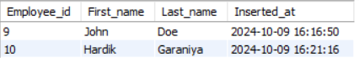

**11.Create table given below: Salesperson and Customer**

**Create Table:**

CREATE TABLE Salesperson ( SNo INT PRIMARY KEY, SName

 VARCHAR(100), City VARCHAR(100), Comm DECIMAL(3, 2) );

**Insert Data:**

INSERT INTO Salesperson VALUES

(1001, 'Peel', 'London', 0.12),

 (1002, 'Serres', 'San Jose', 0.13),

(1004, 'Motika', 'London', 0.11),

 (1007, 'Rafkin', 'Barcelona', 0.15),

 (1003, 'Axelrod', 'New York', 0.10);

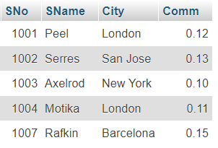

**Create Table:**

CREATE TABLE Customer ( CNo INT PRIMARY KEY, CName

VARCHAR(100), City VARCHAR(100), Rating INT, SNo INT,

 FOREIGN KEY (SNo)REFERENCES Salesperson(SNo) );

**Insert Data:**

INSERT INTO Customer VALUES

 (201, 'Hoffman', 'London', 100, 1001),

 (202, 'Giovanne', 'Roe', 100, 1003),

 (203, 'Liu', 'San Jose', 200, 1002),

 (204, 'Grass', 'Barcelona', 300, 1007),

 (206, 'Clemens', 'London', 100, 1004),

 (207, 'Pereira', 'Roe', 100, 1003);

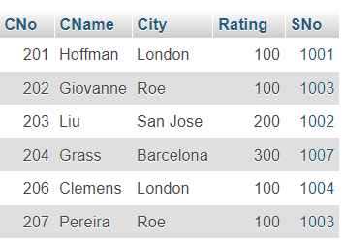

**12.Retrieve the below data from above table**

**13.All orders for more than $1000**

**Select Query:**

Select * from customer where Rating > 1000;



**14. Names and cities of all salespeople in London with commission above 0.12**

**Select Query:**

SELECT SName, City FROM Salesperson

WHERE City = 'London' AND Comm > 0.12;



**15. All salespeople either in Barcelona or in London**

**Select Query:**

SELECT * FROM Customer WHERE City = 'Barcelona' OR City = 'London';

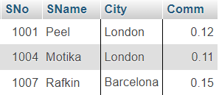

**16.All salespeople with commission between 0.10 and 0.12.(Boundary valuesshould be excluded).**

**Select Query:**

SELECT * FROM Salesperson WHERE Comm > 0.10 OR

 Comm < 0.12;

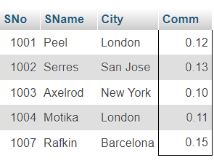

**17.All customers excluding those with rating <= 100 unless they are locatedinRome**

**Select Query:**

Select * From Customer Where (Rating > 100) OR

(City = 'Rome');

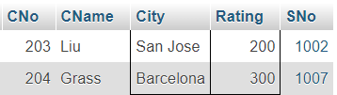

**18. Write a SQL statement that displays all the information about all salespeople**

**Create Table:**

CREATE TABLE Salespeople ( salesman_id INT PRIMARY KEY,

 name VARCHAR(100), city VARCHAR(100), commission

 DECIMAL(3, 2) );

**Insert Data:**

INSERT INTO Salespeople VALUES

 (5001, 'James Hoog', 'New York', 0.15),

 (5002, 'Nail Knite', 'Paris', 0.13),

 (5005, 'Pit Alex', 'London', 0.11),

 (5006, 'Mc Lyon', 'Paris', 0.14),

 (5007, 'Paul Adam', 'Rome', 0.13),

 (5003, 'Lauson Hen', 'San Jose', 0.12);

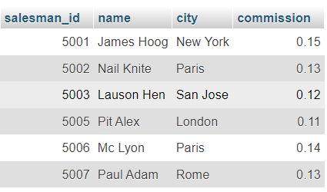

**19. From the following table, write a SQL query to find orders that are delivered by a salesperson with ID. 5001. Return ord_no, ord_date, purch_amt.**

**Create Table:**

CREATE TABLE Orders ( ord_no INT PRIMARY KEY, purch_amt

 DECIMAL(10, 2), ord_date DATE, customer_id INT,

salesman_id INT, FOREIGN KEY (salesman_id) REFERENCES

Salespeople(salesman_id) );

**Insert Data:**

INSERT INTO Orders VALUES

 (70001, 150.5, '2012-10-05', 3005, 5002),

(70009, 270.65, '2012-09-10', 3001, 5005),

 (70002, 65.26, '2012-10-05', 3002, 5001),

 (70004, 110.5, '2012-08-17', 3009, 5003),

 (70007, 948.5, '2012-09-10', 3005, 5002),

 (70005, 2400.6, '2012-07-27', 3007, 5001),

 (70008, 5760, '2012-09-10', 3002, 5001),

 (70010, 1983.43, '2012-10-10', 3004, 5006),

 (70003, 2480.4, '2012-10-10', 3009, 5003),

 (70012, 250.45,'2012-06-27', 3008, 5002),

 (70011, 75.29, '2012-08-17', 3003, 5007),

 (70013, 3045.6, '2012-04-25', 3002, 5001);

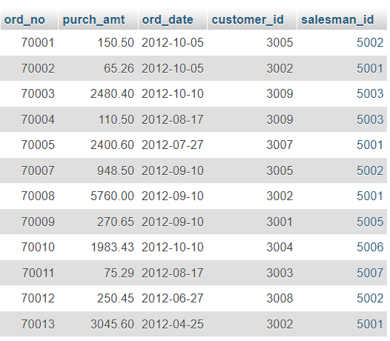

**20. From the following table, write a SQL query to select a range of products whose price is in the range Rs.200 to Rs.600. Begin and end values are included. Return pro_id, pro_name, pro_price, and pro_com.**

**Create Table:**

CREATE TABLE item_mast ( pro_id INT PRIMARY KEY, pro_name VARCHAR(100),

 pro_price DECIMAL(10, 2), pro_com INT );

**Insert Data:**

INSERT INTO item_mast VALUES

 (101, 'Mother Board', 3200.00, 15),

 (102, 'Key Board', 450.00, 16), (103, 'ZIP drive', 250.00, 14),

 (104, 'Speaker', 550.00, 16), (105, 'Monitor', 5000.00, 11),

 (106, 'DVD drive', 900.00, 12),

 (107, 'CD drive', 800.00, 12),

 (108, 'Printer', 2600.00, 13),

 (109, 'Refill cartridge', 350.00, 13),

 (110, 'Mouse', 250.00, 12);

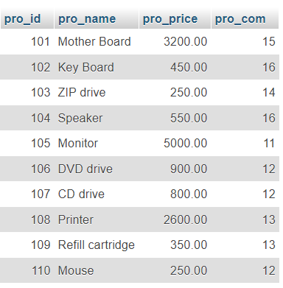

**Select Query:**

SELECT * FROM item_mast WHERE pro_price BETWEEN 200 AND 600;

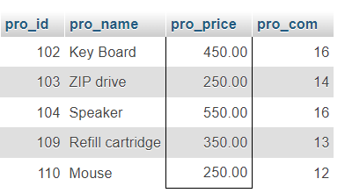

**21. From the following table, write a SQL query to calculate the average price for a manufacturer code of 16. Return avg.**

**Select Query:**

SELECT AVG(pro_price) AS avg_price FROM item_mast WHERE pro_com = 16;

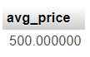

**22. From the following table, write a SQL query to display the pro_name as 'Item Name' and pro_priceas 'Price in Rs**

**Select Query:**

SELECT pro_name AS 'Item Name', pro_price AS 'Price In RS' FROM item_mast;

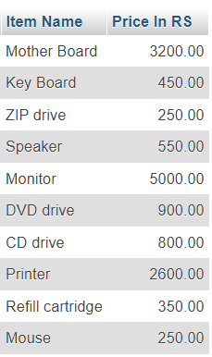

**23. From the following table, write a SQL query to find the items whose prices are higher than or equal to $250. Order the result by product price in descending, then product name in ascending. Return pro_name and pro_price**

**Select Query:**

**SELECT pro_name, pro_price FROM item_mast WHERE pro_price >= 250**

**ORDER BY pro_price DESC, pro_name ASC;**

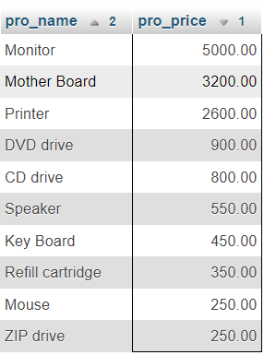

**24. From the following table, write a SQL query to calculate average price of the items for each company. Return average price and company code.**

**Select Query:**

SELECT**pro_com,  AVG(pro_price)  AS  Avg_Price  FROM  item_mast**

**GROUP BY pro_com;**

