Automatic Statistician Report
...

Dataset: iris.csv
Generated: 2026-07-02 19:23
Analysis model: llama-3.3-70b-versatile

Table of Contents
Right-click and choose “Update Field” to build the table of contents.

Executive Summary
The dataset of 150 observations shows complex relationships between variables, with strong positive correlations between petal and sepal measurements, except for sepal width which is negatively correlated. A random forest model was able to accurately classify iris species with 89% accuracy, with most errors occurring between two similar species. The model relied heavily on petal length and width to make predictions, indicating their importance in distinguishing between species. Overall, the results suggest that the model can effectively predict iris species using the given features. The analysis provides a reliable method for classification and identifies key characteristics that distinguish between species.

Data Overview
Rows | 150
Columns | 5
Missing cells | 0
Duplicate rows | 1
Numeric columns | 4
Categorical columns | 1
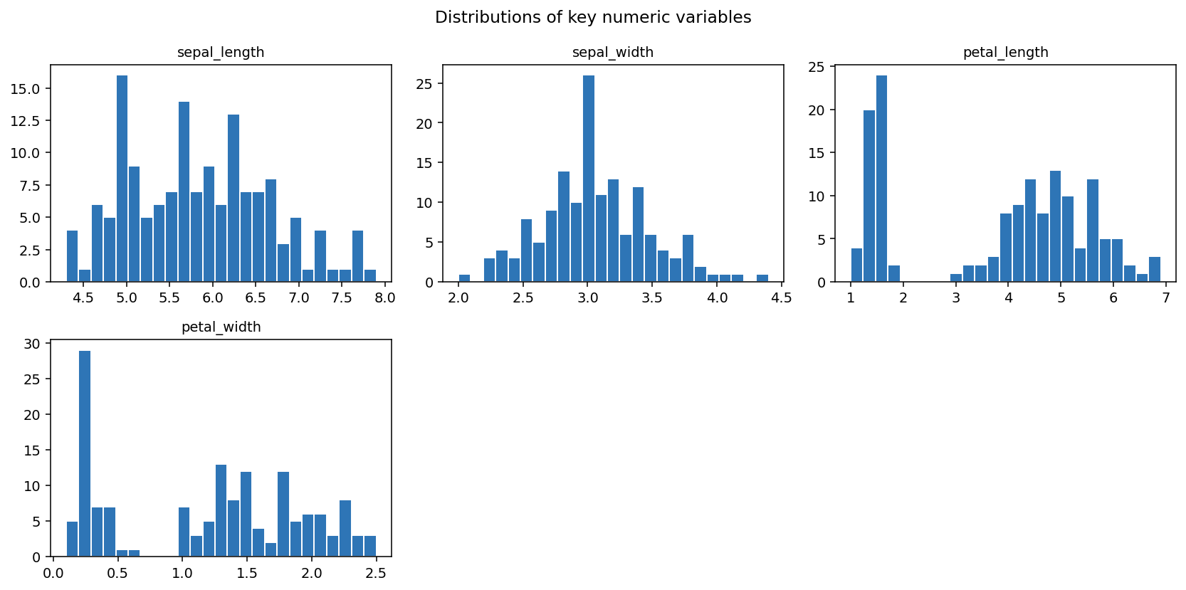
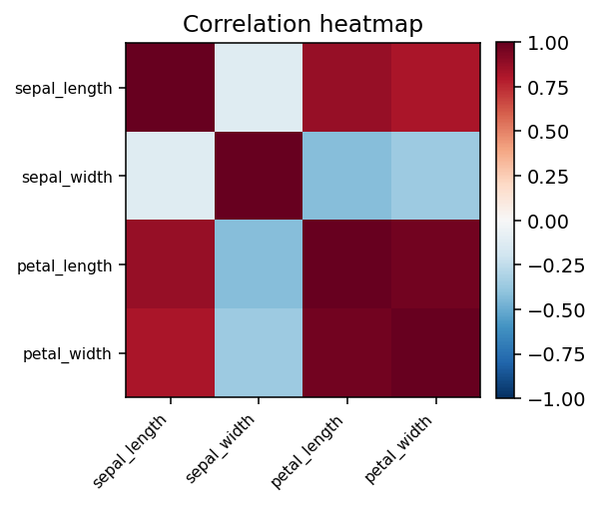

Column Reference
column | type | missing % | n unique
sepal_length | numeric | 0 | 35
sepal_width | numeric | 0 | 23
petal_length | numeric | 0 | 43
petal_width | numeric | 0 | 22
species | categorical | 0 | 3

Analysis Findings

Descriptive statistics and correlations
The dataset contains 150 observations with no missing values. Descriptive statistics show a range of values for each variable. The correlation matrix reveals strong positive correlations between petal length, petal width, and sepal length, with correlation coefficients ranging from 0.8179 to 0.9629. In contrast, sepal width is negatively correlated with the other variables, with correlation coefficients ranging from -0.1176 to -0.4284. These findings suggest that the variables are related to each other in complex ways.

Classification results
The classification test using a random forest model achieved an accuracy of 0.8947, with a macro precision of 0.903, macro recall of 0.8974, and macro F1 score of 0.8968. The confusion matrix shows that the model is able to correctly classify most of the species, with some misclassification between versicolor and virginica. The feature importances suggest that petal length and petal width are the most important features in predicting the species, with importances of 0.4558 and 0.4068, respectively. These results suggest that the model is able to effectively predict the species of iris using the given features.

Statistical Results

Descriptive Stats
Test | descriptive_stats
Columns
 | n | mean | std | min | p25 | median | p75 | max | skewness | kurtosis
sepal_length | 150 | 5.843 | 0.8281 | 4.3 | 5.1 | 5.8 | 6.4 | 7.9 | 0.3118 | -0.5736
sepal_width | 150 | 3.057 | 0.4359 | 2 | 2.8 | 3 | 3.3 | 4.4 | 0.3158 | 0.181
petal_length | 150 | 3.758 | 1.765 | 1 | 1.6 | 4.35 | 5.1 | 6.9 | -0.2721 | -1.395
petal_width | 150 | 1.199 | 0.7622 | 0.1 | 0.3 | 1.3 | 1.8 | 2.5 | -0.1019 | -1.336

Correlation Matrix
Test | correlation_matrix
Method | pearson
Matrix
 | sepal length | sepal width | petal length | petal width
sepal_length | 1 | -0.1176 | 0.8718 | 0.8179
sepal_width | -0.1176 | 1 | -0.4284 | -0.3661
petal_length | 0.8718 | -0.4284 | 1 | 0.9629
petal_width | 0.8179 | -0.3661 | 0.9629 | 1
Pairs ranked
col a | col b | r | p value
petal_length | petal_width | 0.9629 | 0
sepal_length | petal_length | 0.8718 | 0
sepal_length | petal_width | 0.8179 | 0
sepal_width | petal_length | -0.4284 | 0
sepal_width | petal_width | -0.3661 | 0
sepal_length | sepal_width | -0.1176 | 0.1519

Classification Test
Test | classification_test
Model | random_forest
Target | species
Features used | sepal_length, sepal_width, petal_length, petal_width
N train | 112
N test | 38
N classes | 3
Accuracy | 0.8947
Macro precision | 0.903
Macro recall | 0.8974
Macro f1 | 0.8968
Feature importances
Sepal length | 0.1121
Sepal width | 0.0252
Petal length | 0.4558
Petal width | 0.4068
Confusion matrix test
 | setosa | versicolor | virginica
setosa | 12 | 0 | 0
versicolor | 0 | 12 | 1
virginica | 0 | 3 | 10

Methodology Notes
Statistical tests were selected and run by an LLM-based ReAct agent operating inside a restricted code sandbox, using a fixed library of statsmodels/scipy/pingouin wrapper functions (see stats_toolkit.py). Assumption checks (normality via Shapiro-Wilk, equal variance via Levene's test, homoscedasticity via Breusch-Pagan, etc.) are reported alongside each test result. Because the underlying language model is small and runs locally, treat this report as a fast first analysis pass -- verify any decision-critical conclusion independently before relying on it.

