STEP #0:

* Open SEQ.ino file on Arduino IDE.
* Change following credentials

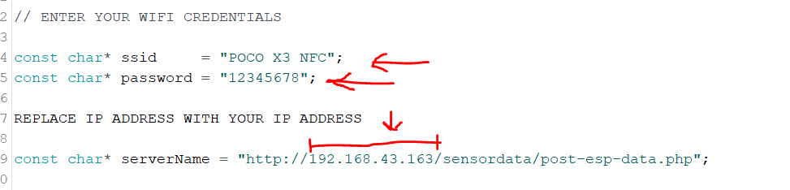

* Burn the code into your ESP32
* Open serial monitor and check if the code is working.

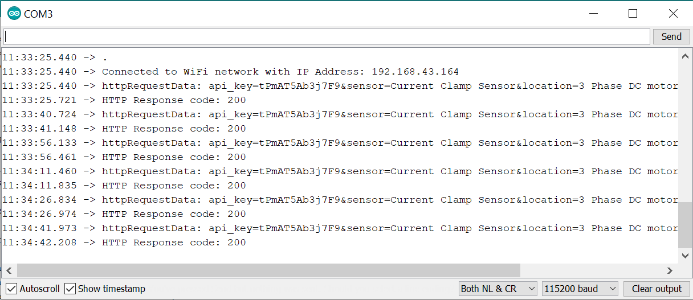

STEP #1:

* Install XAMP file in your PC.
* Open XAMP control panel and start apace and My SQL .As shown in the below.

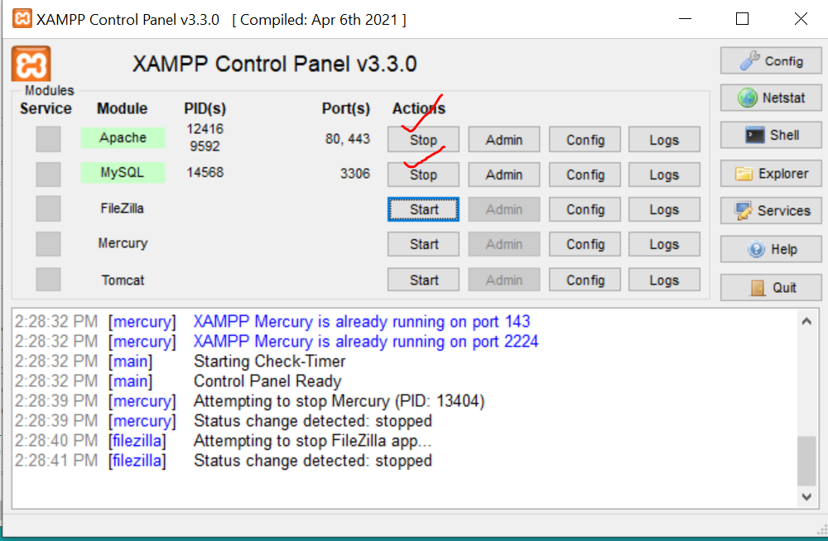

Step 2:

* Enter <http://localhost/phpmyadmin/> in the web browser and PHP my admin will php my admin will be opened.
* Press on MYSQL
* Write name *hardik*
* Press Create

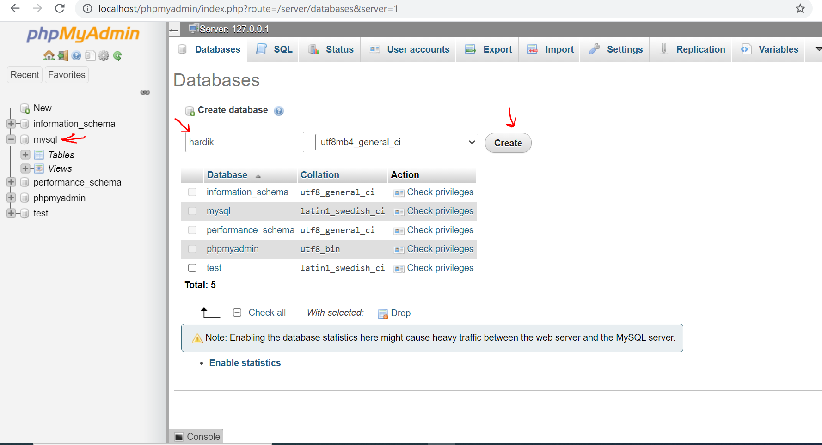

1. Press hardik
2. Press SQL page
3. Paste following code there

|  |
| --- |
| /*creating a table in the database*/  CREATE TABLE sensordata (  id int(6) UNSIGNED AUTO_INCREMENT PRIMARY KEY,  sensor varchar(30) not null,  location varchar(30) not null,  value1 varchar(10),  value2 varchar(10),  value3 varchar(10),  reading_time TIMESTAMP DEFAULT CURRENT_TIMESTAMP ON UPDATE CURRENT_TIMESTAMP  ); |

1. Press GO

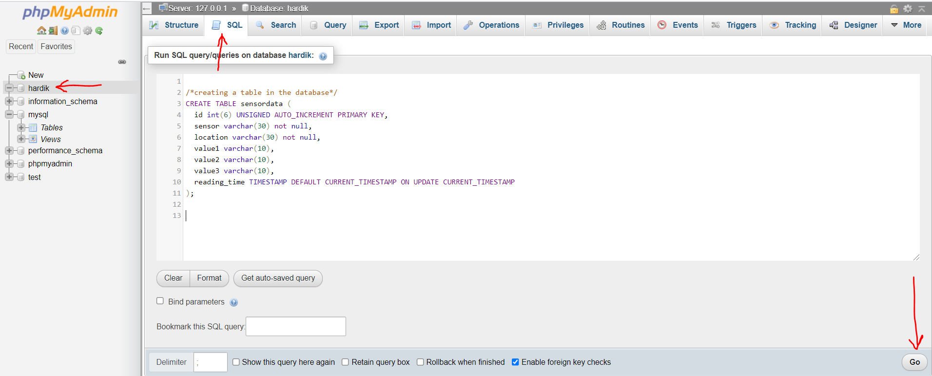

Step 3:

1. Open my computer
2. Go to following address.

C:\xampp\htdocs

1. Paste folder named sensorcode here.

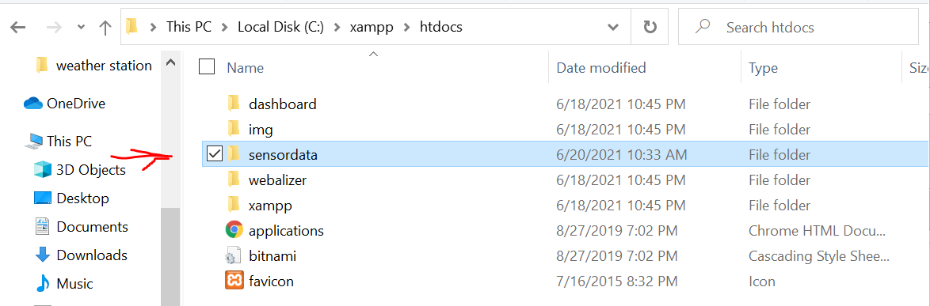

Step 4:

1. Open our your browser
2. Paste <http://localhost/sensordata/BLDC.php> your webpage will be opened there.

