Name : Hardik Patel
ID : 202103032

1. Write a program to create a class figure with method area(). Extend this class for
rectangle, square, circle. Using method overriding, override area() method to
calculate the area of rectangle, square and circle.

Code:

package com.OOP.LAB5;
class Shape{
double area_Of_Square(double l){
return l*l;
}
double area_Of_Rectangel(double l,double b){
return l*b;
}
double area_Of_Circle(double r){
return 3.14*r*r;
}
double area(){
return 0;
}
}
class Square extends Shape{
@Override
double area()
{
return area_Of_Square(2);
}
}
class Rectangle extends Shape{
@Override
double area(){
return area_Of_Rectangel(2,3);
}
}
class Circle extends Shape{
@Override
double area(){
return area_Of_Circle(1);
}
}
public class Exercise1 {
public static void main(String[] args) {
Square s1 = new Square();
//for square length must be the same for all sides
System.out.println("Area of Square = " + s1.area());
Rectangle s2 = new Rectangle();
System.out.println("Area of Rectangle = " + s2.area());
Circle s3 = new Circle();
System.out.println("Area of Circle = " + s3.area());
}
}
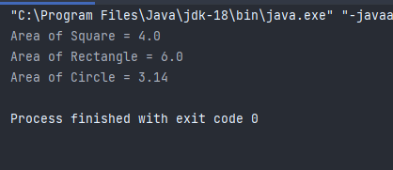
Output:

2. Write a program to calculate the sum of two , three, or four numbers. Use method
overloading to create sum() function.

Code:

package com.OOP.LAB5;
class Count{
//methode overloading
//only chang the number of arguments
int sum(int a, int b){
return a+b;
}
int sum(int a, int b, int c){
return a+b+c;
}
int sum(int a, int b, int c, int d){
return a+b+c+d;
}
}
public class Exercise2 {
public static void main(String[] args) {
Count c = new Count();
System.out.println("sum of two numbeers : " + c.sum(1,2));
System.out.println("sum of three numbeers : " + c.sum(1,2,3));
System.out.println("sum of four numbeers : " + c.sum(1,2,3,4));
}
}

Output:
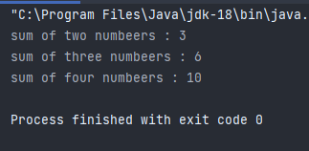
3. Write a program to create sum class and use constructor overloading to calculate
the sum of two, three, four numbers.

Code:

package com.OOP.LAB5;
class Sum{
Sum(int a, int b){
System.out.println(a+b);
}
Sum(int a, int b, int c){
System.out.println(a+b+c);
}
Sum(int a, int b, int c, int d){
System.out.println(a+b+c+d);
}
}
public class Exercise3 {
public static void main(String[] args) {
Sum s1 = new Sum(5,5);
Sum s2 = new Sum(5,5,5);
Sum s3 = new Sum(5,5,5,5);
}
}
Output:
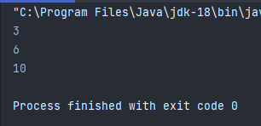
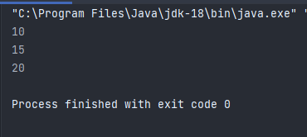

4. What is the output of the following:

a.)
class Base {
public void show() {
System.out.println("Base::show() called");
}
}
class Derived extends Base {
public void show() {
System.out.println("Derived::show() called");
}
}

public class Main {
public static void main(String[] args) {
Base b = new Derived();;
b.show();
}
}

Output : Derived::show() called

b.)
class X
{
//Class X Members
}
class Y
{
//Class Y Members
}
class Z extends X, Y
{
//Class Z Members
}

Output : It won't give output because in java it's not allowed to extend more than one class and here it's extending rwo classes X and Y

c. )
class Person {
public void talk() {
System.out.print("First Program");
}
}
class Student extends Person {
public void talk() {
System.out.print("Second Program");
}
}
public class TestProgram {
public static void main(String args[]) {
Person p = new Student();
p.talk();
}
}

Output : Second Program

5. True/False?

a.) Method Overriding is useful to add extra functionality or code to a method of
subclass with the same name as the inherited method.
True

b.) It is not mandatory to override all or few methods of the superclass.
True
c. )A successful Method Overriding calls the method of the superclass in Java.
False,it's calls the methode of the Subclass

