Name : Hardik Patel
Std Id : 202103032

Q-1) Write a program that takes an input paragraph of 10 lines. Count the total no. of words and total no. of characters (Excluding blank spaces)

Code :
package com.DSA;
import java.util.Scanner;
public class NumberOfWords {
static Scanner in = new Scanner(System.in);
public static void main(String[] args) {
String str = in.nextLine();
count(str);
}
static void count(String str){
char[] ch = str.toCharArray();
int letter = 0;
int space = 0;
int word = 1;
for(int i = 0; i < str.length(); i++){
if(Character.isLetter(ch[i])){
letter ++ ;
}
if(Character.isSpaceChar(ch[i])){
space ++ ;
word ++;
}
}
System.out.println("Number of letters are = " + letter);
System.out.println("Number of spaces are = " + space);
System.out.println("Number of Words are = " + word);
}
}
Output:
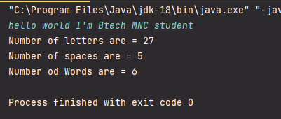
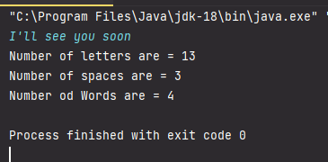

Q-2)Write a program to find the sum of all the elements of an array using pointer

Code:

#include <iostream>
using namespace std;

int main()
{
int array[] = {1,2,3,4};
int *ptr;
ptr = array;
int sum = 0;
int size = sizeof(array)/sizeof(array[0]);
for (int i = 0; i < size; i++)
{
sum += *ptr;
ptr++;
}

cout<<"Sum of an array = " <<sum;

return 0;
}

Output :
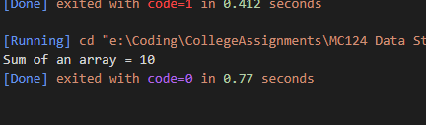
Q-3)Create a structure named student that has member variables roll no, name, m1, m2, m3, sum, average, and grade. Write a program to take user inputs for roll no, name, m1, m2, m3 and, then calculate sum, average and grade of each student. Marks Grade marks<50 F 50≤marks< 60 C 60≤marks<70 B 70≤marks<80 B+ 80≤marks<90 A 90≤mars≤ 100 A

Code:
#include <iostream>
using namespace std;

struct Student
{
int rollNo;
string name;
int m1;
int m2;
int m3;
int sum;
int average;
string grade;
};

int main()
{
struct Student Data;

cout << "Enter roll no : ";
cin >> Data.rollNo;

while (Data.rollNo != 0)
{
cout << "Enter name : ";
cin >> Data.name;

cout << "Enter m1,m2,m3 : ";
cin >> Data.m1 >> Data.m2 >> Data.m3;

Data.sum = Data.m1 + Data.m2 + Data.m3;
cout << "Sum = " << Data.sum << endl;

Data.average = (Data.m1 + Data.m2 + Data.m3) / 3;
cout << "Average = " << Data.average << endl;

if (Data.average < 50)
{
cout << "Grade = F" << endl;
}
else if (51 < Data.average && Data.average < 60)
{
cout << "Grade = C\n" << endl;
}
else if (61 < Data.average && Data.average < 70)
{
cout << "Grade = B\n" << endl;
}
else if (71 < Data.average && Data.average < 80)
{
cout << "Grade = B+\n" << endl;
}
else if (81 < Data.average && Data.average < 90)
{
cout << "Grade = A\n" << endl;
}
else
{
cout << "Grade = A+\n" << endl;
}
cout << "Enter roll no : ";
cin >> Data.rollNo;
}

return 0;
}

Output :
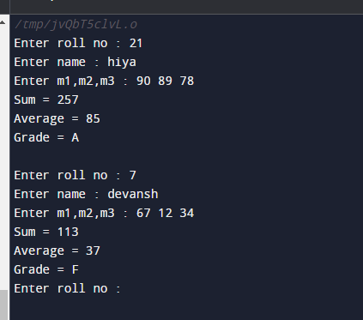

Q-4)Define a structure “complex” to read two complex numbers and perform addition, subtraction of these two complex numbers and display the result

Code:
#include <iostream>
using namespace std;

typedef struct
{
float real;
float imaginary;
} complex;

int main()
{
complex num1, num2, sum;

cout << "Enter real and imaginary part of 1st complex number :\n";
cin >> num1.real >> num1.imaginary;

cout << "Enter real and imaginary part of 2nd complex number:\n";
cin >> num2.real >> num2.imaginary;

sum.real = num1.real + num2.real;
sum.imaginary = num1.imaginary + num2.imaginary;

cout<<"SUM = "<<sum.real <<" + i"<< sum.imaginary<<endl;

sum.real = num1.real - num2.real;
sum.imaginary = num1.imaginary - num2.imaginary;

cout<<"Subtraction = "<<sum.real <<" + i"<< sum.imaginary;

return 0;
}

