Name: Hardik Patel
Std id : 202103032

1.Prepare a Class diagram for all the questions given in Assignment 1.

2. WAP in JAVA to find the area of a circle using constructor.

package com.OOP;
import java.util.Scanner;
public class Exercise2 {
static Scanner in = new Scanner(System.in);
public static void main(String[] args)
{
System.out.println("Enter the radius : ");
double rad= in.nextDouble();
Area area=new Area(rad);
System.out.println("Area of Circle is : " + area.areaOfCirc);
}
static class Area {
double areaOfCirc;
Area(double r)
{
areaOfCirc = r*r*22/7;
}
}
}

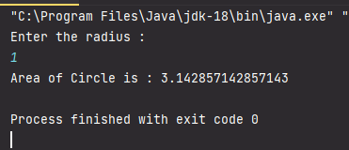

3. WAP in JAVA to input details of student name, enrolment number, and marks in
Science , Math and English. And print all the details along with their percentage as
output.

package com.OOP;
import java.util.Scanner;
public class Exercise3 {
static Scanner in = new Scanner(System.in);
public static void main(String[] args) {
System.out.println("Enter name = " );
String name = in.nextLine();
System.out.println("Enter enrolment no = " );
int enrollNo = in.nextInt();
System.out.println("Enter marks Of science = ");
int markOfSc = in.nextInt();
System.out.println("Enter marks Of maths = " );
int markOfMts = in.nextInt();
System.out.println("Enter marks Of english = " );
int markOfEng = in.nextInt();
System.out.println("name = " + name );
System.out.println("enrolment no = " + enrollNo );
System.out.println("marks Of science = " + markOfSc );
System.out.println("marks Of maths = " + markOfMts );
System.out.println("marks Of english = " + markOfEng );
int percentage = (markOfEng+markOfMts+markOfSc)/3;
System.out.println("percentage = " + percentage);
}
}

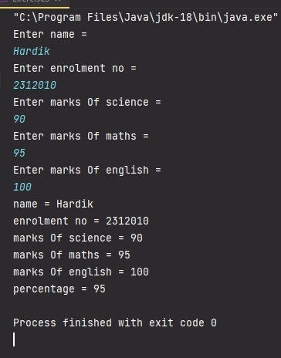
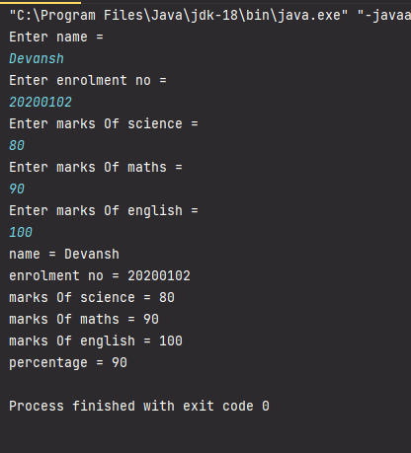

4. WAP in JAVA to check whether a string is palindrome or not.
.
package com.OOP;
public class Exercise4 {
public static void main(String[] args) {
String str= "hello";
System.out.println("String : " + str);
char[] arr = str.toCharArray(); //convert string to char array
int start = 0;
int end = arr.length - 1;
for (int i = 0; i < end; i++) {
swap(arr,start,end);
start++;
end--;
}
String output = new String(arr);
//comparing string to reverse of string
if(str.equals(output)) System.out.println("String is palindrome");
else System.out.println("String is not palindrome");
}
static void swap(char[] arr ,int start , int end){
char temp = arr[start];
arr[start] =arr[end];
arr[end] = temp;
}
}

5. State whether the given below are valid or invalid cases of method overloading. Give
a short explanations.

Case1:
int demo(int a, int b, float c)
int demo(int var1, int var2, float var3)

Ans : invalid
Data types,Number of arguments and sequence are same in both the functions.

Case 2:
int demo(int a, int b)
int demo(float var1, float var2)

Ans : valid
Data types are different in both the functions

Case 3:
int demo(int a, int b)
int demo(int num)

Ans: valid
number of arguments arw different in both function

Case 4:
float demo(int a, float b)
float demo(float var1, int var2)

Ans: valid
sequence of datatype is different

Case 5:
int demo(int a, int b)
float demo(int var1, int var2)

Ans: invalid
in both function number of arguments, datatype and sequence are same

5.Part-b

class Demo1
{
//change datatype of one of the argument
public double myMethod(float num1, int num2)
{
System.out.println(&quot;First myMethod of class Demo&quot;);
return num1+num2;
}
public int myMethod(int var1, int var2)
{
System.out.println(&quot;Second myMethod of class Demo&quot;);
return var1-var2;
}
}
class Demo2
{
public static void main(String args[])
{
Demo2 obj2= new Demo2();
obj2.myMethod(10,10);
obj2.myMethod(20,12);
}
}

