Case Study Report | Applications and Use Cases of Machine Learning (TE7483) | Division A
LoanShield: Machine Learning Based Detection of Unverified Digital Lending Apps Using RBI's DLA Directory
Hardik Gulati¹*, Ashwin Vyas¹, Bhavya Tanna¹, Dakshesh Chauhan¹
¹Department of Artificial Intelligence and Machine Learning, Symbiosis Institute of Technology, Symbiosis International (Deemed University), Lavale, Pune, 412115, Maharashtra, India.
*Corresponding author: hardik.gulati.btech2024@sitpune.edu.in. Contributing authors: ashwin.vyas.btech2024@sitpune.edu.in; bhavya.tanna.btech2024@sitpune.edu.in; dakshesh.chauhan.btech2024@sitpune.edu.in

Abstract
Purpose: Unauthorised digital lending apps in India charge hidden fees, misuse borrowers' contacts and photos, and harass borrowers during recovery. A Reserve Bank of India (RBI) working group found about 600 illegal apps among roughly 1,100 lending apps available to Indian Android users. Since July 2025 the RBI has published a public directory of Digital Lending Apps (DLAs) deployed by regulated entities, but the directory is a passive lookup and no automated system uses it to flag suspicious apps.
Methods: LoanShield is a supervised machine-learning system that uses the RBI directory as ground truth. We built a labelled dataset of 414 Indian lending apps from Google Play listings, Android permissions, developer attributes and user reviews, matched against a snapshot of the directory taken on 2026-10-08. Logistic Regression, Random Forest, XGBoost and LightGBM were trained on tabular and permission features; TF-IDF models and frozen multilingual transformers on review text; and the two were combined by late fusion. Evaluation used developer-grouped cross-validation, a temporal hold-out, bootstrap confidence intervals and SHAP explanations, with headline results on apps discovered independently of the directory.
Results: On those apps (50 unverified, base rate 0.218), logistic regression reached PR-AUC 0.65 ± 0.04 and ROC-AUC 0.85 ± 0.03. Tree ensembles and late fusion were not reliably better, and review text alone was weaker. Apps with no identifiable regulated entity behind them were detected with ROC-AUC up to 0.84. Performance held on newer releases and with information from an app's first 14 days. The strongest signal was whether a listing names its regulated lending partner.
Contribution: To our knowledge, this is the first study to use the RBI DLA directory as a labelling source for app-level classification, and the first to evaluate such a classifier after Google Play's 2026 enforcement of the directory.
Keywords: Digital lending apps, Predatory lending, RBI DLA directory, FinTech consumer protection, Android permissions, App review mining, Explainable machine learning

1 Introduction
Smartphone-based lending has grown rapidly in India because it reaches people whom traditional banking serves poorly: gig workers, students, small traders and first-time borrowers who need a few thousand rupees at short notice. A legitimate digital lending app is operated either by an RBI-regulated entity (RE), such as a bank or non-banking financial company (NBFC), or by a lending service provider acting on its behalf. The borrower usually cannot see this relationship. To the user, a licensed lender's app and a fraudulent one look almost identical: both promise instant approval, both ask for KYC documents, and both are often available on the same app store.
The harm caused by fraudulent apps is well documented. The RBI Working Group on Digital Lending found approximately 1,100 lending apps on more than 80 app stores for Indian Android users in early 2021 and classified about 600 as illegal; it also recorded around 2,562 complaints between January 2020 and March 2021, with Maharashtra reporting the largest share [1]. Security researchers have described the same pattern internationally. Lookout identified 251 Android and 35 iOS loan apps with predatory behaviour, with India among the affected markets [5], and ESET reported 18 "SpyLoan" apps on Google Play with more than 12 million downloads before 17 were removed [6]. Such apps typically refuse to proceed unless the borrower grants access to contacts, SMS and storage, and later use that data during recovery.
Regulation has tightened in response. The RBI's 2022 guidelines required funds to flow directly between borrower and regulated entity and restricted data collection, and the 2025 Directions required REs to report their apps [2]. This led to a public DLA directory on 1 July 2025 [3]. Google Play then required new personal loan apps in India to be on the RBI list from 30 October 2025 and gave existing apps until 28 January 2026 [4]. Enforcement nevertheless remains largely manual. The directory helps a borrower who already suspects an app, but it does not flag apps proactively, and operators now avoid it by publishing loan products as "credit lines", "expense trackers" or similar wrappers.
This paper presents LoanShield, a system that learns what distinguishes verified lenders from unverified ones using signals observable at scale. The contributions are: (i) a labelling procedure that uses the RBI DLA directory as official ground truth for Indian lending apps; (ii) a multi-source feature design combining metadata, permissions and Hinglish review text; (iii) a leakage-aware evaluation protocol with developer-grouped and temporal splits, an evaluation set independent of the directory, and bootstrap uncertainty; and (iv) an explainability layer and public screening tool that report the warning signals behind each prediction. Section 2 reviews related work, Section 3 identifies the research gap, Section 4 details the methodology, Section 5 reports the results, Section 6 discusses applications, limitations and threats to validity, and Section 7 concludes.

2 Related Work

2.1 Regulatory and security investigations
The most detailed account of the Indian ecosystem is the RBI Working Group report of November 2021 [1]. It quantified the number of illegal apps, mapped complaints by state, and recommended a verification mechanism and a public register of authorised apps, which later became the DLA directory [3]. Lookout's analysis showed that predatory apps make the loan application conditional on sensitive permissions and describe data use vaguely in their privacy policies [5]. ESET added that SpyLoan apps copy descriptions and privacy policies from legitimate fintech apps to pass store review [6], which implies that listing text alone can mislead a classifier.

2.2 Machine-learning detection of risky mobile apps
Arp et al. introduced Drebin, which extracted static features such as permissions, API calls and network addresses from Android packages and trained a linear SVM; it detected 94% of malware at a 1% false-positive rate [7]. Permissions are therefore a cheap and informative signal. Predatory loan apps, however, are not always malware: their harm often lies in business practice rather than code. Pendlebury et al. further showed that random train/test splits overstate Android classifier performance because apps change over time, and argued for temporally consistent evaluation [16]. The closest work in intent is a study by Innovations for Poverty Action (IPA) covering personal loan apps on Google Play across 63 countries [8]. More than 70% of those apps had been released since January 2020 and 52% were removed by December 2021. Its models separated suspect from likely legitimate apps with 80–90% accuracy, but labels were hand-coded and the study was not specific to India. Most recently, Akanji, Egele and Stringhini measured 434 loan apps from Indonesia, Kenya, Nigeria, Pakistan and the Philippines against national regulation and Google's Financial Services policy using static and dynamic code analysis with LLM-assisted mapping from policy text to permissions, and found violations in about a third of the apps; Google removed 93 apps after disclosure [19]. India is not part of that sample, and the approach requires installing and executing each app.

2.3 User perception and review mining
Ramesh et al. studied Indian instant loan platforms and financially stressed users, arguing that the power imbalance between platform and borrower leads users to accept intrusive data practices [9]. Lekshmi et al. applied machine learning to reviews of three popular Indian loan apps and found recurring concerns about interest, privacy and predatory practices [10]. Sekhar and Saheb analysed 15,408 reviews of RBI-approved peer-to-peer lending apps, with ensemble models and VGG16 reaching accuracy of up to 0.88 [11]. These studies confirm that review text carries useful signal, but they examine perceptions of known apps and do not classify whether an unseen app is a regulated lender. Table 1 summarises the reviewed work.
Table 1. Comparison of representative work on predatory lending apps and mobile-app risk detection
Reference | Approach | Data | Reported result | Key finding / limitation
RBI WG (2021) [1] | Regulatory survey of app stores and complaints | ~1,100 lending apps, 80+ stores | ~600 illegal apps | Established scale in India; proposed public register of legitimate apps
Lookout (2022) [5] | Manual threat-intelligence analysis | Loan apps on Google Play and App Store | 251 Android + 35 iOS predatory apps | Loan flow gated behind contacts and SMS permissions
ESET (2023) [6] | Malware analysis | 18 loan apps on Google Play | 17 removed; >12M downloads | Copied descriptions defeat text-only screening
Arp et al. (2014) [7] | Static features + linear SVM | 123,453 benign, 5,560 malware APKs | 94% detection at 1% FPR | Permissions informative; targets malware, not lending practice
IPA (2022) [8] | Supervised ML on loan-app data | Loan apps across 63 countries | 80–90% accuracy | Hand-coded labels; not India-specific
Ramesh et al. (2022) [9] | Qualitative study | Indian instant loan users | Qualitative | Financial stress drives acceptance of data abuse
Lekshmi et al. (2025) [10] | ML on user reviews | Reviews of 3 Indian loan apps | Concern themes | No app-level classification
Sekhar & Saheb (2026) [11] | Topic modelling + GBDTs, VGG16 | 15,408 reviews, RBI-approved P2P apps | Accuracy up to 0.88 | Regulated apps only; no unverified class
Akanji et al. (2026) [19] | Static + dynamic code analysis, LLM-assisted policy mapping | 434 loan apps, 5 countries | ~1/3 violate rules; 93 removed by Google | India not covered; requires running each app
This work | Supervised ML on listings, permissions and reviews; RBI directory as labels | 414 Indian lending apps | PR-AUC 0.65 ± 0.04 (base rate 0.218) | Official labels; leakage-aware; explainable public screening

3 Research Gap
Four gaps emerge from the review. First, there is no India-specific dataset grounded in an official reference: prior app-level classification relied on researcher-assigned labels [8], while Indian studies analysed reviews of a few known apps [10, 11], and the most recent measurement study does not cover India [19]. The RBI directory, available only since July 2025, makes official labelling possible for the first time.
Second, early detection is unaddressed. Review-based methods work only after complaints accumulate, by which time a predatory app may have reached many borrowers. How well metadata and permissions alone can flag an app in its first days, and how much reviews add later, is an open question.
Third, operators adapt. Since Google Play began enforcing the directory requirement [4], illegal lenders have moved to apps that do not declare themselves as personal loan apps, and they have long copied text from legitimate lenders [6]. Random splits hide this drift; temporal evaluation [16] is rarely applied in this domain.
Fourth, Indian reviews mix English, Hindi and regional languages, and directory omissions introduce label noise. Both affect reliability, and regulators need explanations they can verify rather than a bare score.

4 Methodology
Fig. 1 shows the end-to-end pipeline. Each stage is described below; the code, data and notebooks are available in the project repository.
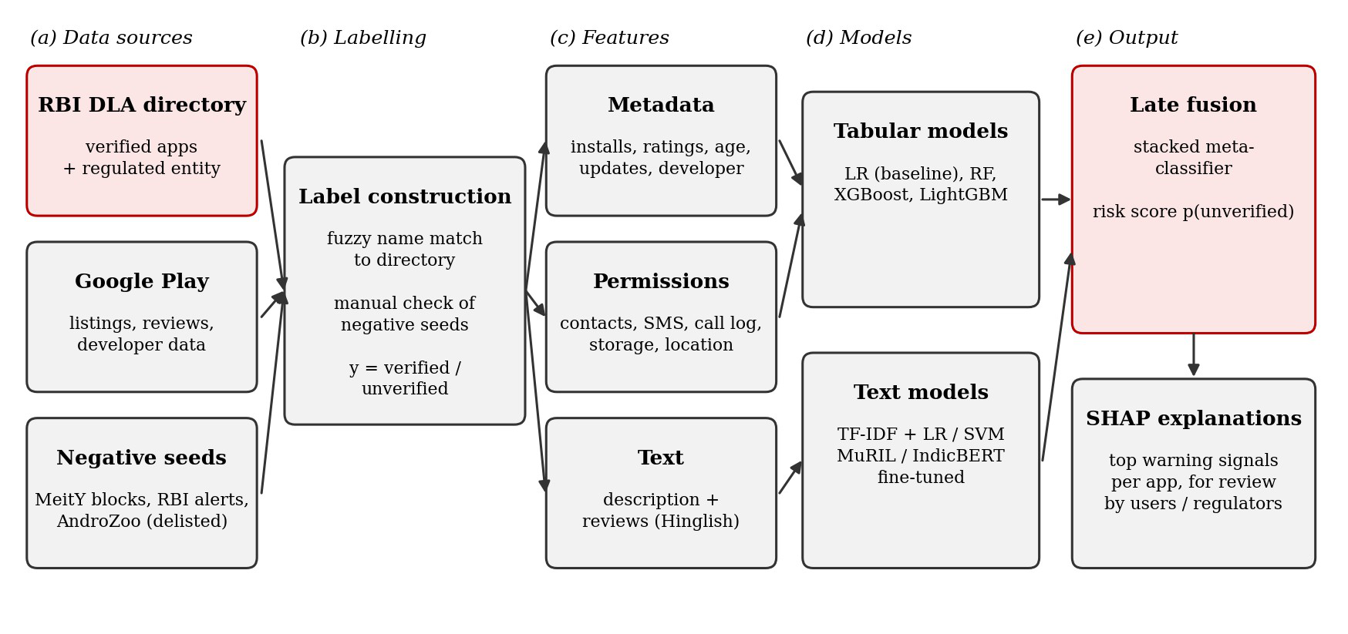
Fig. 1. LoanShield pipeline: (a) data sources, (b) label construction against the RBI DLA directory, (c) feature groups, (d) tabular and text models, (e) late fusion into a risk score with SHAP explanations. As built, the negative-seed and AndroZoo sources contributed no training apps (Section 4.2), and the transformers were used as frozen encoders (Section 4.4).

4.1 Problem formulation
Let each lending-related Android app a be described by a feature vector x = (xᵐ, xᵖ, xᵗ), where xᵐ denotes store and developer metadata, xᵖ binary permission indicators and xᵗ the description and review text. The task is to learn f(x) → y ∈ {verified, unverified}, where an app is verified if it matches an entry in the RBI DLA directory. The model outputs a calibrated risk score p(unverified | x) and a set of feature attributions. This is a supervised binary classification problem over heterogeneous inputs.

4.2 Dataset construction
No public, labelled dataset of Indian lending apps exists, so one was built from the sources in Table 2. The verified class comes from the RBI directory, which lists each app with its deploying entity. The RBI notes that entries are reported by REs through its CIMS portal and are not separately validated [3], so a listing indicates a claimed association rather than an endorsement. We took a complete snapshot of the directory on 2026-10-08 (2,869 entries from 457 regulated entities, with Play Store links for 434 apps).
Candidate apps were collected from Google Play (country India) through keyword searches in English, Hindi and Hinglish, one hop through each Finance app's "similar apps" links, and a second hop around apps that were unverified or uncertain, together with the Play apps linked from the directory itself. Of 1,242 candidates, 652 were Finance apps whose listing mentions lending. Each was labelled automatically where possible: an exact match between its package and a directory link, or a close match on both app name and developer, made it verified, and a lending app with no match was unverified. Non-lending apps (calculators, ledgers, brokerage and insurance apps) were excluded. The 138 remaining borderline apps were labelled manually by a single AI-assisted annotator following a written guide, with a note per non-obvious decision. A random audit of 50 automatic labels found 1 error (2% of 50), which led to one rule correction.
Because Google Play has required loan apps to be on the directory since January 2026 [4], the unverified class could not be taken simply as loan apps missing from the list, and it was planned to include apps named in MeitY blocking actions, RBI and cybercrime alerts, and delisted apps recovered from AndroZoo [12]. In practice the seed list (46 names from police and cyber-cell advisories) yielded no training examples, because 38 of the apps were no longer on Google Play and the rest matched unrelated apps only by name, and AndroZoo access was not obtained. The unverified class therefore consists of live lending apps that match no directory entry: wrapper apps presented as credit lines, apps of foreign-registered lenders, and unlisted apps of regulated lenders. Apps discovered through the directory's own links are verified by construction, so headline results use only apps discovered by search ("organic" apps).
Table 2. Data sources used to build the LoanShield dataset
Source | Contents | Use in model | Notes
RBI DLA directory [3] | App name, deploying RE, RE type, Play link | Verified-class labels | Snapshot of 2026-10-08; RE-reported via CIMS
Google Play listings | Title, developer, installs, ratings, dates, description, privacy policy | Metadata and description features | Collected with google-play-scraper; point-in-time snapshot
Google Play reviews | Text, stars, date, helpful votes | Review-text features | Newest 200 per app; code-mixed Hinglish
AndroZoo [12] | Historical APKs, incl. delisted apps | Planned: manifest permissions | Not used (no API access obtained)
MeitY blocks, police and cybercrime alerts | Names of blocked or flagged apps | Planned: unverified-class seeds | 46 names; no live matches

4.3 Preprocessing and feature engineering
App names were matched to directory entries after normalisation (lowercasing, removing taglines, legal suffixes and generic words such as "loan" and "instant"). Exact package matches against the directory's Play links took precedence; otherwise a token-sort similarity on the remaining distinctive words was used, because the token-set ratio originally planned scored unrelated apps sharing one word as perfect matches. Brand-level matches (same brand, different app) were sent to manual review. Google Play now reports permissions as human-readable labels, which were mapped to Android permission constants. Missing numerical values were imputed with the median and flagged with an indicator column. Install counts were encoded as ordinal bands, and dates were converted to app age and days since last update. Reviews were cleaned (URLs, phone numbers and emojis removed, Hinglish spelling variants normalised) and deduplicated within each app. Table 3 lists the 53 engineered features by group. No feature encodes the directory match itself.
Table 3. Feature groups and the risk each is intended to capture
Group | Example features | Intended signal
Store metadata | Install band, rating, 1-star and 5-star shares, app age, days since update | Short-lived, churned apps; inflated ratings
Developer | Apps per developer, near-duplicate titles, free e-mail domain, e-mail and privacy-policy domains matching the website | Clone farms and throwaway accounts
Permissions | Contacts, SMS, call log, storage, location, camera, microphone, overlay; count of dangerous permissions | Data harvesting for coercive recovery
Listing text | Named partner NBFC or bank, stated APR and tenure, KFS or grievance-officer mention, urgency terms | Missing mandatory disclosures
Review text | Shares of reviews reporting harassment, hidden fees and fraud; review volume and ratings | Borrower-reported abuse

4.4 Model selection and training
Logistic Regression with L2 regularisation served as an interpretable baseline. Random Forest was included because it handles mixed feature types and non-linear interactions with little tuning. XGBoost [14] and LightGBM [17] are gradient-boosted trees that typically perform well on tabular data and natively support class weighting. For review text, TF-IDF (word and character n-grams) with Logistic Regression and with a linear SVM provided classical baselines, each also trained on reviews in which every app's own brand words were masked. MuRIL [13] and a multilingual sentence encoder [20] were used as frozen encoders, with standardised mean-pooled embeddings fed to a logistic regression. We also fine-tuned MuRIL end to end on a Colab GPU (learning rate 2e-5, batch 16, 4 epochs, at most 40 reviews per app, class-weighted cross-entropy) on the same developer-grouped folds. App-level text predictions were obtained by averaging review-level probabilities. The tabular and text outputs were combined by a stacked logistic meta-classifier trained on out-of-fold predictions, so that apps with no reviews still receive a metadata-based score.
Class imbalance was handled with class weights and, for comparison, SMOTE [18] applied only within training folds. Hyperparameters were tuned by randomised search (30 iterations) inside the training folds only. Isotonic calibration was planned, but with about 50 positives it overfits, so the risk scores were calibrated with Platt scaling fitted on out-of-fold predictions.

4.5 Evaluation protocol
Developer-grouped stratified 5-fold cross-validation kept all apps from one developer in the same fold, preventing a model from recognising clones rather than learning general signals [21]. A temporal hold-out trained on apps released before 2025-11-20 and tested on later ones, following the space-and-time evaluation argued for by Pendlebury et al. [16]. Metrics were precision, recall, F1-score, ROC-AUC, PR-AUC and confusion matrices for the unverified class, with recall at a 5% false-positive rate, since wrongly flagging a legitimate small NBFC also has a cost. Decision thresholds for precision, recall and F1 were chosen on the training folds. Ablation removed one feature group at a time, an early-detection experiment restricted each app to information available in its first 14 days, and a random-split experiment measured the leakage that grouped splitting prevents. Uncertainty was quantified with 95% bootstrap confidence intervals and paired bootstrap tests between models.

4.6 Explainability
SHAP [15] values were computed for the best tree model to give global feature importance and per-app explanations. For each app, the system reports the strongest signals that raised and lowered its score in plain language (for example, "does not name an NBFC or bank lending partner"), compared with the typical value among lending apps. A Streamlit prototype accepts a Play Store link, fetches the listing, permissions and reviews live, and returns the calibrated risk score, a direct lookup in the directory snapshot, these explanations, the permission checklist and flagged reviews; an offline mode uses the collected data.

5 Results
All results use developer-grouped five-fold cross-validation unless stated otherwise, so apps from one developer never appear on both sides of a split. The positive class is unverified. We report PR-AUC (average precision) as the primary metric because the classes are imbalanced, together with ROC-AUC, recall at a 5% false-positive rate, and precision, recall and F1 for the unverified class (threshold chosen on the training folds). Values are mean ± standard deviation over folds.
Headline numbers are computed on organic apps, i.e. apps discovered through Play Store search or similar-app links. Apps found through the Play links in the RBI directory itself are verified by construction, so including them would reward a model for recognising how an app was found rather than its risk. All models are trained on every labelled app; results on all apps are reported alongside for comparison.

5.1 Dataset and labels
The RBI Digital Lending Apps directory snapshot (2026-10-08) contained 2,869 entries from 457 regulated entities, linking 434 distinct Play Store apps. Play Store discovery produced 1,242 candidate apps (355 from search, 536 from similar-app links, 275 from RBI-listed links), of which 652 were Finance apps that mention lending. Table 4 summarises the labelled dataset.
Table 4. Labelled dataset. Organic apps were found by Play search or similar-app links.
 | All apps | Organic apps
Verified (listed in the RBI DLA directory) | 364 | 179
Unverified (lends, not listed) | 50 | 50
Base rate (share unverified) | 0.121 | 0.218
Developers | 366 | 198
Excluded (does not lend) | 132
Unique reviews (labelled apps) | 47,177

Automatic matching against the RBI directory labelled 382 apps: 340 verified by an exact Play package match, 13 verified by app-name and developer match, and 29 unverified because they offer credit but match no directory entry. The remaining 138 apps (name matches in the review band, unlisted apps of listed lenders, and unclear lending status) were labelled manually following a written guide, giving 11 verified, 21 unverified and 106 non-lending apps. This was done by a single AI-assisted annotator, so no inter-annotator agreement is available. An audit of 50 random automatic labels found 1 error (2% of 50), a listed bank app excluded by the lending-terms rule, and the rule was corrected. A seed list of 46 app names from police and cyber-cell advisories added no training examples: 38 are no longer on Google Play and the rest matched unrelated apps by name. Unverified apps are markedly newer: 21 of the 50 were released in 2026, consistent with Google Play's removal of unlisted loan apps from January 2026.

5.2 Model comparison
Table 5 compares the tabular, text and fusion models on organic apps; Fig. 2 and Fig. 3 show their precision–recall curves and confusion matrices. The best tabular model was Logistic regression and the best text model TF-IDF + LR; the fusion model stacks the two.
Table 5. Developer-grouped 5-fold CV on organic apps (base rate 0.218). The last column gives PR-AUC on all apps (base rate 0.121).
 | Model | PR-AUC | ROC-AUC | Rec@5% FPR | Precision | Recall | PR-AUC (all)
Tabular | Logistic regression | 0.65 ± 0.04 | 0.85 ± 0.03 | 0.40 ± 0.22 | 0.45 ± 0.15 | 0.52 ± 0.22 | 0.42 ± 0.12
 | Random forest | 0.58 ± 0.06 | 0.80 ± 0.07 | 0.34 ± 0.05 | 0.54 ± 0.13 | 0.54 ± 0.23 | 0.34 ± 0.08
 | XGBoost | 0.55 ± 0.10 | 0.79 ± 0.08 | 0.42 ± 0.16 | 0.54 ± 0.18 | 0.48 ± 0.31 | 0.34 ± 0.08
 | LightGBM | 0.57 ± 0.08 | 0.78 ± 0.08 | 0.36 ± 0.13 | 0.48 ± 0.18 | 0.62 ± 0.33 | 0.37 ± 0.14
Text | TF-IDF + LR | 0.49 ± 0.19 | 0.66 ± 0.18 | 0.29 ± 0.17 | 0.34 ± 0.12 | 0.46 ± 0.28 | 0.32 ± 0.13
 | TF-IDF + SVM | 0.48 ± 0.18 | 0.67 ± 0.17 | 0.27 ± 0.15 | 0.40 ± 0.10 | 0.44 ± 0.24 | 0.32 ± 0.11
 | TF-IDF + LR, brand-masked | 0.48 ± 0.20 | 0.66 ± 0.17 | 0.27 ± 0.18 | 0.31 ± 0.13 | 0.46 ± 0.35 | 0.31 ± 0.11
 | TF-IDF + SVM, brand-masked | 0.47 ± 0.18 | 0.67 ± 0.16 | 0.25 ± 0.15 | 0.29 ± 0.14 | 0.48 ± 0.27 | 0.31 ± 0.10
 | MuRIL (frozen) | 0.40 ± 0.16 | 0.59 ± 0.17 | 0.23 ± 0.19 | 0.17 ± 0.10 | 0.68 ± 0.46 | 0.25 ± 0.11
 | MuRIL (frozen), brand-masked | 0.40 ± 0.14 | 0.59 ± 0.16 | 0.23 ± 0.14 | 0.23 ± 0.18 | 0.64 ± 0.50 | 0.25 ± 0.11
 | MiniLM (frozen) | 0.38 ± 0.18 | 0.64 ± 0.13 | 0.10 ± 0.17 | 0.26 ± 0.07 | 0.67 ± 0.25 | 0.27 ± 0.14
 | MiniLM (frozen), brand-masked | 0.40 ± 0.16 | 0.64 ± 0.14 | 0.15 ± 0.12 | 0.32 ± 0.11 | 0.59 ± 0.13 | 0.29 ± 0.12
Fusion | Logistic regression + TF-IDF + LR | 0.67 ± 0.06 | 0.85 ± 0.05 | 0.36 ± 0.25 | 0.45 ± 0.14 | 0.48 ± 0.26 | 0.40 ± 0.13

Logistic regression was the strongest single model (PR-AUC 0.65 ± 0.04, ROC-AUC 0.85 ± 0.03), roughly three times the organic base rate of 0.218. The tree ensembles did not improve on it (random forest 0.58 ± 0.06, LightGBM 0.57 ± 0.08, XGBoost 0.55 ± 0.10) and varied more across folds: with 50 unverified apps, their extra flexibility does not pay off. The review-text models were weaker (TF-IDF + LR 0.49 ± 0.19). Frozen sentence encoders were weaker still (MuRIL ROC-AUC 0.59 ± 0.17, multilingual MiniLM 0.64 ± 0.13), so off-the-shelf sentence vectors do not carry the signal. Fine-tuning MuRIL on a GPU did not help either: with about 320 training apps per fold, training loss stayed near chance and one fold collapsed to a constant output, so it is excluded from the comparison. Stacking logistic regression with the TF-IDF model gave the highest mean PR-AUC across folds (0.67 ± 0.06), but a paired bootstrap shows no reliable difference from logistic regression alone (see Statistical robustness). On all apps, including those found through the RBI directory's links, absolute PR-AUC is lower because the base rate is lower (0.121).
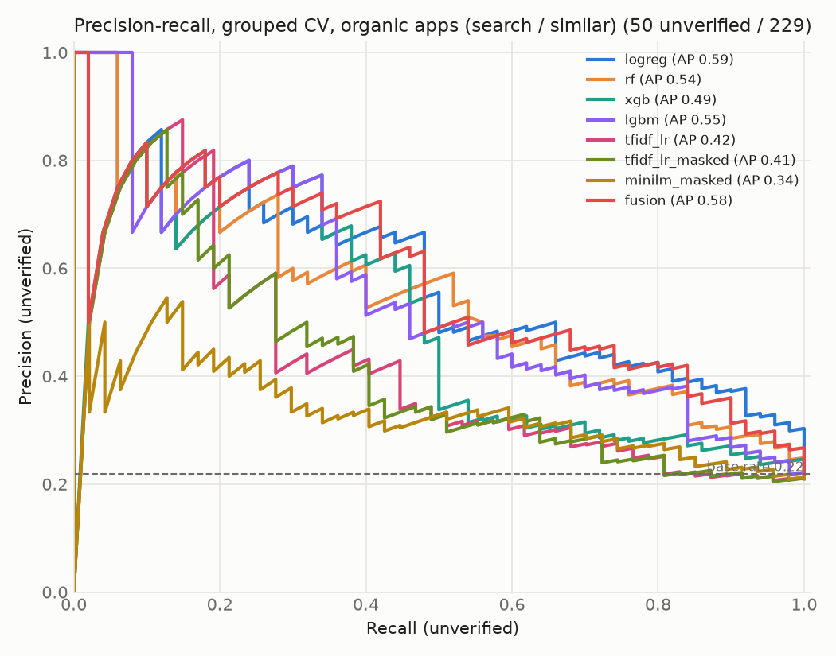
Fig. 2. Precision–recall curves on organic apps (out-of-fold scores pooled across folds, so the legend's average precision differs from the per-fold means in Table 5; dashed line = base rate).
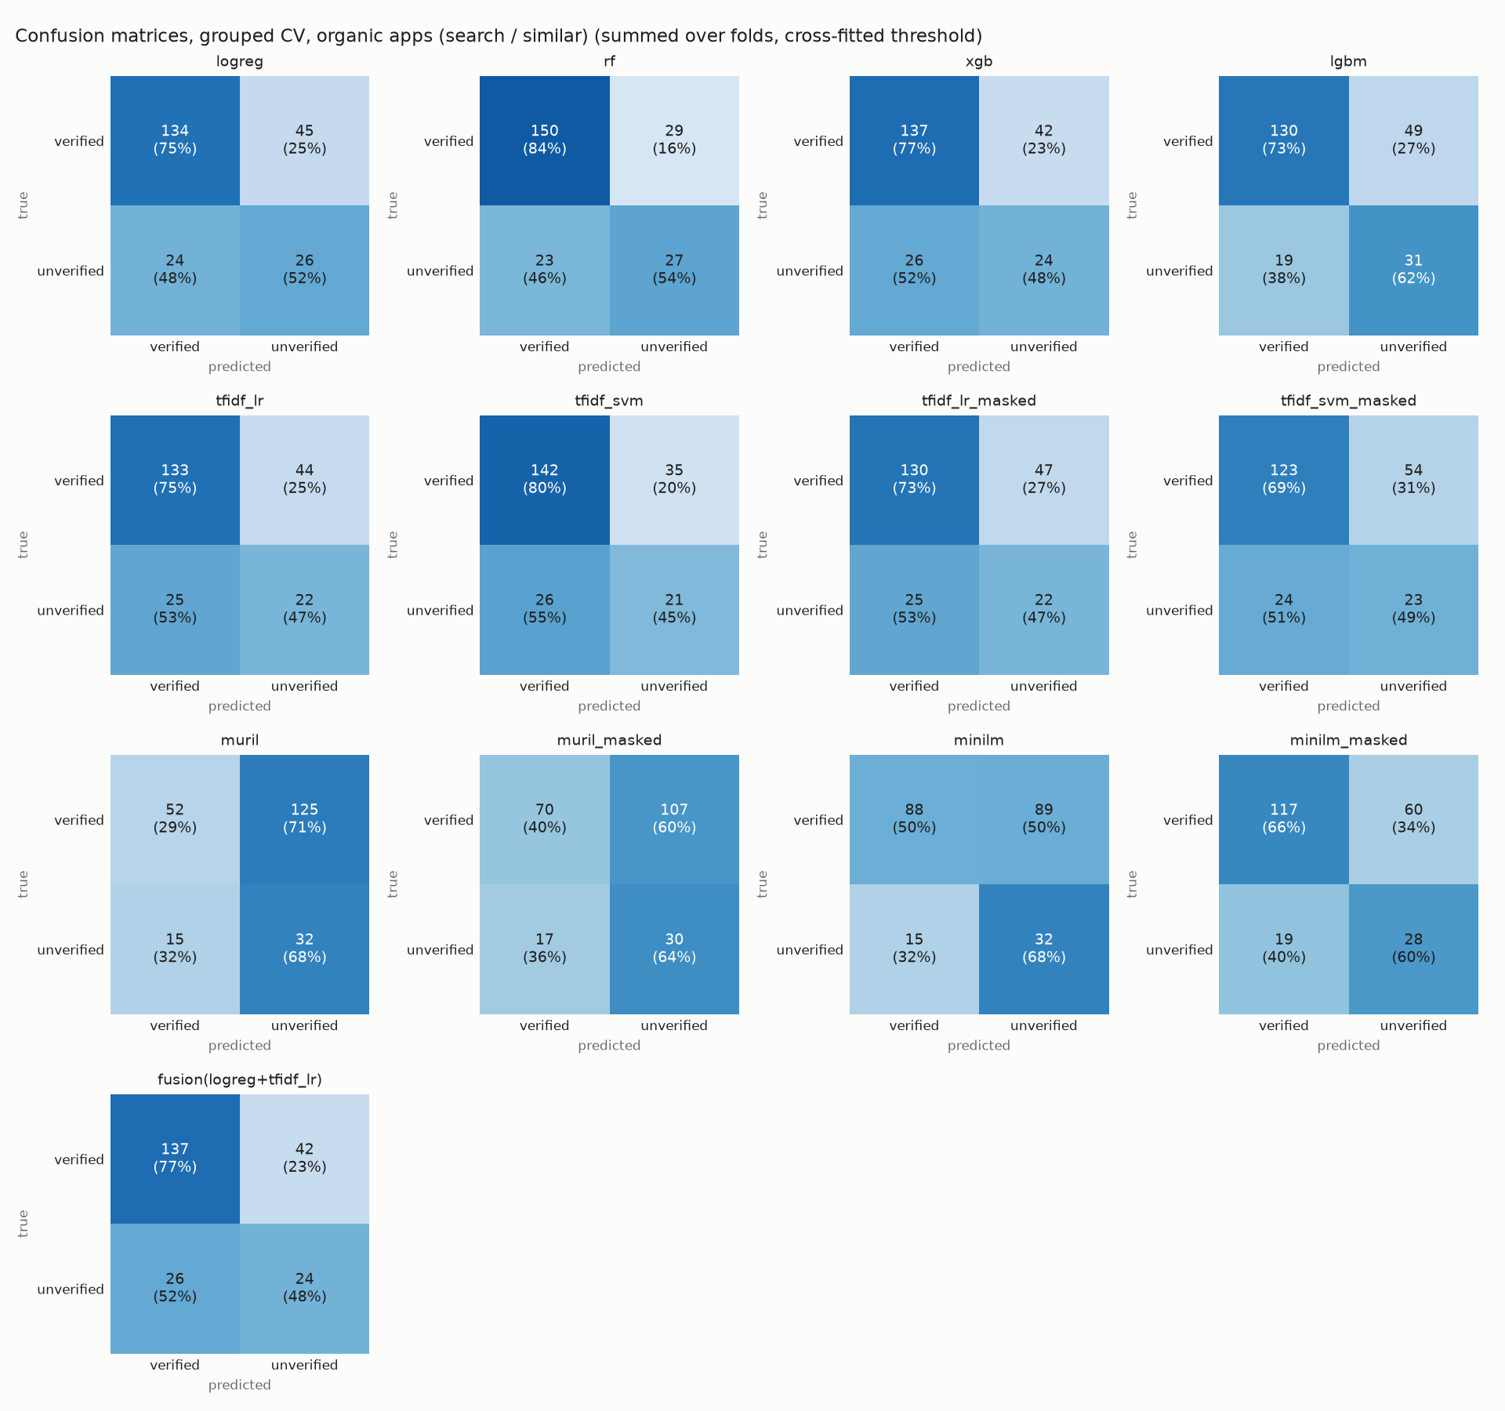
Fig. 3. Confusion matrices on organic apps, summed over folds (threshold chosen on the training folds).

5.3 Generalisation to newer apps
To test whether models trained on older apps flag newly released ones, we trained on apps released before 2025-11-20 (306 apps, 29 unverified) and tested on later releases (43 organic apps, 21 unverified; base rate 0.488). Table 6 reports the three best models.
Table 6. Temporal hold-out on organic apps released on or after 2025-11-20.
Model | PR-AUC | ROC-AUC | Rec@5% FPR
Logistic regression | 0.77 | 0.72 | 0.33
Random forest | 0.87 | 0.88 | 0.67
LightGBM | 0.74 | 0.74 | 0.38

The random forest ranked later releases well (PR-AUC 0.87, ROC-AUC 0.88), and logistic regression less so (ROC-AUC 0.72). The test period is dominated by unverified apps (base rate 0.488): most unverified apps still live were released after Google Play's January 2026 removal of unlisted loan apps, so the higher PR-AUC partly reflects the base rate. ROC-AUC, which does not depend on the base rate, is comparable to grouped cross-validation, which suggests the learned signals carry over to newer apps.

5.4 Feature-group ablation
Removing one feature group at a time from Logistic regression (full model PR-AUC 0.65) changed PR-AUC by +0.004 (metadata), −0.008 (developer), −0.080 (permissions), −0.022 (listing text) and −0.045 (review text) (Fig. 4). The largest drop came from removing permissions.
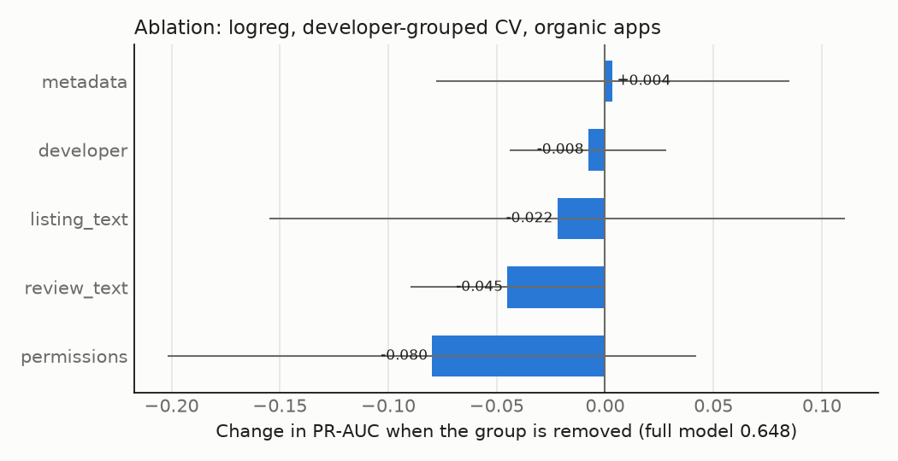
Fig. 4. Change in PR-AUC on organic apps when each feature group is removed (error bars: fold standard deviation).

5.5 Early detection
Using only information available in an app's first 14 days (no install counts, ratings or age, and reviews from the first two weeks only), Logistic regression reached a PR-AUC of 0.62 ± 0.12 (ROC-AUC 0.84 ± 0.05), against 0.65 ± 0.04 (ROC-AUC 0.85 ± 0.03) with full snapshot features. Only 33 labelled apps had any review in their first 14 days, because reviews were collected newest-first, so the early setting relies mainly on listing text and permissions.
Early detection is practical. With only first-fortnight information, ranking performance is close to the full model, so the signals that matter (the listing's disclosures and the permission profile) are available at release rather than accumulating with installs and reviews. Because few apps have early reviews, this result says more about listing and permission signals than about early review text.

5.6 Class imbalance and leakage checks
Table 7 compares class weighting with SMOTE oversampling (applied inside training folds only), and random with developer-grouped splits. A positive gap means random splitting overstates performance because near-identical apps from one developer leak across folds.
Table 7. PR-AUC on organic apps: class weights vs SMOTE, and random vs developer-grouped CV.
Model | Weights | SMOTE | Grouped CV | Random CV | Gap
Logistic regression | 0.65 ± 0.04 | 0.63 ± 0.12 | 0.65 ± 0.04 | 0.70 ± 0.09 | +0.05
Random forest | 0.58 ± 0.06 | 0.65 ± 0.13 | 0.58 ± 0.06 | 0.66 ± 0.12 | +0.08
XGBoost | 0.55 ± 0.10 | 0.57 ± 0.13 | 0.55 ± 0.10 | 0.59 ± 0.13 | +0.04
LightGBM | 0.57 ± 0.08 | 0.57 ± 0.05 | 0.57 ± 0.08 | 0.64 ± 0.12 | +0.07

SMOTE did not help consistently: it raised the random forest's PR-AUC but slightly lowered logistic regression's, and all differences are within fold variability, so class weighting is kept. Random splits overstated PR-AUC for every model (gaps from +0.04 to +0.08), confirming that near-identical apps from the same developer inflate naively split evaluations. All other results therefore use developer-grouped folds.

5.7 Explanations
Fig. 5 shows SHAP values for Random forest fitted on all 414 labelled apps. The five most influential features were names a lending partner, app age (days), states tenure, description length (log) and review count (log).
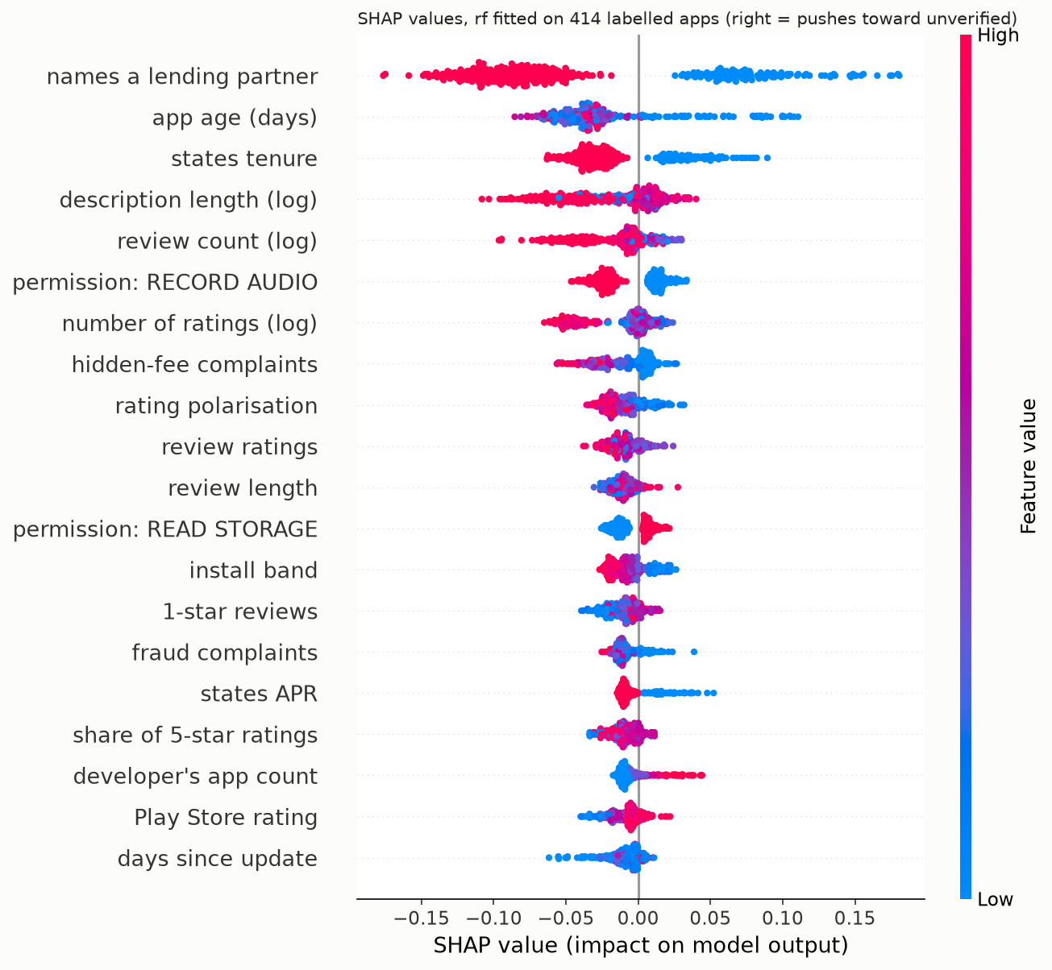
Fig. 5. SHAP summary for Random forest. Points to the right push the prediction toward unverified; colour shows the feature value.
Whether the listing names an NBFC or bank lending partner dominates. Apps that do are pushed strongly toward verified, consistent with RBI's requirement that digital lending apps disclose the regulated entity they lend for. Stating the loan tenure and the APR act the same way. Newer apps are pushed toward unverified, which partly reflects survivorship after the 2026 Play removal rather than an inherent property of risky apps. Larger, more-reviewed apps lean verified. Two signals run against intuition. Requesting microphone access leans verified, as large regulated lenders use it for video KYC. Complaints about hidden fees also lean verified, because complaint volume scales with the user base. Permissions therefore matter through their pattern, not as simple red flags.
For the review-text model, the n-grams most associated with unverified apps included “no personal”, “kuhoo”, “home loan”, “down payment”, “credit card”, and those most associated with verified apps included “good working”, “instant loan”, “fast loan”, “loan and”, “loan apps” (Fig. 6).
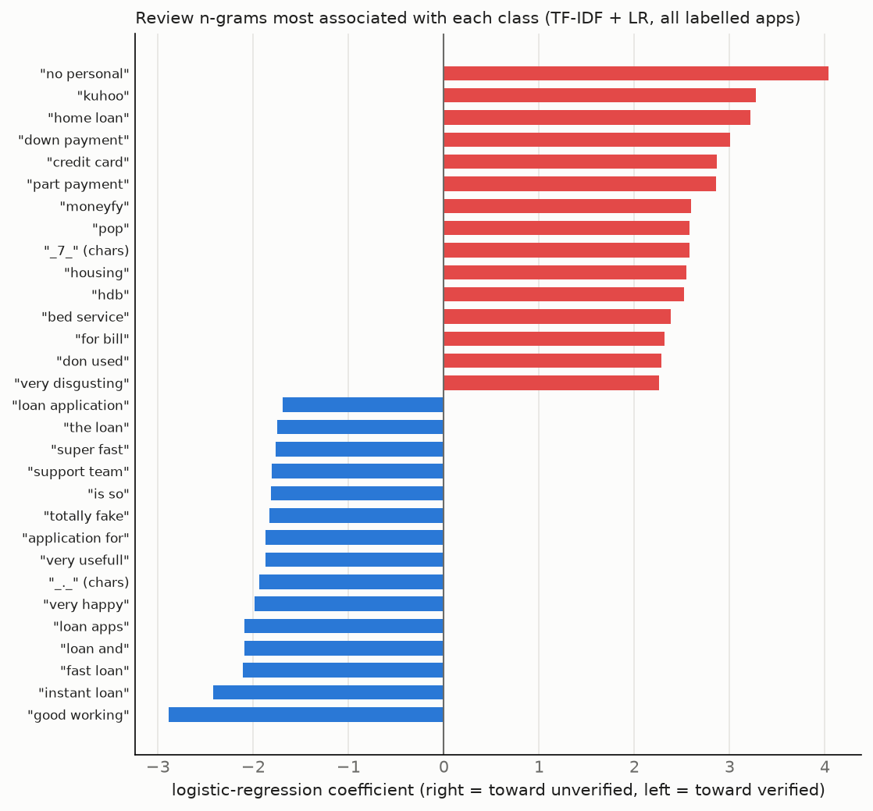
Fig. 6. Review n-grams with the largest logistic-regression weights toward each class.
The strongest "unverified" terms are largely product and app names (e.g. "kuhoo", "moneyfy", "home loan", "housing"). This reflects that many unverified apps are unlisted home-finance and education-loan apps of regulated lenders. Generic complaint phrases such as "totally fake" lean verified, because popular listed apps attract more complaints. The brand-masking experiment below shows that the app names among these terms are not what the model depends on, but the product-category terms are. The text model therefore learns which kinds of loan unverified apps offer rather than risk language, which is consistent with its weaker grouped cross-validation performance.

5.8 Brand names versus risk language
Each app's own brand words (from its title, developer and package name) were replaced by a placeholder in its reviews, so the text models could no longer recognise which app a review was about. Masking changed almost nothing. TF-IDF + LR reached PR-AUC 0.48 ± 0.20 with masking and 0.49 ± 0.19 without, and the paired bootstrap difference between them is +0.006 [−0.015, +0.030]. Brand names rank high among the model's weights (Fig. 6), but its performance does not rest on them. After masking, it relies on product-category words such as "home loan" and "gold", which reflect that many unverified apps are unlisted home-loan and gold-loan apps of regulated lenders. The frozen encoders gained slightly from masking but stayed below TF-IDF (MiniLM 0.40 ± 0.16, MuRIL 0.40 ± 0.14).

5.9 Two kinds of unverified app
Unverified apps are not all alike. We tagged each one by whether its developer is a regulated lender (or a lending service provider the directory already lists) whose app is simply missing from the directory (28 apps), or whether no regulated entity could be identified behind it (22 apps), the group that matters most to borrowers. Table 8 reports how well each model separates verified apps from each group.
Table 8. Verified apps vs each kind of unverified app (organic apps, pooled out-of-fold scores).
Model | No regulated entity: PR-AUC | ROC-AUC | Regulated, unlisted: PR-AUC | ROC-AUC
Logistic regression | 0.50 | 0.83 | 0.41 | 0.82
Random forest | 0.58 | 0.84 | 0.27 | 0.74
Fusion | 0.45 | 0.80 | 0.42 | 0.82
TF-IDF + LR | 0.15 | 0.57 | 0.42 | 0.72
TF-IDF + LR, brand-masked | 0.16 | 0.57 | 0.40 | 0.71

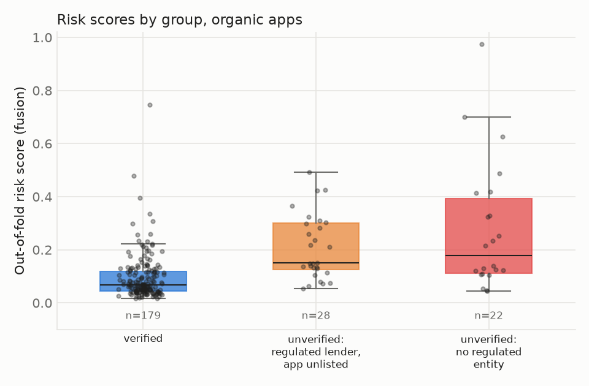
Fig. 7. Out-of-fold risk scores by group on organic apps.
The listing-based models detect the riskier group at least as well as the other. The random forest separates apps with no regulated entity from verified apps with ROC-AUC 0.84 (PR-AUC 0.58 against a base rate of 0.110), and logistic regression with ROC-AUC 0.83. The review-text model behaves the opposite way: it is near chance for apps with no regulated entity (ROC-AUC 0.57) and better for unlisted apps of regulated lenders (0.72), consistent with its reliance on product-category words. For borrower protection, the listing and permission features are therefore the useful part of the system.

5.10 Statistical robustness
With 50 unverified organic apps, differences between models must be read against their uncertainty. On pooled out-of-fold scores, logistic regression reaches PR-AUC 0.59 [0.45, 0.73] (95% bootstrap CI) and the fusion model 0.58 [0.45, 0.72]. A paired bootstrap of fusion minus logistic regression gives −0.014 [−0.074, +0.048] for PR-AUC and −0.012 [−0.039, +0.012] for ROC-AUC. For calibration, Fig. 8 shows the demo's risk percentages, which are calibrated by Platt scaling fitted on the other folds: the Brier score is 0.157 against 0.171 for always predicting the base rate, and the expected calibration error is 0.106.
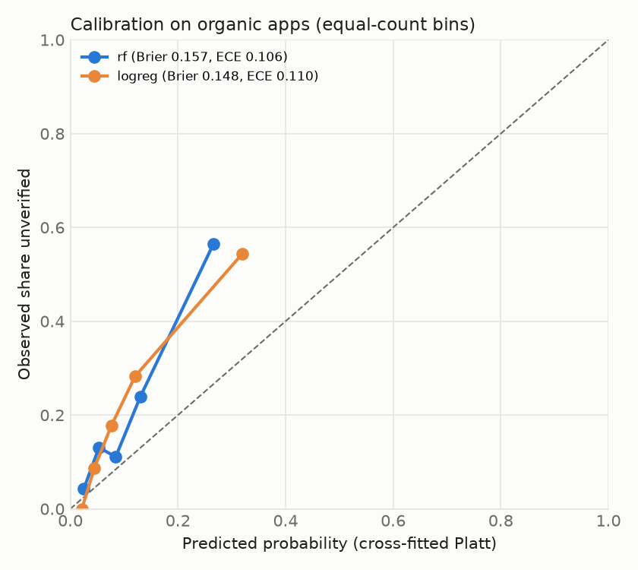
Fig. 8. Calibration of cross-fitted risk probabilities on organic apps (equal-count bins; dashed line = perfect calibration).
The intervals are wide. With 50 unverified apps, logistic regression, fusion and the tree ensembles cannot be reliably ranked against each other, because every paired difference interval includes zero. All of them are clearly above both the base rate and the text-only models: the paired ROC-AUC difference for TF-IDF + LR against logistic regression is −0.170 [−0.262, −0.080]. The risk percentages are only moderately calibrated, so the demo presents them as indicative scores alongside a verdict and its reasons, not as exact probabilities.

5.11 Summary
On organically discovered apps, logistic regression on listing, permission and review features identifies apps missing from RBI's Digital Lending Apps directory with PR-AUC 0.65 ± 0.04 against a base rate of 0.218, and adding review text through stacking does not reliably improve on it. The models detect apps with no identifiable regulated entity, the group that matters most to borrowers, at least as well as unlisted apps of regulated lenders. Performance holds on newer releases and with first-fortnight information, so screening apps at release is feasible. The most informative evidence is whether a listing names its regulated lending partner and states its loan terms, together with its permission profile. Unverified here means "not in the RBI directory snapshot of 2026-10-08", a class that includes unlisted apps of regulated lenders, and the borderline labels come from a single AI-assisted annotator. The model is therefore a screening aid, not a legal determination.

6 Discussion

6.1 Applications and stakeholders
LoanShield is intended as a screening layer, not a replacement for regulation. Borrowers could check an app before installing it; app-store review teams could prioritise suspicious submissions, especially wrapper apps outside the personal-loan category; and the RBI, MeitY and the Indian Cyber Crime Coordination Centre could use ranked lists to focus investigations. Legitimate NBFCs also benefit, because cloned apps that imitate their branding damage their reputation. Because the model relies mainly on listing disclosures and permissions, which exist from the day an app is published, it can screen apps before complaints accumulate.

6.2 Limitations and threats to validity
Absence from the directory is evidence that an app is not linked to a regulated entity, but it does not prove fraud. More than half of the unverified apps in our data belong to regulated lenders whose apps are simply not listed. The system therefore labels apps unverified rather than illegal, and a positive prediction should trigger human review rather than automatic action. The unverified class is small (50 apps) because Google Play removed most unlisted loan apps in 2026, so model comparisons carry wide uncertainty and the surviving unverified apps skew new. The borderline labels come from a single AI-assisted annotator, so no inter-annotator agreement is reported, and label noise from name matching was estimated by auditing a random sample. The directory itself is self-reported and changes over time; results refer to the snapshot of 2026-10-08. Reviews cover only each app's newest 200, and fine-tuning MuRIL on about 320 training apps per fold did not converge: training loss stayed near 0.67 (chance is 0.69), one fold collapsed to a near-constant output, and app scores spanned only 0.37 to 0.49, so the fine-tuned model is not reported among the results. External validity is limited to Google Play and Android; apps distributed through direct APK links on messaging platforms are out of scope. Finally, collection respected platform rate limits, and no personal data of reviewers was retained beyond review text.

6.3 Alignment with the Sustainable Development Goals
The project supports SDG 16 (Peace, Justice and Strong Institutions) by helping regulators and law enforcement act against organised fraud and extortion by illegal lenders (targets 16.4 and 16.6). It supports SDG 10 (Reduced Inequalities) by protecting low-income and financially vulnerable borrowers, who are the main targets of predatory apps, and by strengthening the monitoring of financial services (target 10.5). It also supports SDG 8 (Decent Work and Economic Growth) by preserving trust in legitimate digital credit, which underpins safe access to financial services (target 8.10).

7 Conclusion and Future Scope
Predatory lending apps combine financial harm with privacy abuse, and existing protection in India is mostly reactive. LoanShield shows that the RBI DLA directory can serve as an official labelling source and that public listing data are enough to rank unverified lending apps well above chance: on apps found independently of the directory, logistic regression reached PR-AUC 0.65 ± 0.04 against a base rate of 0.218, held up on newer releases and in the first fortnight after release, and detected apps with no identifiable regulated lender at least as well as unlisted apps of regulated ones. The most informative evidence was whether a listing names its regulated lending partner and states its loan terms, together with its permission profile; review text added little. Future work includes a larger unverified class through repeated snapshots and APK sources, double annotation, fine-tuning multilingual transformers once far more labelled apps are available, extending coverage to iOS and sideloaded APKs, adding dynamic analysis of network behaviour, monitoring model drift as operators adapt, and partnering with regulators to validate flagged apps.

Declarations
Funding Not applicable. Industry mentor Not applicable.
Competing interests The authors declare no competing interests.
Data availability The dataset was assembled from public sources (RBI DLA directory, Google Play listings and reviews) and is released in anonymised form with the project code at https://github.com/Hardik25-iso/LoanShield.
Code availability Code, notebooks and the demo are available at https://github.com/Hardik25-iso/LoanShield.
Use of AI tools Generative AI (Claude, Anthropic) was used to assist with software development, with the manual labelling of the 138 borderline apps and the 50-label audit, and with drafting and editing the text of this report. The authors take full responsibility for the content.
Author contributions Hardik Gulati (PRN 24070126063), Ashwin Vyas (PRN 24070126041), Bhavya Tanna (PRN 24070126046) and Dakshesh Chauhan (PRN 24070126048) contributed to the conception, design, data collection, model development and writing of this report. All authors read and approved the final version.

References
[1] Reserve Bank of India: Report of the Working Group on Digital Lending including Lending through Online Platforms and Mobile Apps. RBI, Mumbai (2021)
[2] Reserve Bank of India: Guidelines on Digital Lending, RBI/2022-23/111 (2022); Reserve Bank of India (Digital Lending) Directions, 2025 (2025)
[3] Press Information Bureau, Government of India: Government and RBI strengthen measures against fraudulent loan apps (2026). https://www.pib.gov.in/PressReleasePage.aspx?PRID=2241255
[4] Google: Personal Loans in India. Play Console Help (2025). https://support.google.com/googleplay/android-developer/answer/16604194
[5] Lookout Threat Lab: Lookout discovers hundreds of predatory loan apps on app stores. Lookout Threat Intelligence (2022)
[6] Štefanko, L.: Beware of predatory fin(tech): loan sharks use Android apps to reach new depths. ESET Research, WeLiveSecurity (2023)
[7] Arp, D., Spreitzenbarth, M., Hübner, M., Gascon, H., Rieck, K.: DREBIN: effective and explainable detection of Android malware in your pocket. In: Proc. Network and Distributed System Security Symposium (NDSS) (2014)
[8] Innovations for Poverty Action: How can you tell if your app is scamming you? Machine learning may help. IPA (2022). https://poverty-action.org/how-can-you-tell-if-your-app-scamming-you-machine-learning-may-help
[9] Ramesh, D., Kameswaran, V., Wang, D., Sambasivan, N.: How platform-user power relations shape algorithmic accountability: a case study of instant loan platforms and financially stressed users in India. In: Proc. ACM Conference on Fairness, Accountability, and Transparency (FAccT), pp. 1917–1928 (2022)
[10] Lekshmi, A., Atul, J., Pillai, A.J., Dhanya, M., Kaladharan, S.: Risks in instant loan apps: analyzing user perceptions using machine learning approach. In: ICT Analysis and Applications (ICT4SD 2024). Springer, Singapore (2025)
[11] Sekhar, K.R., Saheb, S.S.: User perceptions of RBI-approved P2P digital lending apps: an NLP, machine learning, and deep learning approach. Frontiers in Artificial Intelligence 8 (2026). https://doi.org/10.3389/frai.2025.1708080
[12] Allix, K., Bissyandé, T.F., Klein, J., Le Traon, Y.: AndroZoo: collecting millions of Android apps for the research community. In: Proc. 13th International Conference on Mining Software Repositories (MSR), pp. 468–471 (2016)
[13] Khanuja, S., et al.: MuRIL: multilingual representations for Indian languages. arXiv preprint arXiv:2103.10730 (2021)
[14] Chen, T., Guestrin, C.: XGBoost: a scalable tree boosting system. In: Proc. 22nd ACM SIGKDD International Conference on Knowledge Discovery and Data Mining, pp. 785–794 (2016)
[15] Lundberg, S.M., Lee, S.-I.: A unified approach to interpreting model predictions. In: Advances in Neural Information Processing Systems 30, pp. 4765–4774 (2017)
[16] Pendlebury, F., Pierazzi, F., Jordaney, R., Kinder, J., Cavallaro, L.: TESSERACT: eliminating experimental bias in malware classification across space and time. In: Proc. 28th USENIX Security Symposium, pp. 729–746 (2019)
[17] Ke, G., Meng, Q., Finley, T., Wang, T., Chen, W., Ma, W., Ye, Q., Liu, T.-Y.: LightGBM: a highly efficient gradient boosting decision tree. In: Advances in Neural Information Processing Systems 30, pp. 3146–3154 (2017)
[18] Chawla, N.V., Bowyer, K.W., Hall, L.O., Kegelmeyer, W.P.: SMOTE: synthetic minority over-sampling technique. Journal of Artificial Intelligence Research 16, 321–357 (2002)
[19] Akanji, O.A., Egele, M., Stringhini, G.: The cost of convenience: identifying, analyzing, and mitigating predatory loan applications on Android. In: Proc. ACM Asia Conference on Computer and Communications Security (ASIA CCS) (2026). arXiv:2601.12634
[20] Reimers, N., Gurevych, I.: Making monolingual sentence embeddings multilingual using knowledge distillation. In: Proc. Conference on Empirical Methods in Natural Language Processing (EMNLP) (2020)
[21] Kaufman, S., Rosset, S., Perlich, C., Stitelman, O.: Leakage in data mining: formulation, detection, and avoidance. ACM Transactions on Knowledge Discovery from Data 6(4) (2012)

