Results
All results use developer-grouped five-fold cross-validation unless stated otherwise, so apps from one developer never appear on both sides of a split. The positive class is unverified. We report PR-AUC (average precision) as the primary metric because the classes are imbalanced, together with ROC-AUC, recall at a 5% false-positive rate, and precision, recall and F1 for the unverified class (threshold chosen on the training folds). Values are mean ± standard deviation over folds.
Headline numbers are computed on organic apps, i.e. apps discovered through Play Store search or similar-app links. Apps found through the Play links in the RBI directory itself are verified by construction, so including them would reward a model for recognising how an app was found rather than its risk. All models are trained on every labelled app; results on all apps are reported alongside for comparison.

Dataset and labels
The RBI Digital Lending Apps directory snapshot (2026-10-08) contained 2,869 entries from 457 regulated entities, linking 434 distinct Play Store apps. Play Store discovery produced 1,242 candidate apps (355 from search, 536 from similar-app links, 275 from RBI-listed links), of which 652 were Finance apps that mention lending. Table 1 summarises the labelled dataset.
Table 1. Labelled dataset. Organic apps were found by Play search or similar-app links.
 | All apps | Organic apps
Verified (listed in the RBI DLA directory) | 364 | 179
Unverified (lends, not listed) | 50 | 50
Base rate (share unverified) | 0.121 | 0.218
Developers | 366 | 198
Excluded (does not lend) | 132
Unique reviews (labelled apps) | 47,177

Automatic matching against the RBI directory labelled 382 apps: 340 verified by an exact Play package match, 13 verified by app-name and developer match, and 29 unverified because they offer credit but match no directory entry. The remaining 138 apps (name matches in the review band, unlisted apps of listed lenders, and unclear lending status) were labelled manually following a written guide, giving 11 verified, 21 unverified and 106 non-lending apps. This was done by a single AI-assisted annotator, so no inter-annotator agreement is available. An audit of 50 random automatic labels found 1 error (2% of 50), a listed bank app excluded by the lending-terms rule, and the rule was corrected. A seed list of 46 app names from police and cyber-cell advisories added no training examples: 38 are no longer on Google Play and the rest matched unrelated apps by name. Unverified apps are markedly newer: 21 of the 50 were released in 2026, consistent with Google Play's removal of unlisted loan apps from January 2026.

Model comparison
Table 2 compares the tabular, text and fusion models on organic apps; Fig. 1 and Fig. 2 show their precision–recall curves and confusion matrices. The best tabular model was Logistic regression and the best text model TF-IDF + LR; the fusion model stacks the two.
Table 2. Developer-grouped 5-fold CV on organic apps (base rate 0.218). The last column gives PR-AUC on all apps (base rate 0.121).
 | Model | PR-AUC | ROC-AUC | Rec@5% FPR | Precision | Recall | PR-AUC (all)
Tabular | Logistic regression | 0.65 ± 0.04 | 0.85 ± 0.03 | 0.40 ± 0.22 | 0.45 ± 0.15 | 0.52 ± 0.22 | 0.42 ± 0.12
 | Random forest | 0.58 ± 0.06 | 0.80 ± 0.07 | 0.34 ± 0.05 | 0.54 ± 0.13 | 0.54 ± 0.23 | 0.34 ± 0.08
 | XGBoost | 0.55 ± 0.10 | 0.79 ± 0.08 | 0.42 ± 0.16 | 0.54 ± 0.18 | 0.48 ± 0.31 | 0.34 ± 0.08
 | LightGBM | 0.57 ± 0.08 | 0.78 ± 0.08 | 0.36 ± 0.13 | 0.48 ± 0.18 | 0.62 ± 0.33 | 0.37 ± 0.14
Text | TF-IDF + LR | 0.49 ± 0.19 | 0.66 ± 0.18 | 0.29 ± 0.17 | 0.34 ± 0.12 | 0.46 ± 0.28 | 0.32 ± 0.13
 | TF-IDF + SVM | 0.48 ± 0.18 | 0.67 ± 0.17 | 0.27 ± 0.15 | 0.40 ± 0.10 | 0.44 ± 0.24 | 0.32 ± 0.11
 | TF-IDF + LR, brand-masked | 0.48 ± 0.20 | 0.66 ± 0.17 | 0.27 ± 0.18 | 0.31 ± 0.13 | 0.46 ± 0.35 | 0.31 ± 0.11
 | TF-IDF + SVM, brand-masked | 0.47 ± 0.18 | 0.67 ± 0.16 | 0.25 ± 0.15 | 0.29 ± 0.14 | 0.48 ± 0.27 | 0.31 ± 0.10
 | MuRIL (frozen) | 0.40 ± 0.16 | 0.59 ± 0.17 | 0.23 ± 0.19 | 0.17 ± 0.10 | 0.68 ± 0.46 | 0.25 ± 0.11
 | MuRIL (frozen), brand-masked | 0.40 ± 0.14 | 0.59 ± 0.16 | 0.23 ± 0.14 | 0.23 ± 0.18 | 0.64 ± 0.50 | 0.25 ± 0.11
 | MiniLM (frozen) | 0.38 ± 0.18 | 0.64 ± 0.13 | 0.10 ± 0.17 | 0.26 ± 0.07 | 0.67 ± 0.25 | 0.27 ± 0.14
 | MiniLM (frozen), brand-masked | 0.40 ± 0.16 | 0.64 ± 0.14 | 0.15 ± 0.12 | 0.32 ± 0.11 | 0.59 ± 0.13 | 0.29 ± 0.12
Fusion | Logistic regression + TF-IDF + LR | 0.67 ± 0.06 | 0.85 ± 0.05 | 0.36 ± 0.25 | 0.45 ± 0.14 | 0.48 ± 0.26 | 0.40 ± 0.13

Logistic regression was the strongest single model (PR-AUC 0.65 ± 0.04, ROC-AUC 0.85 ± 0.03), roughly three times the organic base rate of 0.218. The tree ensembles did not improve on it (random forest 0.58 ± 0.06, LightGBM 0.57 ± 0.08, XGBoost 0.55 ± 0.10) and varied more across folds: with 50 unverified apps, their extra flexibility does not pay off. The review-text models were weaker (TF-IDF + LR 0.49 ± 0.19). Frozen sentence encoders were weaker still (MuRIL ROC-AUC 0.59 ± 0.17, multilingual MiniLM 0.64 ± 0.13), which indicates that they need task fine-tuning rather than off-the-shelf sentence vectors. Stacking logistic regression with the TF-IDF model gave the highest mean PR-AUC across folds (0.67 ± 0.06), but a paired bootstrap shows no reliable difference from logistic regression alone (see Statistical robustness). On all apps, including those found through the RBI directory's links, absolute PR-AUC is lower because the base rate is lower (0.121).
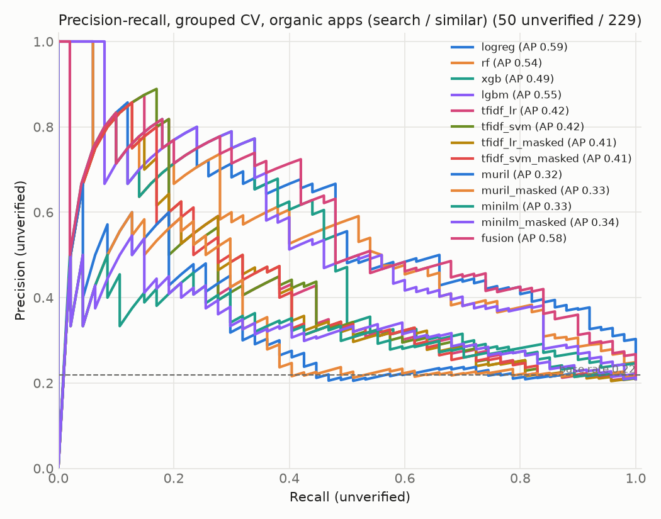
Fig. 1. Precision–recall curves on organic apps (out-of-fold scores pooled across folds, so the legend's average precision differs from the per-fold means in Table 2; dashed line = base rate).
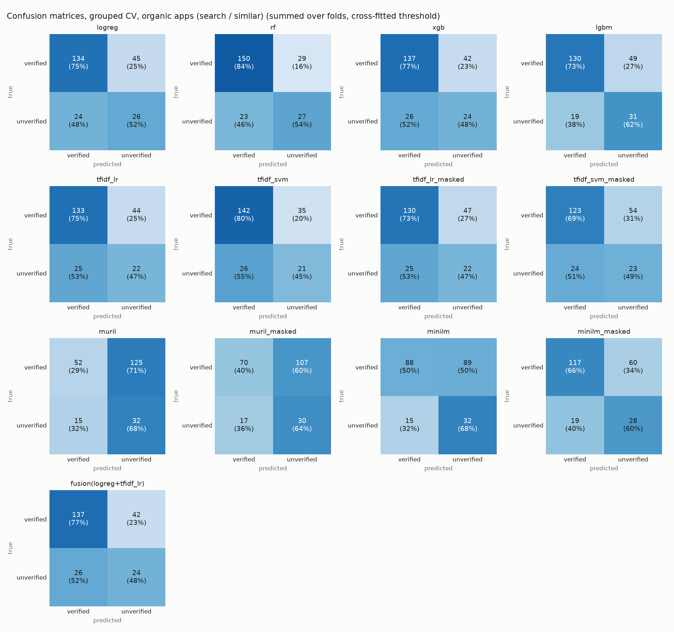
Fig. 2. Confusion matrices on organic apps, summed over folds (threshold chosen on the training folds).

Generalisation to newer apps
To test whether models trained on older apps flag newly released ones, we trained on apps released before 2025-11-20 (306 apps, 29 unverified) and tested on later releases (43 organic apps, 21 unverified; base rate 0.488). Table 3 reports the three best models.
Table 3. Temporal hold-out on organic apps released on or after 2025-11-20.
Model | PR-AUC | ROC-AUC | Rec@5% FPR
Logistic regression | 0.77 | 0.72 | 0.33
Random forest | 0.87 | 0.88 | 0.67
LightGBM | 0.74 | 0.74 | 0.38

The random forest ranked later releases well (PR-AUC 0.87, ROC-AUC 0.88), and logistic regression less so (ROC-AUC 0.72). The test period is dominated by unverified apps (base rate 0.488): most unverified apps still live were released after Google Play's January 2026 removal of unlisted loan apps, so the higher PR-AUC partly reflects the base rate. ROC-AUC, which does not depend on the base rate, is comparable to grouped cross-validation, which suggests the learned signals carry over to newer apps.

Feature-group ablation
Removing one feature group at a time from Logistic regression (full model PR-AUC 0.65) changed PR-AUC by +0.004 (metadata), −0.008 (developer), −0.080 (permissions), −0.022 (listing text) and −0.045 (review text) (Fig. 3). The largest drop came from removing permissions.
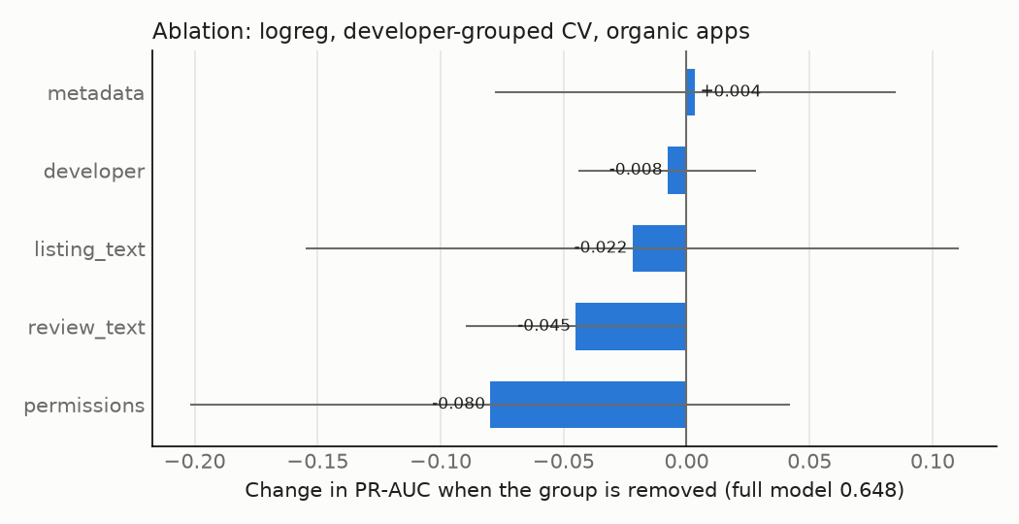
Fig. 3. Change in PR-AUC on organic apps when each feature group is removed (error bars: fold standard deviation).

Early detection
Using only information available in an app's first 14 days (no install counts, ratings or age, and reviews from the first two weeks only), Logistic regression reached a PR-AUC of 0.62 ± 0.12 (ROC-AUC 0.84 ± 0.05), against 0.65 ± 0.04 (ROC-AUC 0.85 ± 0.03) with full snapshot features. Only 33 labelled apps had any review in their first 14 days, because reviews were collected newest-first, so the early setting relies mainly on listing text and permissions.
Early detection is practical. With only first-fortnight information, ranking performance is close to the full model, so the signals that matter (the listing's disclosures and the permission profile) are available at release rather than accumulating with installs and reviews. Because few apps have early reviews, this result says more about listing and permission signals than about early review text.

Class imbalance and leakage checks
Table 4 compares class weighting with SMOTE oversampling (applied inside training folds only), and random with developer-grouped splits. A positive gap means random splitting overstates performance because near-identical apps from one developer leak across folds.
Table 4. PR-AUC on organic apps: class weights vs SMOTE, and random vs developer-grouped CV.
Model | Weights | SMOTE | Grouped CV | Random CV | Gap
Logistic regression | 0.65 ± 0.04 | 0.63 ± 0.12 | 0.65 ± 0.04 | 0.70 ± 0.09 | +0.05
Random forest | 0.58 ± 0.06 | 0.65 ± 0.13 | 0.58 ± 0.06 | 0.66 ± 0.12 | +0.08
XGBoost | 0.55 ± 0.10 | 0.57 ± 0.13 | 0.55 ± 0.10 | 0.59 ± 0.13 | +0.04
LightGBM | 0.57 ± 0.08 | 0.57 ± 0.05 | 0.57 ± 0.08 | 0.64 ± 0.12 | +0.07

SMOTE did not help consistently: it raised the random forest's PR-AUC but slightly lowered logistic regression's, and all differences are within fold variability, so class weighting is kept. Random splits overstated PR-AUC for every model (gaps from +0.04 to +0.08), confirming that near-identical apps from the same developer inflate naively split evaluations. All other results therefore use developer-grouped folds.

Explanations
Fig. 4 shows SHAP values for Random forest fitted on all 414 labelled apps. The five most influential features were names a lending partner, app age (days), states tenure, description length (log) and review count (log).
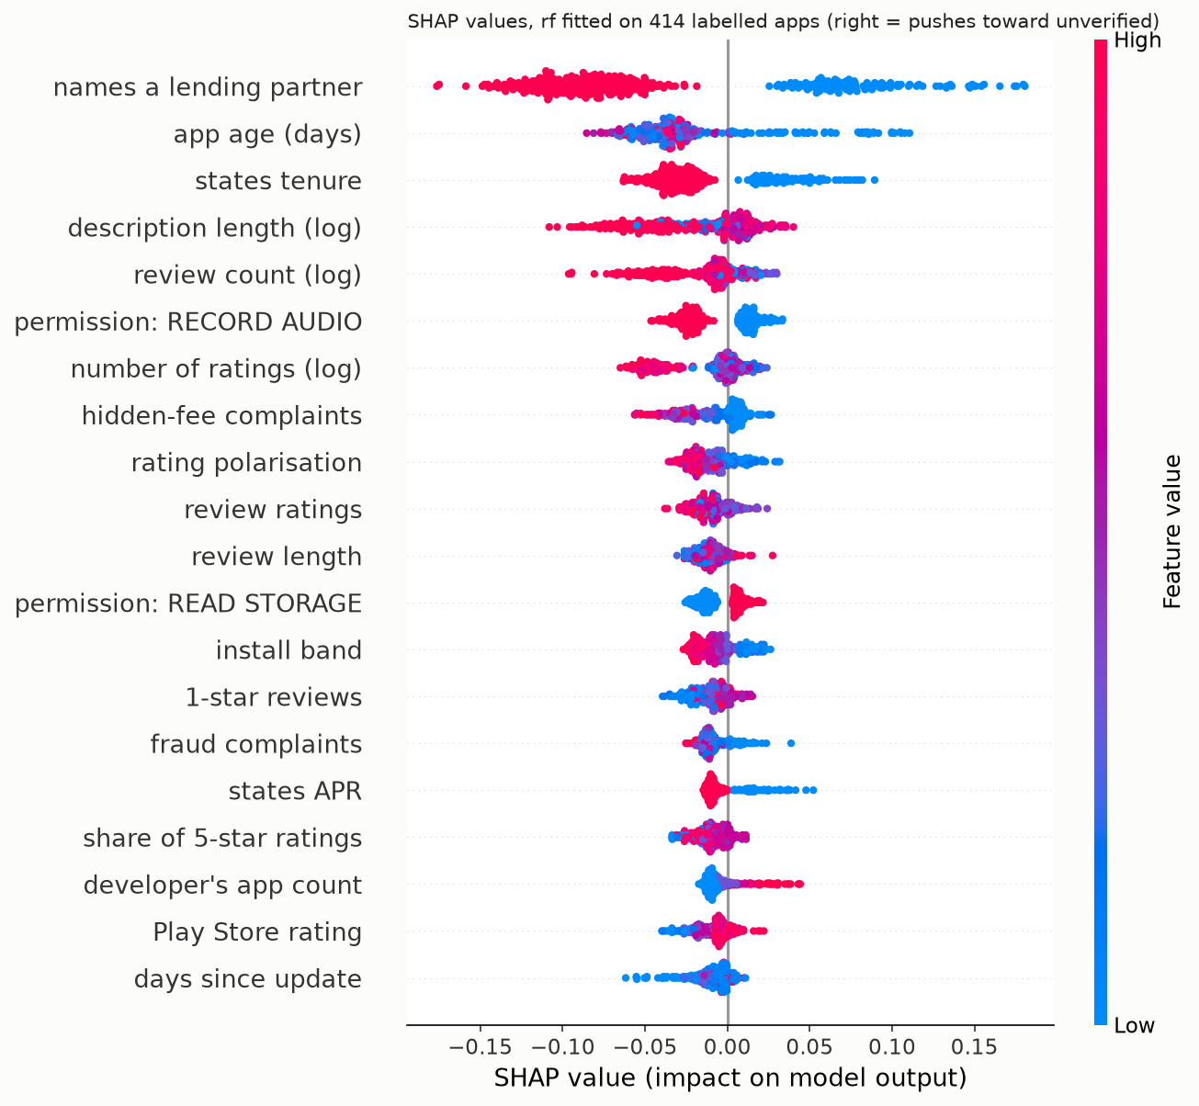
Fig. 4. SHAP summary for Random forest. Points to the right push the prediction toward unverified; colour shows the feature value.
Whether the listing names an NBFC or bank lending partner dominates. Apps that do are pushed strongly toward verified, consistent with RBI's requirement that digital lending apps disclose the regulated entity they lend for. Stating the loan tenure and the APR act the same way. Newer apps are pushed toward unverified, which partly reflects survivorship after the 2026 Play removal rather than an inherent property of risky apps. Larger, more-reviewed apps lean verified. Two signals run against intuition. Requesting microphone access leans verified, as large regulated lenders use it for video KYC. Complaints about hidden fees also lean verified, because complaint volume scales with the user base. Permissions therefore matter through their pattern, not as simple red flags.
For the review-text model, the n-grams most associated with unverified apps included “no personal”, “kuhoo”, “home loan”, “down payment”, “credit card”, and those most associated with verified apps included “good working”, “instant loan”, “fast loan”, “loan and”, “loan apps” (Fig. 5).
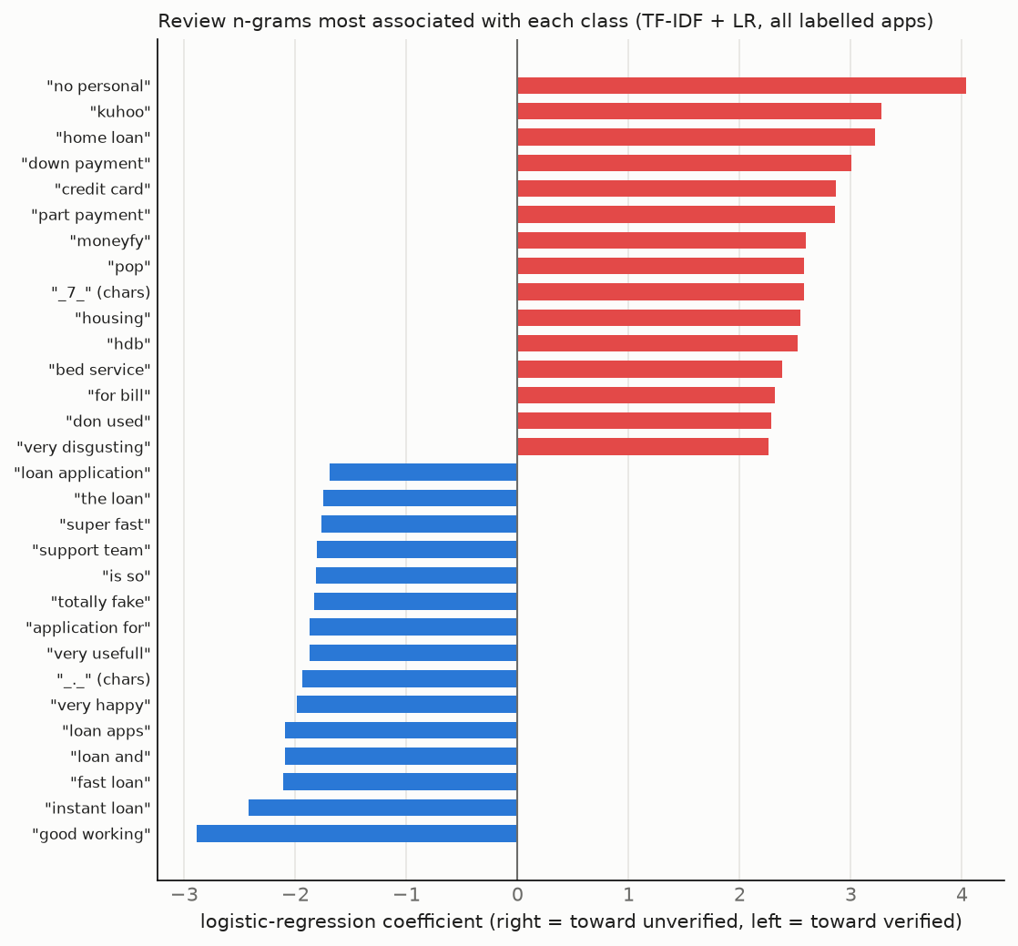
Fig. 5. Review n-grams with the largest logistic-regression weights toward each class.
The strongest "unverified" terms are largely product and app names (e.g. "kuhoo", "moneyfy", "home loan", "housing"). This reflects that many unverified apps are unlisted home-finance and education-loan apps of regulated lenders. Generic complaint phrases such as "totally fake" lean verified, because popular listed apps attract more complaints. The brand-masking experiment below shows that the app names among these terms are not what the model depends on, but the product-category terms are. The text model therefore learns which kinds of loan unverified apps offer rather than risk language, which is consistent with its weaker grouped cross-validation performance.

Brand names versus risk language
Each app's own brand words (from its title, developer and package name) were replaced by a placeholder in its reviews, so the text models could no longer recognise which app a review was about. Masking changed almost nothing. TF-IDF + LR reached PR-AUC 0.48 ± 0.20 with masking and 0.49 ± 0.19 without, and the paired bootstrap difference between them is +0.006 [−0.015, +0.030]. Brand names rank high among the model's weights (Fig. 5), but its performance does not rest on them. After masking, it relies on product-category words such as "home loan" and "gold", which reflect that many unverified apps are unlisted home-loan and gold-loan apps of regulated lenders. The frozen encoders gained slightly from masking but stayed below TF-IDF (MiniLM 0.40 ± 0.16, MuRIL 0.40 ± 0.14).

Two kinds of unverified app
Unverified apps are not all alike. We tagged each one by whether its developer is a regulated lender (or a lending service provider the directory already lists) whose app is simply missing from the directory (28 apps), or whether no regulated entity could be identified behind it (22 apps), the group that matters most to borrowers. Table 5 reports how well each model separates verified apps from each group.
Table 5. Verified apps vs each kind of unverified app (organic apps, pooled out-of-fold scores).
Model | No regulated entity: PR-AUC | ROC-AUC | Regulated, unlisted: PR-AUC | ROC-AUC
Logistic regression | 0.50 | 0.83 | 0.41 | 0.82
Random forest | 0.58 | 0.84 | 0.27 | 0.74
Fusion | 0.45 | 0.80 | 0.42 | 0.82
TF-IDF + LR | 0.15 | 0.57 | 0.42 | 0.72
TF-IDF + LR, brand-masked | 0.16 | 0.57 | 0.40 | 0.71

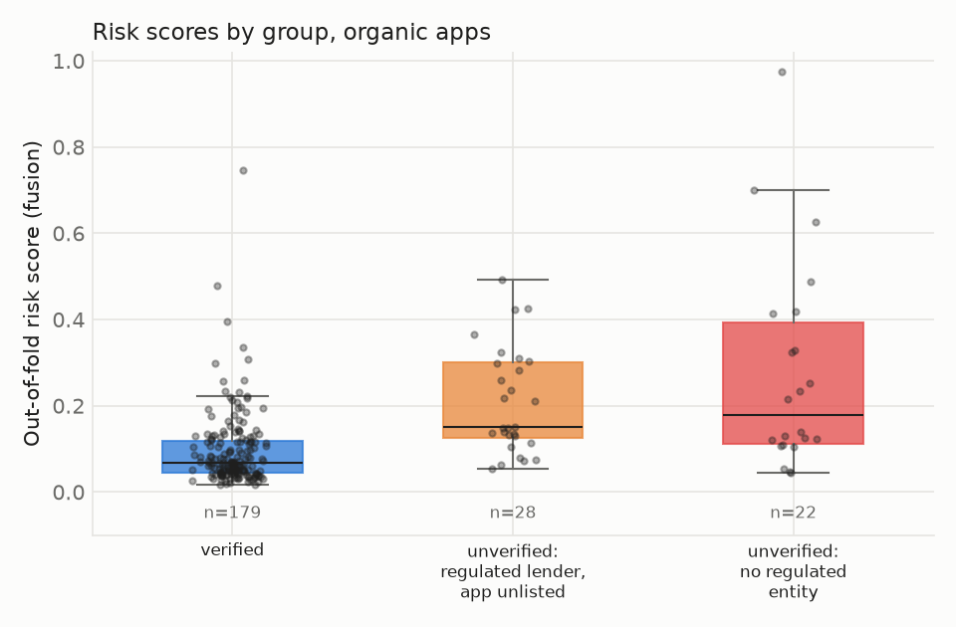
Fig. 6. Out-of-fold risk scores by group on organic apps.
The listing-based models detect the riskier group at least as well as the other. The random forest separates apps with no regulated entity from verified apps with ROC-AUC 0.84 (PR-AUC 0.58 against a base rate of 0.110), and logistic regression with ROC-AUC 0.83. The review-text model behaves the opposite way: it is near chance for apps with no regulated entity (ROC-AUC 0.57) and better for unlisted apps of regulated lenders (0.72), consistent with its reliance on product-category words. For borrower protection, the listing and permission features are therefore the useful part of the system.

Statistical robustness
With 50 unverified organic apps, differences between models must be read against their uncertainty. On pooled out-of-fold scores, logistic regression reaches PR-AUC 0.59 [0.45, 0.73] (95% bootstrap CI) and the fusion model 0.58 [0.45, 0.72]. A paired bootstrap of fusion minus logistic regression gives −0.014 [−0.074, +0.048] for PR-AUC and −0.012 [−0.039, +0.012] for ROC-AUC. For calibration, Fig. 7 shows the demo's risk percentages, which are calibrated by Platt scaling fitted on the other folds: the Brier score is 0.157 against 0.171 for always predicting the base rate, and the expected calibration error is 0.106.
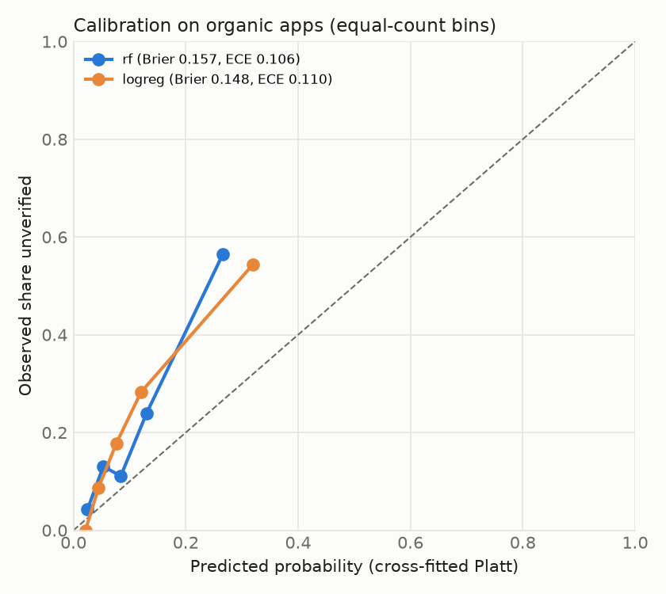
Fig. 7. Calibration of cross-fitted risk probabilities on organic apps (equal-count bins; dashed line = perfect calibration).
The intervals are wide. With 50 unverified apps, logistic regression, fusion and the tree ensembles cannot be reliably ranked against each other, because every paired difference interval includes zero. All of them are clearly above both the base rate and the text-only models: the paired ROC-AUC difference for TF-IDF + LR against logistic regression is −0.170 [−0.262, −0.080]. The risk percentages are only moderately calibrated, so the demo presents them as indicative scores alongside a verdict and its reasons, not as exact probabilities.

Summary
On organically discovered apps, logistic regression on listing, permission and review features identifies apps missing from RBI's Digital Lending Apps directory with PR-AUC 0.65 ± 0.04 against a base rate of 0.218, and adding review text through stacking does not reliably improve on it. The models detect apps with no identifiable regulated entity, the group that matters most to borrowers, at least as well as unlisted apps of regulated lenders. Performance holds on newer releases and with first-fortnight information, so screening apps at release is feasible. The most informative evidence is whether a listing names its regulated lending partner and states its loan terms, together with its permission profile. Unverified here means "not in the RBI directory snapshot of 2026-10-08", a class that includes unlisted apps of regulated lenders, and the borderline labels come from a single AI-assisted annotator. The model is therefore a screening aid, not a legal determination.

