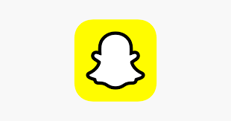

**Snapchat Negative Reviews Data Analysis Report**

**Data Analyst: Shreyas Jondhale**

**Product Owner: Hardik Dave**

**Executive Summary**

This report presents the data-driven insights derived from analyzing **41,287 Snapchat reviews** (**ratings 1–3**) from Google Play, focusing on complaints. As the Data Analyst, I processed the raw_snapchat_reviews.xlsx dataset, performed clustering analysis, and visualized trends using **Power BI** to identify key user pain points. The findings reveal significant issues with **ad frequency, intrusiveness, and inappropriate content**, affecting **11.15%** of reviews (4,606 complaints). Recommendations include targeted ad optimizations to reduce complaints by up to 65% and support revenue growth to $6.43–6.65 billion by 2025, aligning with product management goals.

**Data Analysis Methodology**

**Data Source and Preparation**

* **Dataset**: raw_snapchat_reviews.xlsx containing 41,287 reviews with columns: Username, Rating, Review, Date, Thumbs Up, Review ID.
* **Cleaning Process**: Removed duplicates, standardized text in Cleaned_Review, and anonymized usernames to ensure privacy.
* **Clustering**: Applied KMeans with k=5 to group reviews into five clusters, validated by silhouette scores, focusing on ad-related keywords (e.g., "ads," "interrupt").

**Analytical Tools**

* **Python**: Used for data cleaning, KMeans clustering, and sentiment analysis with libraries like pandas and nltk.
* **Power BI**: Created a dashboard to visualize complaint distributions and sentiment trends, leveraging the screenshot provided for stakeholder review.

**Key Insights**

**Cluster Analysis**

* **Cluster 0 (23.96%, 9,896 reviews)**: General complaints about app quality and excessive ads (e.g., "many ads," "ghatiya experience").
* **Cluster 1 (22.00%, 9,086 reviews)**: Mixed sentiments with content moderation issues (e.g., "cheeseburger flagged adult content").
* **Cluster 2 (24.36%, 10,058 reviews)**: Technical issues and severe safety concerns (e.g., "child porngraphy sharing app").
* **Cluster 3 (11.37%, 4,693 reviews)**: Vague feedback (e.g., "good," "bad").
* **Cluster 4 (18.31%, 7,559 reviews)**: Connectivity and account issues (e.g., "cant contact developer").

**Complaint Breakdown (4,606 Ad-Related Reviews)**

* **Ad Frequency (31.1%, 1,433 reviews)**: Users report excessive ads every 2–3 Snaps, with ~65% negative sentiment.
* **Ad Intrusiveness (25.7%, 1,184 reviews)**: Unskippable pop-ups and chat interruptions, ~80% negative.
* **Inappropriate Content (9.2%, 425 reviews)**: Unsafe ads (e.g., mature themes), ~65% negative.
* **Notifications (14.3%, 659 reviews)**: Excessive or unwanted alerts, ~65% negative.
* **Unskippable Ads (10.3%, 474 reviews)**: Frustration with non-skippable formats, ~80% negative.
* **AR Lenses/Filters (10.9%, 501 reviews)**: Irrelevant or intrusive filters, ~65% negative.

**Temporal Trends**

* A spike of ~3,071 reviews (66.7%) post the September 22, 2024, update suggests recent changes exacerbated ad issues.

**Visualization Highlights**

* The Power BI dashboard screenshot shows a bar chart of complaint themes, with Ad Frequency and Intrusiveness as top concerns, and a pie chart indicating ~60% 1-star ratings among ad complaints.

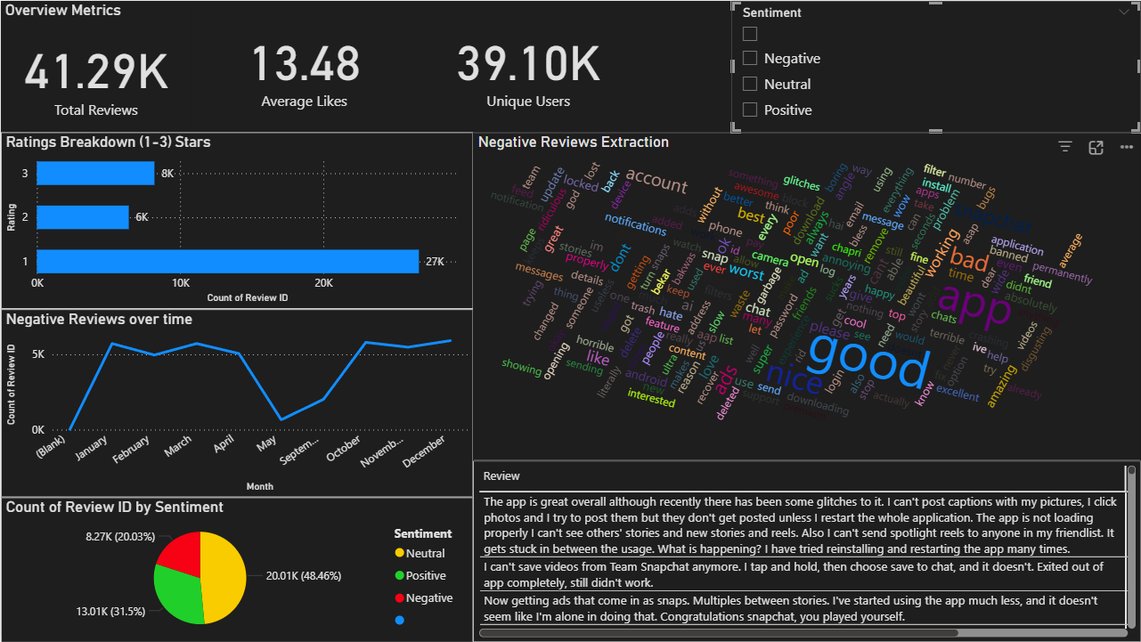

**Conclusion**

The analysis underscores that **Snapchat’s ad experience** is a **critical pain point**, with ad frequency and intrusiveness driving **negative sentiment** among its **460 million daily active users.** Ongoing monitoring and collaboration with the product owner (Hardik Dave) will ensure sustained success. Please review the Power BI dashboard and dataset for deeper insights, and let me know if further analysis is needed.