🧠 DFS & BFS Notes (Exam-Ready)

🔷 DFS — Depth First Search
📌 Concept
- Explore as deep as possible before backtracking.
- Uses Stack (system call stack in recursion).
- Suitable for: trees, graphs, path finding, cycle detection.

⭐ DFS Key Points
Feature | DFS
Data Structure | Stack (recursive or explicit)
Traversal Order | Depth first — go deep into one path
Memory | Requires storing visited + recursion stack
Best Used For | Maze solving, topological sort, checking connectivity
Time Complexity | O(V + E)
Space Complexity | O(V)

📌 DFS Algorithm
- Start from the source node
- Mark node as visited
- Process the node (print / record)
- For each unvisited neighbor:
  - Recursively apply DFS on the neighbor
- Stop when all nodes are visited

🧠 DFS One-Line Definition
DFS traverses a graph by visiting a starting node, then exploring each branch deeply before moving to the next branch.

🟣 BFS — Breadth First Search
📌 Concept
- Explore level by level (breadth-wise).
- Uses a Queue (FIFO).
- Best for shortest path in unweighted graphs.

⭐ BFS Key Points
Feature | BFS
Data Structure | Queue
Traversal Order | Level-wise (neighbors first)
Memory | Needs queue + visited list
Best Used For | Routing, friend suggestions, shortest path
Time Complexity | O(V + E)
Space Complexity | O(V)

📌 BFS Algorithm
- Start with source node
- Mark source as visited
- Insert (enqueue) into queue
- While queue is not empty:
  - Dequeue a node and process it
  - For each unvisited neighbor:
    - Mark neighbor visited
    - Enqueue neighbor
- Stop when queue becomes empty

🧠 BFS One-Line Definition
BFS traverses a graph by first visiting all neighbors of a node, then moving to the next level of neighbors using a queue.

🔍 Difference Summary — DFS vs BFS
Feature | DFS | BFS
Main Concept | Depth-wise | Level-wise
Uses | Stack | Queue
Path Found | Not always shortest | Always shortest (unweighted)
Memory | Lower than BFS | Higher than DFS
Best For | Cycle detection, topo sort | Shortest path, broadcast
Backtracking | Yes | No

📌 Greedy Best-First Search — Notes
🔹 Definition
Greedy Best-First Search is an informed search strategy that selects the next node to explore based on the lowest heuristic value (h(n)) — the node that appears closest to the goal.
It is called “Greedy” because it always chooses what looks best at the moment.

🎯 Search Strategy
- Evaluates nodes using only heuristic function
$$f(n)=h(n)$$
- h(n) = estimated cost from node n to the goal
- Uses Open list (Priority Queue) + Visited set

⭐ A* Search Algorithm — Notes
📌 Definition
A* (A-star) is an informed search algorithm that selects the next node to explore using both:
- g(n): Cost from start to current node
- h(n): Estimated cost from current node to goal (heuristic)
👉 Evaluation Function:
$$f(n)=g(n)+h(n)$$
This makes A* both optimal and complete when using an admissible heuristic.

🎮 Adversarial Search — Notes
📌 Definition
Adversarial Search is used in environments where:
- Multiple agents exist
- Their goals conflict
- One player's gain = another player's loss
➡ Mostly used in two-player zero-sum games
Examples: Chess, Tic-Tac-Toe, Checkers

🔹 Key Concepts
Term | Meaning
Agent | A player that makes decisions
Zero-Sum Game | One wins, other loses equally
Game Tree | All possible game states shown as a tree
Max Player | Tries to maximize score
Min Player | Tries to minimize opponent’s score
Used in decision making under competition (not just path finding).

🔹 Minimax Evaluation
Leaf nodes are assigned heuristic values → Win/Loss likelihood
Then:
- At MAX nodes: choose maximum value
- At MIN nodes: choose minimum value
Algorithm chooses the best worst-case scenario.

📌 Minimax Algorithm Steps (Simple)
- Generate game tree from current state.
- Apply heuristic function at terminal states (leaf nodes).
- Propagate scores upward:
  - MAX chooses max child
  - MIN chooses min child
- The root selects the best move for MAX.

def minimax(board, isMax):
score = evaluate(board)

# If game already finished, return score
if score == 10 or score == -10:
return score

if not moves_left(board): # Draw
return 0

# Maximizing player's move (AI - X)
if isMax:
best = -9999
for i in range(3):
for j in range(3):
if board[i][j] == '_':
board[i][j] = 'X' # Make move
best = max(best, minimax(board, False))
board[i][j] = '_' # Undo move
return best

# Minimizing player (Opponent - O)
else:
best = 9999
for i in range(3):
for j in range(3):
if board[i][j] == '_':
board[i][j] = 'O'
best = min(best, minimax(board, True))
board[i][j] = '_'
return best

def find_best_move(board):
bestVal = -9999
bestMove = (-1, -1)

for i in range(3):
for j in range(3):
if board[i][j] == '_':
board[i][j] = 'X'
moveVal = minimax(board, False)
board[i][j] = '_'

if moveVal > bestVal:
bestVal = moveVal
bestMove = (i, j)

return bestMove
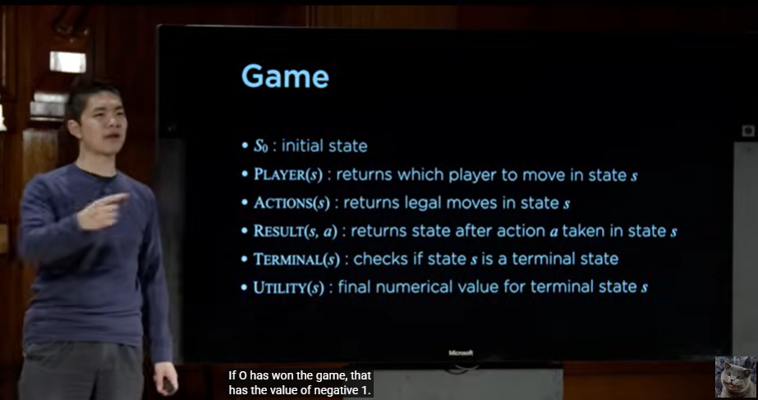

🌳 Alpha-Beta Pruning — Notes

📌 Definition
Alpha-Beta pruning is an optimization technique applied to the Minimax algorithm to reduce the number of nodes evaluated in a game tree without affecting the result.
It eliminates branches that cannot influence the final decision.

🔹 Key Concepts
During evaluation, two values are tracked:
Parameter | Meaning | Used by
Alpha (α) | Best value that MAX can guarantee | MAX layers
Beta (β) | Best value that MIN can guarantee | MIN layers
✔ Alpha starts at −∞
✔ Beta starts at +∞

📌 Limited Depth Minimax Algorithm — Notes
🔹 What is Limited Depth Minimax?
Normal Minimax expands the entire game tree up to terminal states.
But in complex games like Chess or Go, the full tree can be extremely huge → impossible to explore fully.
So, we limit the depth of the search → only explore a fixed number of moves ahead.

TIC-TAC-TOE:
Nice, this is the classic CS50 AI Tic-Tac-Toe skeleton 🙂
I’ll walk you through each function, telling you what exactly should happen inside, and how minimax should be structured, but without writing the exact code.
You can treat this as a checklist while you fill in the functions.

1️⃣ player(board)
Goal: Return whose turn it is right now (X or O).
Inside this function, do this:
- Go through every cell of the board and count how many X and how many O are present.
- At the start of the game, counts are equal (0 and 0), and it's X’s turn.
- In general:
  - If X has played more moves than O, then it's O’s turn.
  - Otherwise, it's X’s turn.
- Return X or O accordingly.
No recursion here, just counting.

2️⃣ actions(board)
Goal: Return a set of all available moves.
Each move is a pair (i, j) where:
- i is the row index (0–2)
- j is the column index (0–2)
Inside this function:
- Create an empty set (e.g., possible_actions).
- Loop over all rows i from 0 to 2.
- Inside that, loop over all columns j from 0 to 2.
- If board[i][j] is EMPTY, add (i, j) to the set.
- At the end, return that set.

3️⃣ result(board, action)
Goal: Return a new board that is the result of applying action on board.
Important:
You must not modify the original board. Work on a deep copy.
Inside this function:
- First, check that action is valid:
  - Extract i, j from action.
  - If board[i][j] is not EMPTY, this is an invalid move → raise an exception.
- Make a deep copy of the board (not just simple assignment).
- Determine whose turn it is by calling player(board).
- On the copied board, set the cell at (i, j) to that current player symbol (X or O).
- Return the new board.

4️⃣ winner(board)
Goal: Return X if X has won, O if O has won, otherwise None.
Inside this function, check:
- Rows: For each row:
  - If all three cells are equal and not EMPTY, return that symbol.
- Columns: For each column:
  - If all three cells in that column are equal and not EMPTY, return that symbol.
- Diagonals:
  - Main diagonal: positions (0,0), (1,1), (2,2)
  - Anti-diagonal: (0,2), (1,1), (2,0)
  - If all three in a diagonal are equal and not EMPTY, return that symbol.
- If none of these checks find a winner, return None.

5️⃣ terminal(board)
Goal: Return True if the game is over, else False.
A game is over if:
- Someone has won, or
- The board is full (no EMPTY cells).
Inside this function:
- If winner(board) is not None, return True.
- Otherwise, check every cell:
  - If you find at least one EMPTY, the game is not over → return False.
- If you finish the loop and found no EMPTY, the board is full → return True.

6️⃣ utility(board)
Goal: Turn a final game state into a number:
- 1 if X has won
- -1 if O has won
- 0 otherwise (draw or game not finished)
Inside this function:
- Call winner(board) and store the result.
- If winner is X, return 1.
- If winner is O, return -1.
- Otherwise, return 0.

7️⃣ minimax(board) — This is the big one ⚠️
Docstring says:
Returns the optimal action for the current player on the board.
So:
✅ It should return (i, j)
❌ It should not just return a score.
Right now your code:
score = utility(board)

if score == 1 or score == -1:
return score

if terminal(board):
return 0
This is not correct for the final version, because:
- minimax must return an action, not a score.
- Checking utility directly is not necessary here; you should rely on terminal(board) and then utility(board) in helper functions.
🔧 Recommended structure
The cleanest approach is:
- Above minimax, define two helper functions:
  - max_value(board)
  - min_value(board)
- These helpers will:
  - Return a numeric score (1, -1, 0).
  - Use recursion and result(...).

Step A: max_value(board) – thinking as X
Inside max_value:
- If terminal(board) is True, return utility(board).
- Otherwise:
  - Initialize a variable with negative infinity (worst possible for max).
  - For each action in actions(board):
    - Compute the score of that action by calling min_value(result(board, action)).
    - Update your variable to the maximum of its current value and that score.
- At the end, return that maximum value.
This represents:
"If it's X's turn, what is the best score X can force from this position?"

Step B: min_value(board) – thinking as O
Inside min_value:
- If terminal(board) is True, return utility(board).
- Otherwise:
  - Initialize a variable with positive infinity (worst possible for min).
  - For each action in actions(board):
    - Compute the score by calling max_value(result(board, action)).
    - Update your variable to the minimum of its current value and that score.
- At the end, return that minimum value.
This represents:
"If it's O's turn, what is the best (lowest) score O can force from this position?"

Step C: Now fix minimax(board)
Goal: Decide the best action for the current player.
Inside minimax:
- If terminal(board) is True, there is no move → return None.
- Find whose turn it is using player(board):
  - If it's X (maximizer):
    - Initialize:
      - A variable for best score = negative infinity.
      - A variable for best action = None.
    - For each action in actions(board):
      - Compute value by calling min_value(result(board, action)).
      - If this value is greater than your current best score:
        - Update best score.
        - Update best action.
    - After looping through all actions, return the best action.
  - If it's O (minimizer):
    - Initialize:
      - Best score = positive infinity.
      - Best action = None.
    - For each action:
      - Compute value by calling max_value(result(board, action)).
      - If value is less than current best score:
        - Update best score and best action.
    - Return best action.

8️⃣ Summary of what you must change in your file
- player: Count X and O; if equal → X, else → O.
- actions: Return set of (i, j) where cell is EMPTY.
- result: Deep copy board, check action valid, place current player symbol, return new board.
- winner: Check all rows, cols, diagonals; return X, O, or None.
- terminal: Use winner and check full board.
- utility: Use winner and map to 1 / -1 / 0.
- minimax:
  - Add max_value and min_value helpers.
  - minimax itself should return an action, not a score.
  - Use helpers to evaluate each possible action and pick the best one.

If you want, you can now paste your updated minimax, max_value, and min_value logic (even if buggy), and I’ll point out mistakes line-by-line without rewriting it for you.

