Some of the key features that make Django a standout choice for developers worldwide are :
1. Ridiculously fast
- Django uses an Object-Relational Mapping (ORM) system, making database queries quick and efficient.
- It also has caching mechanisms and compiled templates that boost speed.
2. Built-in Admin Interface
- Django provides a ready-to-use admin panel to manage your app’s data.
- This saves time by allowing you to add, edit, and delete content easily without extra coding.
3. Modular Design and Reusability
- Follows the DRY (Don't Repeat Yourself) principle, making your code more reusable and easier to maintain.
- You can create individual apps (components) for features like user accounts or blogs, which can be reused in other projects.
4. Highly Scalable
- Django handles heavy traffic efficiently.
- Features like caching and database indexing make it ideal for websites with a lot of users.
5. Reassuringly secure
- Comes with built-in security features to protect against SQL injection, XSS attacks, clickjacking, and more.
- Includes a strong authentication system to manage users securely.
Why we should use Django over other frameworks?
1. Versatile
Django is not limited to a specific type of web application. Whether you're building content management systems (CMS), e-commerce platforms, social networking sites, or APIs, Django provides the tools and flexibility to tackle diverse projects.
2. Availability of Documentation
Django boasts a large and active community. This means ample resources, tutorials, and third-party packages are available, making it easier for developers to find solutions to problems and stay informed about best practices. The comprehensive and well-maintained documentation is an added advantage.
3. Testing Support
Django promotes reliable code through its built-in testing framework. Developers can easily write unit tests, ensuring that any changes to the code won't lead to unexpected issues. This emphasis on testing contributes to the overall stability and dependability of Django applications.
4. Free and open source
Django is an open-source framework, meaning it is free to use and modify. This not only makes it cost-effective for businesses but also fosters a collaborative environment where developers worldwide contribute to its improvement.

Web Development Tools

Visual Studio Code
Visual Studio Code, also commonly referred to as VS Code, is a source-code editor made by Microsoft with the Electron Framework, for Windows, Linux and macOS. Features include support for debugging, syntax highlighting, intelligent code completion, snippets, code refactoring, and embedded Git.
https://code.visualstudio.com/
Git
Git is a distributed version control system that tracks changes in code. It’s widely used by developers to collaborate and manage projects efficiently.
Key Features:
- Tracks Changes: Keeps a record of code updates over time.
- Collaborative Workflows: Helps teams work together on the same codebase.
- Non-linear Workflows: Supports branching and merging for flexible project management.
https://git-scm.com/

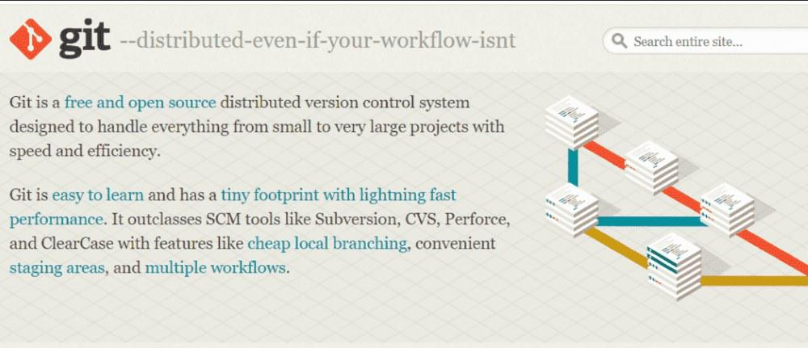

Github
GitHub is a hosting service for Git repositories. It adds tools for collaboration, issue tracking, and task management to Git’s version control features.
Key Features:
- Access Control: Manage permissions for team members.
- Bug Tracking and Wikis: Keep track of issues and document your project.
- Continuous Integration: Automate testing and deployment.
https://github.com/



Postman
Postman is an API Platform for developers to design, build, test and iterate their APIs. As of February 2023, Postman reports having more than 25 million registered users and 75,000 open APIs, which it says constitutes the world's largest public API hub.
https://www.postman.com/
DBeaver
DBeaver is a database administration tool for managing SQL and other types of databases. It supports a variety of databases and provides an intuitive interface.
Key Features:
- Database Management: Manage schemas, tables, and queries.
- Cross-Platform Support: Works with relational and non-relational databases.
- SQL Editor: Write, execute, and analyze SQL queries efficiently.
https://dbeaver.io/
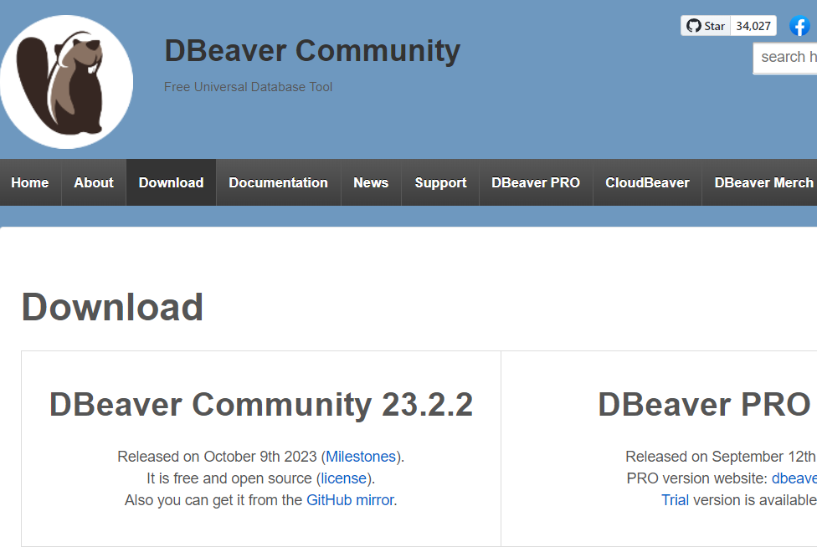

As projects grow in complexity, developers seek tools that not only simplify their workflow but also enhance the quality and stability of their applications. In this article, we'll delve into three powerful tools—Sentry, Locust, and pgAdmin—that have become indispensable for modern web development.
Sentry: Error Tracking and Monitoring
Bug tracking and error monitoring are indispensable components of any web development project. Sentry steps in as a robust solution for detecting, diagnosing, and fixing bugs in real-time. It provides developers with detailed error reports, stack traces, and contextual information, enabling them to quickly identify and resolve issues before they impact users.
Sentry's key features include:
- Real-time Monitoring: Detects errors and performance issues as they occur.
- Detailed Reports: Provides stack traces, environment details, and user context.
- Integrations: Works with tools like GitHub, Slack, and Jira.
With Sentry, developers can proactively address issues, minimize downtime, and deliver exceptional user experiences.
Locust: Load Testing for Scalability
Scalability is a crucial aspect of web development, particularly for applications expected to handle a large volume of traffic. Locust emerges as a powerful tool for load testing, allowing developers to simulate thousands of concurrent users and assess the performance and scalability of their applications.
Key features of Locust include:
- Distributed Load Testing: Simulates thousands of users across machines.
- Real-time Insights: Monitors performance metrics during tests.
- Python Scripting: Write custom user scenarios with minimal effort.
With Locust, developers can conduct comprehensive load tests, identify performance issues early in the development cycle, and optimize their applications for scalability and reliability.
pgAdmin: Database Management Made Easy
Effective database management is essential for maintaining the integrity and performance of web applications. pgAdmin serves as a comprehensive and intuitive tool for managing PostgreSQL databases, offering a wide range of features to streamline database administration tasks.
Key features of pgAdmin include:
- Graphical Interface: Makes managing databases simple and intuitive.
- Query Tool: Write and execute SQL queries directly.
- Backup and Restore: Easily safeguard and recover your data.
By providing developers with a powerful set of tools for database management, pgAdmin enhances productivity and enables seamless interaction with PostgreSQL databases.

Returning HTTP response from Django and understanding URLS

Django provides a straightforward way to handle HTTP responses, allowing developers to communicate with clients based on user requests. The primary tool for handling responses is through Django's HttpResponse class.
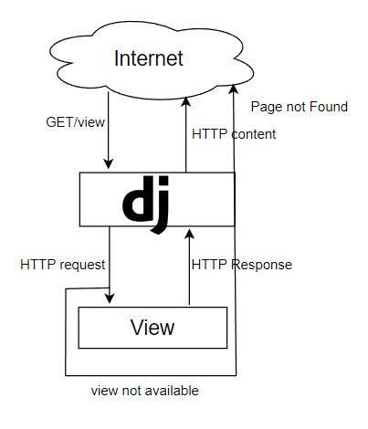

Creating a Simple HTTP Response
To return a simple response, define a view function in your app's views.py file. For example:
home/views.py
from django.http import HttpResponse
​
def index(request):
return HttpResponse("Hi.. from Django Server")
Adding HTML Content to Responses:
You can also include HTML content in the response to display dynamic web pages.
home/views.py
from django.http import HttpResponse
​
def about(request):
html_content = "<h1>Hii.. from Django Server | This is a <b>About Page... </b> <br> <p> This about page can be used to see the about section.</p>"
return HttpResponse(html_content)
Developers can include HTML content within the response to render dynamic web pages.
Understanding URLs in Django
URLs play a pivotal role in mapping user requests to specific views within a Django application. The urls.py file is the entry point for defining URL patterns and connecting them to corresponding views.
1. firstly import the views functions from views.py
core/urls.py
from django.urls import path
from home.views import index, about
2. include the path for calling the views function
core/urls.py
from django.urls import path
from .views import index,about
​
urlpatterns = [
path('', index, name='index'),
path('about/', about, name='about'),
]
3. Run the django server

Visit http://127.0.0.1:8000/ in your web browser, and you should see the "Hi.. from Django Server" message as shown -

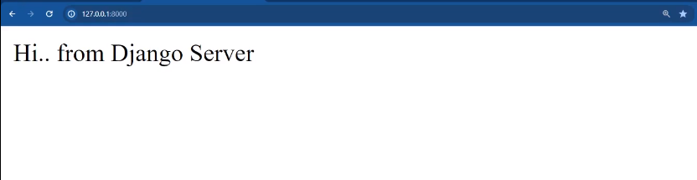
on visiting the http://127.0.0.1:8000/about/ in your web browser you should see the following -

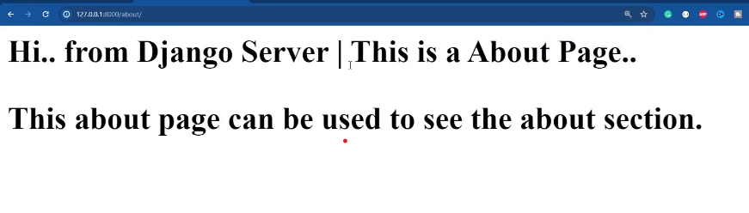
Similarly we can create views for path - http://127.0.0.1:8000/contact/ page.
Returning HTML Page as Response
To serve HTML pages, follow these steps:
1.. Create a templates folder:
Inside your app directory, create a folder named templates

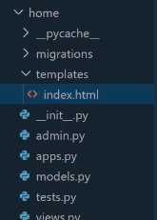

2. Create an HTML file:
Add your HTML file inside the templates folder. For example:
home/templates/index.html
<!DOCTYPE htmL>
<html Lang="en">
<head>
<meta charset-"UTF-8">
<meta name="viewport" content="width=device-width, initial-scale=1.0">
<title› Django Server </title>
</head>
<body>
<h1>This HTML page is returned by Django.</h1>
<p>Django is really nice.</p>
</body>
</html>

3. Update views.py:
Use Django’s render function to serve the HTML file.
home/views.py
from django.shortcuts import render
​
def index(request):
return render(request, 'index.html')
4. Map the view in urls.py:
Define a URL pattern for the view.
5. Run the django server

Visit http://127.0.0.1:8000/ in your web browser, and you should see this -

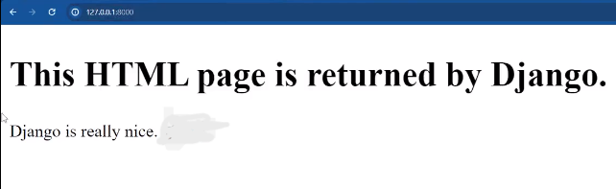

Understanding the namespace of URLs and request parameters in view

We’ve created paths for home, about, and contact pages. Now, let’s link these pages so users can navigate between them using links on the web pages.
Add an href Tag in the Frontend
1. Update index.html:
Add links to the about and contact pages using the <a> (anchor) tag:
templates/index.html
<! DOCTYPE html>
<html Lang="en">
<head>
<meta charset="UTF-8">
<meta name="viewport"
content="width=device-width, initial-scale=1.0">
< title>Django Server</title>
</head>
<body >
<h1>This HTML page is returned by Django. :)</h1>
<p>Django is really nice. 8 8 </p>
@ <p>
<a href="/contact"> Contact </a> • |
<a href="/about"> • About - </a>
</p>
</body>
</html>
2. Update about.html:
utilize same concept in about.html and contact.html to create redirect link in the Django web pages
templates/about.html
‹! DOCTYPE htmL>
<html Lang="en">
<head>
<meta charset="UTF-8">
<meta name="viewport" content="width=device-width, initial-scale=1.0">
<title>Django | About</title>
</head>
<body>
<h1>This HTML page is returned by Django.
• </h1>
<p>Django is really nice.
8 8 </p>
<p>About Page 0 € 0©.</p>
<p>
<a href="/"> Home </a> |
<a href="/contact"> Contact </a>
</p>
</body>
</html>
3. Update contact.html:
Add links to navigate to home and about pages:
templates/Contact.html
‹! DOCTYPE htmL>
<html Lang="en">
<head>
<meta charset="UTF-8">
<meta name="viewport" content="width=device-width, initial-scale=1.0">
<title>Django | About</title>
</head>
<body>
<h1>This HTML page is returned by Django.
• </h1>
<p>Django is really nice.
8 8 </p>
<p>Contact Page 0 € 0©.</p>
<p>
<a href="/"> Home </a> |
<a href="/about"> About </a>
</p>
</body>
</html>
Now the home, about and contact pages are linked and we can move between the pages by redirecting through the links

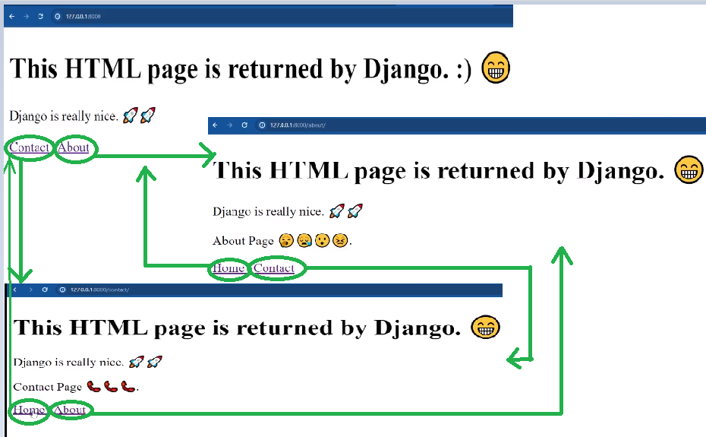

Namespace in Urls
In Django, a namespace is a way to organize URLs within an application. It helps avoid conflicts and provides a structured approach to managing different parts of your web application. Namespaces are defined in the urls.py file of each Django app.
Let's change the url path name in urls.py
from django.urls import path
from .views import index,about
​
urlpatterns = [
path('', index, name='index'),
path('about-xyz-company/', about, name='about'),
]
In the above example we can change the displayed path name according to our preference, but we will use namespace "name='about' "
Use {% url %} Template Tag:
Replace the static href links with the {% url %} tag to dynamically generate URLs based on their names.
templates/index.html
<! DOCTYPE html>
<html Lang="en">
<head>
<meta charset="UTF-8">
<meta name="viewport"content="width=device-width, initial-scale=1.0">
< title>Django Server</title>
</head>
<body>
<h1>This HTML page is returned by Django. :)</h1>
<p>Django is really nice. 8 8 </p>
<p>
<a href={% url 'contact' %}> Contact </a> • |
<a href={% url 'about' %> • About </a>
</p>
</body>
</html>

Testing the Links
- Start the Django development server:
python manage.py runserver
- Visit http://127.0.0.1:8000/ in your web browser.
  - You can now navigate between home, about, and contact pages using the links.

Creating Dynamic URLs in django

Creating dynamic URLs in Django involves using URL patterns to capture variable parts of a URL and pass them as parameters to your views.
Creating views for dynamic url
Now, let's enhance the application to handle parameters in the URL. Create views that will handle the dynamic URLs. For simplicity, let's create a basic 'dynamic_url' view:
home/views.py
def dynamic_url(request,id):
print(f"This is the value that we got in the func -› {id}")
return render (request,"dynamic_url.html")
Creating a template file
Create a template for your 'dynamic_url' view, for example, 'dynamic_url.html' :
templates/dynamic_url.html
<! DOCTYPE htmL>
<html Lang="en">
<head>
<meta charset="UTF-8">
<meta name="viewport" content="width=device-width, initial-scale=1.0">
<title> Django | Dynamic URL </title>
</head>
< body>
<h1 >This HTML page is returned by Django. </h1>
<p>Dynamic URL</p>
<р>
<a href="{% url'index' %}"> Home </a> |
<a href="(% url 'about '%)"> About </a>
</р>
</ body>
</html>

Define URL Patterns
In your urls.py file, define URL patterns. Use angle brackets < > to capture variables from the URL and pass them to the view.
Since in this case we are passing 'id' in our views, define the url as shown:
project/urls.py
from django.urls import path
from .views import index, dynamic_url
​
urlpatterns = [
path('<id>/', dynamic_url, name='dynamic_url'),
]
Passing dynamic URL value to HTML Template
1. Pass the context parameter in the render function of your views, Let's say the 'dynamic_url' view:
def dynamic_url(request,id):
print(f"This is the value that we got in the func -› {id}")
return render (request,"dynamic_url.html", context={"id":id, "name":"Deepika"})
2. Display the values of context in your template using '{{ context_value }}'
<! DOCTYPE htmL>
<html Lang="en">
<head>
<meta charset="UTF-8">
<meta name="viewport" content="width=device-width, initial-scale=1.0">
<title> Django | Dynamic URL </title>
</head>
< body>
<h1 >This HTML page is returned by Django. </h1>
<p> {{name}} </p>
<p>Dynamic URL : {{id}}</p>
<р>
<a href="{% url'index' %}"> Home </a> |
<a href="(% url 'about '%)"> About </a>
</р>
</ body>
</html>
3. Run the server
Visit 'http://127.0.0.1:8000/2345908' in your web browser, and you should see this -
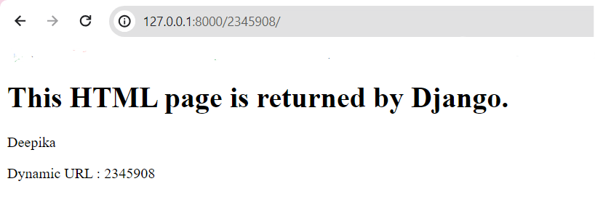
Restricting datatype of dynamic URL
Django provides path converters to enforce data types for dynamic URL parameters. Here are the most common converters:
Converter | Description | Example URL
<int> | Matches integers only | /123/
<str> | Matches any string (no slashes) | /example/
<slug> | Matches letters, numbers, hyphens, and underscores | /example-slug/
<uuid> | Matches a valid UUID | /550e8400-e29b/
<path> | Matches strings including slashes | /example/path/
Django provides built-in path converters that allow you to restrict the data type of dynamic URL parameters. Here's how you can restrict the data type of a dynamic URL parameter using converters:
from django.urls import path
from .views import index, dynamic_url
​
urlpatterns = [
path('<int:id>/<str:name>/', dynamic_url, name='dynamic_url'),
]

Class-based views vs. function-based views

In Django, you have the flexibility to choose between two approaches for handling HTTP requests: Class-based views (CBVs) and Function-based views (FBVs). Each approach offers its own advantages and disadvantages, making it crucial to understand the differences to select the most suitable method for your project's requirements.

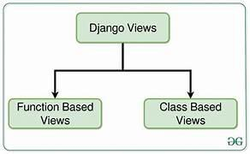

Understanding Class-based Views (CBVs):
CBVs inherit from predefined classes in Django's views.py module, providing a structured approach to handling requests. They offer several benefits:
1. Code Organization: CBVs promote code organization by grouping logic into reusable classes, making your codebase more maintainable and scalable.
2. Inheritance: You can extend parent classes to reuse code and add custom functionality.
3. Built-in Mixins: Django provides mixins that offer common functionalities like authentication, permission checks, and pagination, which you can easily integrate into your CBVs.
4. Generic Views: Django offers pre-built generic CBVs for common tasks like listing, adding, editing, and deleting objects, simplifying view development.
Example of a Class-based View:

class HomeView(View):
template_name = "index.html"
def get(self ,request) :
return render(request, self. template_name)
def post(self, request):
return render(request , self. template_name)
Using the CBV in URLs:
We have a little abstraction and method as_view() is calling the dispatch() to determine which class method needs to be executed, depending on the HTTP request. as_view() let you override the class attributes in your URLs confs.
#urls.py
from django.urls import path
from .views import Homeview
urlpatterns = [
path('home/', Homeview.as_view(),name ='home'),

]

Designing Your Own Class-based View:
To create your own class-based view, follow these steps:
1. Choose a base class: Select a suitable base class from Django's views.py module. View is a basic class, but others like FormView or TemplateView offer additional functionality.
2. Define the template name: Set the template_name attribute to the template you want to render.
3. Handle HTTP methods: Define methods like get and post (and others as needed) to handle different request types.
4. Access and process request data: Use the request object to access data like headers, body, and query parameters. Process the data as needed for your view's logic.
5. Return a response: Use the render function or other appropriate methods to return an HTTP response object, typically with a rendered template and any relevant data.
Pros
- Are extensible
- They take advantage of OOP concepts (most importantly inheritance)
- Great for writing CRUD views
- Cleaner and reusable code
- Django's built-in generic CBVs
- They're similar to Django REST framework views
Cons
- Implicit code flow (a lot of stuff happens in the background)
- Use many mixins, which can be confusing
- More complex and harder to master
- Decorators require an extra import or code override
Understanding Function-based Views (FBVs):
FBVs are simple functions that take an HTTP request object as input and return an HTTP response object. They offer:
1. Simplicity: They're easier to understand and write for newcomers to Django.
2. Flexibility: They provide more granular control over request handling logic.
Example of a Function-based View:
from django.shortcuts import render
from django.http import HttpResponse
​
def dynamic_url(request, id, name):
print(f"This is the value that we got in the func → (id)")
return render (request,"dynanic_url.html", context = ("id": id,"name": name))
Using the FBV in URLs:
#urls.py
​
urlpatterns = [
path('<int:id/<str:name>/', dynamic_url, name = "dynamic_url"),

]
Pros
- Explicit code flow (you have full control over what happens)
- Simple to implement
- Easy to understand
- Great for unique view logic
- Easy to integrate with decorators
Cons
- A lot of repeated (boilerplate) code
- Handling of HTTP methods via conditional branching
- Don't take advantage of OOP
- Harder to maintain

Introduction to template tags

Django template tags are special syntax used within templates to add dynamic functionality, such as displaying content, controlling the template’s logic, and executing Python code. Template tags are written within {% %} and variables are displayed with {{ }}.
Why Use Template Tags?
Template tags allow developers to create dynamic and interactive web pages by embedding Python code directly into HTML templates. They provide a powerful way to manipulate and render data dynamically, making Django templates flexible and versatile.
Types of Template Tags
Django provides several types of template tags, each serving a specific purpose:
1. Displaying Variables
Template tags can display the values of variables within the template. For example:
<p>Hello, {{ user.name }}!</p>
In this example, the {% for %} tag iterates over a list of items, and the {{ item }} tag displays the value of each item.
2. Conditional Logic
Template tags can execute conditional logic to control the flow of the template. For example:
{% if user.is_authenticated %}
<p>Welcome, {{ user.username }}!</p>
{% else %}
<p>Please log in to access this page.</p>
{% endif %}

In this example, the {% if %} tag checks if the user is authenticated, and depending on the result, it displays a welcome message or a login prompt.
3. Looping
Template tags can iterate over lists or querysets to display repetitive content. For example:
<ul>
{% for item in items %}
<li>{{ item }}</li>
{% endfor %}
</ul>
In this example, the {% for %} tag iterates over a list of items and displays each item as a list item (<li>).
4. Including Templates
You can include other templates within the current template using the {% include %} tag. For example:
{% include 'header.html' %}

In this example, the {% include %} tag includes the contents of the header.html template within the current template.
5. Loading Custom Template Tags
You can also create custom template tags to perform specific logic within templates. These are registered with Python code and allow you to encapsulate complex operations. Custom tags can be used for tasks that aren't covered by built-in Django template tags.

Django template language

Django's template language is a powerful tool that allows developers to build dynamic web pages with ease. In this comprehensive guide, we'll explore the ins and outs of Django's template language, covering syntax, built-in tags and filters, template inheritance, and advanced techniques.
Understanding Django Template Language
Django template language is a lightweight templating system that allows developers to design dynamic HTML templates with placeholders for dynamic content. These placeholders, called template variables, can be populated with data from views or context processors.
Syntax Overview
Django template language uses curly braces ({{ }}) for rendering variables and expressions, and percentage signs ({% %}) for executing template tags and filters. Here's a quick overview of the syntax:
Variables: {{ variable_name }}
Tags: {% tag_name %}
Filters: {{ variable_name|filter_name }}
Let's dive deeper into each aspect of Django template language.
Variables
Variables are dynamic pieces of data passed to the template. They can be anything from a simple string to complex objects.
<!DOCTYPE html>
<html>
<head>
<title>{{ title }}</title>
</head>
<body>
<h1>Welcome, {{ user.username }}!</h1>
</body>
</html>
In this example, title and user.username are template variables.
Adding Context and Passing it to the Template
In Django, context refers to a dictionary containing data that is passed from views to templates. This data can include variables, objects, lists, or any other information that needs to be rendered in the template. Here's how you can add context in your views and pass it to the template:
# views.py
from django.shortcuts import render
​
def my_view(request):
# Define context data
context = {
'title': 'Welcome to My Website',
'user': request.user,
'items': ['Item 1', 'Item 2', 'Item 3'],
'date': '2024-03-18',
'number': 123.456,
}
# Pass context to the template
return render(request, 'my_template.html', context)
Tags
Tags in Django templates are used to control the logic and flow of the template. They allow developers to perform actions such as looping over lists, conditionally rendering content, including other templates, and more. Here are some commonly used tags:
For Loop: Iterates over a list and renders template content for each item.
If Statement: Conditionally renders content based on a condition.
Include: Includes another template within the current template.
Block and Extend: Implements template inheritance, allowing developers to create reusable base templates and override specific blocks in child templates.
{% for item in items %}
<li>{{ item }}</li>
{% endfor %}
​
{% if user.is_authenticated %}
<p>Welcome, {{ user.username }}!</p>
{% else %}
<p>Please log in to access this page.</p>
{% endif %}
Filters
Filters in Django templates allow developers to modify the output of variables before rendering them in the template. Django provides a variety of built-in filters for common tasks such as formatting dates, converting text to uppercase or lowercase, and more. Here are some examples:
{{ text|lower }} <!-- Convert text to lowercase -->
{{ date|date:"D d M Y" }} <!-- Format date -->
{{ number|floatformat:2 }} <!-- Format number with 2 decimal places -->
Custom Template Tags and Filters
You can create custom template tags and filters to extend DTL's functionality for specific use cases.
# custom_tags.py
from django import template
​
register = template.Library()
​
@register.simple_tag
def multiply(a, b):
return a * b

<!-- Usage in template -->
{% load custom_tags %}
{% multiply 2 3 %}
Best Practices
- Keep Templates Concise: Maintain clarity and readability by avoiding excessive logic in templates. Complex logic should reside in views or template tags/filters.
- Use Template Filters Wisely: Utilize built-in filters or create custom filters for formatting data within templates, enhancing reusability and maintainability.
- Separation of Concerns: Adhere to the MVC (Model-View-Controller) pattern by keeping business logic in views and presentation logic in templates.

Template inheritance

Django's template inheritance empowers you to structure your application's HTML code efficiently and maintainably. By leveraging this feature, you can create reusable templates that define common layout elements, allowing you to focus on content-specific variations for different pages.
Key Concepts:
Base Template: Defines the overall layout structure, including header, footer, navigation, and other common elements.
Child Templates: Extend the base template and provide content specific to individual pages.
Blocks: Designated sections in the base template that child templates can override or fill with custom content.
Context: Data passed from views to templates, accessible within both base and child templates.
Benefits of Template Inheritance:
Reduced Code Duplication: Create reusable layout components, avoiding repetitive HTML code.
Improved Maintainability: Make changes to common elements in one place, impacting all related pages.
Consistent Design: Enforce a unified look and feel across your application.
Step-by-Step Guide:
1. Create a Base Template:
- Name it base.html and place it in your template directory.
- Define the overall layout structure using HTML and placeholders for content that varies across pages.
- Use {% block %} and {% endblock %} tags to define blocks for content variations.
<!--base.html-->
<!DOCTYPE html>
<html lang="en">
<head>
<meta charset-"UTF-8">
<meta name="viewport" content = "width-device-width, initial-scale=1.0">
<title>Django Server</title>
</head>
<body>
{% block start %}

{% endblock %}
<footer>
&copy; 2024 My Page
</footer>
</body>
</html>
2. Create Child Templates:
- Name them based on their purpose (e.g., home.html, about.html, contact.html).
- Extend the base template using the {% extends "base.html" %} tag.
- Override specific blocks using {% block %} and {% endblock %} tags with your custom content.
<!--home.html-->
{% extends "base.html"%}
​
{% block start %}
<h1>This HTML page is returned by Django. ?</h1>
<p>Django is really nice. ??</p>
<p>Home Page ????.</p>
​
<p>
​
<a href="{% url 'about' %}" target="_blank"> About </a> |
<a href="{% url 'contact'%}" target="_blank"> Contact </a>
</p>
​
{% endblock %}
3. Pass Context Data:
- In your views, pass data to be used in templates using the context argument of the render function.
- Access this data in both base and child templates using template variables.
# Your view
def home_page(request):
context = {'message': 'Hello from the Home Page!'}
return render(request, 'home.html', context)

<!--home.html-->
{% extends "base.html"%}
​
{% block start %}
<h1>This HTML page is returned by Django. ?</h1>
<p>Django is really nice. ??</p>
<p>Home Page ????.</p>
<p> {{ message }} </p>
<p>
​
<a href="{% url 'about' %}" target="_blank"> About </a> |
<a href="{% url 'contact'%}" target="_blank"> Contact </a>
</p>
​
{% endblock %}

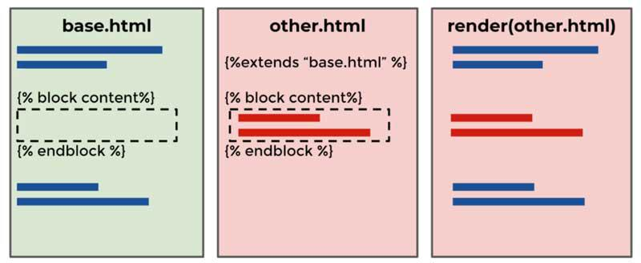Template inheritance
Understanding the include Tag:
In Django templates, the include tag allows you to insert the contents of one template into another, promoting code reuse and modularity.
It's different from inheritance, as it doesn't create a parent-child relationship between templates. Instead, it simply incorporates a specific portion of one template into another.
Example:
1. Create image.html:
<div class="image-container">
<img src="{{ image_url }}" alt="{{ image_alt_text }}">
{% if description %}
<p>{{ description }}</p>
{% endif %}
</div>
2. Include image.html in home.html:
<!--home.html-->
{% extends "base.html"%}
​
{% block start %}
{% include "image.html" with image_url="path/to/image.jpg" image_alt_text="My Image" description="A beautiful image" %}
{% endblock %}
​
<h1>This HTML page is returned by Django. ?</h1>
<p>Django is really nice. ??</p>
<p>Home Page ????.</p>
<p> {{ message }} </p>
<p>
​
<a href="{% url 'about' %}" target="_blank"> About </a> |
<a href="{% url 'contact'%}" target="_blank"> Contact </a>
</p>
​
{% endblock %}
Explanation:
- home.html extends base.html to inherit its layout.
- Within the content block, it uses {% include "image.html" %} to incorporate image.html.
- The with clause passes three variables to image.html:
- image_url: The URL of the image to display.
- image_alt_text: The alt text for the image.
- description: An optional description to display below the image.
The include tag doesn't create a parent-child relationship; it merely inserts content.
You can pass variables to the included template using the with clause.
It's often used for reusable components like headers, footers, or navigation menus.

Adding CSS

In web development, Cascading Style Sheets (CSS) play a vital role in defining the visual presentation and layout of HTML documents. While it's common practice to link external CSS files to HTML templates, there are scenarios where directly adding CSS within HTML templates is necessary or preferred.
Techniques for Adding CSS Directly in HTML Templates
1. Inline Styles with the style Attribute:
Apply styles directly to HTML elements using the style attribute. For example:
<!DOCTYPE html>
<html>
<head>
<title>Page Title</title>
</head>
<body>
<h2>Welcome To GFG</h2>
<p style="color: red; font-size: 16px;">This is a paragraph with inline styles.</p>
</body>
</html>
2. Embedded CSS:
Embed CSS rules within <style> tags in the <head> section of the HTML document. This method allows for more extensive styling while keeping it contained within the HTML file.
<!DOCTYPE html>
<html>
<head>
<style>
p {
color: blue;
font-size: 14px;
}
</style>
</head>
<body>
<h2>Welcome To GFG</h2>
<p>Default code has been loaded into the Editor.</p>
</body>
</html>
3. <style> Block within HTML Body:
Similar to embedded CSS, you can place <style> blocks within the body of the HTML document to define styles for specific sections.
<!DOCTYPE html>
<html>
<head>
<title>Page Title</title>
</head>
<body>
<div>
<h1>Heading</h1>
<style>
h1 {
color: green;
font-size: 24px;
}
</style>
</div>
</body>
</html>

Bootstrap is a popular CSS framework that helps create responsive, visually appealing websites. Integrating Bootstrap into your Django project can improve the design and streamline the development process.
Understanding the Base HTML Template
Before integrating Bootstrap, let's examine the base HTML template provided. This template serves as the foundation for all other HTML pages in the Django project. It includes the necessary metadata and defines blocks for extending content.
<!DOCTYPE html>
<html lang="en">
<head>
<meta charset="utf-8">
<meta name="viewport" content="width=device-width, initial-scale=1">
<title>Bootstrap demo</title>
<link href="https://cdn.jsdelivr.net/npm/bootstrap@5.3.2/dist/css/bootstrap.min.css" rel="stylesheet">
</head>
<body>
<style>
p { color: aqua;
}
</style>
{% block start %}
{% endblock %}
<script>
alert('Hello Django lovers hea')
</script>
<script src="https://cdn.jsdelivr.net/npm/bootstrap@5.3.2/dist/js/bootstrap.bundle.min-js"></script>
</body>
</html>
In this base template:
- The meta tags define the character set and viewport for responsive design.
- The Bootstrap CSS file is linked from a CDN (Content Delivery Network).
- The {% block start %} and {% endblock %} tags define a block where other templates can inject their content.
- The Bootstrap JavaScript file is included at the end of the body tag for optimal loading performance.
- <script> tag includes JavaScript code directly within the HTML document. In this case, an alert message saying "Hello Django lovers hea" will be displayed when the page loads.
Integrating Bootstrap into Django Templates
To use Bootstrap’s styles and components in Django templates:
- Create a base template (e.g., base.html) that includes the Bootstrap CSS and JavaScript.
- Extend the base template in other templates and add specific content within the defined blocks.
{% extends 'base.html' %}
​
{% block start %}
<nav class="navbar navbar-expand-lg navbar-dark bg-dark">
<div class="container-fluid">
<a class="navbar-brand" href="#">Django Bootstrap Demo</a>
<button class="navbar-toggler" type="button" data-bs-toggle="collapse" data-bs-target="#navbarNav" aria-controls="navbarNav" aria-expanded="false" aria-label="Toggle navigation">
<span class="navbar-toggler-icon"></span>
</button>
<div class="collapse navbar-collapse" id="navbarNav">
<ul class="navbar-nav">
<li class="nav-item">
<a class="nav-link active" aria-current="page" href="#">Home</a>
</li>
<li class="nav-item">
<a class="nav-link" href="#">About</a>
</li>
<li class="nav-item">
<a class="nav-link" href="#">Contact</a>
</li>
</ul>
</div>
</div>
</nav>
​
<div class="container mt-5">
<h1>Welcome to our Django Bootstrap Demo!</h1>
<p>Django is a powerful web framework for building web applications, and Bootstrap is a popular CSS framework for designing responsive and mobile-first websites.</p>
</div>
{% endblock %}

An alert message saying "Hello Django lovers hea" will be displayed when the page loads.

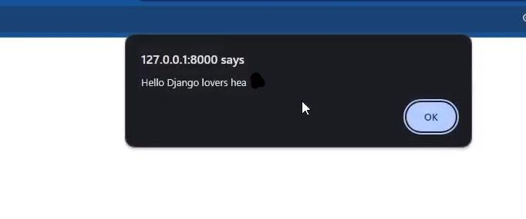page loading

Installing databases

Setting up MySQL with XAMPP and PostgreSQL with PgAdmin involves a series of steps.
Setting up MySQL with XAMPP:
Step 1: Download and Install XAMPP
- Go to the XAMPP official website and download the latest version of XAMPP.
- Run the installer and follow the on-screen instructions.
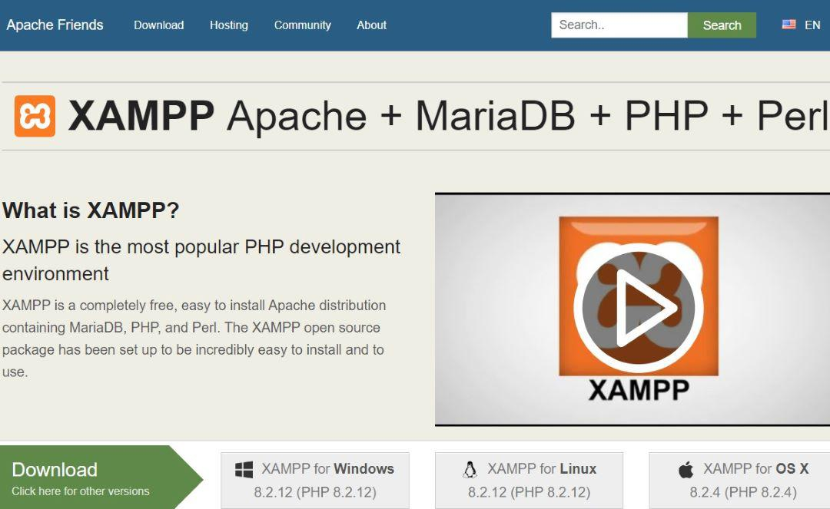

Step 2: Start MySQL Server
- Open the XAMPP Control Panel.
- Start the Apache server by clicking the "Start" button next to Apache.
- Start the MySQL server by clicking the "Start" button next to MySQL.
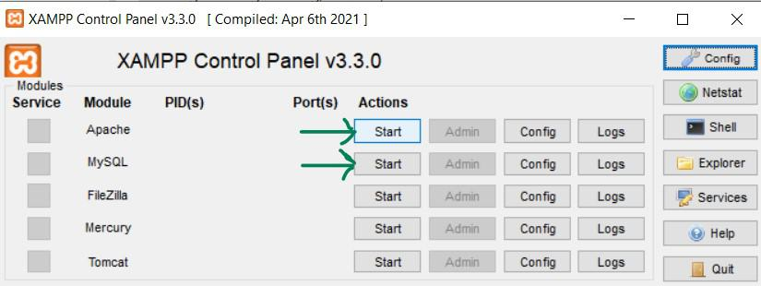XAMPP Control Panel

Step 3: Access MySQL Database
- Open a web browser and go to http://localhost/phpmyadmin/.
- You will be directed to the phpMyAdmin interface. Here, you can create databases, tables, and manage your MySQL server.

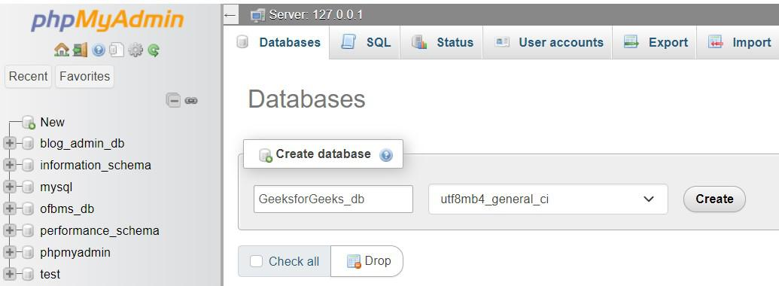http://localhost/phpmyadmin/

Setting up PostgreSQL with PgAdmin:
Step 1: Download and Install PostgreSQL
- Visit the PostgreSQL official website and download the installer for your operating system.
- Run the installer and follow the on-screen instructions.

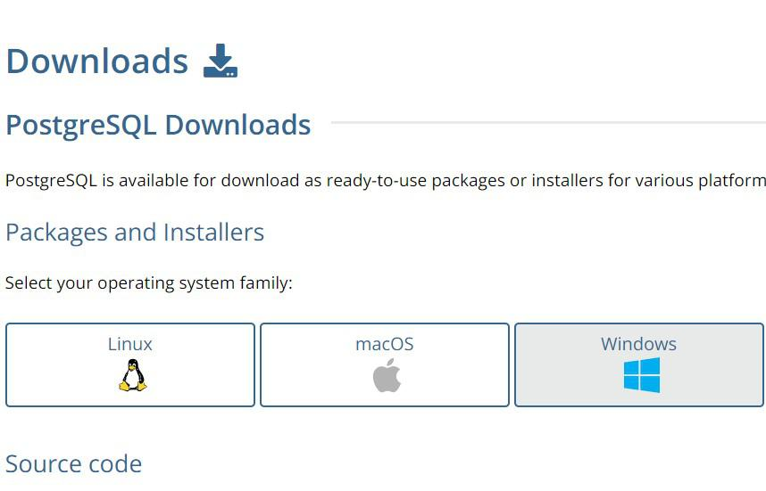

Step 2: Configure PostgreSQL
- During installation, you'll be prompted to set a password for the PostgreSQL superuser (postgres). Remember this password.
- Note down the port number (default is 5432) and the server address (default is localhost).
Step 3: Install and Open PgAdmin
- Download and install PgAdmin for windows, linux etc.
- Open PgAdmin and set up a new server connection.
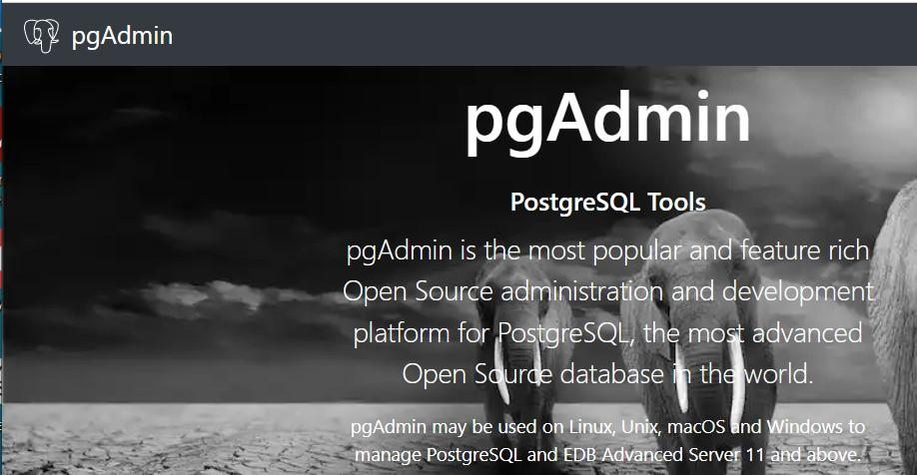
- Open PgAdmin.
- Right-click on "Servers" in the left panel and choose "Create" -> "Server..."
- In the General tab, provide a name for the server.
- Go to the "Connection" tab, enter the server address, port number, and the superuser (postgres) credentials.
- Click "Save" to connect.

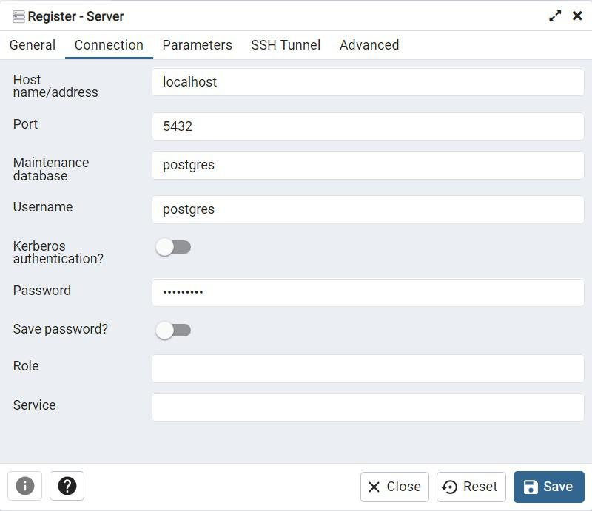

Step 4: Create a Database in PgAdmin
- In PgAdmin, expand the server node, right-click on "Databases," and choose "Create" -> "Database..."
- Enter a name for your database, choose an owner (typically postgres), and click "Save."

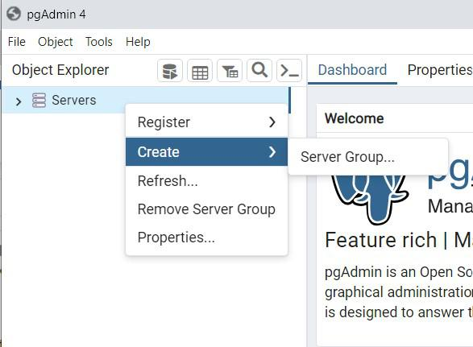

Step 5: Accessing the PostgreSQL Database
- Now you can use tools like PgAdmin or connect to PostgreSQL using various programming languages.

Connecting with different DB like mysql and postgres ,sqlite

Django, a high-level web framework for Python, simplifies database interactions by providing an Object-Relational Mapping (ORM) system. Let's see how to connect Django to MySQL, PostgreSQL, and SQLite databases.
Django and MySQL
Django's MySQL backend allows you to use the powerful features of MySQL in your web applications. Ensure the MySQL server is running, and Django will handle the database connections seamlessly.
Step 1: Install the MySQL Connector for Django
pip install mysqlclient
Step 2: Configure Django Settings
In your Django project's settings.py file:
DATABASES = {
'default': {
'ENGINE': 'django.db.backends.mysql',
'NAME': 'your_database',
'USER': 'your_username',
'PASSWORD': 'your_password',
'HOST': 'localhost',
'PORT': '3306',
}
}
Step 3: Run Migrations
python manage.py migrate
Django and PostgreSQL
PostgreSQL is known for its advanced features and support for complex queries. When using PostgreSQL with Django, you benefit from a reliable and scalable database system.
Step 1: Install the PostgreSQL Connector for Django
pip install psycopg2-binary
Step 2: Configure Django Settings
DATABASES = {
'default': {
'ENGINE': 'django.db.backends.postgresql',
'NAME': 'your_database',
'USER': 'your_username',
'PASSWORD': 'your_password',
'HOST': 'localhost',
'PORT': '5432',
}
}
Step 3: Run Migrations
python manage.py migrate
Django and SQLite
No additional installation is required as SQLite comes bundled with Django by default. SQLite is a lightweight, serverless database that is perfect for development and small to medium-sized projects. Django's integration with SQLite simplifies the development process, making it easy to get started.
Step 1: Configure Django Settings
DATABASES = {
'default': {
'ENGINE': 'django.db.backends.sqlite3',
'NAME': 'path/to/your/database.db',
}
}
Step 2: Run Migrations
python manage.py migrate
Django Migration
Django migrations allow you to propagate changes you make to your models (adding a new model, altering an existing one, etc.) into your database schema. This ensures that your database structure reflects the current state of your Django models.
Migrations are represented as files in the migrations directory within each Django app. These files, generated by the makemigrations command, contain Python code that describes the changes to be made to the database.
The 'python manage.py migrate' Command
Applies Pending Migrations:
- Executes the migration files that haven't been applied to the database yet.
Updates the django_migrations Table:
- Tracks which migrations have been applied, preventing reapplying migrations accidentally.
Workflow: Applying Migrations
Creating Migrations:
- Make changes to your Django models.
- Run python manage.py makemigrations to create migration files.
Checking Migrations:
- Inspect the generated migration files to ensure they reflect the desired changes.
Applying Migrations:
- Run python manage.py migrate to apply the pending migrations.
Verifying Changes:
- Check your database to ensure that the changes are reflected.

