GOOGLE CLOUD PLATFORM

Network Engineering Lab
VPC, Firewall & Linux VM Deployment
Step-by-step practical record with sanitized evidence screenshots
Lab information | Value
Platform | Google Cloud Platform
Region / zone | asia-south1 / asia-south1-a
VPC | hp-network-lab
Subnet | hp-app-subnet – 10.10.1.0/24
Firewall targets | Network tag lab-vm
VM | hp-linux-vm-01
Machine type | e2-micro
Operating system | Ubuntu 24.04 LTS, x86-64
Internal IPv4 observed | 10.10.1.2
External IPv4 | None
Current VM state | Stopped after lab session
Status | VPC, subnet, firewall, VM, SSH and initial Linux checks completed

Purpose: Create a private Linux VM inside a custom VPC, apply targeted ingress firewall rules, connect through SSH-in-browser and verify the operating system and network configuration.

1. Architecture overview
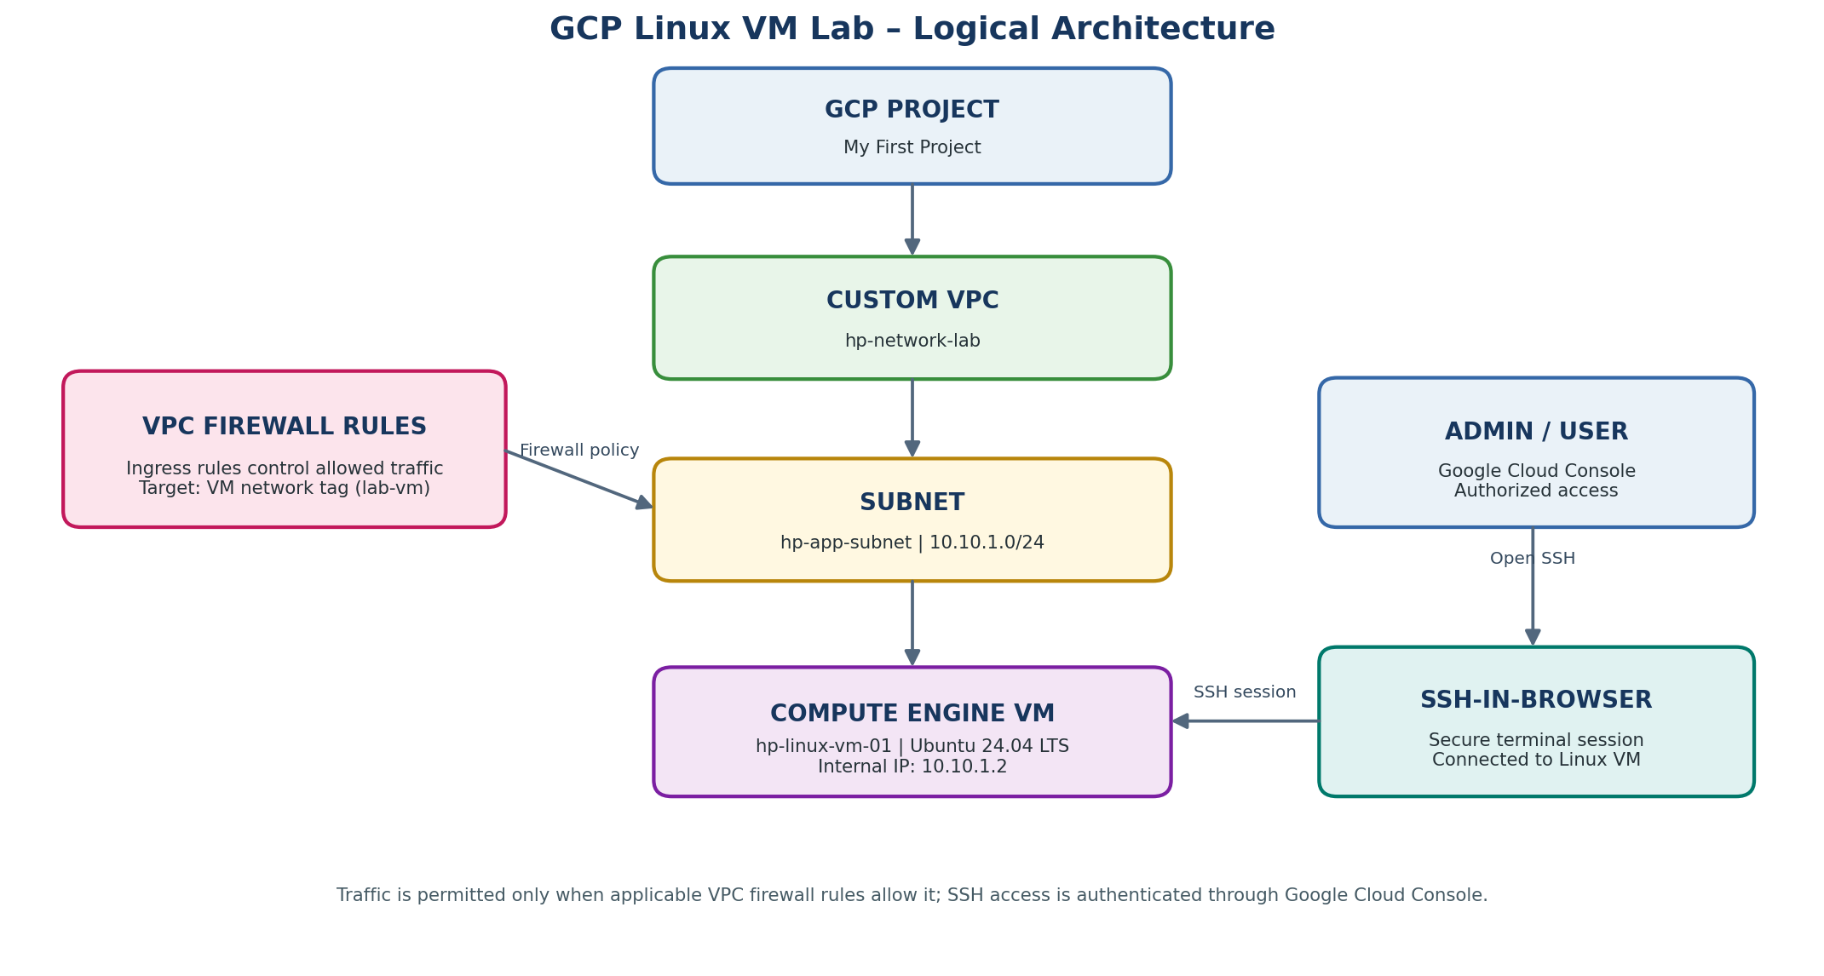
The custom VPC contains the regional subnet and Compute Engine VM. Firewall rules target the VM using the lab-vm network tag. The VM has no external IPv4 address; SSH-in-browser was used for administration.

2. Lab 01 – Custom VPC and subnet

Step 1 – Select the GCP project
Open Google Cloud Console and select the intended practice project. Confirm the selected project in the project picker before creating resources. Project IDs and project numbers are intentionally excluded from this public portfolio copy.

Step 2 – Create a custom VPC
Navigate to VPC network → VPC networks → Create VPC network. Enter hp-network-lab and choose Custom subnet creation mode. Review and create the VPC.
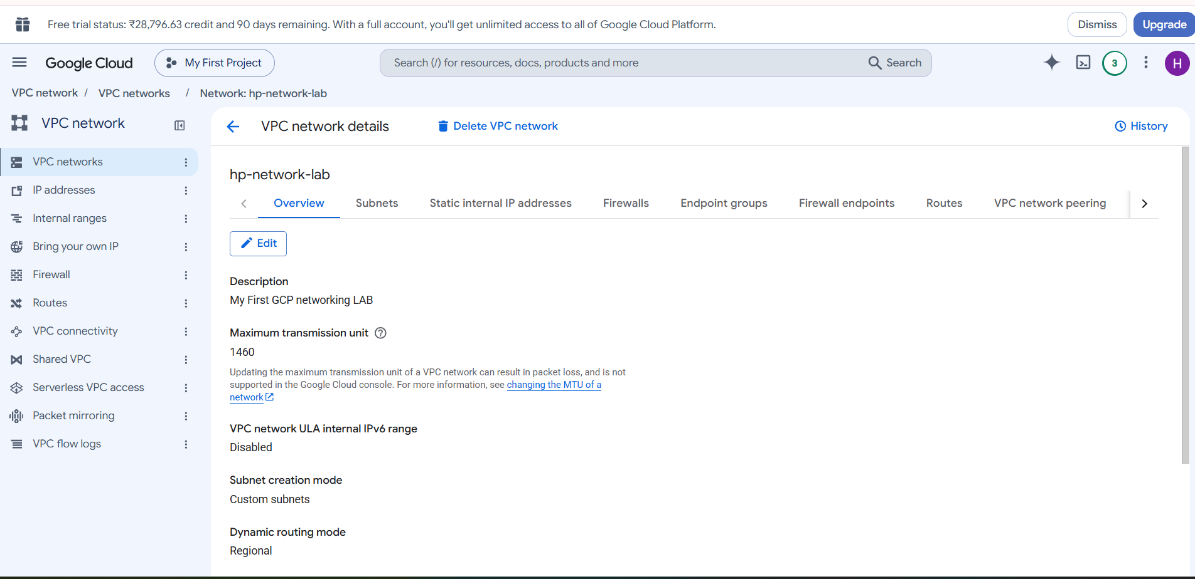
Figure 1. Custom VPC details (browser URL/project identifier cropped).

Step 3 – Create the subnet
Create a subnet named hp-app-subnet in region asia-south1 with primary IPv4 range 10.10.1.0/24. The subnet is regional and provides private IP addresses for resources attached to it.
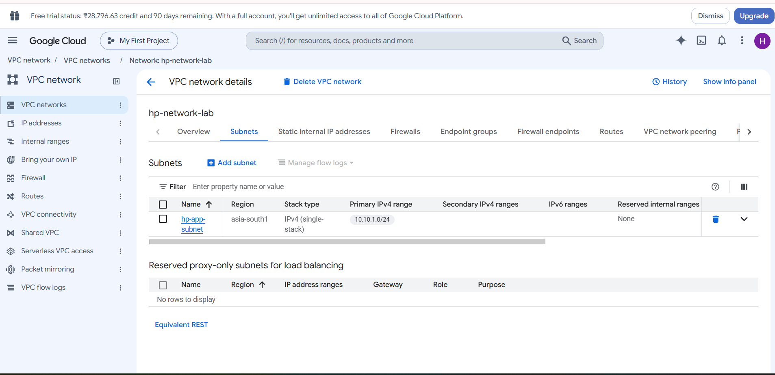
Figure 2. Subnet hp-app-subnet and IPv4 range.

3. Lab 02 – Firewall rules
Create two VPC ingress allow rules on hp-network-lab. Both target the VM network tag lab-vm and use priority 1000.
Field | Rule 1 – ICMP | Rule 2 – SSH via IAP
Name | allow-icmp-from-lab-subnet | allow-ssh-from-iap
Direction | Ingress | Ingress
Action | Allow | Allow
Target tag | lab-vm | lab-vm
Source range | 10.10.1.0/24 | 35.235.240.0/20
Protocol | ICMP | TCP 22
Priority | 1000 | 1000
Logging | Off | Off

Procedure: Open the VPC firewall rules page, select Create firewall rule, choose network hp-network-lab, set direction Ingress, action Allow and priority 1000. Select target type Specified target tags and enter lab-vm. Enter the relevant source range and protocol/port, then create and verify each rule.
Security note: The VM must carry network tag lab-vm for these targeted rules to apply. The IAP source range does not itself grant user access; appropriate IAM tunnel permissions and SSH/OS Login permissions are also required. Do not expose TCP 22 to 0.0.0.0/0 for this lab.
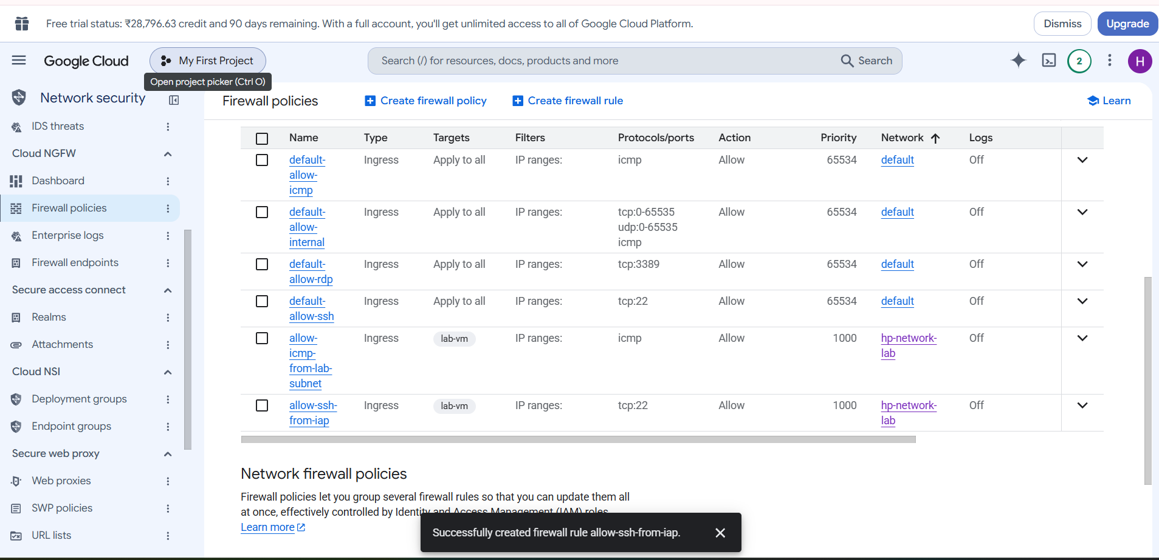
Figure 3. Custom ICMP and IAP SSH rules created on hp-network-lab.

4. Lab 03 – Compute Engine VM deployment

Step 4 – Configure the VM
Setting | Value
VM name | hp-linux-vm-01
Zone | asia-south1-a
Machine type | e2-micro
Operating system | Ubuntu 24.04 LTS (x86-64)
Boot disk | 10 GB standard persistent disk
VPC | hp-network-lab
Subnet | hp-app-subnet (10.10.1.0/24)
Network tag | lab-vm
External IPv4 | None
IP forwarding | Disabled
HTTP / HTTPS | Unchecked

Under Networking, keep exactly one VPC network interface. Select hp-network-lab and hp-app-subnet. Use an automatically assigned internal address, set external IPv4 to None, and add network tag lab-vm. Keep IP forwarding disabled.

Step 5 – Review and create
Review machine type, OS image, boot disk, VPC, subnet, tag and external IP selection. Create the instance and wait until it appears in Compute Engine → VM instances.
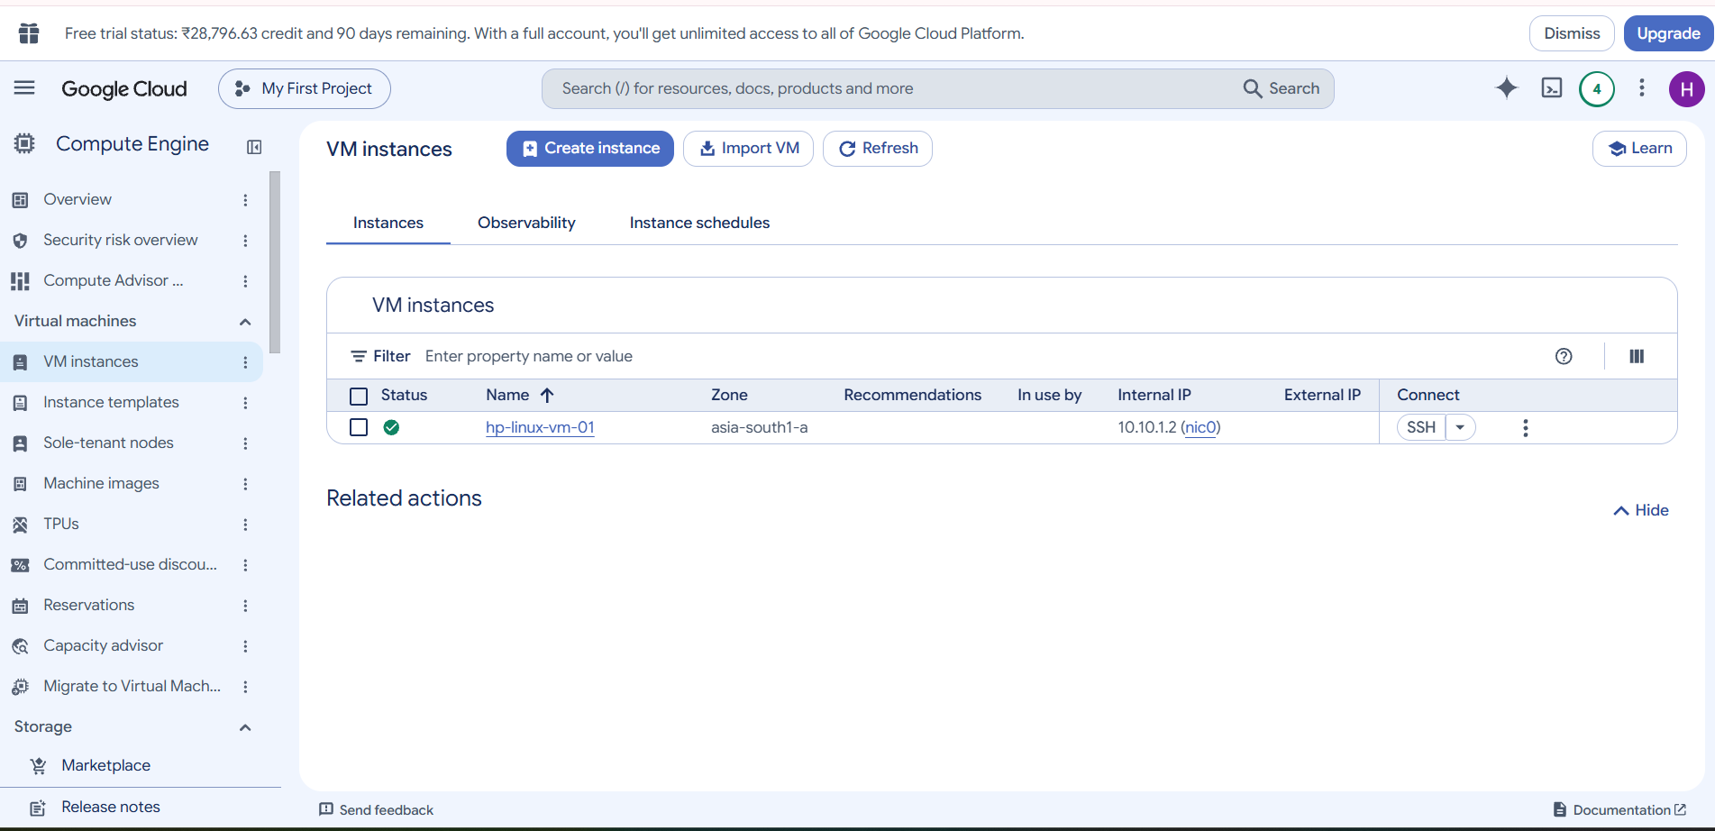
Figure 4. VM instance created; the VM was stopped after the lab session.

5. SSH access and Linux verification

Step 6 – Connect using SSH-in-browser
Open Compute Engine → VM instances and select SSH for hp-linux-vm-01. SSH-in-browser opened successfully even though the VM had no external IPv4 address. IAP/SSH access requires the applicable IAM permissions and firewall rule.

Step 7 – Run initial Linux checks
Command | Purpose | Observed result
hostname | Display host name | hp-linux-vm-01
hostnamectl | OS/kernel/virtualization details | Ubuntu 24.04.5 LTS; x86-64; Google Compute Engine
uname -a | Kernel and architecture | Linux 7.0.0-1014-gcp shown in session
ip addr | Interfaces and IPs | ens4 UP; 10.10.1.2/32
ip route | Routing table | Default via 10.10.1.1 dev ens4
free -h | Memory status | About 953 MiB RAM
df -h | Filesystem usage | Root filesystem about 8.7 GB; 28% used

hostname
hostnamectl
uname -a
ip addr
ip route
free -h
df -h
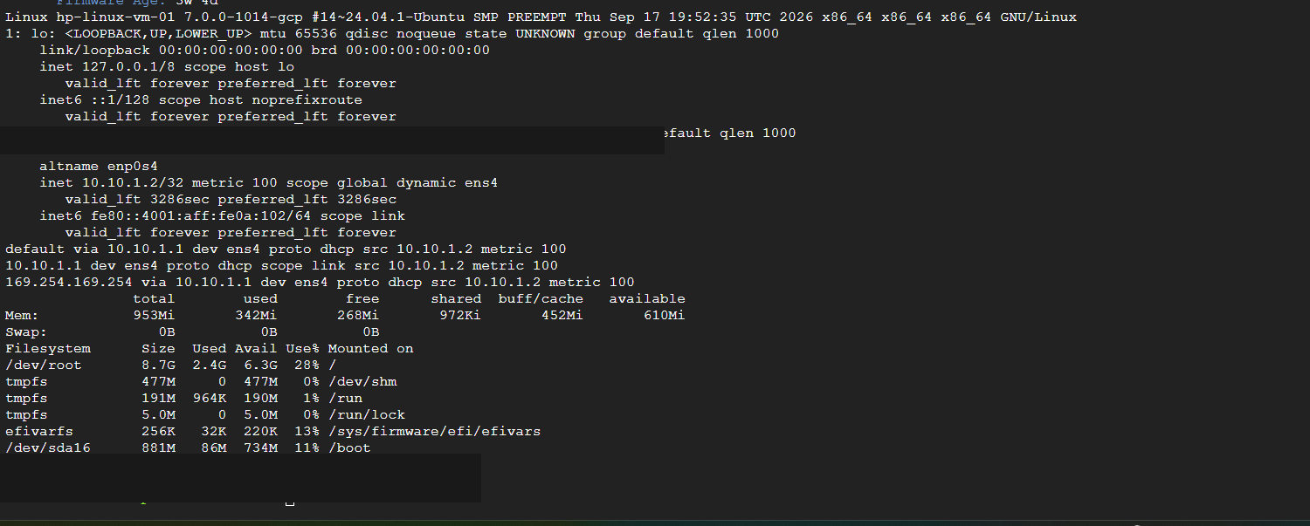
Figure 5. Sanitized SSH terminal output showing interface, internal IP, route, memory and disk checks.

Note on the /32 interface address
The guest showed 10.10.1.2/32 on ens4. This is expected for Google Cloud VPC network interfaces, which use a host-route model in the guest.

6. Completion status
Activity | Status
Custom VPC and subnet | Completed
ICMP ingress rule | Created
IAP SSH ingress rule | Created
Ubuntu Compute Engine VM | Created
SSH-in-browser login | Successful
Linux hostname, OS and kernel checks | Completed
Interface, IP and route checks | Completed
Memory and filesystem checks | Completed
VM cleanup state | Stopped after practice
Metadata server commands | Pending
VM-to-VM connectivity | Upcoming

7. Cost, retention and cleanup
The console displayed a monthly estimate of approximately US$7.82 for the selected e2-micro configuration and 10 GB standard persistent disk at the time of creation. This is an estimate, not a bill or guaranteed price. The VM has since been stopped. Persistent disks and retained snapshots can continue to incur charges while the VM is stopped. The creation summary showed snapshot schedule default-schedule-1; verify whether it was detached and whether any snapshots remain.

8. Next exercise – Metadata Server (not yet completed)
The following read-only metadata queries are planned for the next session. Start the VM before running them. Record the actual outputs after execution; do not mark this exercise complete until then.
curl -H "Metadata-Flavor: Google" http://metadata.google.internal/computeMetadata/v1/instance/name
curl -H "Metadata-Flavor: Google" http://metadata.google.internal/computeMetadata/v1/instance/zone
curl -H "Metadata-Flavor: Google" http://metadata.google.internal/computeMetadata/v1/instance/network-interfaces/0/ip
curl -H "Metadata-Flavor: Google" http://metadata.google.internal/computeMetadata/v1/instance/tags

9. Public portfolio hygiene
The evidence screenshots in this package have had browser URL bars removed; the SSH terminal image also omits the shell username, VM MAC address and upper machine/boot ID section. Continue to avoid publishing project IDs, billing data, personal account details, private keys, service-account keys, passwords or tokens. Resource names and lab IP details are retained as practical configuration evidence.

