Computational Analysis of the
Śrī Caitanya-caritāmṛta
A guide to cc_analysis.ipynb — method, figures and findings
This document explains what this analysis does, why the analysis was undertaken, what it is useful for, and how to read every figure and table it produces. It is written to be read on its own, without running the notebook.
Item | Value
Text analysed | Śrī Caitanya-caritāmṛta (Kṛṣṇadāsa Kavirāja, c. 1612), English translation
Unit of analysis | 62 chapters (Ādi 17, Madhya 25, Antya 20)
Corpus size | 21,290 sentences · 403,642 words · 9,384 unique words
Method | Character interaction networks, sentiment, emotion, topic modelling
Notebook | cc_analysis.ipynb — 34 cells, 10 figures, 8 tables

1. Why this analysis exists

The research question
The Caitanya-caritāmṛta is the principal biography of Caitanya Mahāprabhu (1486–1534) and the foundational text of the Gauḍīya Vaiṣṇava tradition. It has been studied for four centuries by close reading. It has never been studied by measuring its structure.
The question this notebook asks is simple: if we treat the text as a network of people who appear together, what shape does it have, and does that shape tell us anything a reader would not already know?

Why it is worth doing
- It is testable. A claim like "Caitanya is the centre of the narrative" becomes a number that can be checked, disputed and compared against other texts.
- It scales. A reader cannot hold 21,290 sentences and 145 named figures in mind at once. A network can.
- It is comparative. Published network studies exist for the Mahābhārata, the Rāmāyaṇa and the Iliad, so the CC can be placed against them on the same measures.
- It finds things close reading is bad at — not meaning, but proportion: who bridges whom, which groups are separate, where sentiment shifts across 62 chapters.

What it is good for
Three concrete uses. First, as a contribution to digital humanities: no computational study has treated this text as its own object. Second, as a method demonstration for devotional literature in general — the problems solved here (legacy fonts, name resolution for figures with many names) recur across the whole Indic corpus. Third, as a check on received readings: the analysis either confirms what scholarship already says, which validates the method, or disagrees with it, which is interesting.

2. How it works
The pipeline has three stages: get readable text out of the PDFs, work out who the characters are, then measure the structure.
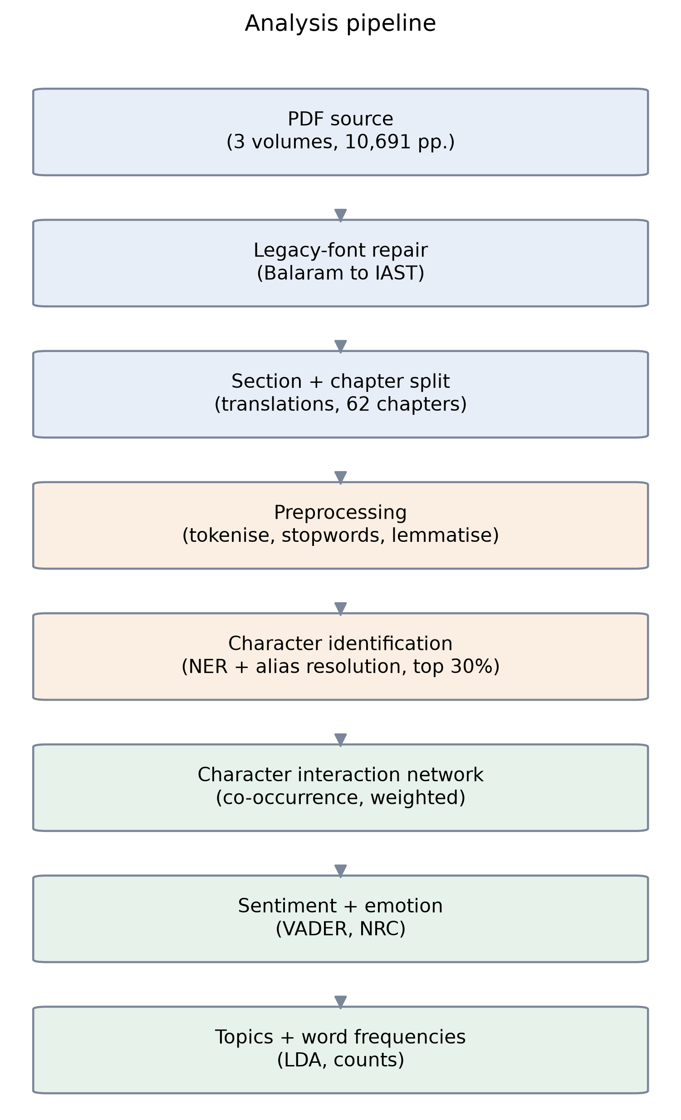
Figure A — The analysis pipeline. Blue: text preparation. Orange: language processing. Green: measurement.

Stage 1 — Getting the text out (harder than it sounds)
Three problems had to be solved before any analysis was possible. Each one would have silently corrupted the results.
Problem | What it does | Fix
Legacy font encoding | The PDFs use the Balaram font. Naive extraction gives "Kåñëa" where the word is "Kṛṣṇa", and "Çré" for "Śrī" — every important name is mangled. | A verified character map converts the text back to standard IAST.
Triplicated text | Each PDF ends with a "Reviews" section reprinting every translation. Every verse appeared three times, inflating all counts. | Extraction stops at the last page of the main body.
Mixed authorship | The edition interleaves the 16th-century text with a 1970s English commentary, unevenly: 39% of Ādi but only 9% of Antya. | Only the translation sections are analysed.
Extraction was then audited against the text's own structure: all 62 chapters recovered, 11,359 translation blocks captured at 100%, and 11,554 of the canonical 11,555 verses present. The single discrepancy is a heading damaged in the PDF itself; that verse's translation is still included.

Stage 2 — Working out who the characters are
This is the hard part of the method, and the part most likely to be questioned. Off-the-shelf name recognition fails badly on this text: the software labels Caitanya as a place, splits Kṛṣṇa between "person" and "organisation", and calls the scripture Vedānta a person. Filtering on its "person" label would lose the protagonist entirely.
So candidate names are pooled regardless of label and resolved by name instead, using four rules:
- Honorific stripping — "Śrīla Rūpa Gosvāmī" and "Rūpa" are one person.
- An alias map — "Mahāprabhu", "Gaurāṅga" and "Nimāi" all mean Caitanya.
- A stoplist of 190+ scriptures, places, titles and categories that the software mistakes for people.
- Protected names, where the last word identifies rather than decorates: Rāmacandra Purī, Rāmacandra Khān and Lord Rāmacandra are three different figures and must not be merged.
Every merge was checked against the corpus before being applied. For example, Dāmodara appears 409 times: 341 as Svarūpa Dāmodara and 41 as Dāmodara Paṇḍita — two different men, and the text names the second one's brother. They are kept separate.
Result: 145 figures are named at least 10 times; the top 50% of those — 72 characters — form the cast.

Stage 3 — Measuring
Two characters are linked when they are named in the same sentence, and the link gets heavier the more often that happens. From that network we measure who is central (four different senses of "central"), which groups form, how sentiment moves across the 62 chapters, which emotions attach to whom, and what topics the text covers.

3. What we found

Finding 1 — Kṛṣṇa is invoked everywhere; Caitanya holds the story together
This is the main result, and it comes from comparing different kinds of centrality. Caitanya leads all three measures, but by wildly different margins:
Measure | What it means | Caitanya | Kṛṣṇa | Lead
Degree | How many others they appear with | 0.958 | 0.915 | +5%
Betweenness | How often they bridge separate groups | 0.156 | 0.143 | +9%
Eigenvector | How connected their connections are | 0.647 | 0.427 | +52%
Kṛṣṇa is named alongside almost everyone — his degree is nearly Caitanya's. But he is not named alongside the well-connected, which is why his eigenvector score is barely two-thirds of Caitanya's. That is the numeric signature of a theological referent versus a narrative protagonist: Kṛṣṇa is invoked throughout as the object of devotion; Caitanya is the person the events actually happen to.

Finding 2 — The network rediscovers the phases of Caitanya's life
Community detection was run without being told anything about the text. It returned five groups that map onto the biography:
Size | Who | What it is
21 | Advaita, Nityānanda, Haridāsa, Gadādhara Paṇḍita, Murāri Gupta, Śrīvāsa | The Navadvīpa circle — the early devotees
20 | Caitanya, Jagannātha, Sārvabhauma Bhaṭṭācārya, Kāśī Miśra, Pratāparudra, Kazi | The Purī circle — the middle and later years
16 | Kṛṣṇa, Brahmā, Viṣṇu, Rādhā, Nārāyaṇa, Śiva, Nanda, Yaśodā, Vyāsadeva | The cosmological figures — theology, not biography
8 | Rūpa, Sanātana, Raghunātha, Jīva, Kṛṣṇadāsa | The Vṛndāvana Gosvāmīs — the literary successors
7 | Mādhavendra Purī, Gopāla, Gopīnātha, Īśvara Purī | The Mādhavendra / Remuṇā Deity episode
The algorithm separated the 16th-century biography from the theology it is embedded in, and recovered the three geographic phases of Caitanya's life — Navadvīpa, Purī, Vṛndāvana — without being told that any of this existed.

Finding 3 — The text is far more tightly knit than the Sanskrit epics
Text | Clustering coefficient
Caitanya-caritāmṛta (this study) | 0.712
Rāmāyaṇa (Evans 2026) | 0.532
Mahābhārata (Evans 2026) | 0.509
Iliad (Evans 2026) | 0.438
Clustering measures how often a character's associates also know each other. The CC scores far higher than either Sanskrit epic. The likely reason is structural: the CC is built around one man's successive circles of companions, whereas the epics are built around opposing factions who must interact across the divide. Tight, largely separate groups produce high clustering; adversarial structure lowers it.
Caveat: the comparison figures come from networks built by hand from close reading, while ours is automated. Treat the comparison as indicative rather than exact.

Finding 4 — The antagonists the method finds are the right ones
Figure | Sentiment | Chapters | Who they are
Rāmacandra Purī | −0.312 | 5 | The sannyāsī who publicly criticised Caitanya
Rāmacandra Khān | −0.150 | 2 | The landlord who plots against Haridāsa Ṭhākura
Gopīnātha Paṭṭanāyaka | −0.095 | 4 | Faces execution in the Purī treasury episode
These are the three figures a reader of the text would name, which is a useful validation that the sentiment layer is tracking something real. Rāmacandra Purī only became visible after the name resolution separated him from the positively-scored Rāma avatar; before that, the three Rāmacandras were one node and cancelled out.
Use Rāmacandra Purī as the primary example — Rāmacandra Khān appears in only two chapters, so his score is narratively meaningful but statistically thin.

4. Guide to every figure
Each figure below appears in the notebook in this order and is saved to results/figures/ at 300 dpi for use in the paper.

Figure 0 — Chapter sizes
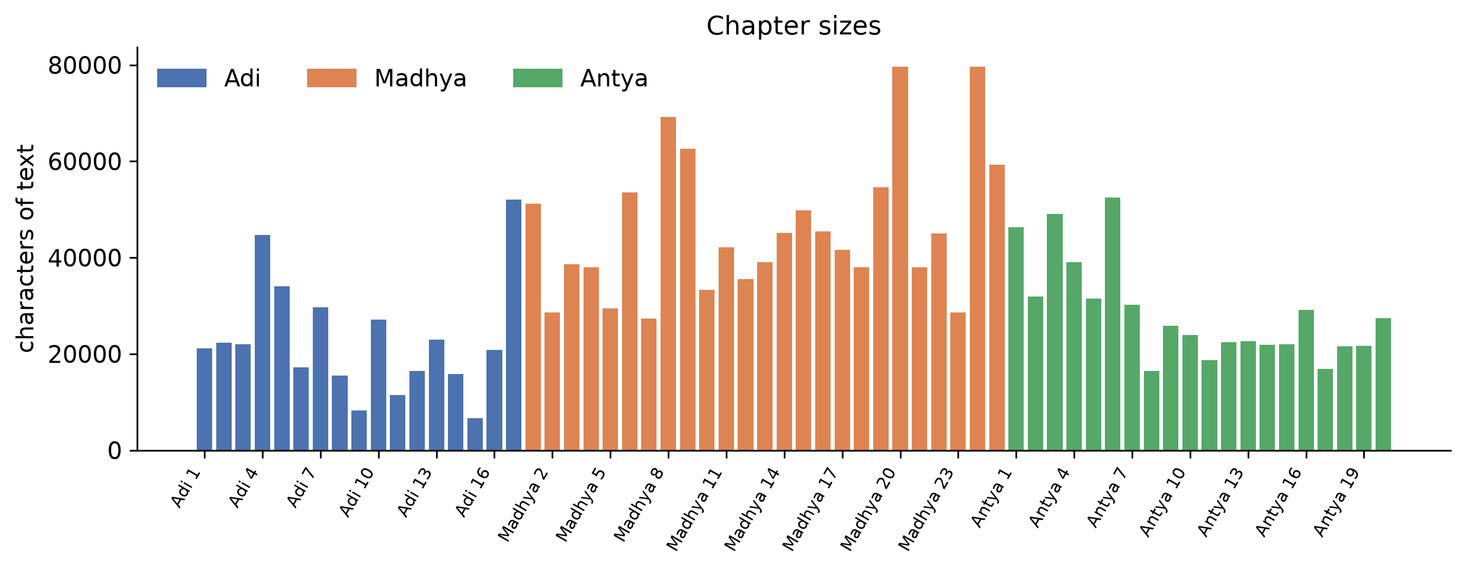
Figure 0 — Length of each of the 62 chapters, coloured by līlā.
A housekeeping figure that matters more than it looks. It shows the unit of analysis is reasonably even, so a chapter-by-chapter comparison is not dominated by one enormous chapter. Madhya-līlā chapters are visibly longer, which is why Madhya contributes the most text.

Figure 1 — The character interaction network
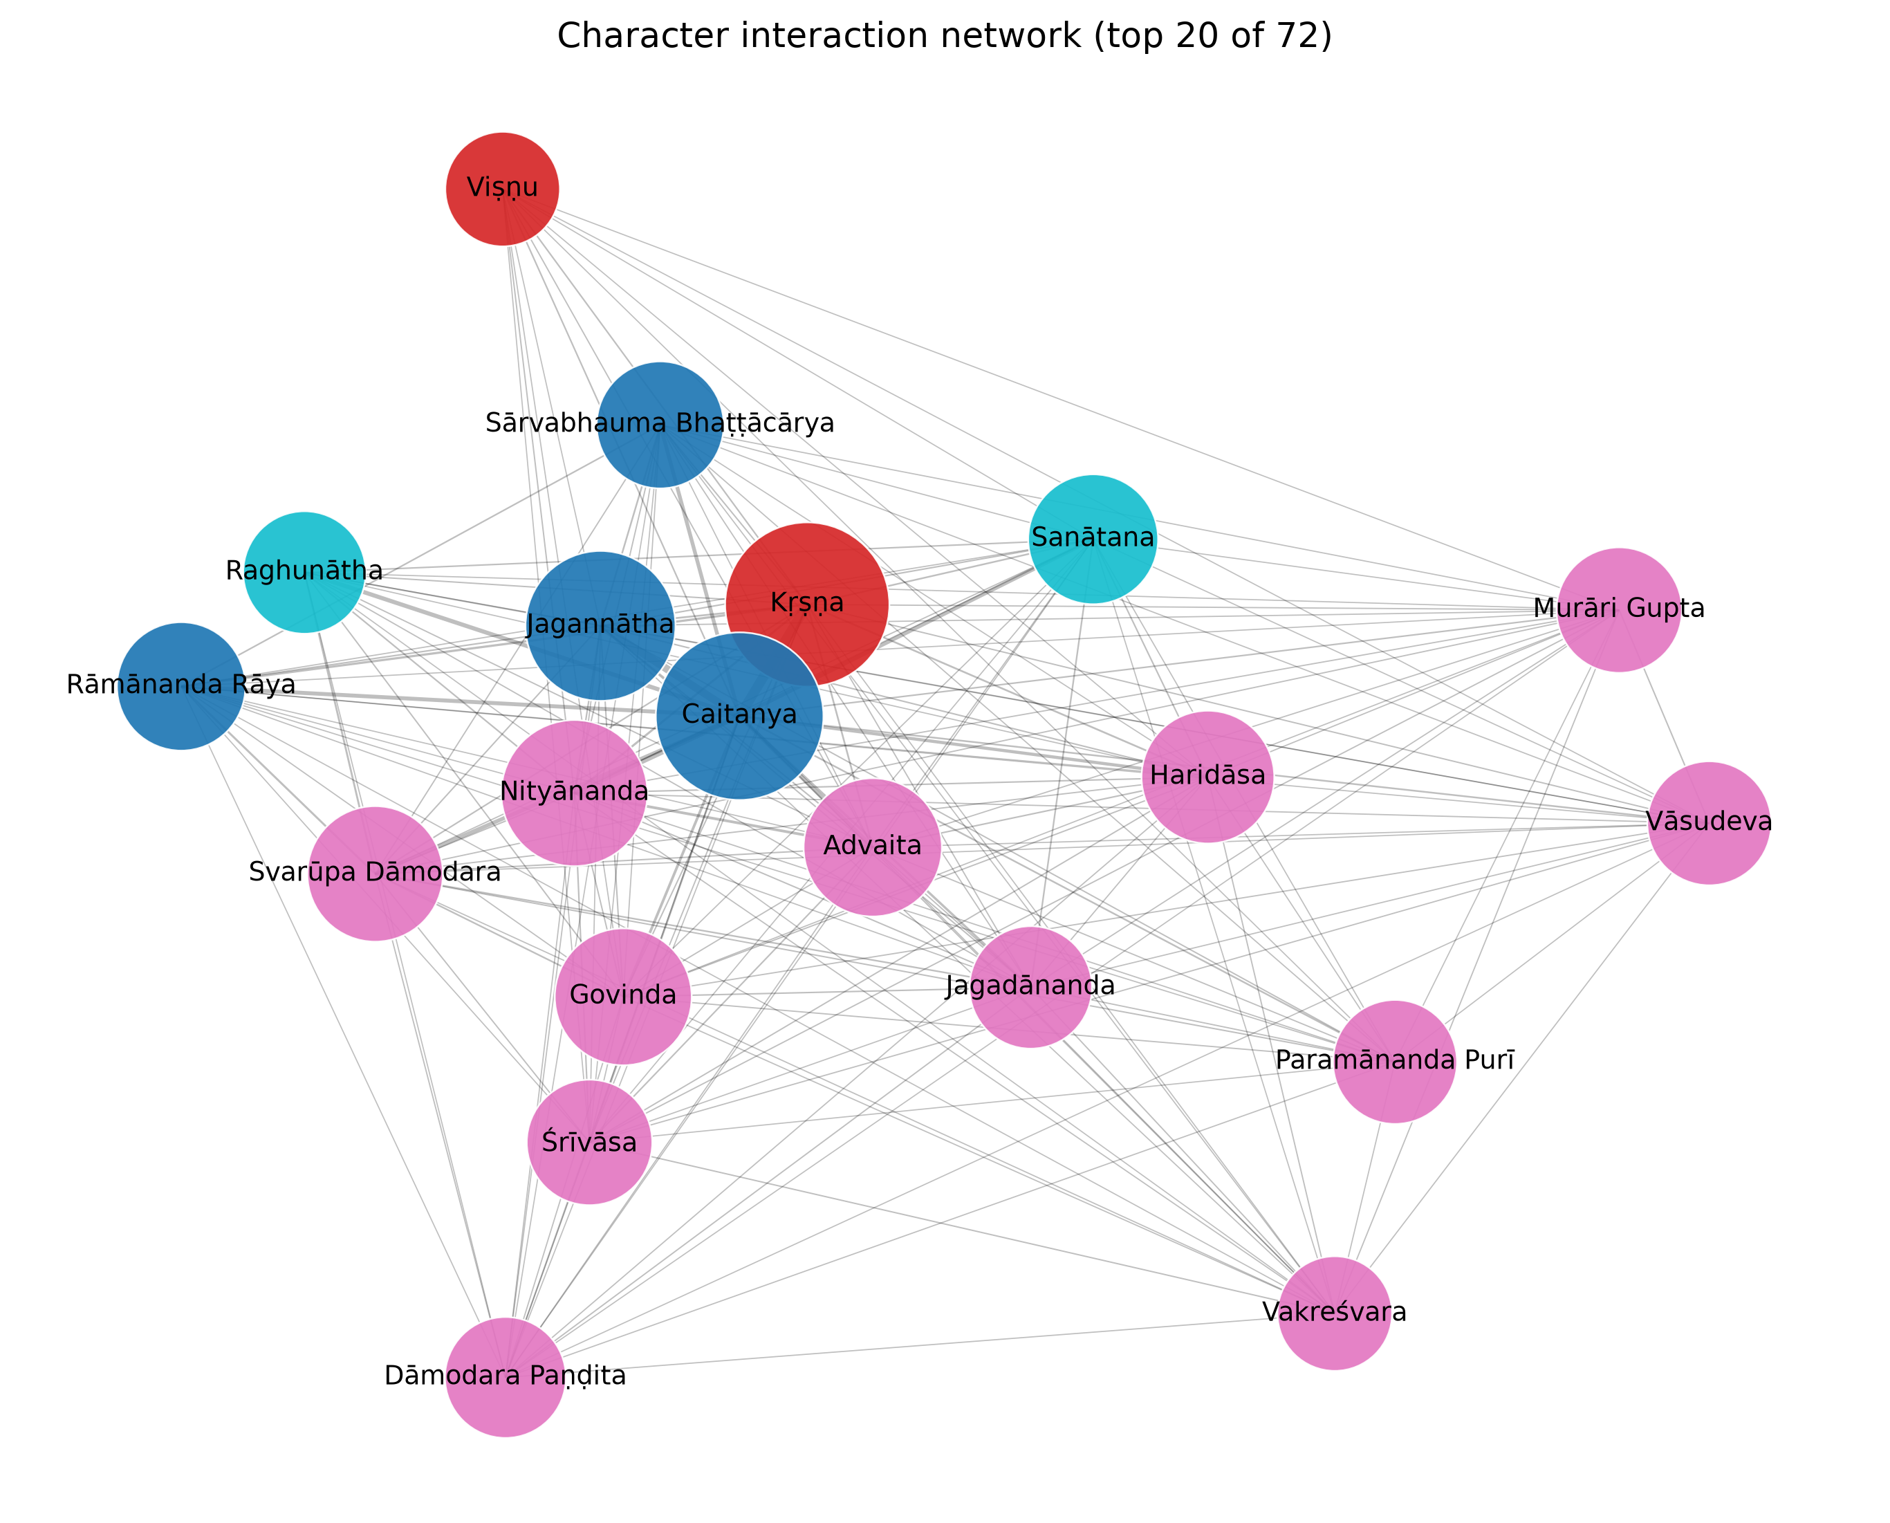
Figure 1 — Top 20 characters. Node size = degree; colour = community; edge thickness = how often the pair share a sentence.
The central image of the study. Caitanya and Kṛṣṇa sit at the middle with the heaviest link between them. The colours are the communities from Finding 2 — the cosmological figures form a visibly distinct group from the human associates. Read node size as "appears with many people" and position as "how tightly bound to the core".

Figure 1b — Networks per līlā
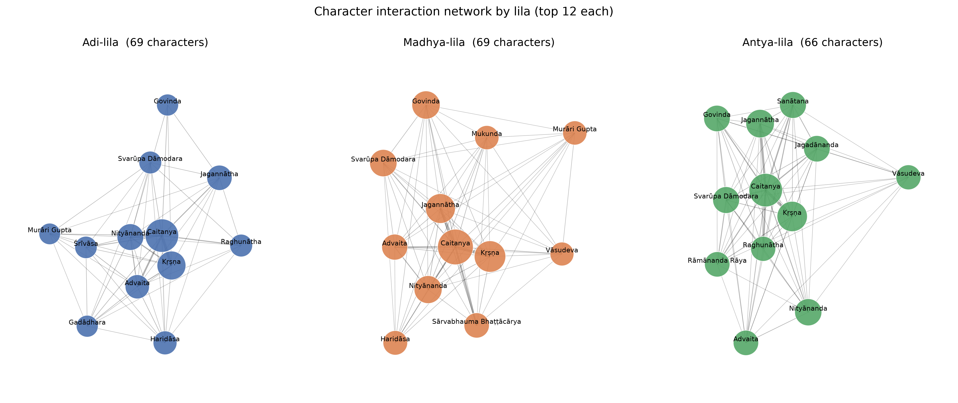
Figure 1b — The same analysis run separately on each of the three līlās.
This is the figure that shows the narrative moving. The cast turns over between volumes while Caitanya and Kṛṣṇa remain central throughout: Ādi features Śrīvāsa, Nārāyaṇa and Viṣṇu; Madhya brings in Sārvabhauma Bhaṭṭācārya and Mukunda; Antya shifts to Svarūpa Dāmodara, Rāmānanda Rāya, Raghunātha and Jagadānanda — the Purī intimates of the final years.
Līlā | Characters | Links | Density | Communities
Ādi | 69 | 356 | 0.152 | 8
Madhya | 69 | 514 | 0.219 | 7
Antya | 66 | 425 | 0.198 | 6

Figure 2 — Centrality comparison
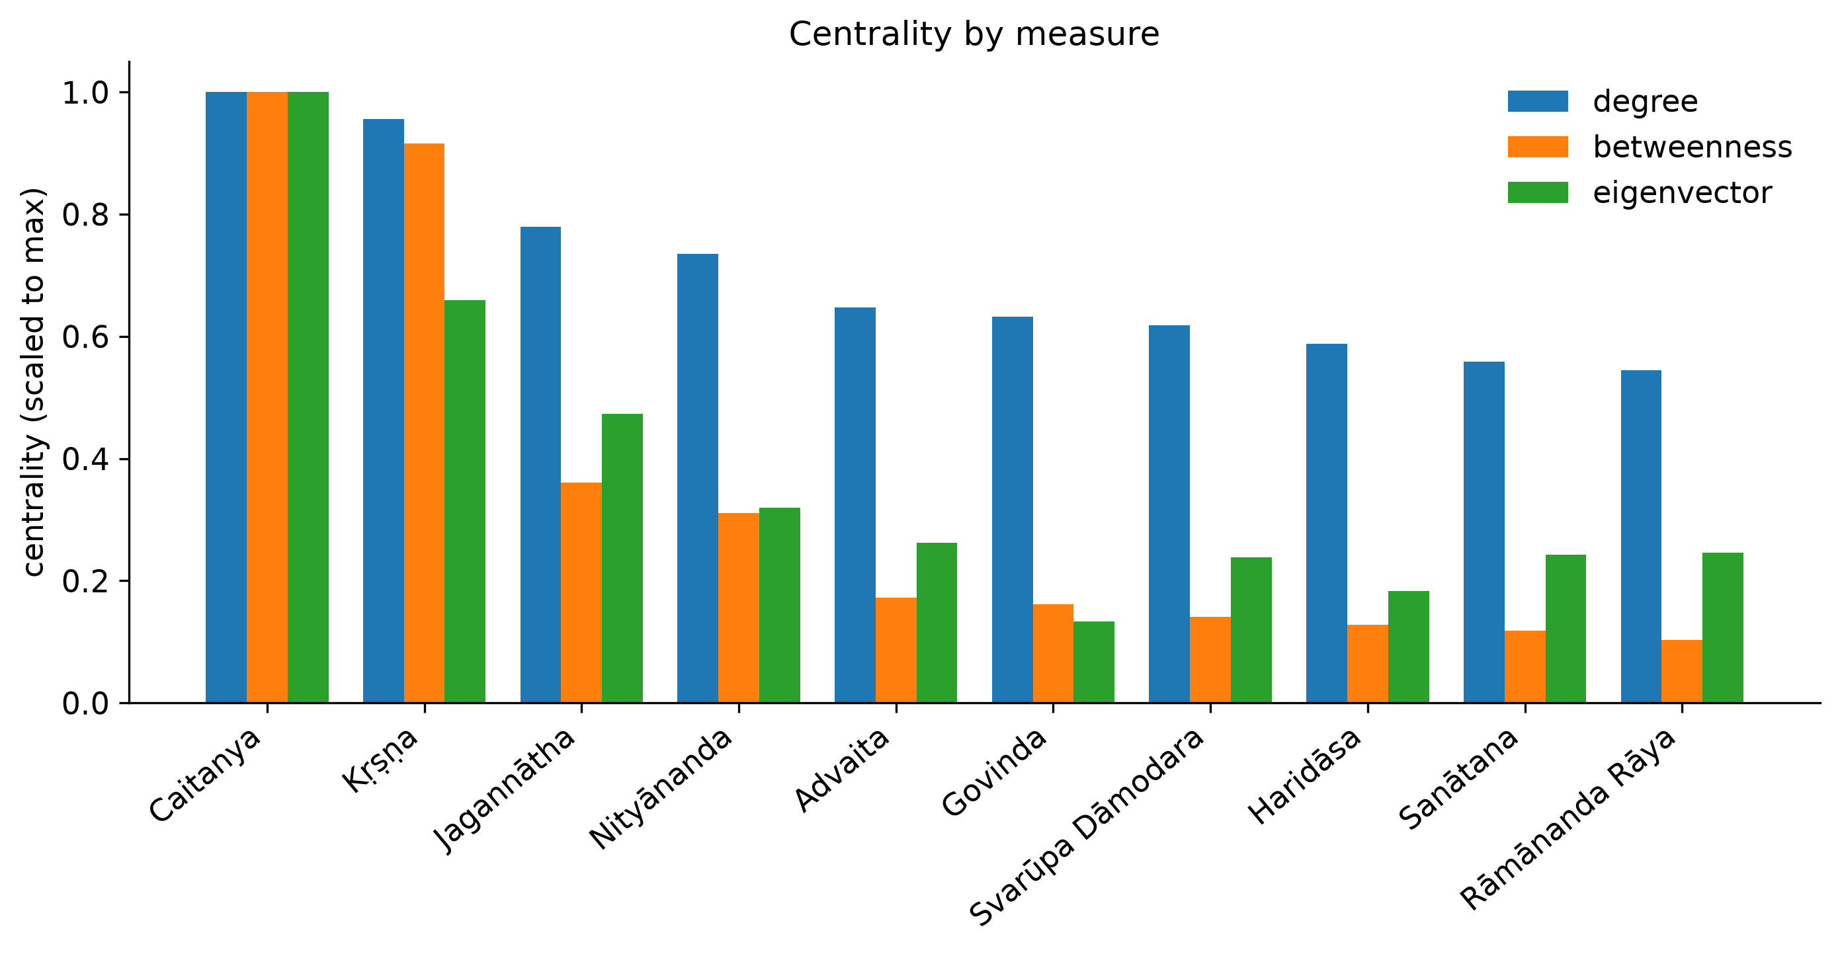
Figure 2 — The top ten characters under three different measures of centrality, each scaled to its own maximum.
This figure is the evidence for Finding 1. Look at the Kṛṣṇa bars: his degree is almost level with Caitanya's, but his eigenvector bar is dramatically shorter. That divergence between measures is the whole point — it is what distinguishes being mentioned everywhere from being structurally central.

Figure 3 — Sentiment across the 62 chapters
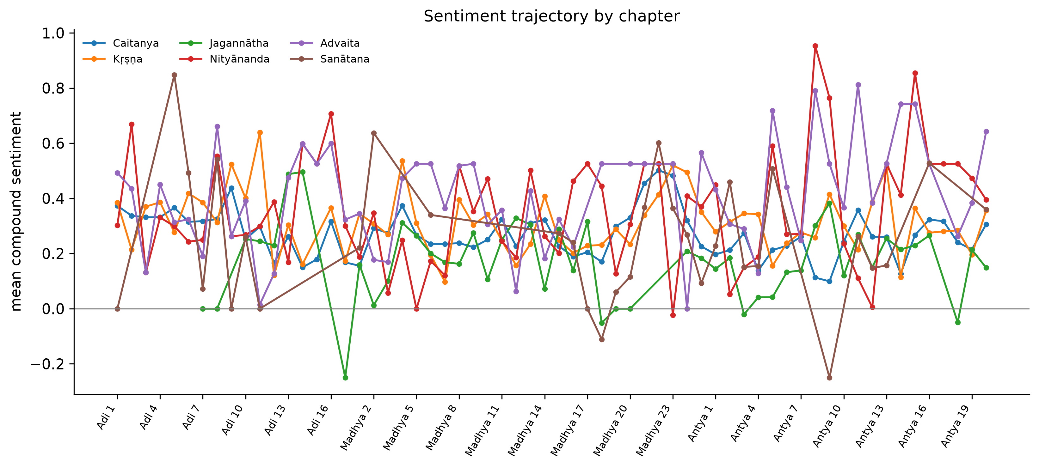
Figure 3 — Average sentiment of the sentences naming each lead character, chapter by chapter.
Sentiment is overwhelmingly positive throughout, which is expected of a devotional biography. The value is in the dips and in the comparison between characters rather than in the absolute level. This is also the most methodologically fragile figure in the notebook — see the limitations section.

Figure 4 — Emotion profiles
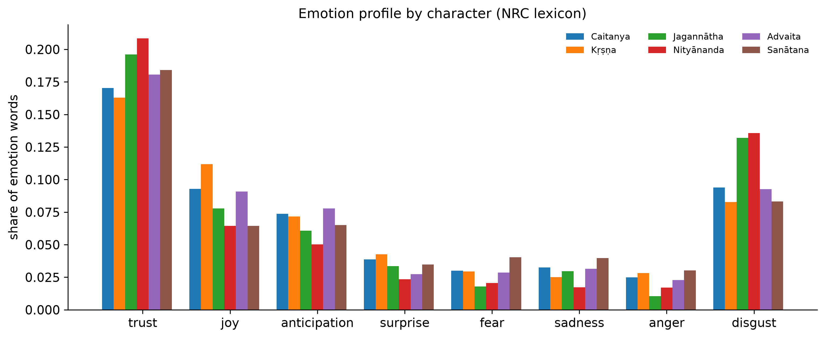
Figure 4 — Share of emotion-bearing words associated with each lead, using the NRC emotion lexicon.
Trust dominates for every major figure — the highest is Nityānanda at 0.209, followed by Jagannātha at 0.196. Joy is second. This is a coherent profile for a devotional text and works as a sanity check: a method returning anger or fear as the dominant emotion here would be suspect.

Figure 5 — Narrative presence
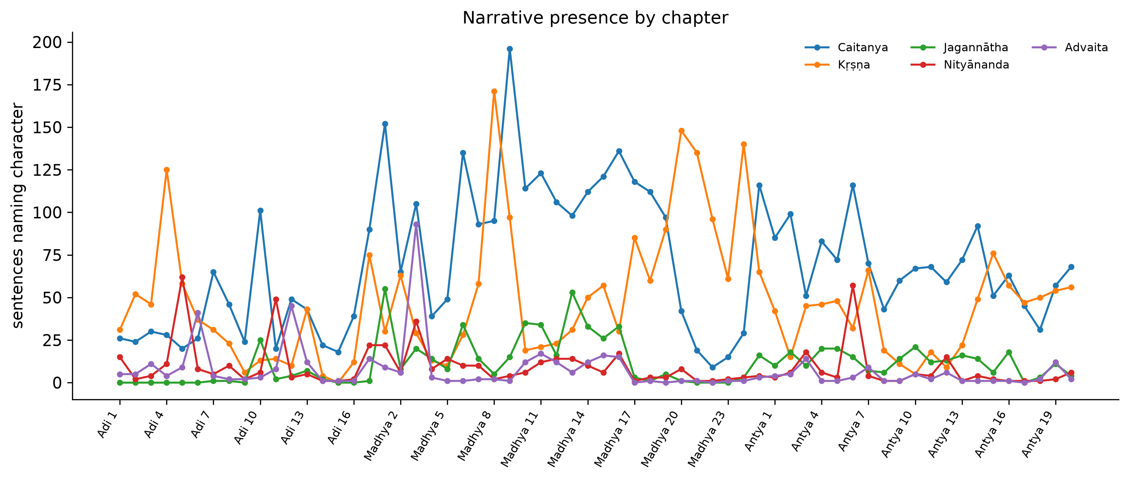
Figure 5 — How many sentences name each lead character, chapter by chapter.
The simplest figure and a useful reality check on the network: it shows when each figure is actually on stage. Caitanya is continuous across all 62 chapters; the others appear in bursts corresponding to the episodes they belong to.

Figure 6 — Word clouds
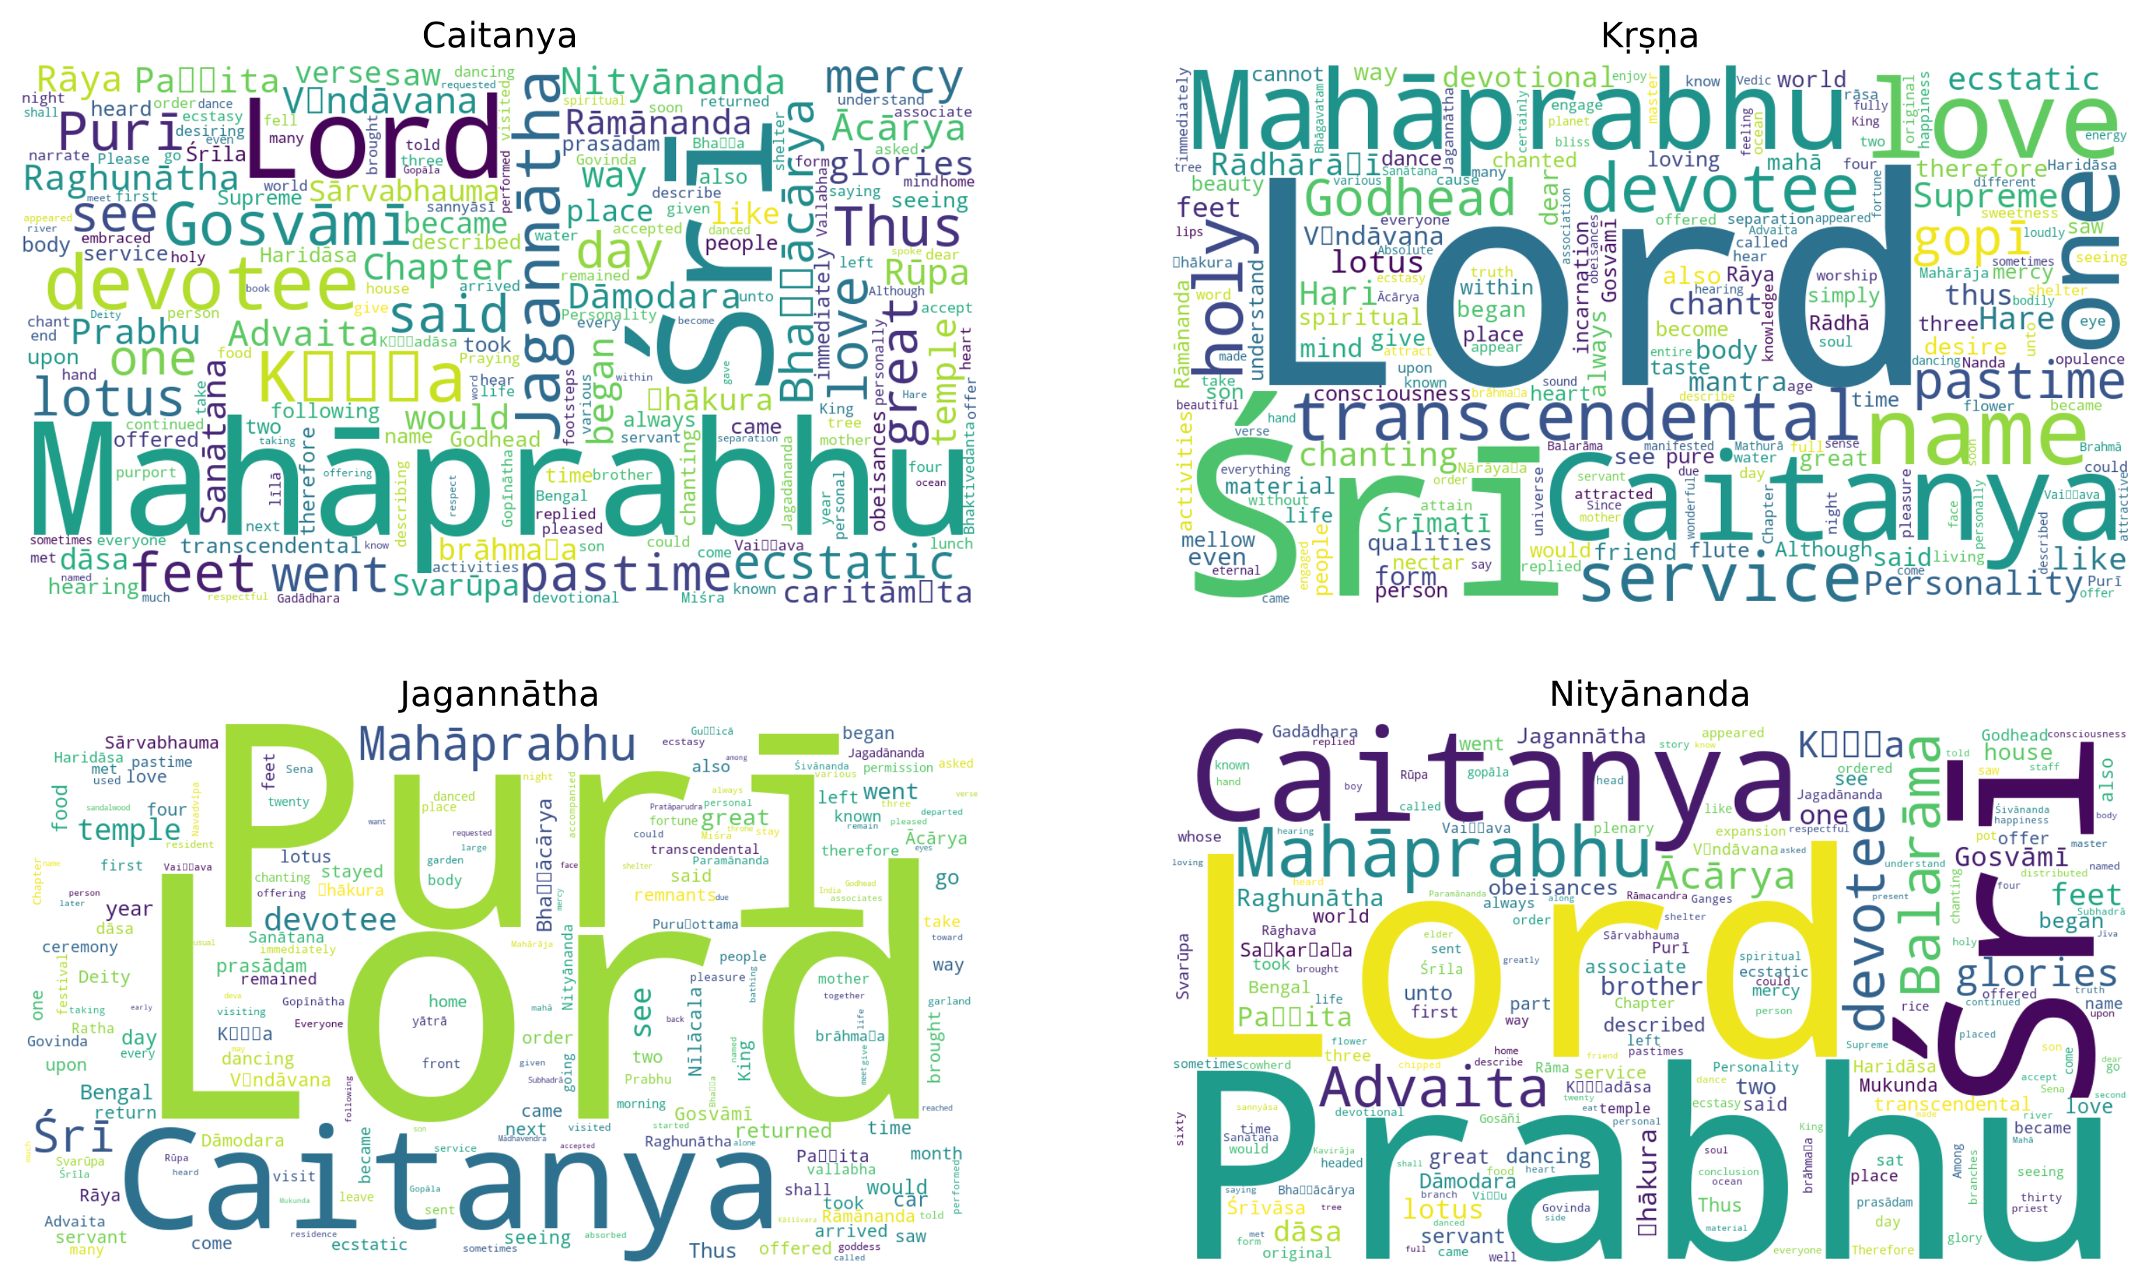
Figure 6 — The vocabulary surrounding each of the four most-mentioned characters.
A qualitative complement to the numbers: these show what is being said around each figure rather than how often they appear. Useful for presentation, weaker as evidence — word clouds have no statistical content and should support a claim, never carry one.

Figure 7 — Word frequencies by līlā
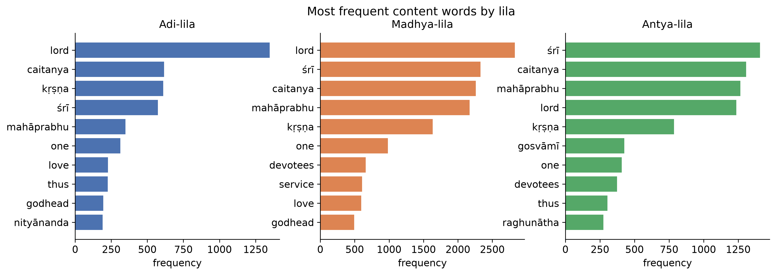
Figure 7 — The most frequent content words in each of the three volumes.
Shows the vocabulary shifting between volumes. "Lord", "Caitanya" and "Kṛṣṇa" dominate throughout, but the supporting vocabulary changes — Antya-līlā, for instance, carries noticeably more "gosvāmī" and "devotees", consistent with its focus on the established community.

5. The tables, and what the topics show
Alongside the figures the notebook prints eight tables: corpus statistics, the top-20 cast, centrality rankings, communities, the most negative characters, emotion values, per-līlā network statistics, and the topic model.

The five topics
Latent Dirichlet Allocation groups the vocabulary of the 62 chapters into five themes. They are interpretable, which is itself a check that the text preparation worked:
Topic | Leading words | Reading
1 | purī, devotional, brāhmaṇa, mādhavendra, deity, gopāla, temple | Deity worship and the Mādhavendra episodes
2 | material, spiritual, sanātana, viṣṇu, form, living, energy, incarnations | Vaiṣṇava philosophy and doctrine
3 | jagannātha, rāmānanda, ecstatic, rāya, bhaṭṭācārya, gopīs, vṛndāvana | Purī, Rāmānanda Rāya, and ecstatic devotion
4 | gosvāmī, dāsa, paṇḍita, haridāsa, sanātana, vṛndāvana, jagadānanda | The Gosvāmīs and the devotee community
5 | miśra, brāhmaṇa, came, jagannātha, mother, went, immediately | Navadvīpa domestic and narrative scenes

The cast
Rank | Character | Mentions
1 | Caitanya | 5,588
2 | Kṛṣṇa | 2,835
3 | Jagannātha | 708
4 | Nityānanda | 480
5 | Advaita | 404
6 | Sanātana | 403
7 | Svarūpa Dāmodara | 327
8 | Raghunātha | 304
9 | Haridāsa | 299
10 | Rādhārāṇī | 284

6. Limitations to state openly
Each of these is a real constraint. Stating them is stronger than waiting to be asked.
Limitation | What it means
Names, not pronouns | A sentence saying "He then went" is not attributed to anyone. Mention counts are therefore lower bounds, and characters referred to mostly by pronoun are undercounted.
The sentiment tool is out of domain | VADER was designed for social media. Published work shows it performs poorly on literary prose, and that human annotators cannot reliably agree on sentiment in historical texts at all. Treat Figure 3 as a screening signal needing manual confirmation, not as measurement.
This is a translation | The corpus is one English edition of a Bengali and Sanskrit work. Published work shows network measures can differ between original and translated versions, so conclusions are about this edition.
Two coding choices move the numbers | Treating "Hari" as a name of Kṛṣṇa rather than a separate figure, and setting the cast filter at the top 50% rather than 30%, both change the results. Both are defensible; both should be reported.
Community detection is not deterministic | The algorithm is seeded for reproducibility, but a different seed can shift borderline members between groups. The five-group structure is stable; individual placements at the edges are not.

7. Where this sits in the literature
A literature review was carried out before the analysis. The honest position:

What can be claimed
- The first published character-level network analysis of a Gauḍīya Vaiṣṇava text.
- The first dedicated computational study of the Caitanya-caritāmṛta — existing work includes it only as one row among seven texts.
- The first published mapping of the Balaram font encoding to standard Unicode. No peer-reviewed work on this exists; only undocumented community tools.
- A documented case of standard name-recognition software failing on transliterated devotional text, with a working alternative.

What cannot be claimed
- Not the first computational analysis of the CC — a 2024 doctoral thesis includes it among seven texts.
- Not the first graph analysis of a Hindu religious text — a 2016 study covers all four Vedas and fourteen Mahābhārata parvas.
- Not the first automated protagonist/antagonist detection on an Indic text — a 2023 study does this on the Mahābhārata.
The closest comparable work is Das, Das & Mahesh, "A Computational Analysis of Mahabharata" (ICON 2016), which uses nearly the same design and toolkit. Any write-up should cite and differentiate from it explicitly.

