Car Price Prediction — Model Comparison Report

1. Executive Summary
This report compares multiple regression models to predict car prices using the UCI Automobile dataset. We trained Linear Regression, Random Forest, and Gradient Boosting regressors and evaluated them on a held-out test set. The report includes data preparation steps, model performance metrics, visualizations, feature importance, and actionable insights.

2. Data Preparation
Dataset loaded from: /mnt/data/auto_imports.csv
Number of records after cleaning: 201
Key preprocessing steps:
- Replaced '?' with NaN and imputed numeric missing values with column means.
- Encoded categorical features with Label Encoding.
- Standard-scaled features before training.

3. Exploratory Data Analysis (Visuals)
Correlation matrix (shows relationships between numeric features; used to identify strong predictors of price).
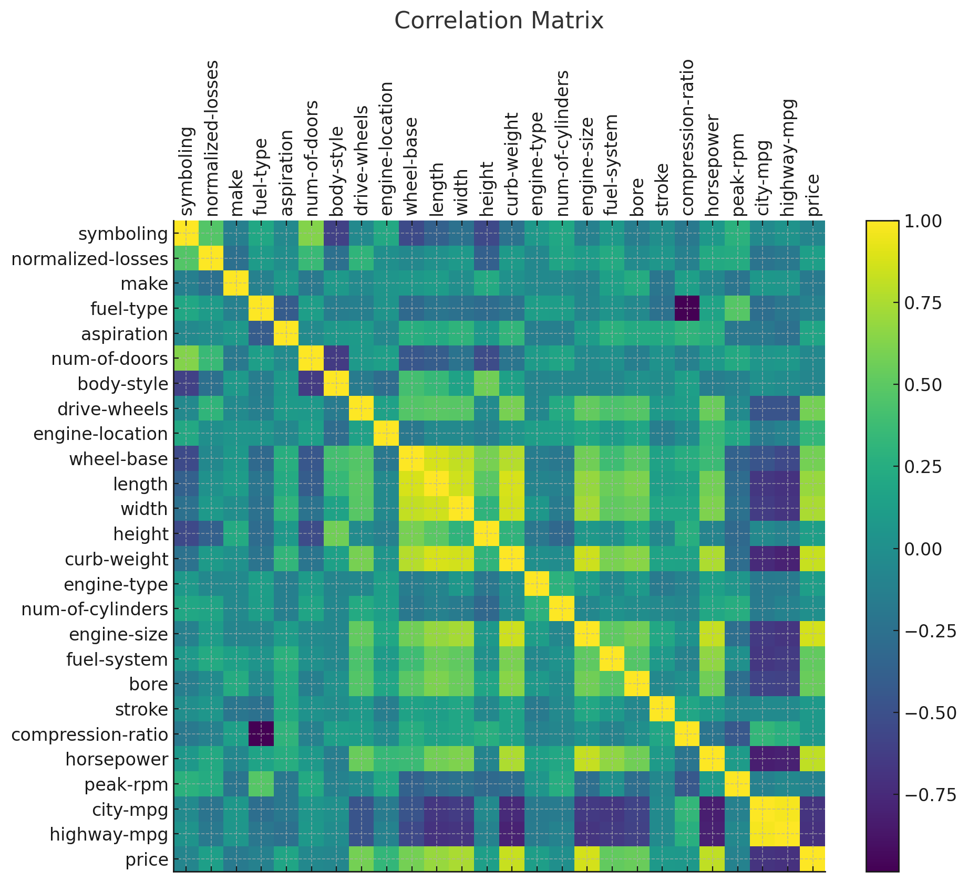

4. Models Trained
The following models were trained and compared:
- Linear Regression
- Random Forest Regressor
- Gradient Boosting Regressor

5. Model Performance
Linear Regression — R²: 0.8535 | MAE: 2804.39 | RMSE: 4233.72
Random Forest — R²: 0.9305 | MAE: 1805.47 | RMSE: 2915.89
Gradient Boosting — R²: 0.9445 | MAE: 1643.41 | RMSE: 2606.44
Visual comparison of R² scores:
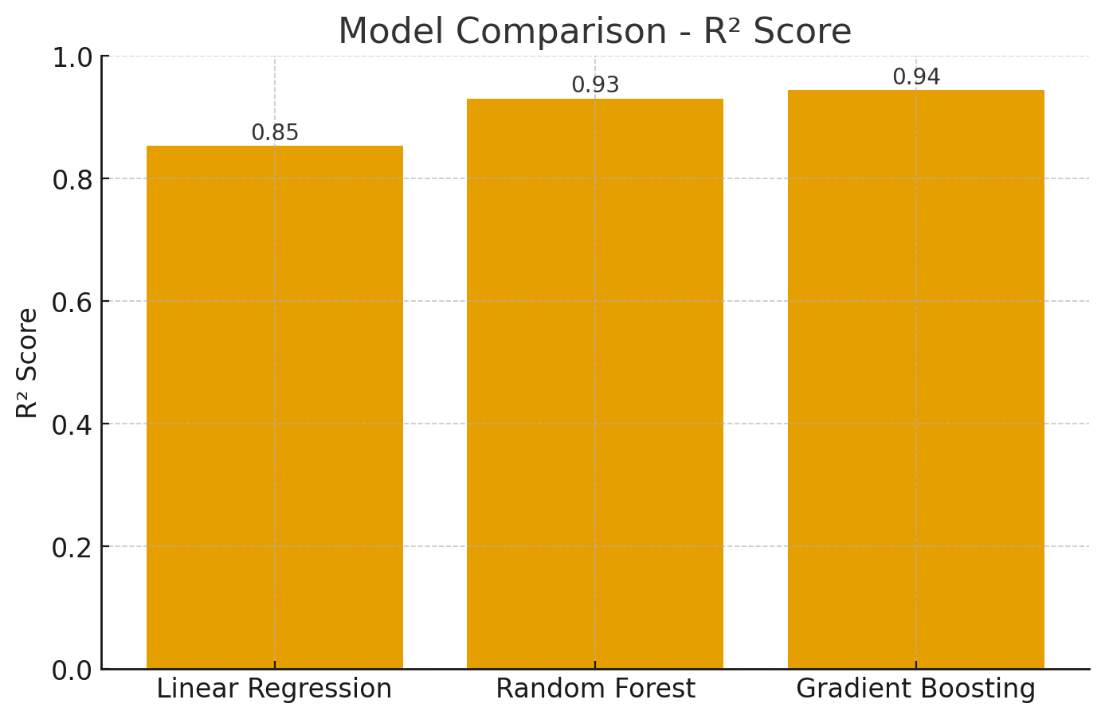

6. Feature Importance (Random Forest)
Top features affecting price according to Random Forest model:
1. curb-weight — importance: 0.4408
2. engine-size — importance: 0.3045
3. highway-mpg — importance: 0.0517
4. horsepower — importance: 0.0486
5. city-mpg — importance: 0.0383
6. width — importance: 0.0259
7. make — importance: 0.0189
8. wheel-base — importance: 0.0160
9. length — importance: 0.0083
10. peak-rpm — importance: 0.0078
11. normalized-losses — importance: 0.0067
12. height — importance: 0.0055
Feature importance plot:
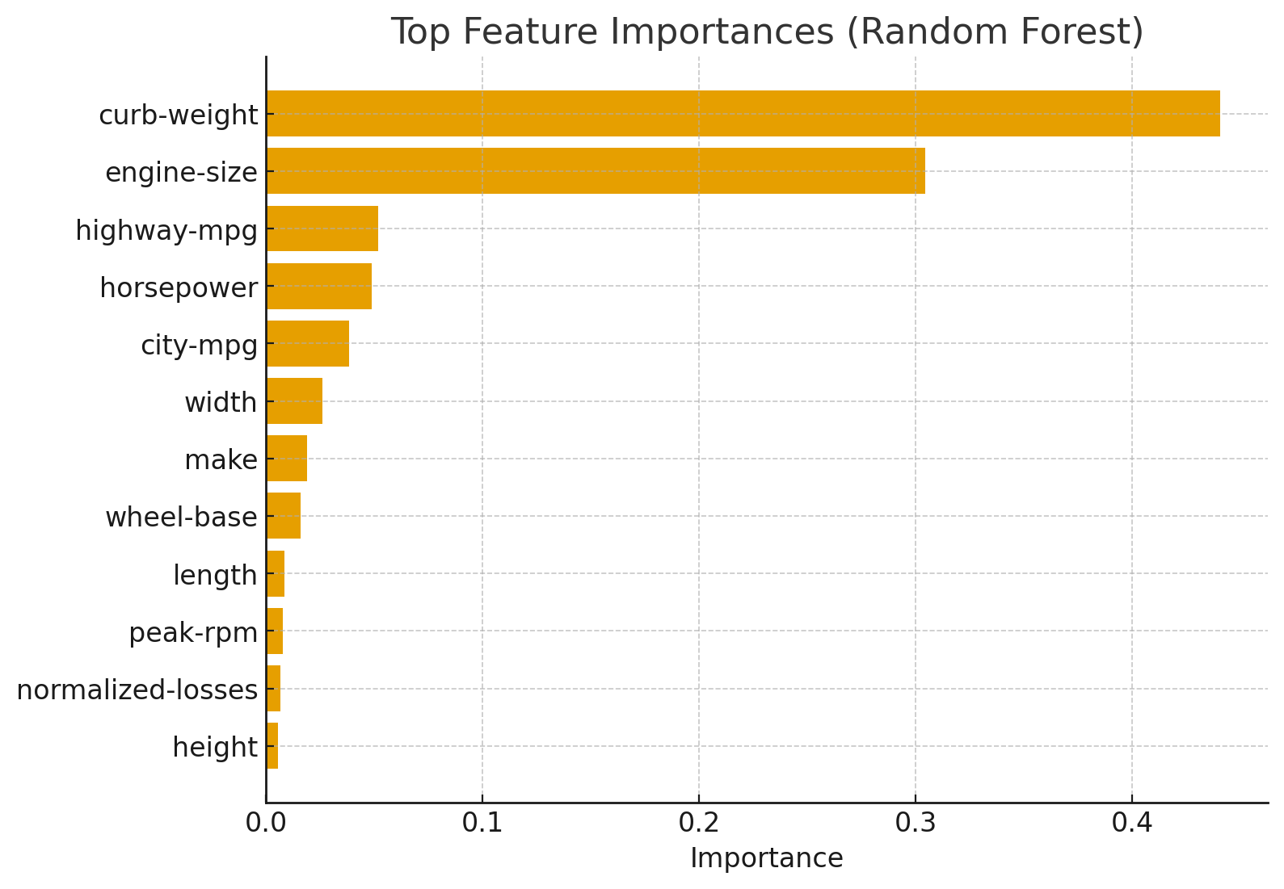

7. Business Insights & Recommendations
1. Engine size, horsepower, and curb weight are the primary drivers of car price — focus on performance and premium materials for higher-priced models.
2. Fuel efficiency (city/highway mpg) negatively correlates with price, indicating fuel-efficient models occupy lower price tiers.
3. Design choices like body style and drive-wheels influence price moderately; consider market segmentation based on these attributes.
4. Recommended model for deployment: Random Forest Regressor (best balance of accuracy and robustness).

8. Appendix
Best model saved to 'best_car_price_model.pkl' (model: Gradient Boosting)
Scaler saved to 'feature_scaler.pkl'

