- Assignment: Understanding and Maintenance of Networks

- Section 1: Multiple Choice

- What is the primary function of a router in a computer network?
Forwarding data packets between networks

- What is the purpose of DNS (Domain Name System) in a computer network?
Converting domain names to IP addresses

- What type of network topology uses a centralized hub or switch to connect all devices?
Star

- Which network protocol is commonly used for securely accessing and transferring files over a network?
FTP

- Section 2: True or False

- True or False: A firewall is a hardware or software-based security system that monitors and controls incoming and outgoing network traffic based on predetermined security rules.
True

- True or False: DHCP (Dynamic Host Configuration Protocol) assigns static IP addresses to network devices automatically.
False

- True or False: VLANs (Virtual Local Area Networks) enable network segmentation by dividing a single physical network into multiple logical networks.
True

- Section 3: Short Answer

- Explain the difference between a hub and a switch in a computer network.
Feature | Hub | Switch
Data Transmission | Broadcasts data to all connected devices/ports. | Directs (Unicasts) data only to the intended recipient device/port.
Address Learning | Does not read or store MAC addresses. | Reads the destination MAC address and maintains a table to map addresses to specific ports.
Data Unit | Transmits bits (operates as a multi-port repeater). | Transmits frames or data packets.
Efficiency | Less efficient due to unnecessary traffic and frequent data collisions. | More efficient as it reduces network congestion and collisions.
OSI Layer | Operates at the Physical Layer (Layer 1). | Operates at the Data Link Layer (Layer 2).
Duplex Mode | Supports only Half-Duplex (devices can only send or receive data at one time, not simultaneously). | Supports Full-Duplex (devices can send and receive data simultaneously, allowing for dedicated bandwidth).
Collision Domain | All devices on the hub are in a single collision domain. | Each port on the switch is its own collision domain, which minimizes collisions.

- Describe the process of troubleshooting network connectivity issues.

Identify and Define the Problem:
Scope: Is the issue isolated to one device (e.g., your laptop) or does it affect all devices (e.g., all phones and computers) on the network?
Symptom: Is there no connection at all, or is the connection simply slow or intermittent (dropping packets)?
Recent Changes: What changed just before the issue started? (e.g., new software installs, driver update, hardware replacement, or a power outage).

Check Physical Connectivity (Layer 1):
Power: Ensure the modem, router, and any network switches are powered on and their status lights are normal (no flashing error lights). A simple reboot (power cycling) of the modem and router often resolves temporary glitches.
Cables: Verify that all Ethernet cables are securely plugged into the correct ports on both the device and the wall/router. Check for any visible damage to the cables.
Wi-Fi: Ensure Wi-Fi is turned on on your device and that Airplane Mode is off. Try moving closer to the access point to rule out signal interference or distance
Verify Local Connection (Layer 2 & 3):
Tool | Command (Windows/macOS) | Purpose
IP Configuration | ipconfig (Win) / ifconfig (Mac/Linux) | Checks if your device has a valid IP address, Subnet Mask, and Default Gateway (router's IP). If the IP starts with 169.254.x.x, it means the device failed to get a valid address from the DHCP server.
Ping | ping 127.0.0.1 | Tests your local network stack. A failure indicates a problem with the network adapter or driver.
Ping | ping [Default Gateway IP] | Tests connectivity to your router. If this fails, the problem is likely between your device and the router.
Ping | ping 8.8.8.8 (Google DNS) | Tests connectivity to the internet by IP address. If this works, you have internet connectivity, and the problem is likely with DNS.

Test External Routing and Name Resolution (Layer 3 & 7):
If you can ping an IP address (like 8.8.8.8) but cannot open websites by name (like https://www.google.com/url?sa=E&source=gmail&q=google.com), the issue is likely DNS (Domain Name System) resolution.
- DNS Check (nslookup): Use the nslookup command to test your DNS server.
  - nslookup google.com
  - If this fails, but ping 8.8.8.8 works, try changing your device's DNS server (e.g., to Google DNS 8.8.8.8).
- Trace Route (tracert): Use the tracert (or traceroute on Mac/Linux) command to see the path data packets take to a destination.
  - tracert google.com
  - This command shows each hop (router) along the path. Look for high latency (long response times) or asterisks (*) indicating where the connection times out. This helps pinpoint whether the failure is on your local network, with your ISP, or somewhere further out on the internet.
Check Software and Security:
Firewall/Security: Temporarily disable your firewall or security software (antivirus) to see if it's blocking traffic. If the connection works, you need to adjust its rules.
Drivers: Ensure your network adapter drivers are up to date.
Browser: If only one browser is having trouble, clear its cache and cookies.
Contact ISP and Document:
If all local and internal steps fail, the issue is likely external.
- ISP Contact: Contact your Internet Service Provider (ISP). They can check for outages in your area or diagnose issues with the signal coming into your modem.
- Document: Document all steps you took, the commands you ran, and the results. This historical record is invaluable for yourself or any technician assisting you
- Section 4: Practical Application

- Demonstrate how to configure a wireless router's security settings to enhance network security.

Access the Router's Administration Interface:
You must first log into your router's web-based configuration page.
- Connect: Connect a computer to the router, preferably using an Ethernet cable to ensure a stable connection during configuration changes.
- Find IP Address: Open a web browser and enter the router's Default Gateway IP address (e.g., 192.168.1.1 or 192.168.0.1) into the address bar.
- Log In: Enter the administrator username and password.
  - Crucial Step: Immediately change the default administrator credentials (often admin/password or similar) to a unique, strong password. This prevents anyone from easily accessing your settings
Update Router Firmware:
Firmware is the router's operating system. Manufacturers regularly release updates to fix security vulnerabilities.
- Locate: Find the Firmware Update or System section in the administration interface.
- Apply: Follow the manufacturer's instructions to check for and install the latest firmware version.
Configure Wireless Security (Encryption):
This is the most critical step for protecting data transmitted over the air. Navigate to the Wireless, Wi-Fi Settings, or Security section.
- Security Protocol: Select the strongest encryption protocol available.
  - WPA3 Personal (Recommended): The newest and most secure standard, offering stronger protection against dictionary and brute-force attacks.
  - WPA2/WPA3 Transitional: A good option if you have older devices that only support WPA2, allowing the network to use WPA3 with compatible clients.
  - WPA2 Personal (AES): If WPA3 is not available, ensure you use WPA2 Personal (often labeled WPA2-PSK or WPA2-Personal) with the AES cipher (avoid using TKIP, WEP, or WPA as they are obsolete and vulnerable).
- Set a Strong Password: Set a unique, complex Wi-Fi password (Passphrase) that is at least 12 characters long and includes a mix of uppercase letters, lowercase letters, numbers, and symbols.
Disable Vulnerable Features:
Certain convenience features can introduce security risks.
- Disable WPS: Find the Wi-Fi Protected Setup (WPS) setting and disable it. WPS is convenient (connecting with a button or short PIN) but is vulnerable to brute-force attacks on its 8-digit PIN.
- Disable Remote Management: Ensure the Remote Management or Remote Access feature is disabled. This prevents external access to your router's admin page from the internet.
- Disable UPnP (Universal Plug and Play): This feature can allow network devices to automatically open ports, which may be exploited by malware. It is generally safer to disable it and manually forward ports only when necessary
Additional Best Practices:
- Change the SSID (Network Name): Change the default network name (SSID) to something unique that does not reveal the router brand or model (e.g., change from "Netgear-1234" to "MySecureLAN").
  - Note: Hiding the SSID offers minimal security and is often recommended to be left visible for compatibility.
- Create a Guest Network: If your router supports it, enable a Guest Network with a separate password. This keeps visitors and their potentially compromised devices isolated from your main network, protecting your personal computers and shared files.
- Enable Firewall: Ensure the router's built-in firewall is enabled in the security settings.
Regularly review these settings, especially after a factory reset or firmware update, to ensure your network remains secure
- Section 5: Essay

- Discuss the importance of network documentation and provide examples of information that should be documented.

- Faster Troubleshooting and Reduced Downtime: When an issue arises, detailed documentation (like an IP address scheme or a network diagram.

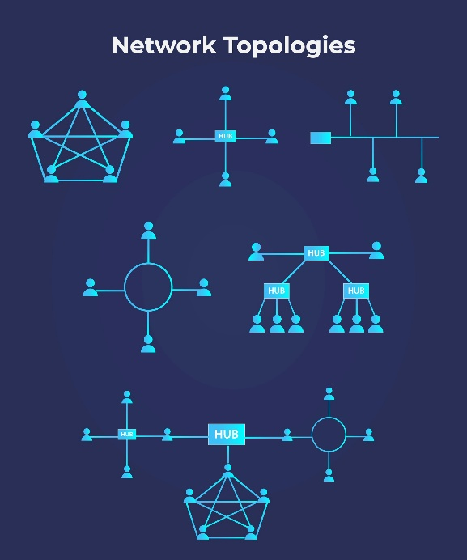
- Effective Knowledge Transfer: It prevents a "single point of failure" when key IT staff leave the company. New hires or external consultants can get up to speed quickly on the network's design, configurations, and established processes.
- Better Change Management: Documentation provides a baseline configuration. Before any change (e.g., a router upgrade or a VLAN modification), the impact can be accurately predicted, and a rollback plan can be easily created using the previous configuration records.
- Regulatory Compliance and Auditing: Many industry regulations (like HIPAA or PCI-DSS) require organizations to demonstrate control and visibility over their infrastructure. Detailed documentation of security policies, firewall rules, and access controls is essential for passing compliance audits.
- Informed Budgeting and Planning: It gives a clear picture of all network assets, including their warranty dates, licensing costs, and end-of-life status, enabling accurate budgeting for replacements and expansions
Essential Information to Document:

1. Network Topology and Physical Layout
This describes what the network looks like in the real world.
- Network Diagrams:
Logical Topology: A visual map showing how devices communicate (routers, switches, firewalls) and the flow of data, including VLANs and routing protocols
- Hardware Inventory:
- Make, Model, and Serial Numbers.
- Firmware/OS Version.
- Purchase Date and Warranty Expiration.
- Physical Location (e.g., "Server Rack 3, U12")
2. Logical Configuration
This describes how the network is set up to function.
- IP Address Management (IPAM) Scheme:
  - Subnetting and VLAN Assignments (e.g., VLAN 10 for Users, VLAN 20 for Servers).
  - DHCP Scopes and ranges.
  - List of all Static IP Assignments (for servers, printers, and network devices).
- Device Configuration Backups:
  - Text-based backup files of configurations for all critical devices (routers, switches, firewalls).
  - Details on where these backups are stored (e.g., a Configuration Management server).
- Naming Conventions: A policy detailing how all devices, hostnames, and IP addresses are consistently named (e.g., FW-HQ-01, SW-4F-Closet-A).
3. Operational and Security Procedures
This describes how the network is managed and protected.
- Security Policies:
  - Firewall Rule Sets and the business justification for each rule.
  - VPN configuration details (protocols, user groups).
  - Access Control Lists (ACLs) and security zones.
- Change Management Log: A chronological record of every modification made to the network, including:
  - Date and Time.
  - Responsible Technician.
  - Description of the Change (e.g., "Upgraded Router R1 firmware to v1.2.3").
  - Reason for the change.
- Disaster Recovery (DR) and Backup Procedures:
  - Backup schedules and retention policies.
  - Location of backup data (on-site/off-site).
  - Step-by-step procedures for restoring critical services in a disaster scenario.

