**FR. CONCEICAO RODRIGUES COLLEGE OF ENGINEER**

**Department of Electronics and Computer Science**



**Expt 1: To study Amplitude Modulation and Demodulation**

1. **Course, Subject & Experiment Details**

|  |  |  |  |
| --- | --- | --- | --- |
| **Timeline (3)** | **Understanding (3)** | **Self Efforts (4)** | **Total (10)** |
|  |  |  |  |

|  |  |  |  |
| --- | --- | --- | --- |
| **Student’s Name** | **Hardik Prajapati** | **Roll No.** | **9152** |
| **Academic Year** | **2022 – 23** | **Estimated Time** | **2 Hours** |
| **Course & Semester** | **T.E. (ECS) Sem. V** | **Subject**  **Name** | **Communication Engineering Laboratory** |
| **Unit No.** | **2** | **Chapter**  **Title** | **Analog modulation Systems** |
| **Experiment Type** | **Software Performance** | **Subject Code** | **ECL 501** |

1. **Aim of the Experiment:**

To Study the amplitude modulation and demodulation.

# Apparatus:

CRO, Trainer Kit ST 2201, connecting probes.

# Expected Outcome of Experiment

Students will be able to measure the modulation index from the waveform observed on the CRO and identify over modulation and its effect on the demodulated audio frequency signal.

# Theoretical Description

In amplitude modulation (AM) the amplitude of carrier signal is varied according to the amplitude of the modulating signal, whose frequency is invariably less than that of the carrier. Thus, AM is the system of modulation in which the amplitude of the carrier is made proportional to the instantaneous amplitude of the modulating voltage. The standard form of AM is defined by

𝑣𝐴𝑀(𝑡) = 𝑉𝑐(1 + 𝑚𝑠𝑖𝑛𝜔𝑚𝑡)𝑠𝑖𝑛𝜔𝑐𝑡

where 𝑉𝑐 is the amplitude of the carrier, m is modulation index, 𝜔𝑚 is the modulating frequency, and 𝜔𝑐 is the carrier frequency.

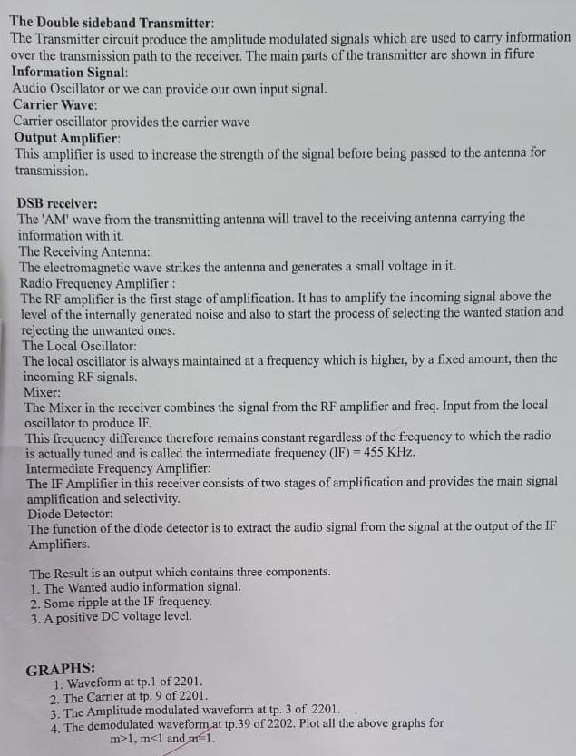

6.Conclusion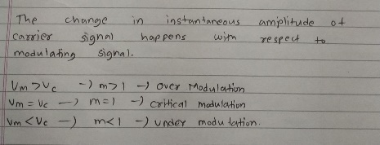

Circuit Diagram

