|  |  |
| --- | --- |
|  | 1. Identify scenarios, develop suitable process model and draw Use case and Class Diagram for the given problem. |

|  |  |  |  |
| --- | --- | --- | --- |
| **Name of Student** | **Hardik Prajapati** | **Roll No.** | **9152** |
| **Sign here to indicate that you have read all relevant material provided /available on Moodle while performing and writing this experiment** | | **Sign:** | |

**Late Submission Details (if any)**

|  |  |  |
| --- | --- | --- |
| **Reason(s) of late submission** | **Date of practical performance** | **Date of practical submission** |
|  |  |  |

**References used**

|  |  |  |
| --- | --- | --- |
| 1 | Name and author of reference book(s) with page nos. |  |
| 2 | Name and roll nos. of the peers whose help you have taken (if any) |  |

|  |  |  |  |  |  |  |  |  |  |  |  |  |  |  |  |  |  |  |  |  |
| --- | --- | --- | --- | --- | --- | --- | --- | --- | --- | --- | --- | --- | --- | --- | --- | --- | --- | --- | --- | --- |
| **Rubrics for assessment of Experiment:**   |  |  |  |  | | --- | --- | --- | --- | | Indicator | Poor | Average | Good | | Timeliness  Maintains Experiment deadline (3) | Experiment not done (0) | One or More than One week late (1-2) | Maintains deadline (3) | | Completeness and neatness  Complete all parts of Experiment (3) | N/A | < 80% complete (1-2) | 100% complete (3) | | Originality  Extent of plagiarism (2) | Copied it from someone else (0) | At least try to implement but could not succeed (1) | Implemented (2) | | Knowledge  In depth knowledge of the Experiment (2) | Unable to answer any questions (0) | Unable to answer few questions (1) | Able to answer all questions (2) | |
| **Assessment Marks:**   |  |  | | --- | --- | | Timeliness |  | | Completeness and neatness |  | | Originality |  | | Knowledge |  | | Total |  | |

**Signature of Teacher with date**

|  |  |
| --- | --- |
| **1.** | **Course, Subject & Experiment Details** |

|  |  |  |  |
| --- | --- | --- | --- |
| **Course & Branch** | **T.E. (ECS)** | **Estimated Time** | **02 Hours Per Week** |
| **Current Semester** | **Semester V** | **Subject Name** | **SE** |
| **Chapter No. & Unit** | **(Pre-requisite)** | **Chapter Title** | **-** |
| **Experiment Type** | **Software Performance** | **Subject Code** | **ECC 503** |

|  |  |
| --- | --- |
| **2.** | **Aim & Objective of Experiment** |

1. Construct suitable software process model for the given problem
2. Identify different scenarios for the given problem and draw use case and class diagrams

|  |  |
| --- | --- |
| **3.** | **Expected Outcome of Experiment** |

1. To understand the mapping between existing software process models and their problem statement
2. To convert the given problem statement into use case and class diagrams

|  |  |
| --- | --- |
| **4.** | **Brief Description of the experiment** |

1. **Identify different scenarios and construct suitable software process model for the given problem statement. Justify your answer.**

The waterfall model is a **sequential, plan driven-process** as it doesn’t require too much of time to plan initial stages. Moreover it is faster in execution hence, the end product comes out faster than other models. That’s why we are using waterfall model.

1. **Draw use case diagram and class diagram for the given problem**

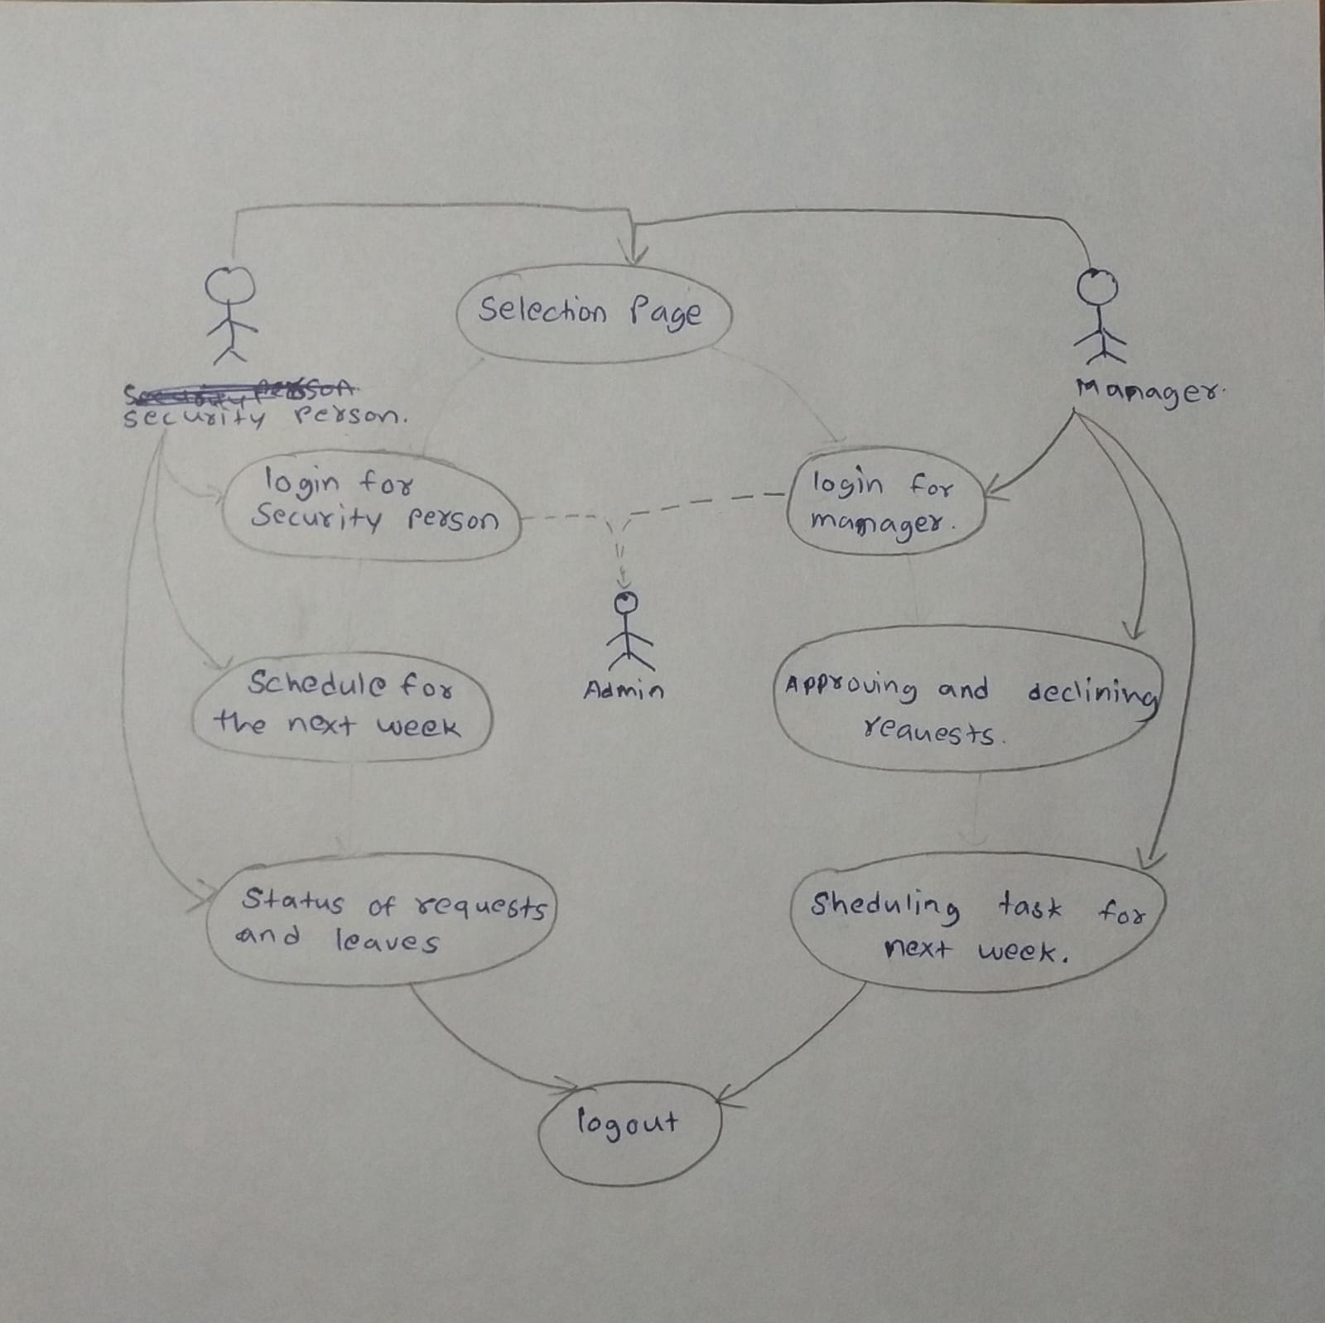

|  |  |
| --- | --- |
| **5.** | **Conclusions & Inferences** |

|  |  |
| --- | --- |
| **6.** | **Post Lab exercise** |

Suggest the most appropriate generic software process model that might be used as a basis for managing the development of the following systems. Explain your answer according to the type of the system being developed

1. A system to control antilock breaking in a car

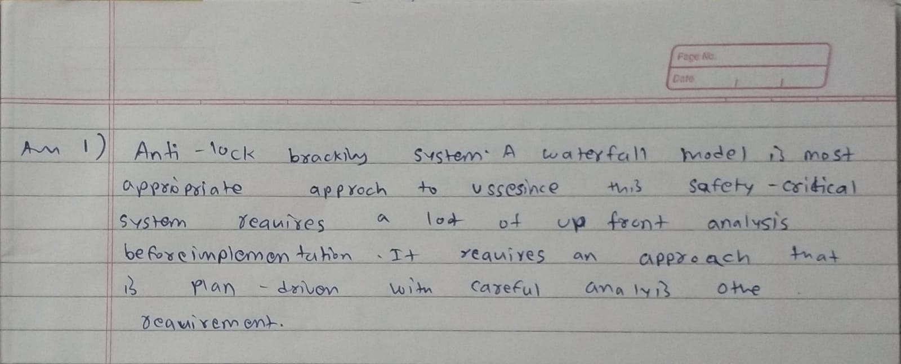

1. An interactive travel planning system that helps users plan journeys with the lowest environmental

impact



