Assignment No: 1

**Q1. Consider the following AI Classical problems :( solve batch wise questions given for Q1)**

1. **Water Jug Problem :**

You are given two jugs, a 4-gallon one and a 3-gallon one, a pump which has unlimited water which you can use to fill the jug, and the ground on which water may be poured. Neither jug has any measuring markings on it. How can you get exactly 2 gallons of water in the 4-gallon jug?

1. **The 4-Queens Problem:**

This problem consists of placing four queens on a 4 x 4 chessboard so that no two queens can capture each other. That is, no two queens are allowed to be placed on the same row, the same column or the same diagonal.

1. **The wolf, goat and cabbage problem is a river crossing**

Once upon a time a farmer went to a market and purchased a [wolf](https://en.wikipedia.org/wiki/Wolf), a [goat](https://en.wikipedia.org/wiki/Goat), and a cabbage. On his way home, the farmer came to the bank of a river and rented a boat. But crossing the river by boat, the farmer could carry only himself and a single one of his purchases: the wolf, the goat, or the cabbage. If left unattended together, the wolf would eat the goat, or the goat would eat the cabbage. The farmer's challenge was to carry himself and his purchases to the far bank of the river, leaving each purchase intact. How did he do it?

1. **Missionaries and cannibals problem**

In the missionaries and cannibals problem, three missionaries and three cannibals must cross a river using a boat which can carry at most two people, under the constraint that, for both banks, if there are missionaries present on the bank, they cannot be outnumbered by cannibals (if they were, the cannibals would eat the missionaries). The boat cannot cross the river by itself with no people on board. And, in some variations, one of the cannibals has only one arm and cannot row.

1. **8 Puzzle Problem**

In this puzzle solution of 8 puzzle problem is discussed.  
Given a 3×3 board with 8 tiles (every tile has one number from 1 to 8) and one empty space. The objective is to place the numbers on tiles to match final configuration using the empty space. We can slide four adjacent (left, right, above and below) tiles into the empty space.

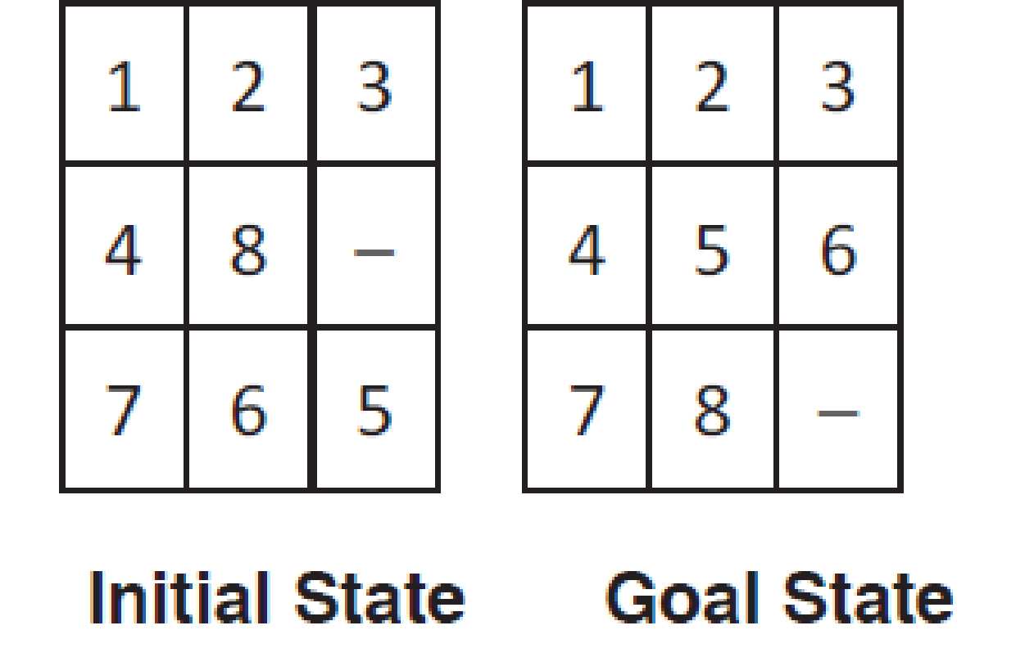

1. **Holiday in Romania Problem**

               Travel from Arad to Bucharest

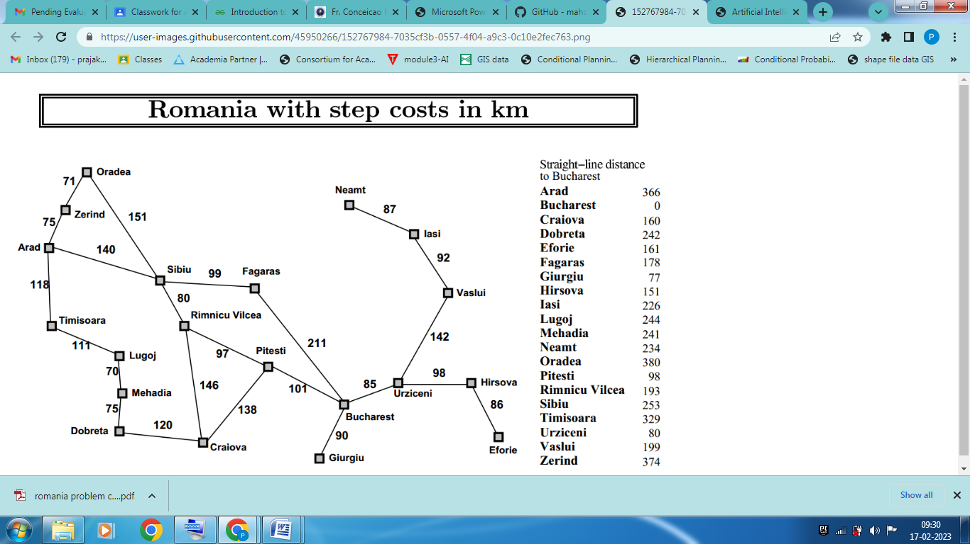

**7. Tower Of Hanoi**

Tower of Hanoi is a mathematical puzzle where we have three rods (**A**, **B**, and **C**) and **N** disks. Initially, all the disks are stacked in decreasing value of diameter i.e., the smallest disk is placed on the top and they are on rod **A**. The objective of the puzzle is to move the entire stack to another rod (here considered **C**), obeying the following simple rules:

* Only one disk can be moved at a time.
* Each move consists of taking the upper disk from one of the stacks and placing it on top of another stack i.e. a disk can only be moved if it is the uppermost disk on a stack.
* No disk may be placed on top of a smaller disk.

**Batch: A**

1. Apply Uninformed search Techniques **((DFS, BFS, DLS and Iterative Deepening DFS)** on problems 1,2,3.

Your solution should contain

1. Draw a diagram of the complete state space.
2. Show the path explored by each algorithm stepwise
3. Compare the performance of each algorithm (DFS, BFS and DLS)  wrt following

* Time
* Space
* Optimal
* Completeness

**Batch: B**

1. Apply Uninformed search Techniques **((DFS, BFS ,DLS and Iterative Deepening DFS)** on problems 4,5,6.

Your solution should contain

1. Draw a diagram of the complete state space.
2. Show the path explored by each algorithm stepwise
3. Compare the performance of each algorithm (DFS, BFS and DLS)  wrt following

* Time
* Space
* Optimal
* Completeness

**Batch: C**

1. Apply simple Hill Climbing Algorithm to solve 8 puzzle problem using Hamming distance and Manhattan distance Heuristics

Your solution should contain

1. Draw a diagram of the complete state space.
2. Show the path explored by each algorithm stepwise

**Batch: D**

Apply Uninformed search Techniques **((DFS, BFS ,DLS and Iterative Deepening DFS)** on problem 5,6,7

Your solution should contain

1. Draw a diagram of the complete state space.
2. Show the path explored by each algorithm stepwise
3. Compare the performance of each algorithm (DFS, BFS and DLS)  wrt following

* Time
* Space
* Optimal
* Completeness

**Q2**

**Apply Best first search and A* algorithm on the AI Classical Problem Holiday in Romania ( refer map given in the figure**)

Hint: f(n)= g(n)+ h(n)

 g(n)= actual path cost

h(n)=  straight-line distance from *n* to Bucharest

**Q3. Perform Min max algorithm with and without alpha beta Pruning on following example**

