|  |  |  |  |
| --- | --- | --- | --- |
| **Practical Number:** | **1**B | **Date of Practical:** |  |
| **Title:** | Design the state space problem for given Problem statements. | | |

Practical grading using Rubrics

|  |  |  |  |  |  |
| --- | --- | --- | --- | --- | --- |
| **Indicator** | **Very Poor** | **Poor** | **Average** | **Good** | **Excellent** |
| **Timeline** (2) | More than a  session late (0) | NA (0.5) | NA(1) | NA (1.5) | Early or on  time (2) |
| **Completeness**  (3) | N/A | N/A | Not Com-  pleted (1) | Partially  Completed (2) | Completed(3) |
| **Legibility** (3) | N/A | N/A | poor(1) | Good(2) | Very Good  (3) |
| **Postlab** (2) | N/A | N/A | N/A | Partially  Correct(1) | All correct  answers (2) |

|  |  |
| --- | --- |
| **Total Marks (10)** | **Sign of instructor** |
|  |  |

**Experiment No: 1**B

Problem Statement: Design the state space representation for given Problem statements

Theory:

**Problem:**

Three missionaries and three cannibals, along with one boat that fits at most two people ( and requires at least one for operation), are on the left bank of a river. The most salient thing about missionaries and cannibals in “cohabitation” is that if ever the cannibals in any one spot (left bank, right bank, on the boat outnumber the missionaries, the outnumbered missionaries will be consumed – eaten! The goal of this problem is to get all six individuals safely across the river from the left bank to the right bank.

**Objects of the State World:**

M M M C C C B

3 missionaries, 3 cannibals, 1 boat, a left river bank, and a right river bank.

C represents a cannibal, M represents a missionary, and B represents the location

of the boat.

**Representation of a State of the World:**

L<M C B> R<M C B>

A state of the world is represented as 2 lists :

L is the left bank.

R is the right bank.

C represents the location’s amount of cannibals.

M represents the location's amount of missionaries.

B is 1 when the boat is on the shore and 0 when it is on the opposite shore.

**The State Space Description:**

Initial State: Goal State:

L<3 3 1> R<0 0 0> L<0 0 0> R<3 3 1>

State Space Operands:

1 Cannibal goes left:

L1C L< M C B > R< M C B > => L< M (C-1) (B-1) > R< M (C+1) (B+1) >

2 Cannibals go left:

L2C L< M C B > R< M C B > => L< M (C-2) (B-1) > R< M (C+2) (B+1) >

1 Missionary goes left:

L1M L< M C B > R< M C B > => L< (M-1) C (B-1) > R< (M+1) C (B+1) >

2 Missionaries go left:

L2M L< M C B > R< M C B > => L< (M-2) C (B-1) > R< (M+2) C (B+1) >

1 Cannibal goes right:

R1C L< M C B > R< M C B > => L< M (C+1) (B+1) > R< M (C-1) (B-1) >

2 Cannibals goes right:

R2C L< M C B > R< M C B > => L< M (C+2) (B+1) > R< M (C-2) (B-1) >

1 Missionary goes right:

R1M L< M C B > R< M C B > => L< (M+1) C (B+1) > R< (M-1) C (B+1) >

2 Missionaries go right:

R2M L< M C B > R< M C B > => L< (M+2) C (B+1) > R< (M-2) C (B+1) >

1 Cannibal and 1 Missionary go left:

LMC L< M C B > R< M C B > => L< (M-1) (C-1) (B-1) > R< (M+1) (C+1) (B+1) >

1 Cannibal and 1 Missionary go right:

RMC L< M C B > R< M C B > => L< (M+1) (C+1) (B+1) > R< (M+1) (C+1) (B+1) >..

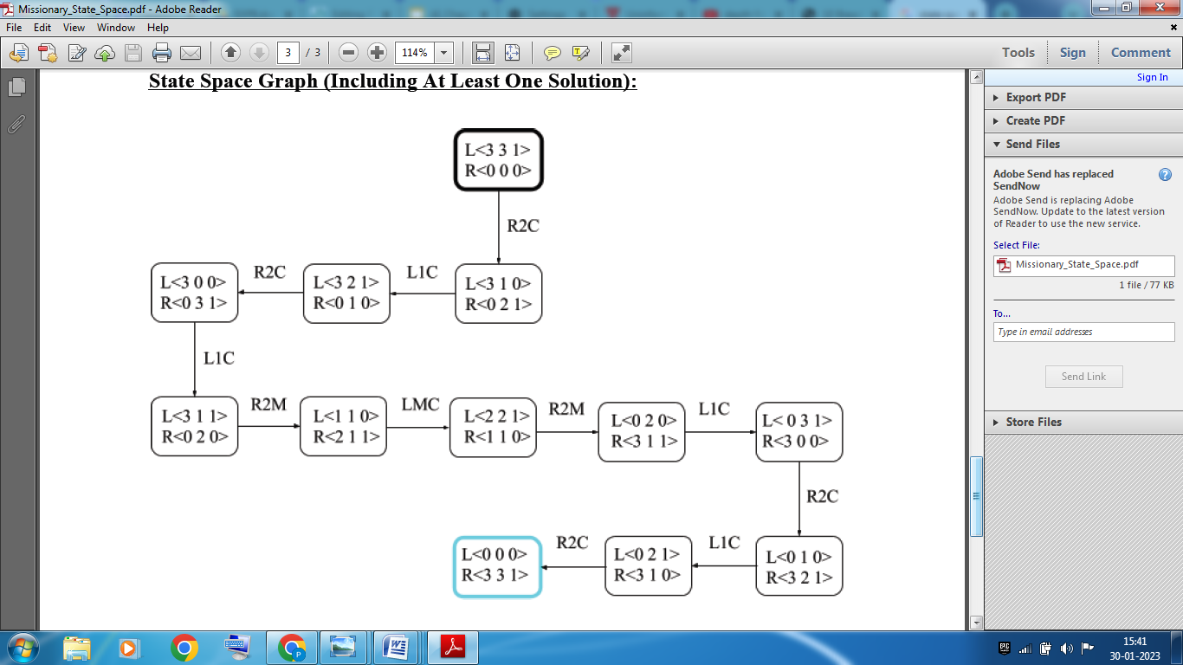

**Postlab:**

Give a state space representation for the following problems.

1. 4 Queen Problem
2. 8 Puzzle Problems.