

**Fr. CONCEICAO RODRIGUES COLLEGE OF ENGINEERING ( FrCRCE)**

**Department of Electronics and Computer Science (ECS)**

**CN EXPERIMENT NO.2**

|  |  |  |  |
| --- | --- | --- | --- |
| **Name of Student** | **Hardik Prajapati** | **Roll No.** | **9152** |
| **Sign here to indicate that you have read all relevant material provided /available on Moodle while performing and writing this experiment** | | **Sign:** | |

|  |  |  |  |  |  |  |  |  |  |  |  |  |  |  |  |  |  |  |  |  |
| --- | --- | --- | --- | --- | --- | --- | --- | --- | --- | --- | --- | --- | --- | --- | --- | --- | --- | --- | --- | --- |
| **Rubrics for assessment of Experiment:**   |  |  |  |  | | --- | --- | --- | --- | | Indicator | Poor | Average | Good | | Timeliness :Maintains Experiment deadline (3) | Experiment not done (0) | One or More than One week late (1-2) | Maintains deadline (3) | | Completeness and neatness  Complete all parts of Experiment (3) | N/A | < 80% complete (1-2) | 100% complete (3) | | Originality  Extent of plagiarism (2) | Copied it from someone else (0) | At least try to implement but could not succeed (1) | Implemented (2) | | Knowledge  In depth knowledge of the Experiment (2) | Unable to answer any questions (0) | Unable to answer few questions (1) | Able to answer all questions (2) | |
| **Assessment Marks:**   |  |  | | --- | --- | | Timeliness |  | | Completeness and neatness |  | | Originality |  | | Knowledge |  | | Total |  | |

**Signature of Teacher with date**

**AIM:** Usebasic networkingcommands inLinux(ping,tracert,nslookup, netstat, ARP,RARP, ip, ifconfig,dig,route )

**THEORY:**

1. **ifconfig**

**ifconfig**(interface configuration) command is used to configure the kernel-resident network interfaces. It is used at the boot time to set up the interfaces as necessary. After that, it is usually used when needed during debugging or when you need system tuning. Also, this command is used to assign the IP address and netmask to an interface or to enable or disable a given interface.

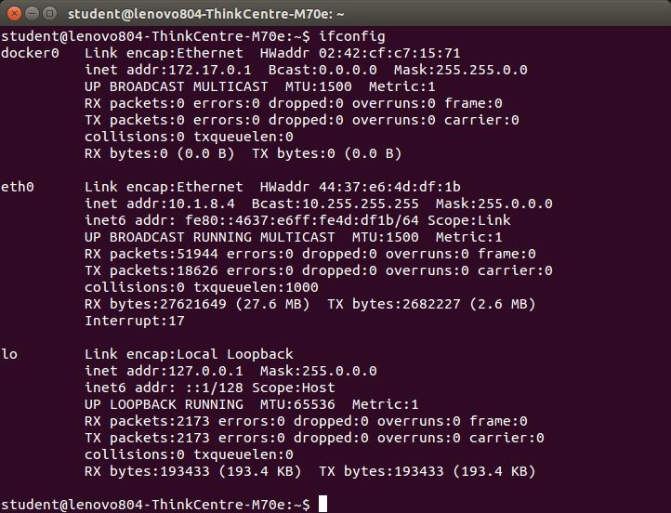

1. **NSLOOKUP**

**Nslookup**(stands for “Name Server Lookup”) is a useful command for getting information from DNS server. It is a network administration tool for querying the Domain Name System (DNS) to obtain domain name or IP address mapping or any other specific DNS record. It is also used to troubleshoot DNS related problems.

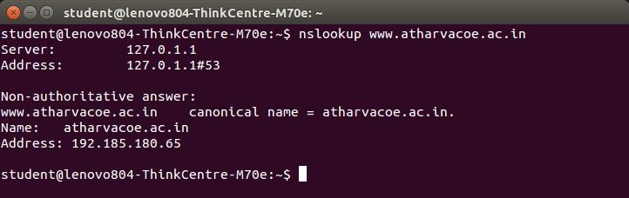

1. **Ping**

# PING (Packet Internet Groper) command is used to check the network connectivity between host and server/host. This command takes as input the IP address or the URL and sends a data packet to the specified address with the message “PING” and get a response from the server/host this time is recorded which is called latency. Fast ping low latency means faster connection. Ping uses [ICMP(Internet Control Message Protocol)](https://www.geeksforgeeks.org/internet-control-message-protocol-icmp/) to send an ICMP echo message to the specified host if that host is available then it sends ICMP reply message. Ping is generally measured in millisecond every modern operating system has this ping pre-installed.

1. **TRACEROUTE**

**traceroute** command in Linux prints the route that a packet takes to reach the host. This command is useful when you want to know about the route and about all the hops that a packet takes. Below image depicts how traceroute command is used to reach the Google(172.217.26.206) host from the local machine and it also prints detail about all the hops that it visits in between.

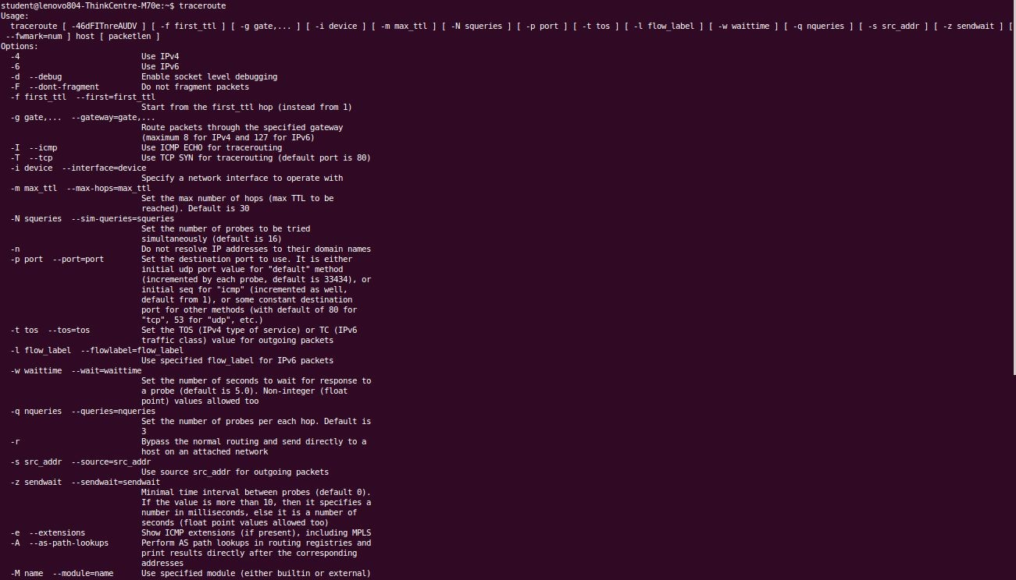

**Netstat**

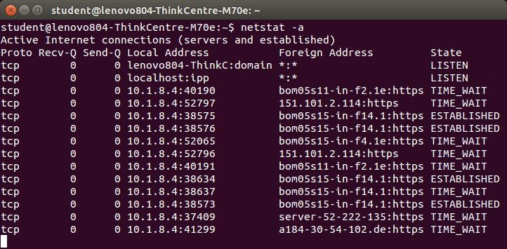Netstat command displays various network related information such as network connections, routing tables, interface statistics, masquerade connections, multicast memberships etc.,

1. **ARP**

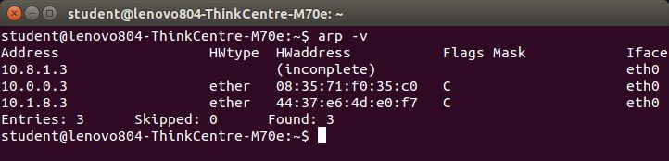 **arp command** manipulates the System’s ARP cache. It also allows a complete dump of the ARP cache. ARP stands for Address Resolution Protocol. The primary function of this protocol is to resolve the IP address of a system to its mac address, and hence it works between level 2(Data link layer) and level 3(Network layer).

1. **IP**

**ip** command in Linux is present in the net-tools which is used for performing several network administration tasks. IP stands for Internet Protocol. This command is used to show or manipulate routing, devices, and tunnels. It is similar to [*ifconfig*](https://www.geeksforgeeks.org/ifconfig-command-in-linux-with-examples/) command but it is much more powerful with more functions and facilities attached to it. *ifconfig* is one of the deprecated commands in the net-tools of Linux that has not been maintained for many years. ip command is used to perform several tasks like assigning an address to a network interface or configuring network interface parameters.  
It can perform several other tasks like configuring and modifying the default and static routing, setting up tunnel over IP, listing IP addresses and property information, modifying the status of the interface, assigning, deleting and setting 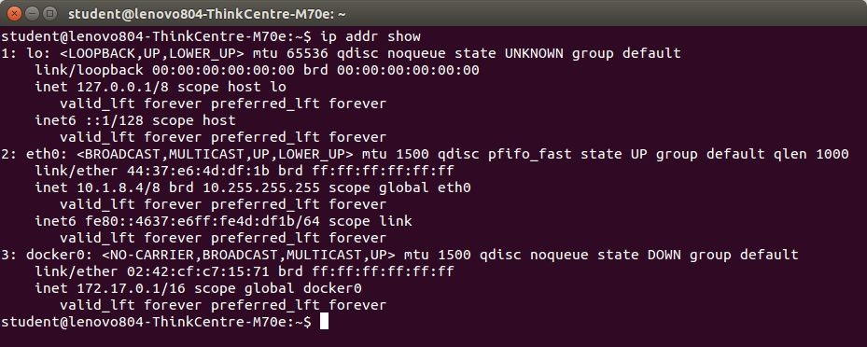up IP addresses and routes.

1. **Dig**

**dig** command stands for ***Domain Information Groper***. It is used for retrieving information about DNS name servers. It is basically used by network administrators. It is used for verifying and troubleshooting DNS problems and to perform DNS lookups. Dig command replaces older tools such as [nslooku](https://www.geeksforgeeks.org/nslookup-command-in-linux-with-examples/)p and the [host](https://www.geeksforgeeks.org/host-command-in-linux-with-examples/).

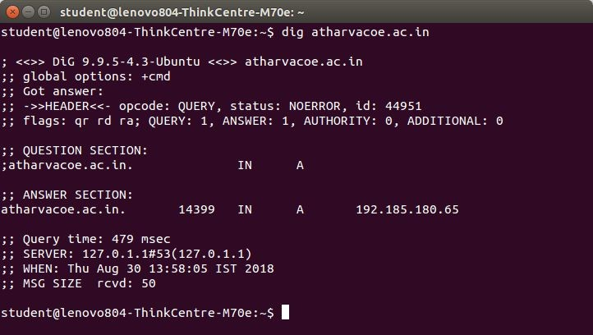

**CONCLUSION:** Hence, in this experiment, we have successfully studied some important networking command and also implemented them in Linux.