**FR. CONCEICAO RODRIGUES COLLEGE OF ENGINEER**

**Department of Electronics and Computer Science**



**1. OUTPUT AND TRANSFER CHARACTERISTICS**

**Expt 5: Socket Programming**

1. **Course, Subject & Experiment Details**

|  |  |  |  |
| --- | --- | --- | --- |
| **Timeline (2)** | **Understanding (4)** | **Self Efforts (4)** | **Total (10)** |
|  |  |  |  |

|  |  |  |  |  |
| --- | --- | --- | --- | --- |
| **Student’s Name** | **Shalaka Vengurlekar** | **Roll No.** | **9171** | |
| **Academic Year** | **2022 – 23** | **Estimated Time** | **2 Hours** | |
| **Course & Semester** | **T.E. (ECS) Sem. VI** | **Subject Name** | **AI & Computer Networks Laboratory** | |
| **Unit No.** | **5** | **Chapter Title** | **Transport Layer** | |
| **Experiment Type** | **Software Performance** | **Subject Code** | **ECL 602** | |
| **Rubrics for assessment of Experiment:**   |  |  |  |  | | --- | --- | --- | --- | | Indicator | Poor | Average | Good | | Timeliness :Maintains Experiment deadline (3) | Experiment not done (0) | One or More than One week late (1-2) | Maintains deadline (3) | | Completeness and neatness  Complete all parts of Experiment (3) | N/A | < 80% complete (1-2) | 100% complete (3) | | Originality  Extent of plagiarism (2) | Copied it from someone else (0) | At least try to implement but could not succeed (1) | Implemented (2) | | Knowledge  In depth knowledge of the Experiment (2) | Unable to answer any questions (0) | Unable to answer few questions (1) | Able to answer all questions (2) | | | | |
| **Assessment Marks:**   |  |  | | --- | --- | | Timeliness |  | | Completeness and neatness |  | | Ori Originality |  | | Kn Knowledge |  | | Tot Total |  | | | | |

**Signature of Teacher with date**

1. **Aim of the Experiment:**

To Study Socket Programming using Python or Java.

1. **Software/ Apparatus:**

Java or Python software

**4. Expected Outcome of Experiment**

Students will be able to demonstrate Socket Programming and communication between client and server using server socket and client programme.

**5. Theoretical Description**

**Java Socket Programming**

* Java Socket programming is used for communication between the applications running on different JRE.
* Java Socket programming can be connection-oriented or connection-less.
* Socket and ServerSocket classes are used for connection-oriented socket programming and DatagramSocket and DatagramPacket classes are used for connection-less socket programming.

The client in socket programming must know two information:

1. IP Address of Server, and
2. Port number.

Here, we are going to make one-way client and server communication. In this application, client sends a message to the server, server reads the message and prints it. Here, two classes are being used: Socket and ServerSocket.

The Socket class is used to communicate client and server. Through this class, we can read and write message. The ServerSocket class is used at server-side. The accept() method of ServerSocket class blocks the console until the client is connected. After the successful connection of client, it returns the instance of Socket at server-side.

# #Socket class

A socket is simply an endpoint for communications between the machines. The Socket class can be used to create a socket.

# #ServerSocket class

The ServerSocket class can be used to create a server socket. This object is used to establish communication with the clients.

# Creating Server:

To create the server application, we need to create the instance of ServerSocket class. Here, we are using 6666 port number for the communication between the client and server. You may also choose any other port number. The accept() method waits for the client. If clients connects with the given port number, it returns an instance of Socket.

ServerSocket ss=**new** ServerSocket(6666);

Socket s=ss.accept();//establishes connection and waits for the client

# Creating Client:

To create the client application, we need to create the instance of Socket class. Here, we need to pass the IP address or hostname of the Server and a port number. Here, we are using "localhost" because our server is running on same system.

Socket s=**new** Socket("localhost",6666);

**Code:**

# An example script to connect to Google using socket  
# programming in Python  
import socket # for socket  
import sys  
   
try:  
    s = socket.socket(socket.AF_INET, socket.SOCK_STREAM)  
    print ("Socket successfully created")  
except socket.error as err:  
    print ("socket creation failed with error %s" %(err))  
   
# default port for socket  
port = 80  
   
try:  
    host_ip = socket.gethostbyname('[www.google.com](http://www.google.com/)')  
    print(host_ip)  
except socket.gaierror:  
   
    # this means could not resolve the host  
    print ("there was an error resolving the host")  
    sys.exit()  
   
# connecting to the server  
s.connect((host_ip, port))  
   
print ("the socket has successfully connected to google")

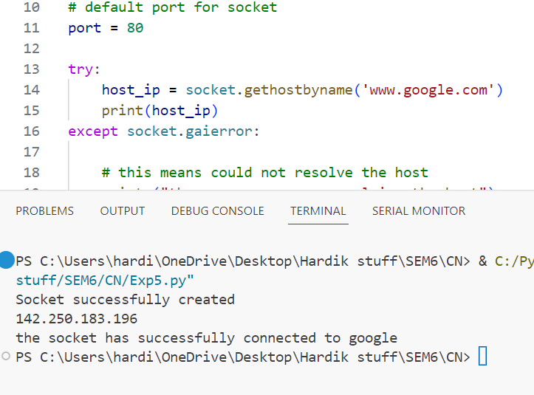

**CONCLUSION:** So, in this experiment we have successfully understood the concept of Socket Programming and implemented it using Python/Java Programming.

**6. Post Lab Questions**

I) Explain Socket Programming.

II)List the following system calls syntax with parameters

a)Socket creation syntax and description

b)Bind c) Listen d)Accept e)Connect