|  |  |
| --- | --- |
|  | 2. Implementation of OLAP operations: Slice, Dice, Rollup, Drilldown and Pivot table for the Experiment 1 problem statement |

|  |  |  |  |
| --- | --- | --- | --- |
| **Name of Student** | **Hardik Prajapati** | **Roll No.** | **9152** |
| **Sign here to indicate that you have read all relevant material provided**  **/available on Moodle while performing and writing this experiment** | | **Sign:** | |

# Late Submission Details (if any)

|  |  |  |
| --- | --- | --- |
| **Reason(s) of late submission** | **Date of practical performance** | **Date of practical submission** |
|  | 7.2.23 | 24.2.23 |

**References used**

|  |  |  |
| --- | --- | --- |
| 1 | Name and author of reference book(s) with page nos. |  |
| 2 | Name and roll nos. of the peers whose help you have taken (if any) |  |

|  |  |  |  |  |  |  |  |  |
| --- | --- | --- | --- | --- | --- | --- | --- | --- |
| **Rubrics for assessment of Experiment:** | | | | | | | | |
|  | | Indicator | | Poor | | Average | Good |  |
| Timeliness  Maintains Experiment deadline (3) | | Experiment not done (0) | | One or More than One week late (1-2) | Maintains deadline (3) |
| Completeness and neatness  Complete all parts of Experiment (3) | | N/A | | < 80% complete (1-2) | 100% complete  (3) |
| Originality  Extent of plagiarism (2) | | Copied it from someone else (0) | | At least try to implement but could not succeed (1) | Implemented (2) |
| Knowledge  In depth knowledge of the Experiment (2) | | Unable to  answer any questions (0) | | Unable to answer few questions (1) | Able to answer all questions (2) |
| **Assessment Marks:** | | | | | | | | |
|  | Timeliness | |  | |  | | | |
|  | Completeness and neatness | |  | |
|  | Originality | |  | |
|  | Knowledge | |  | |
|  | Total | |  | |

# Signature of Teacher with date

|  |  |
| --- | --- |
| **1.** | **Course, Subject & Experiment Details** |

|  |  |  |  |
| --- | --- | --- | --- |
| **Course & Branch** | **T.E. (ECS)** | **Estimated Time** | **02 Hours Per Week** |
| **Current Semester** | **Semester V** | **Subject Name** | **DWM** |
| **Chapter No. & Unit** | **2** | **Chapter Title** | **ETL Operations** |
| **Experiment Type** | **Software Performance** | **Subject Code** | **ECC 604** |

|  |  |
| --- | --- |
| **2.** | **Aim & Objective of Experiment** |

1. Understand the use of ETL techniques and apply OLAP operations (CO2)

|  |  |
| --- | --- |
| **3.** | **Expected Outcome of Experiment** |

**1.** To understand various OLAP operations such as roll-up, drill-down, dice and slice

|  |  |
| --- | --- |
| **4.** | **Code of the experiment** |

1. Create the Dimension Tables using PostgreSQL
2. Create the Fact Table using PostgreSQL
3. Insert values in both dimension and fact tables using PostgreSQL
4. Display the tables and draw 3D model of any one dimension table

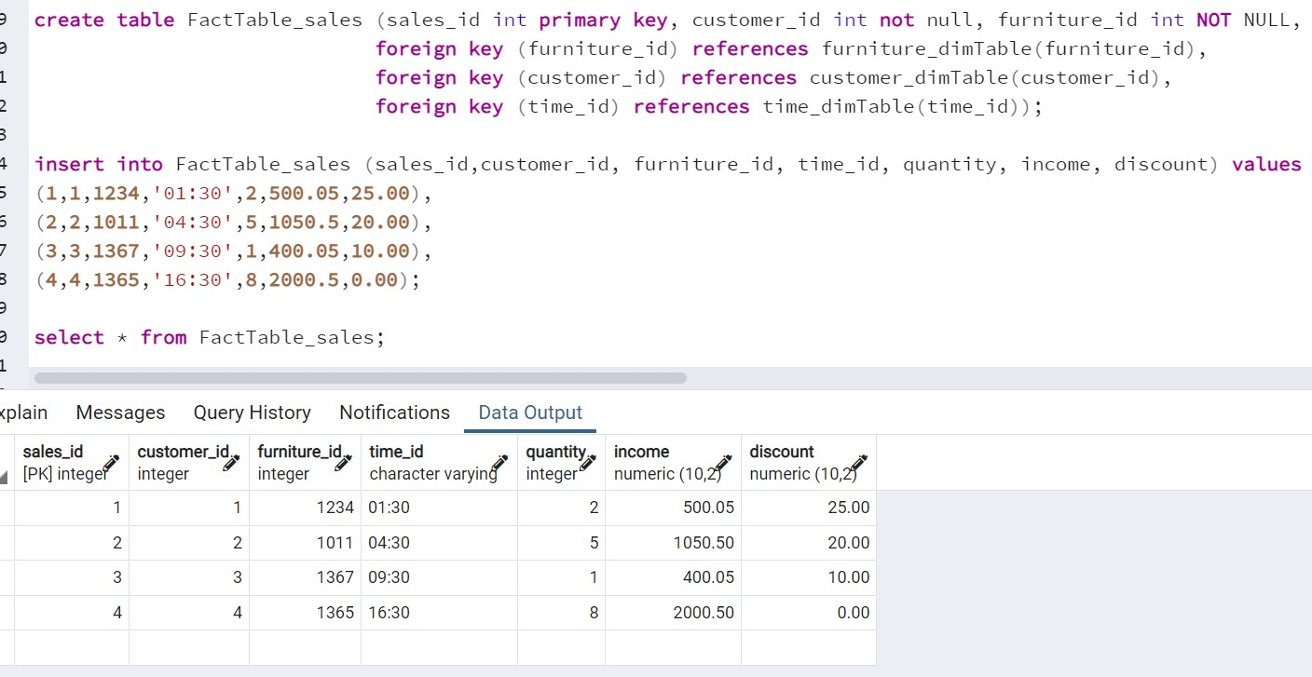

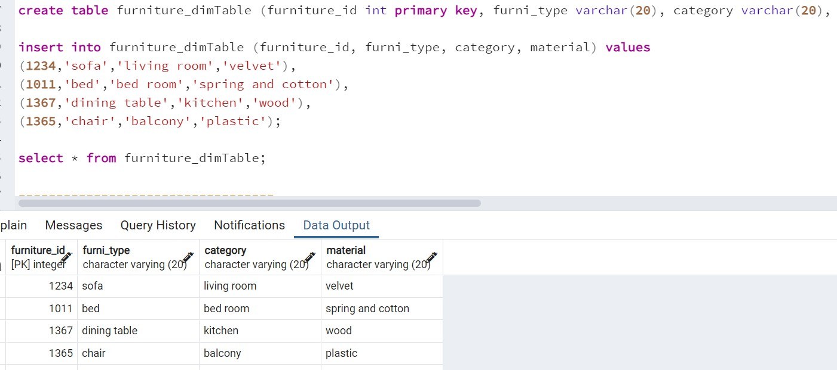

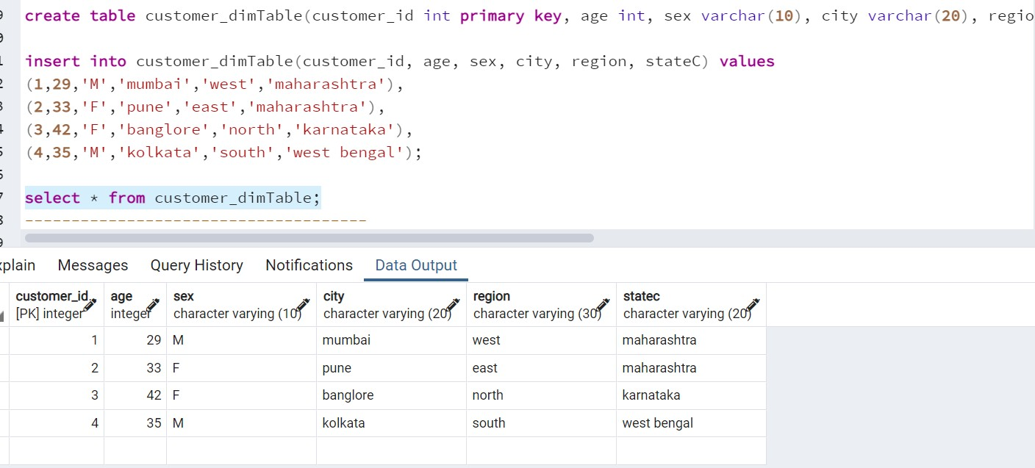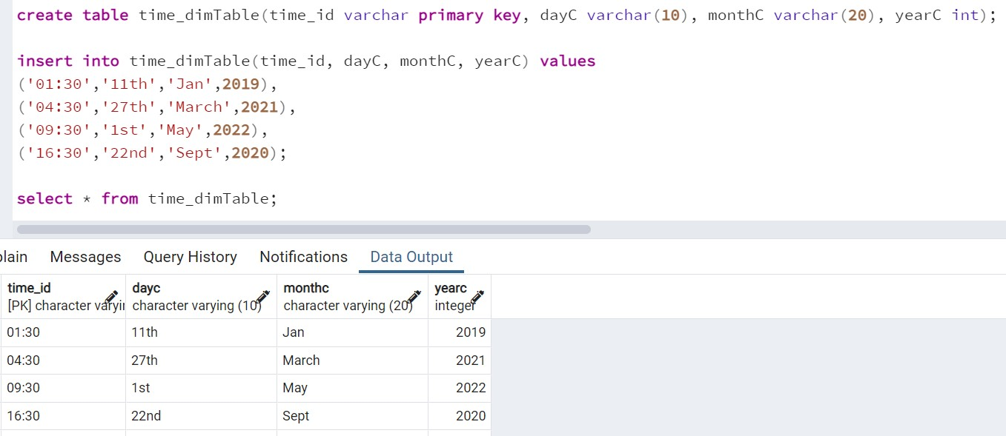

# SQL statement for roll-up operation

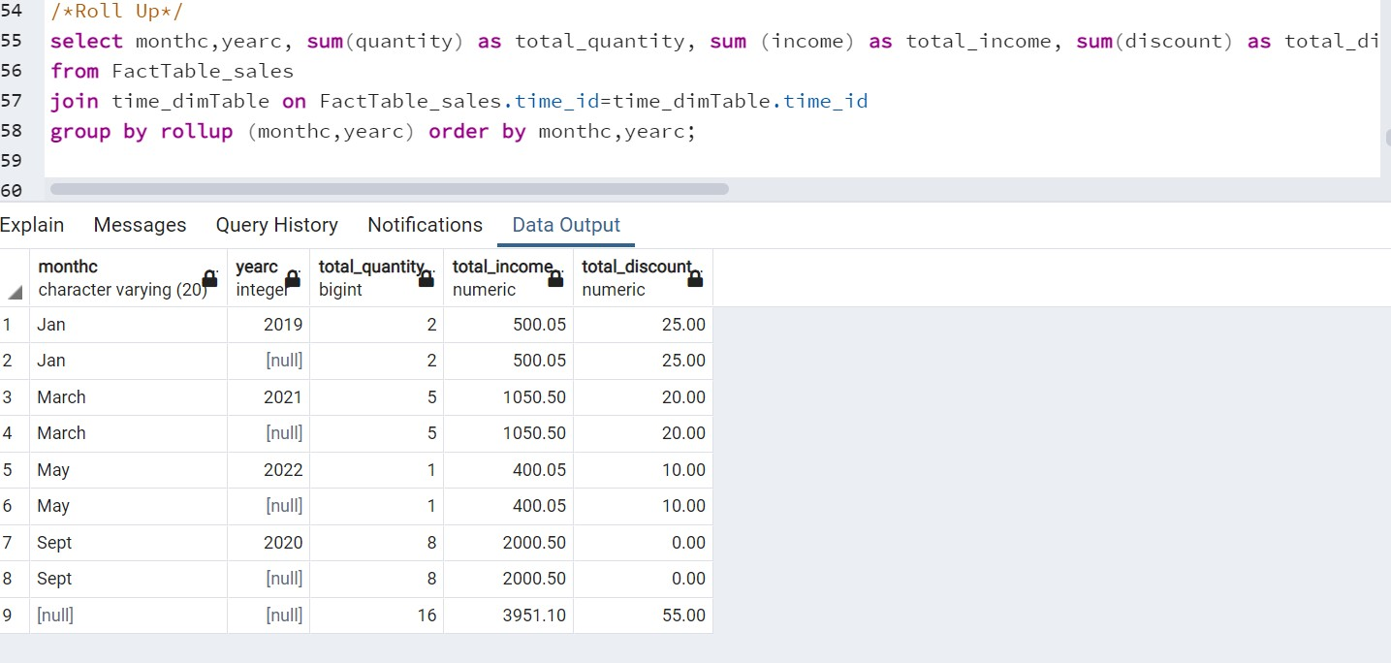

1. **SQL code for DRILL-DOWN operation**

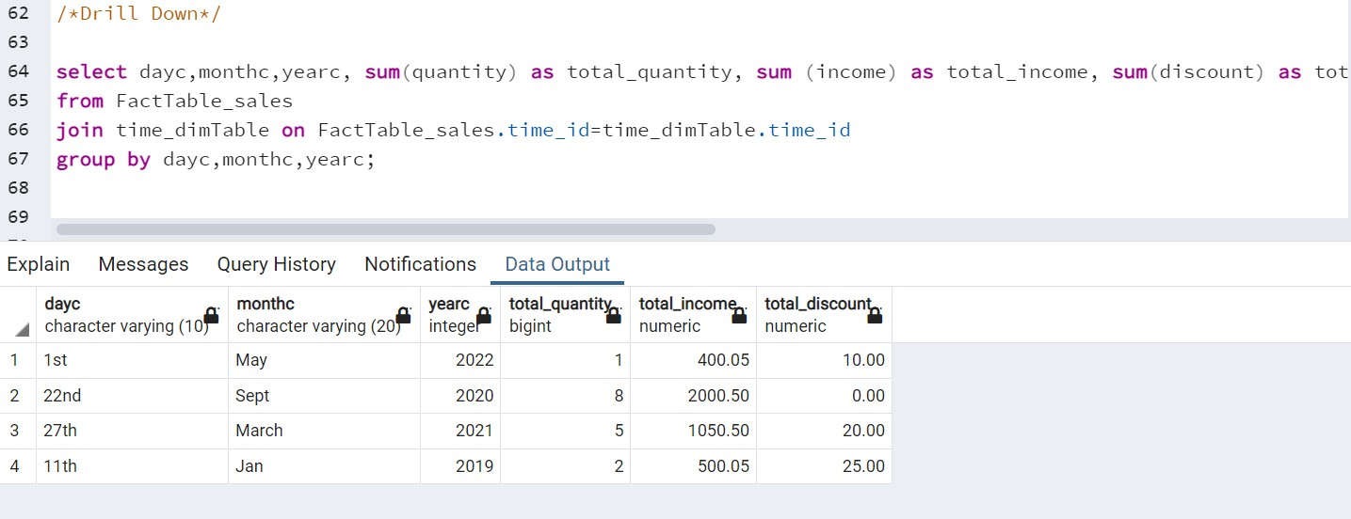

# SQL code for slice operation

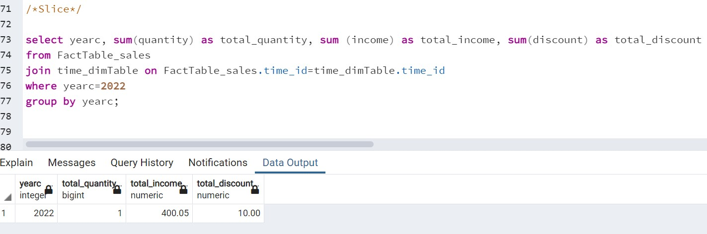

1. 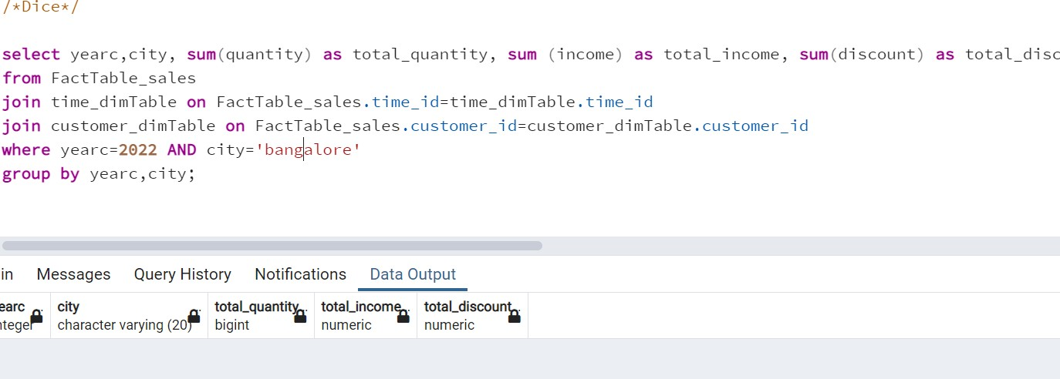**SQL code for dice operation**

# PIVOT operation using MS EXCEL.

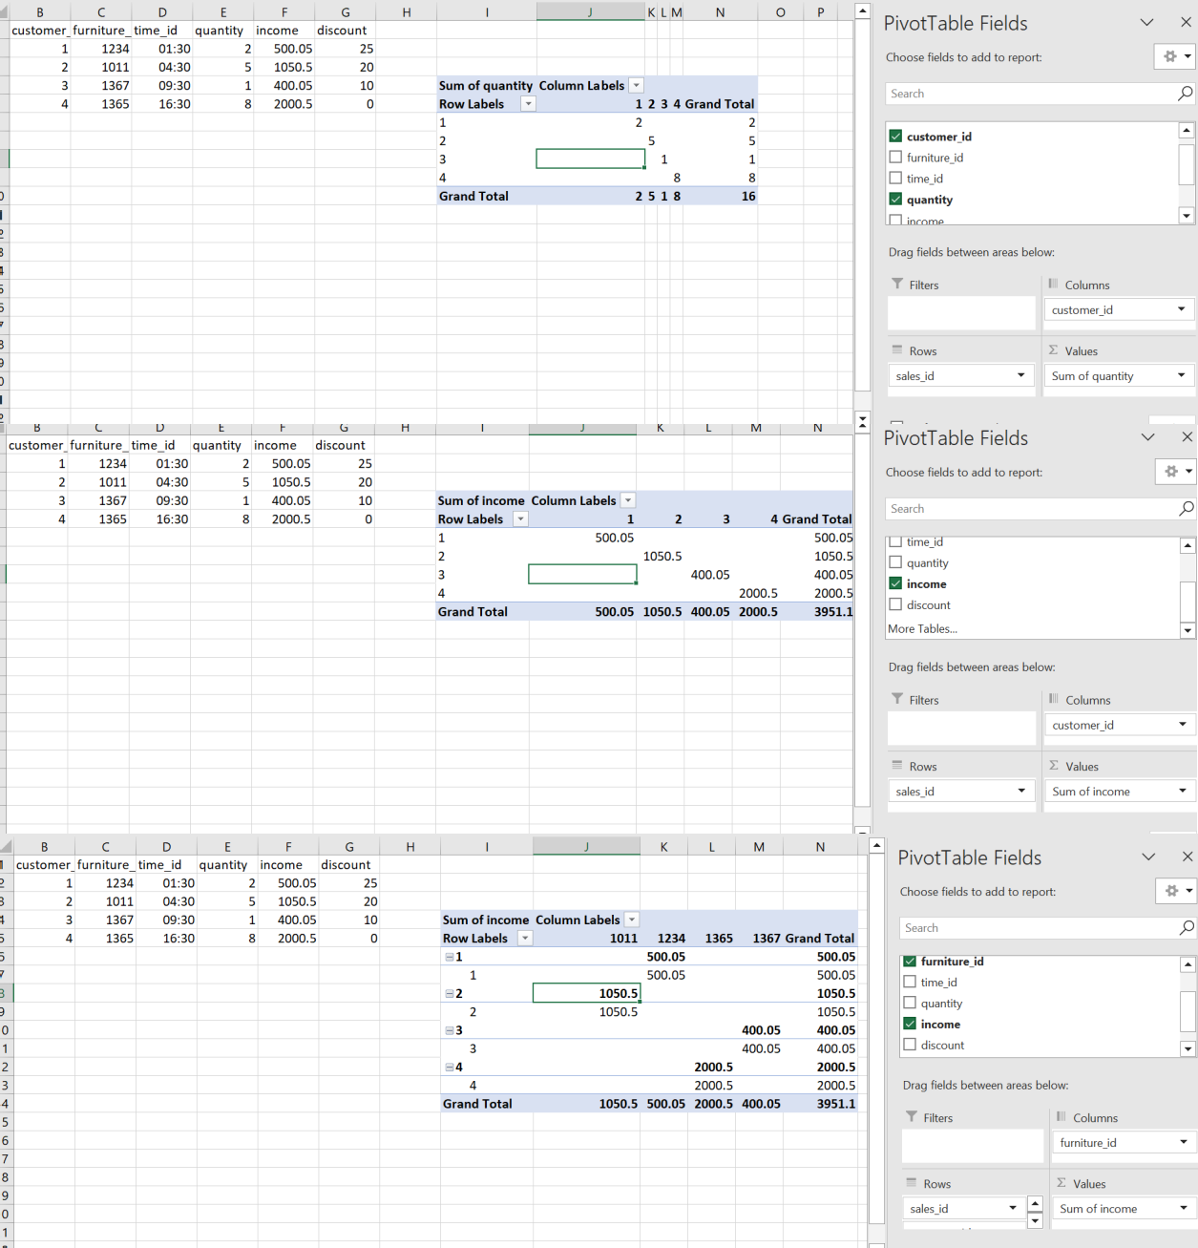

|  |  |
| --- | --- |
| **5.** | **Conclusions & Inferences** |

We have understood the use of ETL techniques and apply OLAP operations and the various OLAP operations such as roll-up, drill-down, dice and slice.

|  |  |
| --- | --- |
| **6.** | **Post Lab exercise** |

1. Discuss importance of OLAP operations
2. Discuss the industry standard tools used for OLAP operations

******************