|  |  |
| --- | --- |
|  | 1. Classify the given dataset using Naive Bayesian algorithm |

|  |  |  |  |
| --- | --- | --- | --- |
| **Name of Student** | **Hardik Prajapati** | **Roll No.** | **9152** |
| **Sign here to indicate that you have read all relevant material provided /available on Moodle while performing and writing this experiment** | | **Sign:** | |

**Late Submission Details (if any)**

|  |  |  |
| --- | --- | --- |
| **Reason(s) of late submission** | **Date of practical performance** | **Date of practical submission** |
|  |  |  |

**References used**

|  |  |  |
| --- | --- | --- |
| 1 | Name and author of reference book(s) with page nos. |  |
| 2 | Name and roll nos. of the peers whose help you have taken (if any) |  |

|  |  |  |  |  |  |  |  |  |  |  |  |  |  |  |  |  |  |  |  |  |
| --- | --- | --- | --- | --- | --- | --- | --- | --- | --- | --- | --- | --- | --- | --- | --- | --- | --- | --- | --- | --- |
| **Rubrics for assessment of Experiment:**   |  |  |  |  | | --- | --- | --- | --- | | Indicator | Poor | Average | Good | | Timeliness  Maintains Experiment deadline (3) | Experiment not done (0) | One or More than One week late (1-2) | Maintains deadline (3) | | Completeness and neatness  Complete all parts of Experiment (3) | N/A | < 80% complete (1-2) | 100% complete (3) | | Originality  Extent of plagiarism (2) | Copied it from someone else (0) | At least try to implement but could not succeed (1) | Implemented (2) | | Knowledge  In depth knowledge of the Experiment (2) | Unable to answer any questions (0) | Unable to answer few questions (1) | Able to answer all questions (2) | |
| **Assessment Marks:**   |  |  | | --- | --- | | Timeliness |  | | Completeness and neatness |  | | Originality |  | | Knowledge |  | | Total |  | |

**Signature of Teacher with date**

|  |  |
| --- | --- |
| **1.** | **Course, Subject & Experiment Details** |

|  |  |  |  |
| --- | --- | --- | --- |
| **Course & Branch** | **T.E. (ECS)** | **Estimated Time** | **02 Hours Per Week** |
| **Current Semester** | **Semester V** | **Subject Name** | **DWM** |
| **Chapter No. & Unit** | **4** | **Chapter Title** | **Linear regression** |
| **Experiment Type** | **Software Performance** | **Subject Code** | **ECC 604** |

|  |  |
| --- | --- |
| 2**.** | **Aim & Objective of Experiment** |

1. Understand Navie Basian classification

|  |  |
| --- | --- |
| 3**.** | **Expected Outcome of Experiment** |

1. Demonstrate classifications, prediction, etc. on datasets using open source tools

|  |  |
| --- | --- |
| 4. | **Code of the experiment** |

Consider Weather Dataset

**Outlook Temp Humidity Windy Play**

Rainy Hot High f no

Rainy Hot High t no

Overcast Hot High f yes

Sunny Mild High f yes

Sunny Cool Normal f yes

Sunny Cool Normal t no

Overcast Cool Normal t yes

Rainy Mild High f no

Rainy Cool Normal f yes

Sunny Mild Normal f yes

Rainy Mild Normal t yes

Overcast Mild High t yes

Overcast Hot Normal f yes

Sunny Mild High t no

**Query:**Whether Players will play or not when the weather conditions are [Outlook=Rainy, Temp=Cool, Humidity=Normal, Windy=f]?

**Write Python code to get the output of above query. You can use sklearn and pandas library or you can write the python code using traditional way (without using library)**

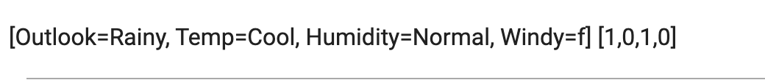

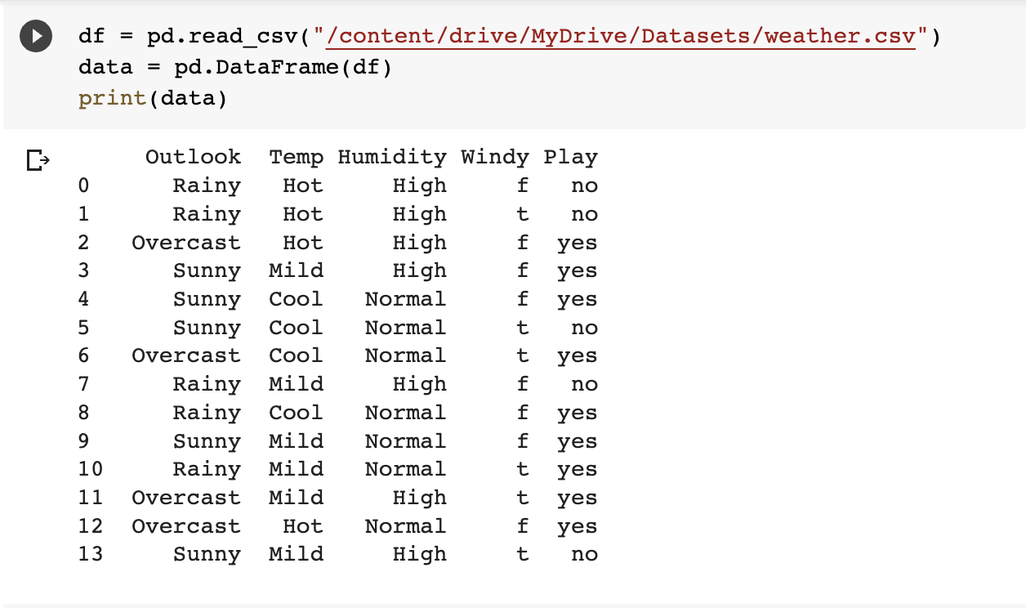

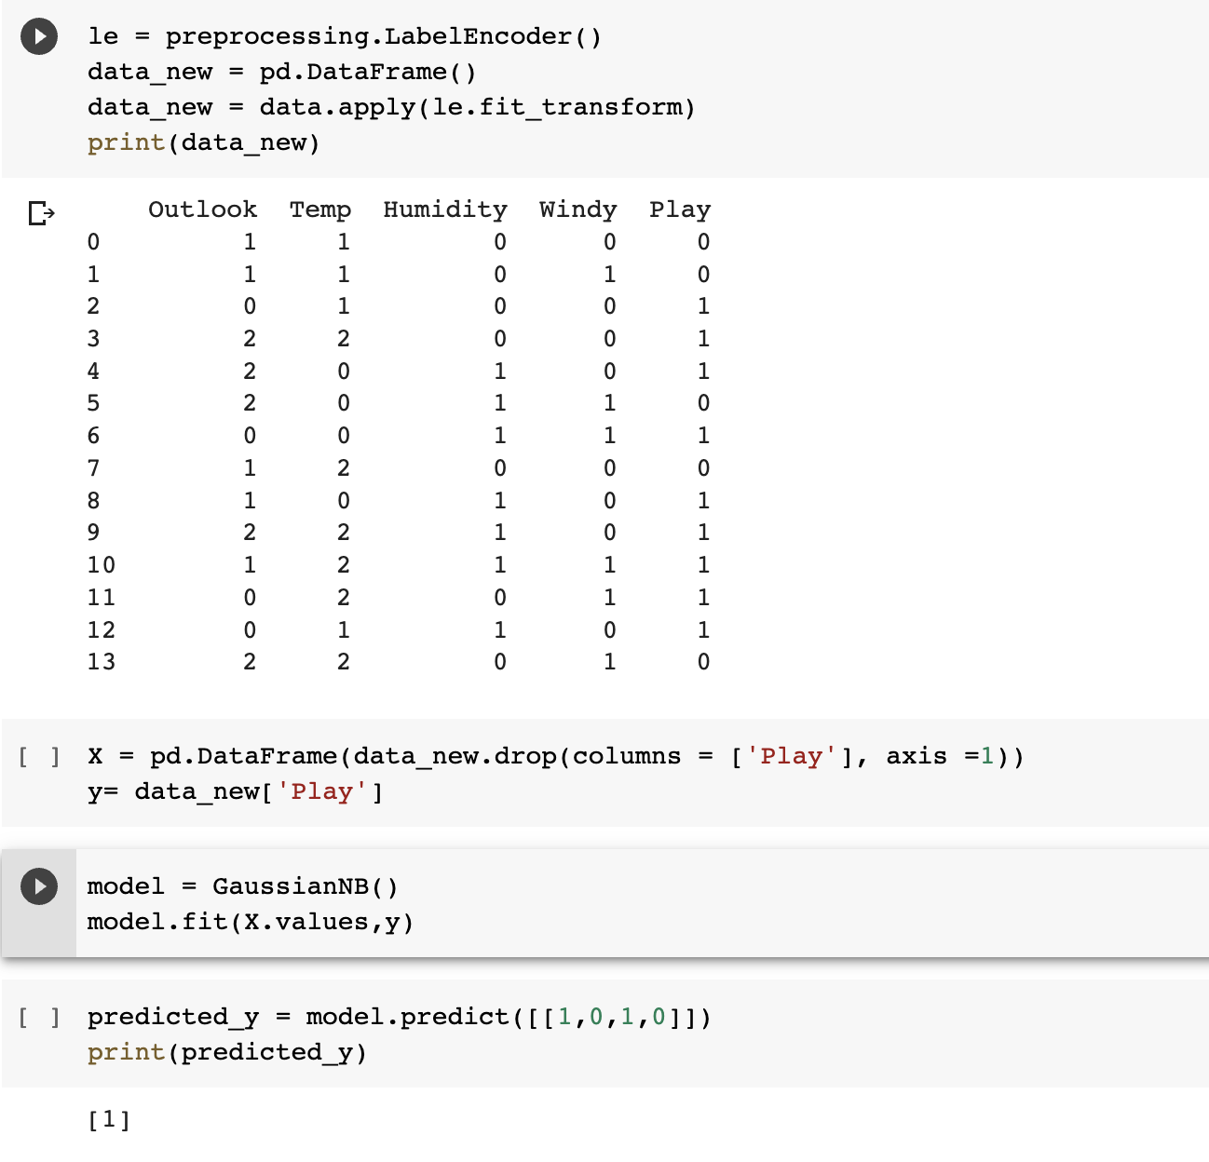

|  |  |
| --- | --- |
| 5**.** | **Conclusions & Inferences** |

From this experiment we learned to classify the dataset using Naive Bayesian algorithm.

|  |  |
| --- | --- |
| 6**.** | **Post Lab exercise** |

Load this data in Weka. Then apply Naive Basian algorithm and find the result of classification for the required data.

