1. **Han and kamber**

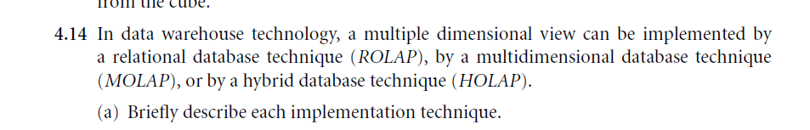

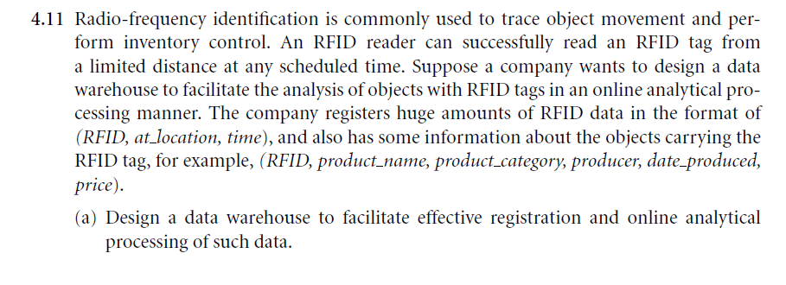

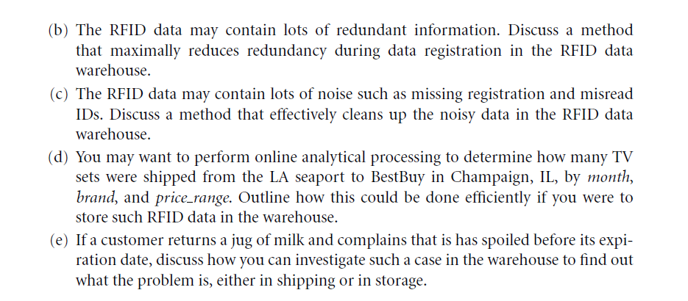

1. **Paulraj poniea**



1. **Discuss different OLAP operations in detail with the help of an example**
2. **Write in brief on various types of metadata?**
3. **Discuss OLAP Models: MOLAP, ROLAP**
4. **Discuss data transformation tasks and major transformation types**