**Fr. CONCEICAO RODRIGUES COLLEGE OF ENGINEERING ( FrCRCE)**

**Department of Electronics and Computer Science (ECS)**

** 2.STEPPER MOTOR INTERFACING**

**Course, Subject & Experiment Details**

|  |  |  |  |
| --- | --- | --- | --- |
| **Academic year** | **2022 – 2023** | **Estimated Time** | **02 Hours** |
| **Course** | **T.E. (ECS)** | **Subject Name** | **Embedded systems and RTOS** |
| **Semester** | **VI** | **Chapter Title** | **Motor interfacing** |
| **Experiment Type** | **Coding** | **Subject Code** | **ECC 601** |

**Aim & Objective of Experiment**

1. To write and execute an assembly language program to interface a stepper motor to the 8051 (Using KEIL Micro-Vision) with direction control

2. To design the system (using Proteus VSM) and show simulation results.

**Theory:**

Stepper motors rotate or step from one fixed position to the next in small increments. Common step size range from 0.9° to 30°.Stepper motors are stepped from one position to the next by changing the currents to the field of the motor. The two common field connections are required to as two phases and four phases. Stepper motor control involves interfacing the motor coil connections to the microcontroller port via a driver circuit that provides the necessary drive current for the motor. The microcontroller generates patterns on the port providing the excitation to the field coils which cause it to rotate. The tables below show the switching sequence for the typical stepper motor for full step mode and half step mode. In full step mode motor, steps through the step angle each time it is excited. In half step mode, motor steps through half the mode angle each time. This is accomplished by maintaining one field excitation at a time and changing the other field. Each the microcontroller output one step code it must wait a few milliseconds before the next step code is given out because the motor can only step so fast.

**Full Step Drive Sequence** :

|  |  |  |  |  |
| --- | --- | --- | --- | --- |
|  | **D** | **C** | **B** | **A** |
| **1** | **0** | **0** | **1** | **1** |
| **2** | **1** | **0** | **0** | **1** |
| **3** | **1** | **1** | **0** | **0** |
| **4** | **0** | **1** | **1** | **0** |

**Fr. CONCEICAO RODRIGUES COLLEGE OF ENGINEERING ( FrCRCE)**

**Department of Electronics and Computer Science (ECS)**

**Half Step Drive Sequence:**

|  |  |  |  |  |
| --- | --- | --- | --- | --- |
|  | **D** | **C** | **B** | **A** |
| **1** | **0** | **0** | **1** | **1** |
| **2** | **0** | **0** | **0** | **1** |
| **3** | **1** | **0** | **0** | **1** |
| **4** | **1** | **0** | **0** | **0** |
| **5** | **1** | **1** | **0** | **0** |
| **6** | **0** | **1** | **0** | **0** |
| **7** | **0** | **1** | **1** | **0** |
| **8** | **0** | **0** | **1** | **0** |

**Algorithm:**

**#include <reg51.h>**

**sbit SW = P2 ^ 7;**

**void MSDelay(unsigned int value)**

**{**

**unsigned int x, y;**

**for (x = 0; x < 1275; x++)**

**for (y = 0; y < value; y++);**

**}**

**void main()**

**{**

**SW = 1;**

**while (1)**

**{**

**if (SW == 0)**

**{**

**P1 = 0x66;**

**MSDelay(50);**

**P1 = 0xCC;**

**MSDelay(50);**

**P1 = 0x99;**

**MSDelay(50);**

**P1 = 0x33;**

**MSDelay(50);**

**}**

**else**

**{**

**P1 = 0x66;**

**MSDelay(50);**

**P1 = 0x33;**

**MSDelay(50);**

**P1 = 0x99;**

**MSDelay(50);**

**P1 = 0xCC;**

**MSDelay(50);**

**}**

**}**

**}**

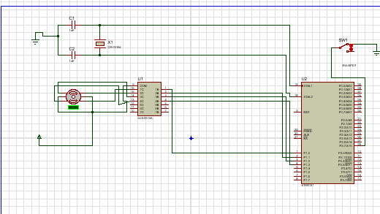

**Fr. CONCEICAO RODRIGUES COLLEGE OF ENGINEERING ( FrCRCE)**

**Department of Electronics and Computer Science (ECS)**

**Post- Lab Questions**

1. Study the hardware setup of the motor. Explain why the clamp diodes are used across the driving transistors.
2. Why is a slight jerking motion induced in the motor motion in the full step drive?