**Fr. CONCEICAO RODRIGUES COLLEGE OF ENGINEERING ( FrCRCE)**

**Department of Electronics and Computer Science (ECS)**



**3. Sensor Interfacing**

**Course, Subject & Experiment Details**

|  |  |  |  |
| --- | --- | --- | --- |
| **Academic year** | **2022 – 2023** | **Estimated Time** | **02 Hours** |
| **Course** | **T.E. (ECS)** | **Subject Name** | **Embedded systems and RTOS** |
| **Semester** | **VI** | **Chapter Title** | **Sensor interfacing** |
| **Experiment Type** | **Coding** | **Subject Code** | **ECC 601** |

**Aim & Objective of Experiment**

1. To write and execute an assembly language program to interface a Temperature sensor using an ADC to the 8051 (Using KEIL Micro-Vision)

2. To design the system (using Proteus VSM) and show simulation results.

**Theory:**

Analog to digital converters are among the most widely used devices for data acquisition. digital computers use binary (discrete) values but in the physical world, all parameters are analog (continuous) in nature. Therefore, we need an analog to digital converter to translate the analog signals to digital to be processed by the microcontroller.

An ADC has n bit resolution where n can be 8,10, 12,16 or 24 bits. The higher resolution ADC provides a smaller step size where step size is the smallest change that can be discerned by an ADC. In addition to resolution, conversion time is another major factor in choosing an ADC. Conversion time is defined as the time it takes for the ADC to convert from analog to digital. ADC chips can be serial or parallel. In parallel ADCs, multiple pins are used as output but in serial ADC, we have only one pin for data out.

Note : ADC 0808/0809 is a 8 bit ADC chip from National Semiconductors. It is a 8 channel ADC and each channel can be selected by using three select lines.

LM 35:The LM35 series are precision integrated-circuit temperature sensors, whose output voltage is linearly proportional to the Celsius (Centigrade) temperature. The LM35 thus has an advantage over linear temperature sensors calibrated in ˚ Kelvin, as the user is not required to subtract a large constant voltage from its output to obtain convenient Centigrade scaling. The LM35 does not require any

**Fr. CONCEICAO RODRIGUES COLLEGE OF ENGINEERING ( FrCRCE)**

**Department of Electronics and Computer Science (ECS)**

external calibration or trimming to provide typical accuracies of ±1⁄4˚C at room temperature and ±3⁄4˚C over a full −55 to +150˚C temperature range.

**Algorithm:**

**#include <reg51.h>**

**#include "lcd_header.h"**

**#define adc_input P1**

**sbit wr = P2^5;**

**sbit rd = P2^6;**

**sbit intr = P2^7;**

**unsigned int value;**

**void main(){**

**init();**

**P1 = 0xFF;**

**P3 = 0x00;**

**intr = 1;**

**rd = 1;**

**wr = 1;**

**while(1){**

**delay(1);**

**wr = 1;**

**delay(10); //high to low pulse on wr to start conversion**

**wr = 0;**

**while(intr == 1); // wait for conversion to finish**

**rd = 0; //rd low to read data**

**value = P1;**

**cmd(0x01);**

**write(value);**

**delay(10);**

**rd = 1;**

**}**

**}**

**Screenshot of Proteus**

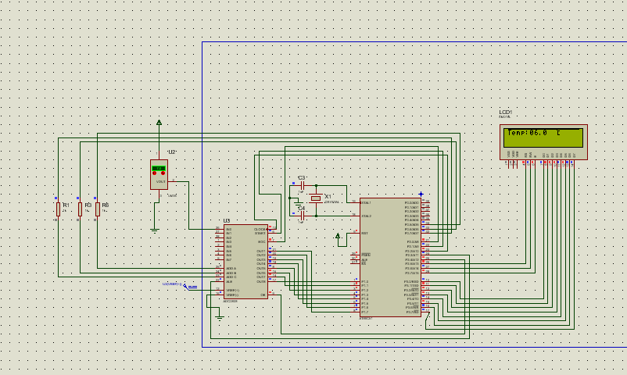

**Post- Lab Questions**

1. **Explain the significance of the Vref terminal in the ADC 0808.**

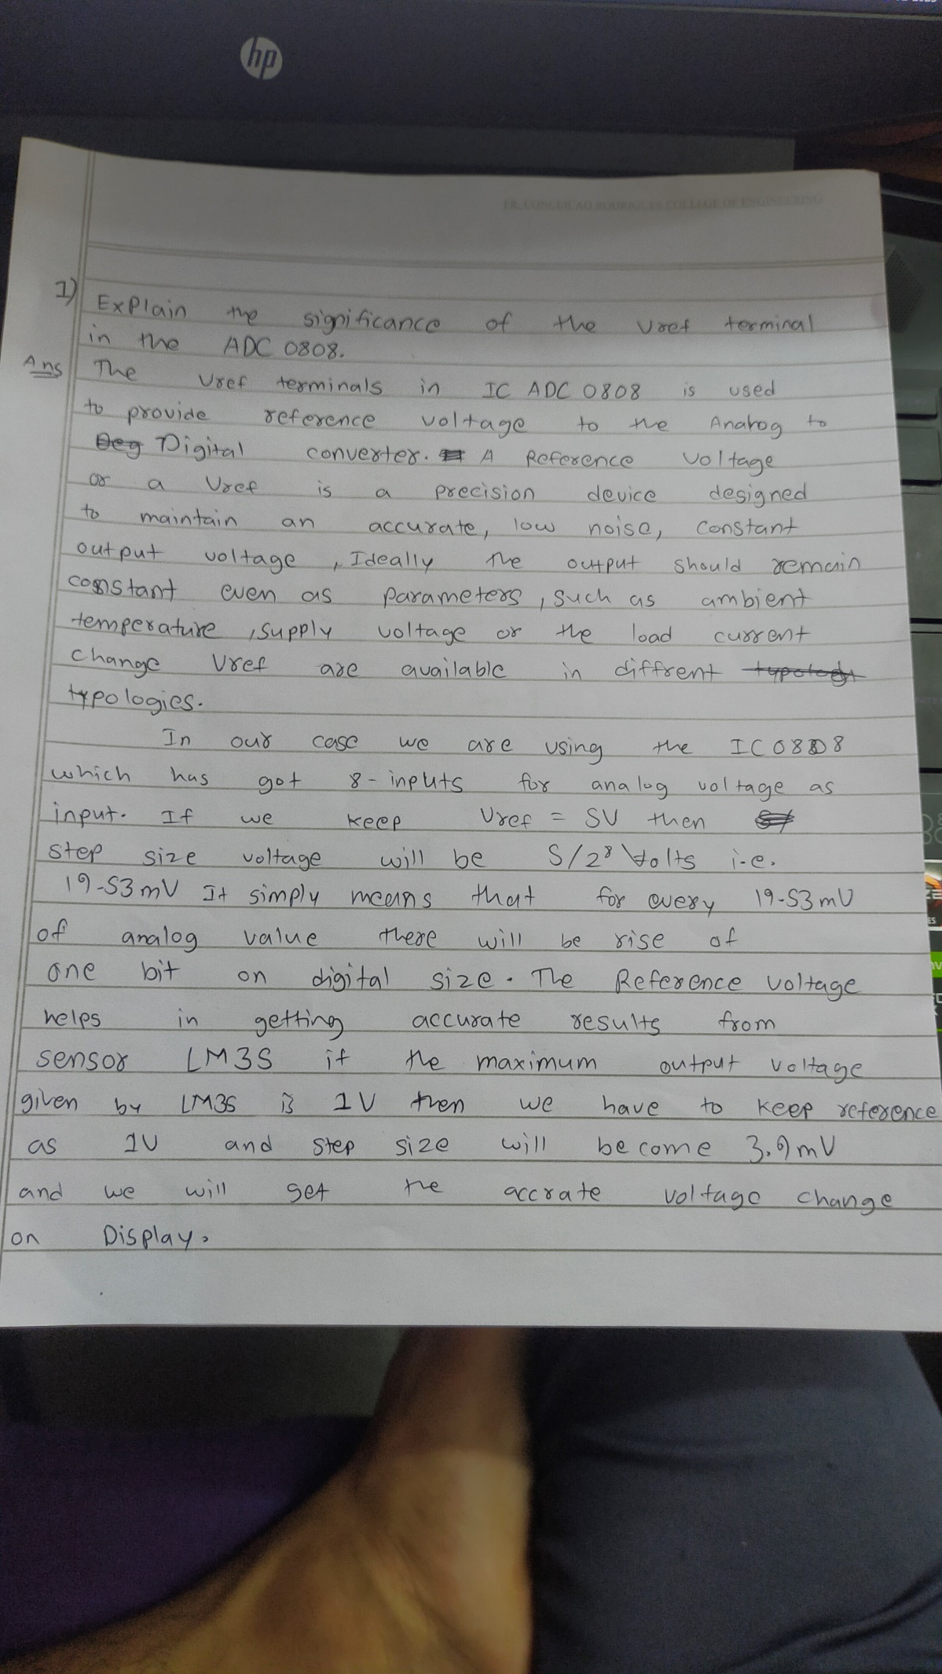

1. **Explain the handshaking sequence with a neat timing diagram.**



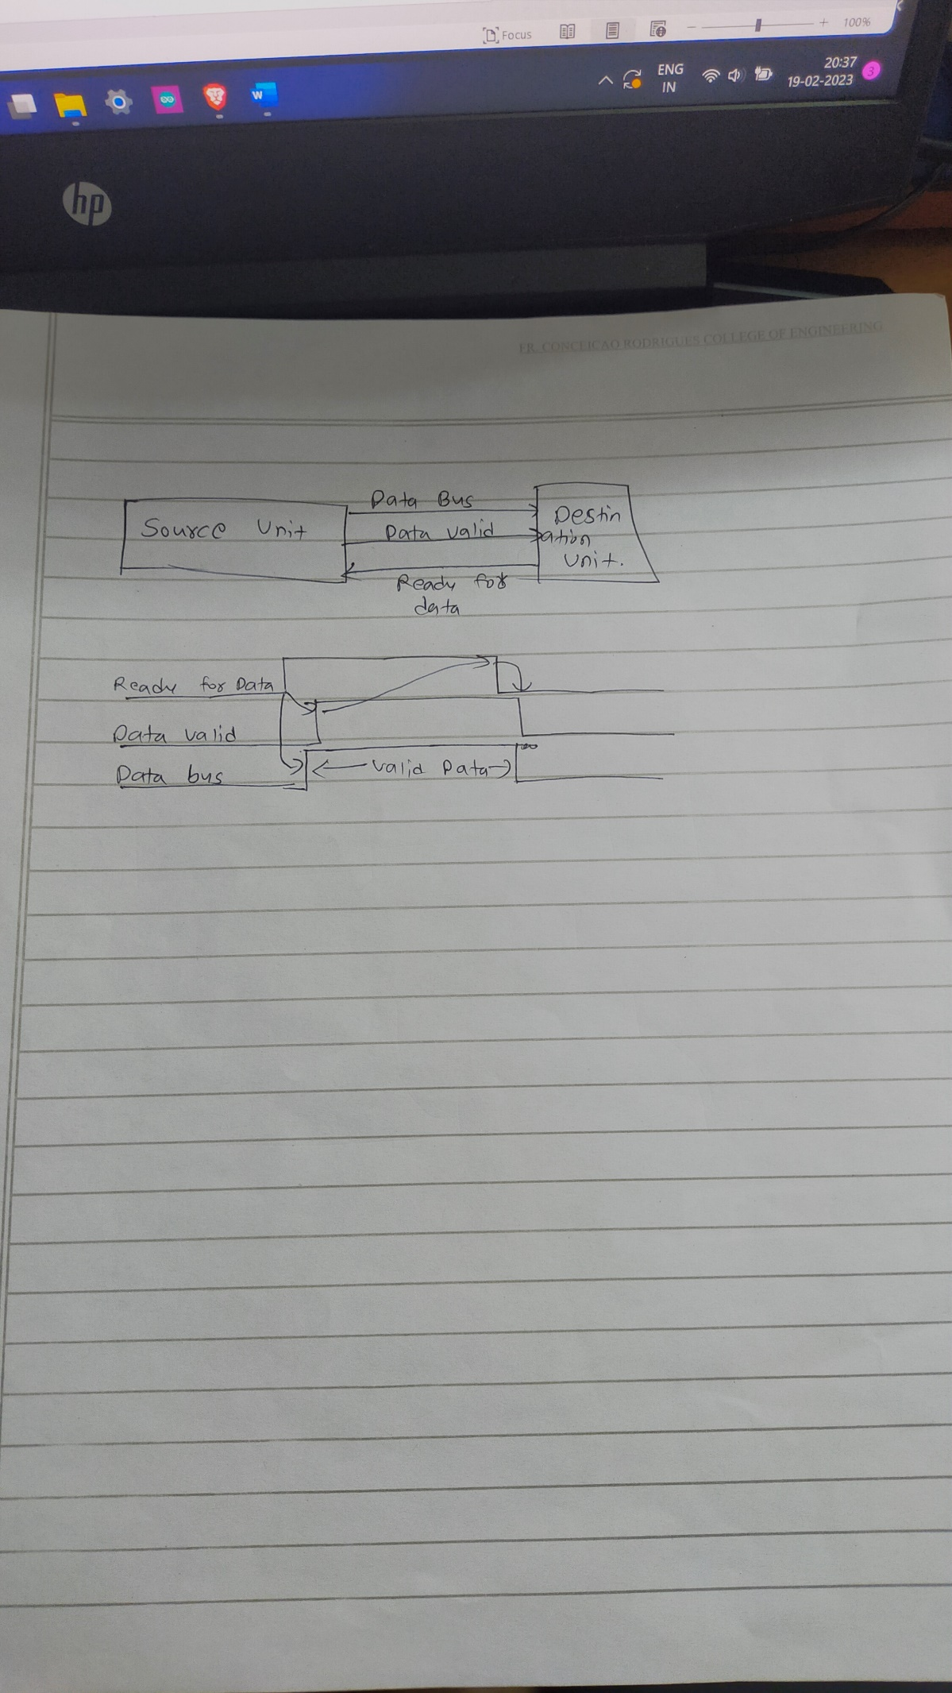

**3.Explain the successive approximation technique for A to D conversion.**

