|  |  |
| --- | --- |
|  | 1. Identify scenarios, develop suitable process model and draw Use case and Class Diagram for the given problem. |

|  |  |  |  |
| --- | --- | --- | --- |
| **Name of Student** | **Hardik Prajapati** | **Roll No.** | **9152** |
| **Sign here to indicate that you have read all relevant material provided /available on Moodle while performing and writing this experiment** | | **Sign:** | |

**Late Submission Details (if any)**

|  |  |  |
| --- | --- | --- |
| **Reason(s) of late submission** | **Date of practical performance** | **Date of practical submission** |
|  |  |  |

**References used**

|  |  |  |
| --- | --- | --- |
| 1 | Name and author of reference book(s) with page nos. |  |
| 2 | Name and roll nos. of the peers whose help you have taken (if any) |  |

|  |  |  |  |  |  |  |  |  |  |  |  |  |  |  |  |  |  |  |  |  |
| --- | --- | --- | --- | --- | --- | --- | --- | --- | --- | --- | --- | --- | --- | --- | --- | --- | --- | --- | --- | --- |
| **Rubrics for assessment of Experiment:**   |  |  |  |  | | --- | --- | --- | --- | | Indicator | Poor | Average | Good | | Timeliness  Maintains Experiment deadline (3) | Experiment not done (0) | One or More than One week late (1-2) | Maintains deadline (3) | | Completeness and neatness  Complete all parts of Experiment (3) | N/A | < 80% complete (1-2) | 100% complete (3) | | Originality  Extent of plagiarism (2) | Copied it from someone else (0) | At least try to implement but could not succeed (1) | Implemented (2) | | Knowledge  In depth knowledge of the Experiment (2) | Unable to answer any questions (0) | Unable to answer few questions (1) | Able to answer all questions (2) | |
| **Assessment Marks:**   |  |  | | --- | --- | | Timeliness |  | | Completeness and neatness |  | | Originality |  | | Knowledge |  | | Total |  | |

**Signature of Teacher with date**

|  |  |
| --- | --- |
| **1.** | **Course, Subject & Experiment Details** |

|  |  |  |  |
| --- | --- | --- | --- |
| **Course & Branch** | **T.E. (ECS)** | **Estimated Time** | **02 Hours Per Week** |
| **Current Semester** | **Semester V** | **Subject Name** | **SE** |
| **Chapter No. & Unit** | **(Pre-requisite)** | **Chapter Title** | **-** |
| **Experiment Type** | **Software Performance** | **Subject Code** | **ECC 503** |

|  |  |
| --- | --- |
| **2.** | **Aim & Objective of Experiment** |

1. Construct suitable software process model for the given problem
2. Identify different scenarios for the given problem and draw use case and class diagrams

|  |  |
| --- | --- |
| **3.** | **Expected Outcome of Experiment** |

1. To understand the mapping between existing software process models and their problem statement
2. To convert the given problem statement into use case and class diagrams

|  |  |
| --- | --- |
| **4.** | **Brief Description of the experiment** |

1. **Identify different scenarios and construct suitable software process model for the given problem statement. Justify your answer.**
2. **Draw use case diagram and class diagram for the given problem**

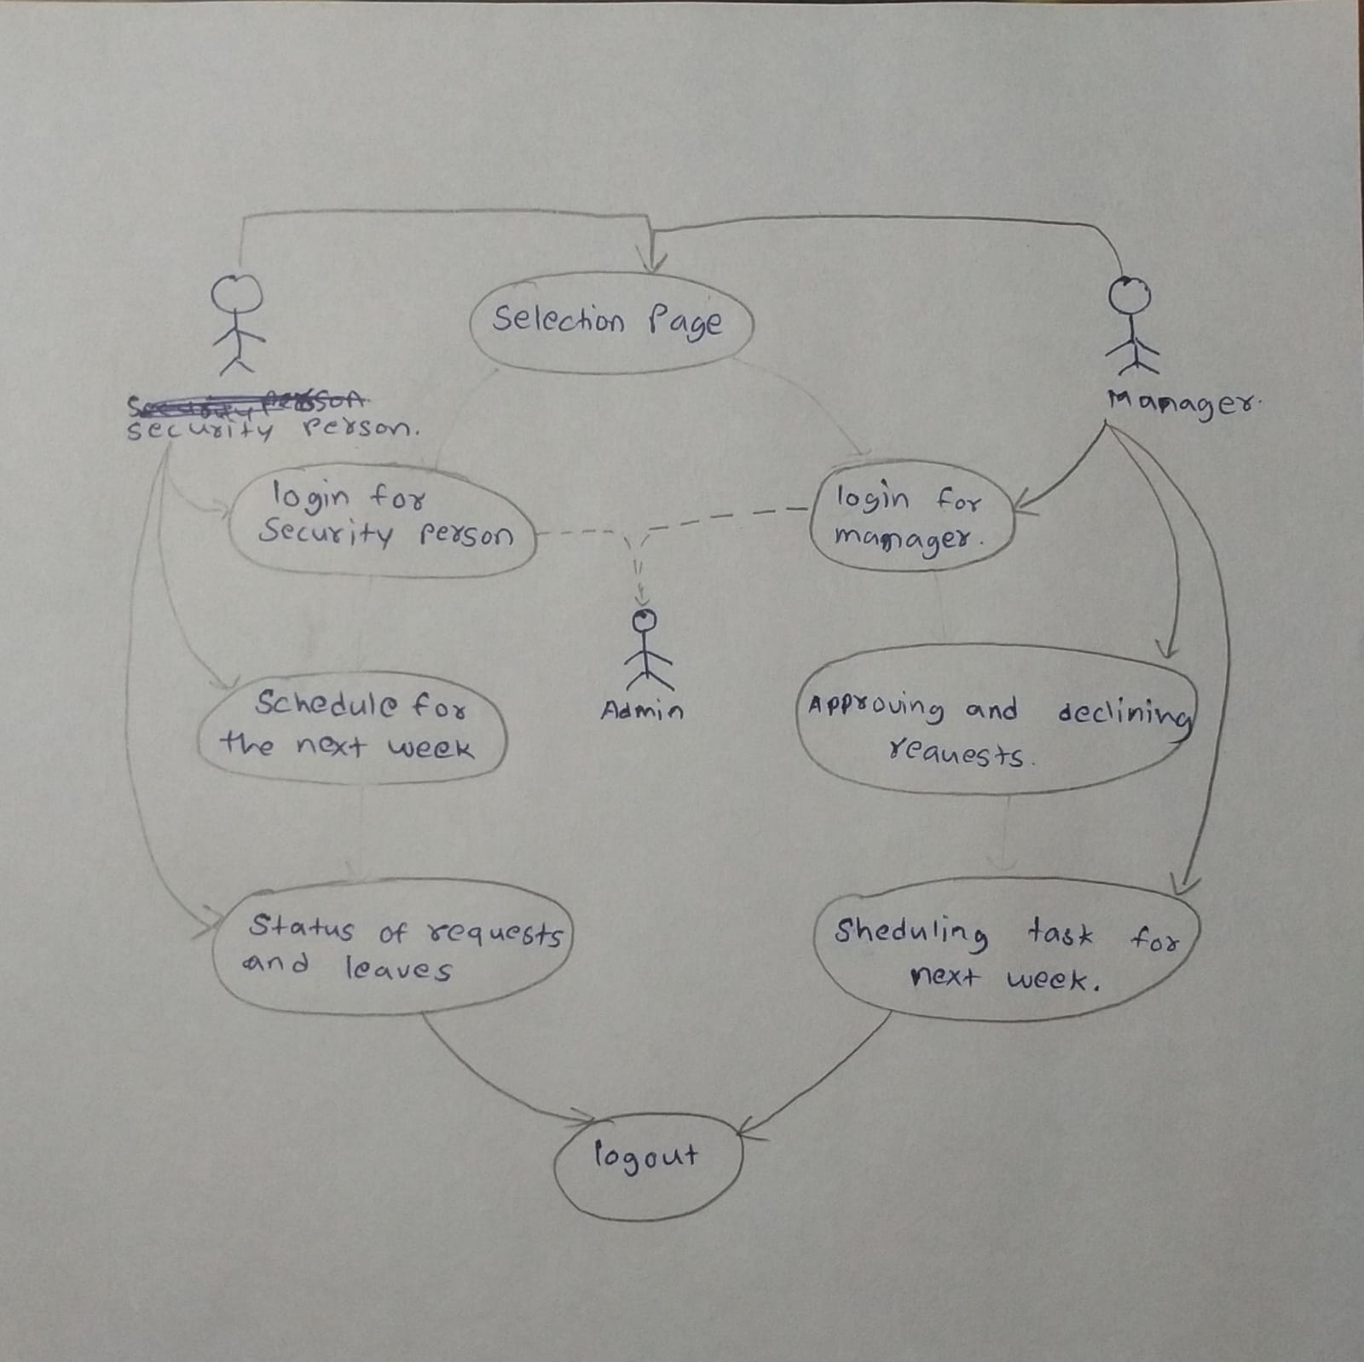

|  |  |
| --- | --- |
| **5.** | **Conclusions & Inferences** |

|  |  |
| --- | --- |
| **6.** | **Post Lab exercise** |

Suggest the most appropriate generic software process model that might be used as a basis for managing the development of the following systems. Explain your answer according to the type of the system being developed

1. A system to control antilock breaking in a car

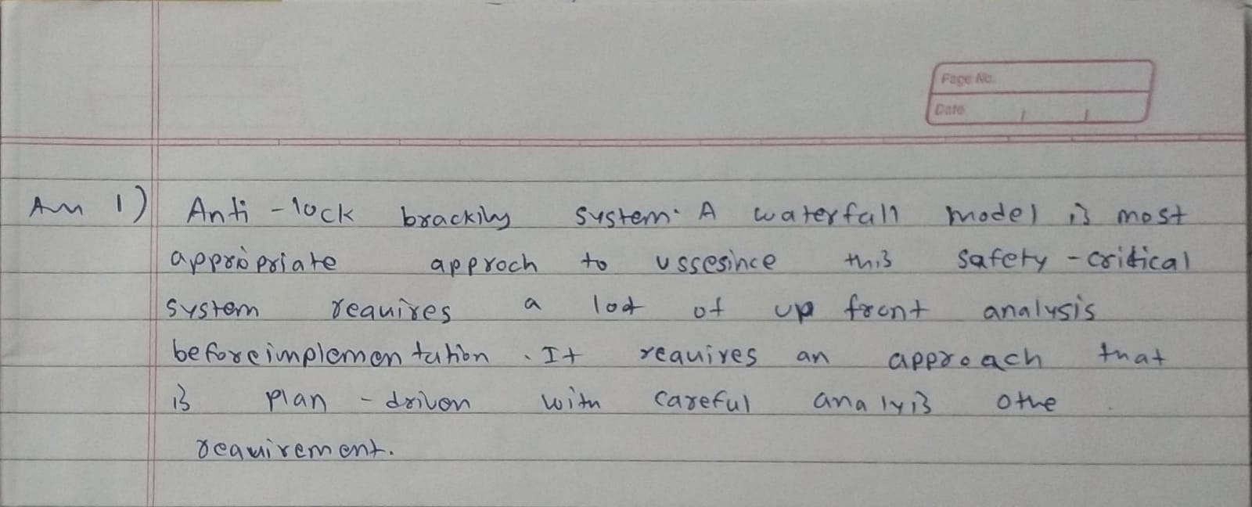

1. An interactive travel planning system that helps users plan journeys with the lowest environmental

impact



